**PROPOSAL**

**FARA Vendor Database Management System (FARA VDMS)**

NAME

DATE

1. **A. INTRODUCTION**

The Forum for Agricultural Research in Africa (FARA) together with the Sub-Regional Agricultural Research Organizations (SROs) offer a strategic platform that fosters continental and global networking to strengthen the innovation capacities of Africa’s agricultural research system. FARA also has a mandate from the AUC to serve as its technical arm in the advancement of the Science Agenda in Africa’s Agriculture.

To achieve transformation in the agricultural sector, FARA has identified an increasing need for deeper collaboration among Agricultural Research for Development practitioners and private sector partners in Africa. FARA has therefore embarked on an inclusive process together with the Sub Regional Organizations (ASARECA, CCARDESA, CORAF) and AFAAS, to develop a new vision of collaboration and operationalization with private sector partners. This is being done through the European Union (EU) funds under the Development Smart Innovation through Research in Agriculture (DeSIRA) initiative. The initiative aims to implement a 4-year project in Africa called CAADP Ex-Pillar 4 (CAADP-XP4).

The overall objective of the CAADP-XP4 is to increase the contribution of Africa’s regional and country-level agriculture and food innovation systems towards the achievement of climate-relevant and sustainable transformation of the continent’s agriculture and food systems.

FARA continues to embrace the digital revolution, it is increasing its reliance on IT tools to perform its functions. FARA has found the need to establish a vendor database of eligible individual experts and firms to be engaged to provide services or supply goods whenever needed. FARA, therefore, intends to implement this excellent initiative through the CAADP-XP4 project supported by the European Commission & IFAD.

The vendor software will allow FARA to develop a comprehensive vendor management process and obtain a complete view of the vendor relationships and vendor risk. The solution will enable efficient vendor due diligence, maintain vendor records (addresses, contact, area of specialization, etc), announcement, notification of bids, status proposals, submission of documents, etc. 2 | P a g e

The overall objective of the assignment is to engage a consultant to lead the design of a Vendor Database Management Software (VDMS) for FARA.

1. **B. OBJECTIVES OF ASSIGNMENT**

The purpose of the assignment is to develop a vendor management software to manage FARA’s vendor information, such as contact information, nature of business, experiences, qualifications, receive automated reminders of key dates, secure access to all files, messages and communicate directly with the vendors.

1. **C. SCOPE OF ASSIGNMENT**

Under the guidance of the FARA’s Web Developer, Procurement Expert, IT Officer, and the overall oversight of the Human Resource Manager, the consultant will undertake the following tasks:

|  |  |  |
| --- | --- | --- |
| **No.** | **Scope** | **Description** |
| 1. | User management | The solution should provide different levels of access to the database: administrator, manager, user, who may be able to read, write and edit depending on their role. |
| 2. | Database maintenance | The solution should enable users to insert, update and delete records in database tables. |
| 3. | Transfer mechanism | The solution should enable users to transfer data from other databases and Excel files to the database, and to export data into other formats, including but not limited to Excel. |
| 4. | Data manipulation functions | The solution should enable users to perform operations including searching, sorting data, merging/uploading files and documents as attachments, sending online messages. |
| 5. | Macro language | The solution should include a macro language that allows conditions and loops plus all the data manipulation functions listed above, with a recording engine, macro-management tools (create, save, delete, load, change) and documentation. |
| 6. | User interface | The solution should have a user-friendly interface and also allow the display of data and all the functionalities listed above at the front end. |
| 7. | Data transfer | The solution should allow data transfer between the internal and external databases and storage devices. |
| 8. | Database history | The solution should include a log of all changes to the records in the database that can be used as a “restoration table” to undo changes that were made. |
| 9. | Training and closure | The consultant/developer of the solution should provide all the tools, training and maintenance necessary for the effective use of the solution, including but not limited to: system usage guides, training for administrators and users, system documentation, system maintenance contracting, system support and system upgrade. |

**User management**

This will be implemented with the PHP-MySQL User management system. This is a powerful PHP script that offers a secure user management system. The application is a great way to build the proposed system, allowing users to register an account and build restricted access to certain users. It also offers great support.

User Features

* Login
* Signup
* Change Password
* Edit Profile
* View Messages / Notification

Admin Features

* Dashboard (Total Users, Deleted Users, Notification, Feedback Messages)
* Signup
* Change Password
* Edit Admin Profile
* Reply Feedback
* Delete Users
* Confirm Users
* View Feedback
* Notification
* View Deleted Users
* Search users, feedback messages
* Download User Excel File
* Sorting

**Transfer Mechanism**

To transfer data from other databases and Excel files to the database, and to export data into other formats, including but not limited to Excel, This will be achieved using PHPSpreadsheet. PHPSpreadsheet is a library written in pure PHP and offers a set of classes that allows to read and write various spreadsheet file formats such as Excel and LibreOffice Calc.

**User interface**

Preparing the UI (User Interface) flow, this is a type of deliverable prepare during the UX design process. It makes it possible to visualize the way the user interacts with the interface in a glanceable way. It will contain the following elements:

* User Interface (Mockups or Wireframes) – this will be designed in Adobe XD with other UI design kits
* Trigger Nodes – the entry point, UI element where user start interaction
* Decision Nodes – if there are any constraints or rules that complicate the flow
* Target Nodes – the exit points, elements that point the result or destination of triggered action
* Loops – if there is a flow that is repeatable it is good to visualize its lifecycle
* Modes – if the screen has got more than one state, there should be a visualization of the particular case.
* Connections – to visualize the flow of the elements to be connected together. Connections are usually arrows that connect trigger nodes and target nodes

After the user flow has been developed, Bootstrap which is a frontend web framework will be used to achieve the final front end view with full responsiveness and scalability

**Data manipulation functions**

Enabling users to perform operations including searching, sorting data, merging/uploading files and documents as attachments, sending online messages. The system will feature a MySQL Database where CRUD (Create Read Update and Delete) Operation can be done.

**Defining the Project Scope**

The purpose of this first phase is to find out the scope of the problem and determine solutions. This system will allow the procurement unit of FARA take care of the processes involved in the end-to-end vendor management process, from initial contact to final closure of a deal or establishing a business relationship.

Taking a modular approach, the vendor database management system will be divided into apps that take care of processes like vendor onboarding and account system

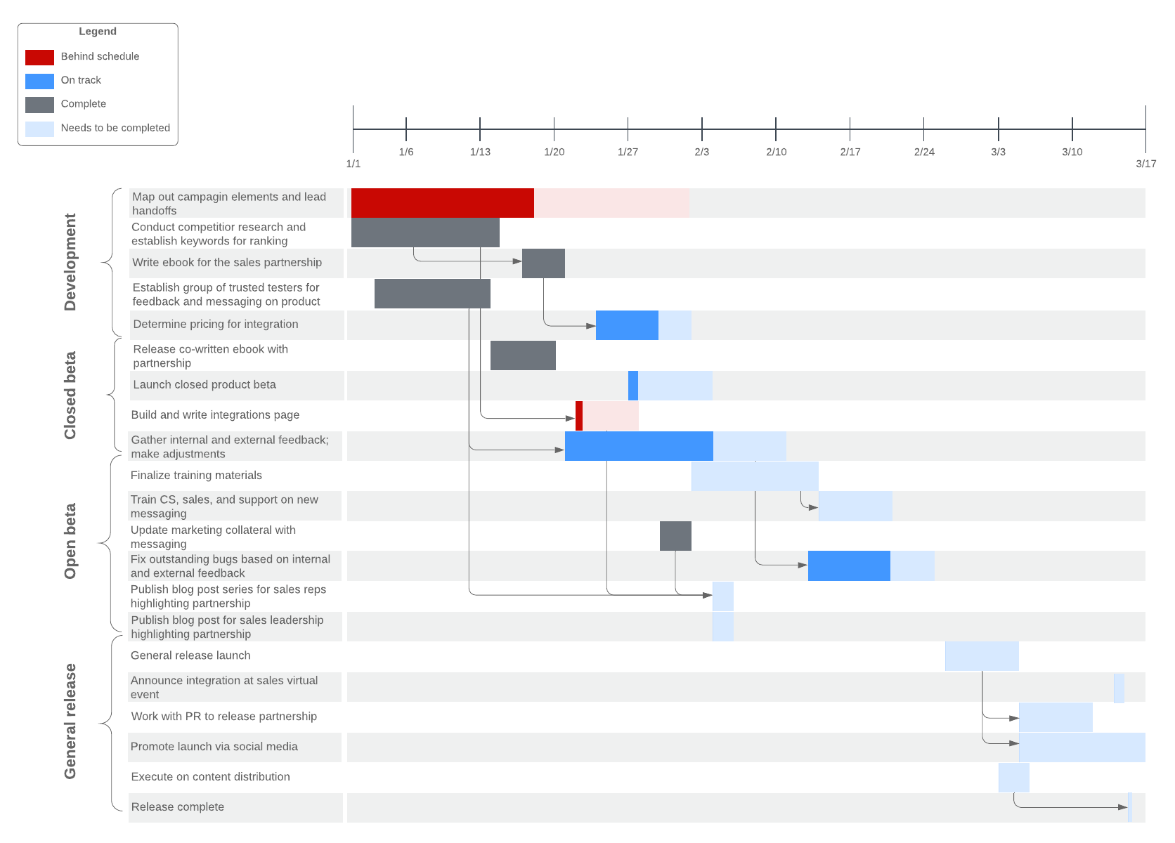

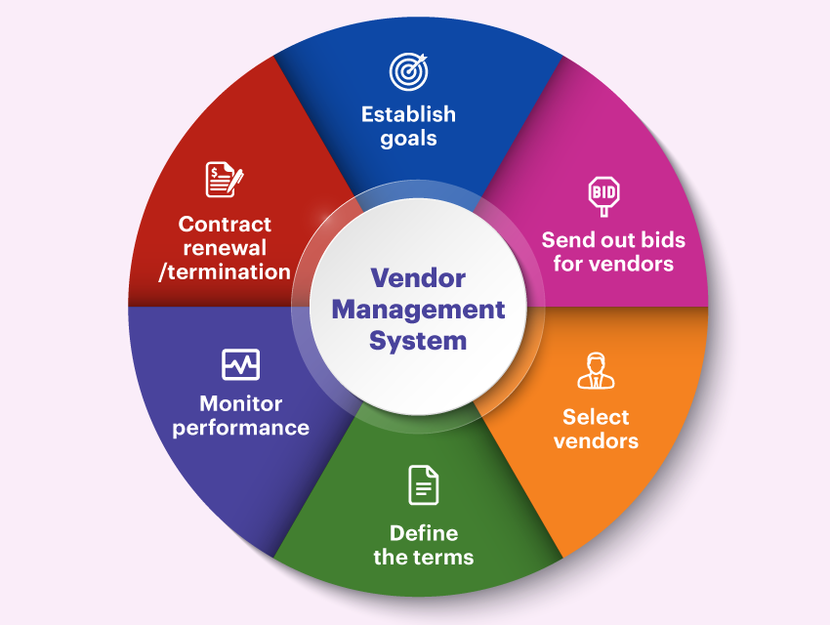

**Database Management Scope**

**Database Design Process**

* **Determine the purpose of your database**

This helps prepare for the remaining task in designing the database.

* **Find and organize the information required**

Gathering of all the types of information needed to record in the database, such as product name and order number.

* **Divide the information into tables**

Here the information items is divided into major entities or subjects, such as Vendor or Assets. Each subject then becomes a table.

* **Turn information items into columns**

Here a decision is made on what information need to be stored in each table. Each item becomes a field, and is displayed as a column in the table. For example, a Vendor table might include fields such as Last Name and Hire Date.

* **Specify primary keys**

Set primary key attributes. The primary key is a column that is used to uniquely identify each row. An example might be VendorID.

* **Set up the table relationships**

Here a decision is made on how the data in one table is related to the data in other tables. New fields might be added to tables or create new tables to clarify the relationships, as necessary.

* **Refine your design**

Design is carefully analysed for errors.

* **Apply the normalization rules**

Apply the data normalization rules to see if your tables are structured correctly. Adjust the tables, as needed.

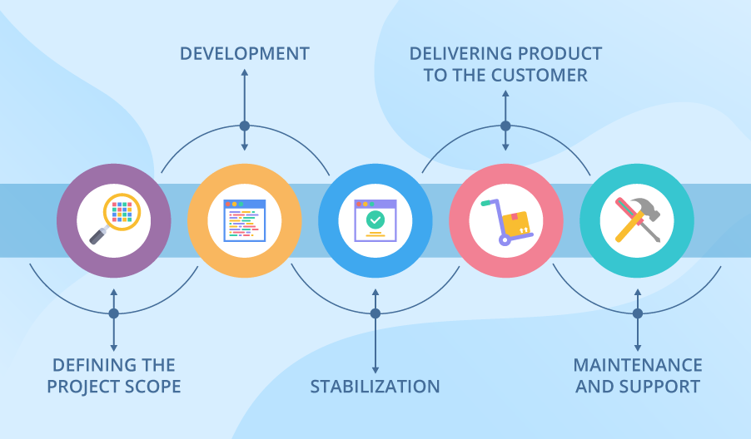

**Training for Project closure**

The closing phase of the project is the final phase of the project lifecycle. This is the stage where all deliverables are finalized and formally transferred, and all documentation will be signed off, approved, and archived.

The process will ensure that, all work has been completed according to project plan and scope and all project management processes have been executed.

**Project Timeline**

|  |  |
| --- | --- |
| Activity | Duration in Days |
| Requirement Gathering | **6** |
| System Specification and Design | **10** |
| System Development | **20** |
| System testing /Evaluation | **6** |
| System Deployment | **2** |
| Final testing | **6** |

**Budget for the Project**

|  |  |  |
| --- | --- | --- |
| CONSULTANT | FEE GHc | 40 DAYS |
| Total Number of  Personnel  1 | **$ 262.5** | **$ 10,500** |
| TOTAL |  | **$ 10,500** |