
CAMPUSCONNECT
Smart Campus Event & Club Management System
A C++ Object-Oriented Programming Mini Project
PROJECT REPORT
Submitted for the course
Object-Oriented Programming using C++

Project Details | Information
Submitted by | Samdarsh Kumar Pandey
Roll Number / UID | 25BCD10048
Programme | BCA (Data Science)
Semester / Section | 3rd Sem
Submitted to | Mrs. Shuchi Sharma Ma’am
Institution | Chandigarh University
Academic Session | 2026–2027

GitHub Repository: ______________________________________________

ABSTRACT
CampusConnect is a console-based campus event and club management prototype developed in C++. It represents common activities in a college environment, including browsing workshops, cultural events and seminars, registering students, checking seat availability, viewing student clubs, and reviewing registration records.
The project uses an abstract Event class and specialised Workshop, CulturalEvent and Seminar classes to demonstrate abstraction, inheritance and runtime polymorphism. Private data members support encapsulation, while STL vectors and smart pointers manage event and registration data. Text files preserve event capacity and registration records between sessions.
CampusConnect is an educational prototype. It does not provide a web portal, online authentication, payment processing, QR attendance, or multi-user database access.

Keywords
C++, OOP, campus management, event registration, abstraction, inheritance, polymorphism, STL, file handling.

TABLE OF CONTENTS
Section | Contents
1 | Introduction and Problem Statement
2 | Objectives and Scope
3 | Requirements and Tools
4 | System Design and Workflow
5 | OOP Concepts Applied
6 | Implementation Details and Core Code
7 | Testing and Sample Output
8 | Limitations and Future Scope
9 | Conclusion, References and Viva Questions

1. INTRODUCTION
Colleges organise workshops, seminars, cultural programmes and club activities throughout the academic year. Students need a simple way to discover events, check available seats and register. Organisers also need a basic record of registrations and event capacity.

1.1 Problem Statement
When event details and student registrations are maintained manually or in separate lists, it can be difficult to track seat availability, avoid duplicate registrations and keep records organised. This project addresses the problem by creating a small menu-driven application that groups event-related data and operations into C++ classes.

1.2 Proposed Solution
CampusConnect stores different event types using a common abstract Event base class. Students can view events and clubs, register using their name and UID, and view saved registration records. The application checks capacity and prevents the same UID from registering twice for the same event.

1.3 Distinctive Features
- Separate event types: workshops, cultural events and seminars.
- Seat availability check before registration.
- Duplicate registration prevention using student UID and event ID.
- Persistent event and registration records using text files.
- Event summary using overloaded functions.
- Clear examples of core C++ OOP concepts.

2. OBJECTIVES AND SCOPE

2.1 Objectives
- Develop a menu-driven campus event application in standard C++17.
- Demonstrate classes, objects, encapsulation, abstraction, inheritance and polymorphism.
- Use vector and unique_ptr from the C++ Standard Library.
- Allow students to browse events and register for available seats.
- Maintain club information and registration records.
- Store event capacity and registration details in text files.
- Validate input and handle common errors.

2.2 Scope
The prototype is designed for a single local user running the application in a terminal. It contains sample event and club records, student registration by name and UID, event capacity checks, a registration list and a simple event summary.

2.3 Out of Scope
- Online student login or university ERP integration.
- Online payments, ticket sales or QR-code check-in.
- Cloud database and simultaneous multi-user access.
- Email/SMS notifications and automatic calendar integration.
- Administrator dashboard or graphical user interface.

2.4 Intended Users
The application is intended for students learning C++ OOP, instructors assessing programming concepts and beginners exploring basic event-management logic.

3. REQUIREMENTS AND TOOLS

3.1 Hardware Requirements
Component | Minimum Requirement
Computer | Windows, Linux or macOS computer
Memory | 2 GB RAM or more
Storage | Approximately 20 MB for source and compiler output
Input / Output | Keyboard and terminal or console

3.2 Software Requirements
Tool | Purpose
C++ compiler supporting C++17 | Compile and run the application
VS Code / Code::Blocks | Write and edit source code
GCC / MinGW g++ | Compile on Windows or Linux
Text files | Store events and registrations

3.3 Main C++ Libraries
Header | Purpose
iostream | Console input and output
vector | Store events and registrations
memory | Manage derived event objects using unique_ptr
fstream | Read and write text files
sstream | Parse saved event records
iomanip | Format console tables
stdexcept | Handle invalid values and runtime errors
limits | Clear invalid console input

3.4 Compile and Run
g++ -std=c++17 -Wall -Wextra main.cpp -o CampusConnect
./CampusConnect
On Windows, run CampusConnect.exe after compilation. Run the executable from the project folder so events.txt and registrations.txt are created or accessed in the expected location.

4. SYSTEM DESIGN AND WORKFLOW
Module | Responsibility
Event catalogue | Displays event names, types, dates and available seats.
Event subclasses | Store event-specific details such as instructor, venue or department.
Student registration | Collects student name and UID and validates registration.
Club directory | Displays available campus clubs and their focus areas.
Registration records | Shows saved student-to-event registrations.
File storage | Loads and saves event counts and registration records.
Event summary | Counts total events by type.

4.1 Program Workflow
- Start the application and load event records from events.txt.
- If the event file does not exist, create a default event catalogue and save it.
- Load existing registration records from registrations.txt.
- Display the menu and accept the user's choice.
- Allow event browsing, registration, club viewing or registration review.
- Before registration, verify the event ID, seat availability and duplicate UID.
- Save the updated event count and append the registration record.
- Continue until the user selects Exit.

4.2 Data Files
File | Example Record | Purpose
events.txt | W|101|Python Bootcamp|20-11-2026|40|3|Data Science Faculty | W = Workshop; stores event fields
events.txt | C|102|CU Cultural Night|25-11-2026|100|5|Open Air Theatre | C = Cultural event
events.txt | S|103|Future of AI|28-11-2026|60|2|Computer Science | S = Seminar
registrations.txt | Aman Sharma|25BCD10001|101 | Student name, UID and event ID

The pipe character (|) separates fields. Student names, UIDs and event details should not contain this character.

5. OOP CONCEPTS APPLIED
Concept | Where Used | Explanation
Classes and Objects | Event, Workshop, CulturalEvent, Seminar, Club and CampusConnect | Classes combine data and related operations.
Encapsulation | Private fields in Event and Club | Controls access to internal data through public methods.
Abstraction | Abstract Event class | Pure virtual methods define a common interface.
Inheritance | Three event subclasses inherit from Event | Shares common event data and behaviour.
Runtime polymorphism | Virtual display/type/serialize methods | Derived implementation is selected through a base pointer.
Constructors | Model classes | Initialise objects when they are created.
Function overloading | countEvents() and countEvents(type) | Same function name with different parameter lists.
STL and smart pointers | vector and unique_ptr | Manage collections and object memory safely.
File handling | events.txt and registrations.txt | Preserves selected records between runs.
Exception handling | try/catch and standard exceptions | Handles invalid records and runtime errors.

5.1 Example of Polymorphism
Event defines virtual functions such as getType(), extraInfo() and serialize(). Workshop, CulturalEvent and Seminar override these functions. The application stores the different derived objects as unique_ptr<Event>. When a virtual function is called through the base-class pointer, C++ selects the correct derived-class implementation at runtime.

5.2 Memory Management
The event collection uses vector<unique_ptr<Event>>. A unique_ptr owns one event object and automatically releases it when the object is removed or the application ends. This avoids manual delete operations.

6. IMPLEMENTATION DETAILS AND CORE CODE

6.1 Abstract Event Class
class Event {
private:
int id;
string title;
string date;
int capacity;
int registered;
public:
virtual string getType() const = 0;
virtual string serialize() const = 0;
bool registerStudent();
};
The data members are private, demonstrating encapsulation. Pure virtual functions make Event an abstract class, so the application creates objects of derived event types.

6.2 Derived Class Example
class Workshop : public Event {
private:
string instructor;
public:
string getType() const override { return "Workshop"; }
string extraInfo() const override {
return "Instructor: " + instructor;
}
};
CulturalEvent stores a venue, while Seminar stores a department. All three classes reuse the common fields and methods of Event.

6.3 Student Registration
struct Registration {
string studentName;
string studentId;
int eventId;
};
Before saving a registration, the program checks whether the event exists, whether seats are available and whether the same student UID is already registered for that event.

6.4 File Handling
void saveEvents() const {
ofstream file("events.txt");
if (!file)
throw runtime_error("Unable to save events.txt");
for (const auto& event : events)
file << event->serialize() << '\\n';
}
The event file is rewritten with the latest seat counts. New registration records are appended to registrations.txt. This is a small educational storage approach, not a transactional database.

6.5 Function Overloading
int countEvents() const;
int countEvents(const string& type) const;
The first function returns the total number of events. The overloaded version counts only events matching a supplied type, such as Workshop or Seminar.

6.6 Complete Source Code
The complete, compilable source code is supplied separately as main.cpp in the project folder and ZIP package.

7. TESTING AND SAMPLE OUTPUT
The following is a test plan. Mark tests as passed only after running them on the final compiled program.
ID | Test Case | Expected Result
T01 | Start without events.txt | Default events are created and saved.
T02 | View all events | Event list shows type, date and seats.
T03 | Register with valid event ID and UID | Registration is saved and available seats decrease.
T04 | Enter unknown event ID | Event-not-found message appears.
T05 | Register for a full event | Full-event message appears.
T06 | Register same UID twice for one event | Duplicate registration is rejected.
T07 | View clubs | Club names and focus areas appear.
T08 | View registrations | Saved student registration records appear.
T09 | Restart after registration | Updated seat counts and records load from files.
T10 | Enter invalid menu choice | Invalid-choice message appears.

7.1 Illustrative Console Menu
============================================
CAMPUSCONNECT
Campus Event & Club Management
============================================
1. View all events
2. Register for an event
3. View student clubs
4. View registrations
5. Event summary
6. Exit
Enter your choice: 1
ID Event Type Date Seats
101 Python Bootcamp Workshop 20-11-2026 40/40
102 CU Cultural Night Cultural 25-11-2026 100/100
103 Future of AI Seminar 28-11-2026 60/60
The displayed sample is illustrative. Actual seat counts change as students register.

8. LIMITATIONS AND FUTURE SCOPE

8.1 Current Limitations
- The prototype runs locally in a console and supports one user at a time.
- Student identity is entered as text; there is no authentication.
- Text files are used instead of a database.
- No online event publishing, notifications or QR attendance.
- Event records are sample data and are not connected to the university timetable.
- The pipe-delimited file format has basic validation and is not intended for arbitrary text fields.

8.2 Future Enhancements
- Add administrator login and event creation/editing.
- Integrate SQLite or another database for reliable records.
- Add a graphical or web-based user interface.
- Generate QR codes and record attendance.
- Send email or SMS registration confirmations.
- Add event search, filters, waitlists and cancellation options.
- Connect to a university portal if authorised.

8.3 Responsible Use
This project is an educational prototype. Do not use it to store sensitive student information or as an official university registration system without authentication, access control, privacy safeguards and reliable database storage.

9. CONCLUSION
CampusConnect demonstrates how a campus event and club management problem can be represented using C++ object-oriented programming. The abstract Event class and derived event types illustrate abstraction, inheritance and runtime polymorphism. Private data members and public methods demonstrate encapsulation. STL vectors and smart pointers manage collections and object lifetimes, while text files preserve event capacity and student registration records between sessions.
The application is intended for learning and demonstration. A database, authentication, administrator tools, notifications and a graphical interface would be useful future improvements.

REFERENCES
- Bjarne Stroustrup, The C++ Programming Language, Addison-Wesley.
- cppreference.com — C++ language and standard library reference: https://en.cppreference.com/
- ISO C++ — C++ language resources: https://isocpp.org/
- Course notes on Object-Oriented Programming using C++.

VIVA QUESTIONS
1. What is a class? A class is a user-defined blueprint that groups data members and member functions.
2. What is an object? An object is an instance of a class.
3. Why is Event an abstract class? It contains pure virtual functions and cannot be instantiated directly.
4. What is inheritance? Inheritance allows a derived class to reuse and extend a base class.
5. What is runtime polymorphism? It selects an overridden virtual function at runtime through a base pointer or reference.
6. What is encapsulation? Encapsulation combines data and methods and controls access to internal data.
7. Why use unique_ptr? It provides automatic ownership and memory cleanup.
8. What is function overloading? Using the same function name with different parameter lists.
9. Why use file handling? To preserve records after the program closes.
10. How does the project prevent duplicate registration? It checks whether the same student UID is already registered for the selected event.

GITHUB REPOSITORY
Repository URL:

[Paste your GitHub repository URL here after uploading the source files.]
[Insert a screenshot of your GitHub repository here after uploading.]

APPENDIX A: ACTUAL PROGRAM OUTPUT
The following screenshot was captured from an actual execution of the compiled C++17 program. The demonstration views the event catalogue and clubs, displays the event summary, registers a demonstration student, and verifies the updated seat count and registration record.
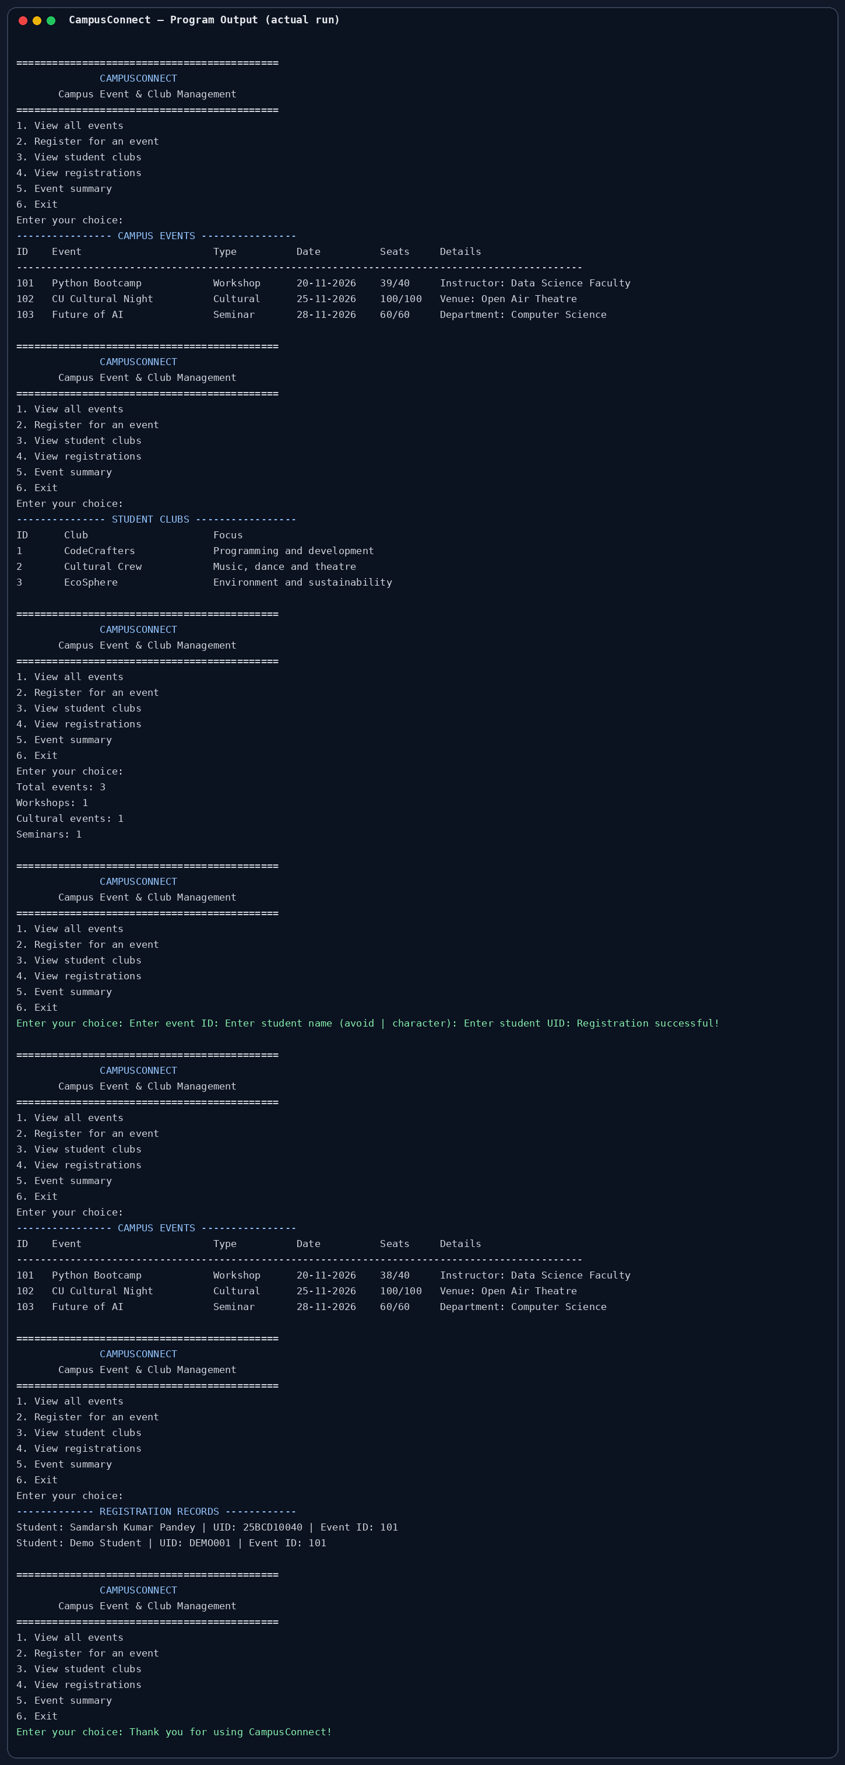
Demonstration data: Demo Student / DEMO001. This is sample data, not a real student registration.

