SOFTWARE DESIGN AND DEVELOPMENT

Mr Legge

Sam Davison

32522939

“ActionScript 3 Program / Game”

Contents

Zombie Defence Design Specifications 2

Zombie Defence Log book 3

Zombie Defence Gantt chart 7

Zombie Defence Context Diagram 8

Zombie Defence Data Dictionary 8

Zombie Defence Storyboard 9

Zombie Defence Test Report 9

Zombie Defence Evaluation of Solution 10

Zombie Defence Maintenance Projection 10

# Zombie Defence Design Specifications

|  |  |
| --- | --- |
| Developer Specifications | User Specifications |
| Thorough documentation covering all stages of development | Easy to use User Interface |
| Meaningful variable names | Well-designed Help menu |
| Thorough intrinsic documentation | Appropriate headings |

# Zombie Defence Log book

# 

|  |  |  |  |  |
| --- | --- | --- | --- | --- |
| Date /Time | Progress | Tasks achieved | Issues | References |
| 18.6.20 | 1. Started Design Specifications  2. Started Gantt Chart | N/A | N/A | N/A |
| 19.6.20 | 1. Started a Context Diagram | Completed Context Diagram. | N/A | N/A |
| 21.6.20 | 1. Continued work on Gantt Chart | Completed Gantt Chart. | N/A | N/A |
| 22.6.20 | 1. Continued work on Design Specifications  2. Started Storyboard  3. Started Data Dictionary | Completed Design Specifications. | N/A | N/A |
| 24.6.20 | 1. Started game, adapted all code from previous Spaceship game from the spaceship and asteroid (now character and zombie, respectively)  2. Rendered a small scene in Blender 3D of a few trees and a house for the game environment.  3. The Character and Zombie were both created as basic objects (a circle and square respectively) | Character can now move freely around the screen in any direction by using the arrow keys on the keyboard.  Zombies spawn at any x location on the screen at the top and slowly move down towards the bottom of the screen. | N/A | AS3 Game Tutorials. *Top Down RPG Shooter – Part 4 – Shooting*. Ben Reynolds.  https://as3gametuts.com/2013/07/10/top-down-rpg-shooter-4-shooting/#more-1211 |
| 28.6.20 | 1. Created two other frames, Frame 1 for the Main Menu and Frame 3 for the Help Menu.  2. Downloaded two transparent images for the character and zombie objects.  3. Remade the background, as the character walked over the house, rather than stopping, and an easy solution was to create a highway scene, with a car with lights on at the bottom.  4. Created a bullet to fire, and adapted bullet code online to spawn the bullet in the characters location when the mouse is clicked.  5. Wrote code to make bullet move upwards when spawned in. | Character and Zombie have their own sprites.  Background is complete.  Bullet spawns in when created. | Unsure of how to adapt the collision function to the bullets – it doesn’t seem to work at the moment. | AS3 Game Tutorials. *Top Down RPG Shooter – Part 4 – Shooting*. Ben Reynolds.  <https://as3gametuts.com/2013/07/10/top-down-rpg-shooter-4-shooting/#more-1211> |
| 1.7.20 | 1. Worked on collision code for the bullets to collide with the zombies – still having issues.  2. Found an alternative method of incorporating bullets that features creating an array and pushing each bullet into the array once it is created.  3. Created a post on Stack Overflow regarding my issue with the bullet collision – I attached some code, and the one person who responded did not see any fault in the code – it must have something to do with the way it is added to the stage, and the hierarchy of the objects. | Stack Overflow Post. | Still having issues with the collision function on the bullets – I believe there has to be something in the hierarchy of the objects added to the stage. | The Code Village. *Action Script 3 Tutorial - Space Shooter – 2: Coding Projectiles*. Mark Bennison.  <http://www.markbennison.com/actionscript/as3-space-shooter/2-coding-projectiles/>  Link to Stack Overflow post:  <https://stackoverflow.com/questions/62674783/how-do-i-get-a-top-down-shooter-bullet-to-collide-with-an-enemy-as3?noredirect=1#comment110850103_62674783> |
| 6.2.20 | 1. Decided to ultimately remove the shooting bullets function from the game, and therefore replaced the character with a similar one holding a knife.  2. Added an exit button to the game screen.  3. Tried an alternative method to adding the zombies to the stage, but did not work as the program used a different structure to my own.  4. Created a post on Stack Overflow regarding an issue with the character not colliding with the first zombie spawned into the game, but colliding with every other one. No response, unfortunately, but I was able to solve this myself by decreasing the amount of children taken into consideration of the collision For loop. | Exit button added to game screen.  Second Stack Overflow post. | The function controlling the exit button on the game screen is constantly presenting errors and not allowing any gameplay. | The Code Village. *Action Script 3 Tutorial - Space Shooter – 3: Spawning Enemies with Basic AI*. Mark Bennison.  <http://www.markbennison.com/actionscript/as3-space-shooter/3-spawning-enemies-with-basic-ai/>  Link to Stack Overflow post:  <https://stackoverflow.com/questions/62689544/collision-detection-is-ignoring-first-enemy-in-top-down-shooter-as3> |
| 7.2.20 | 1. Continued work on the game until completion, tidying up the code and adding author blocks and comments throughout.  2. Completed and embedded Gantt Chart and Data Dictionary.  3. Uploaded all documentation and game / project to GitHub and shared with teacher. | Exit button on game screen.  Completion of Game.  Completion of Gantt Chart.  Completion of Data Dictionary. | N/A | N/A |

# Zombie Defence Gantt chart

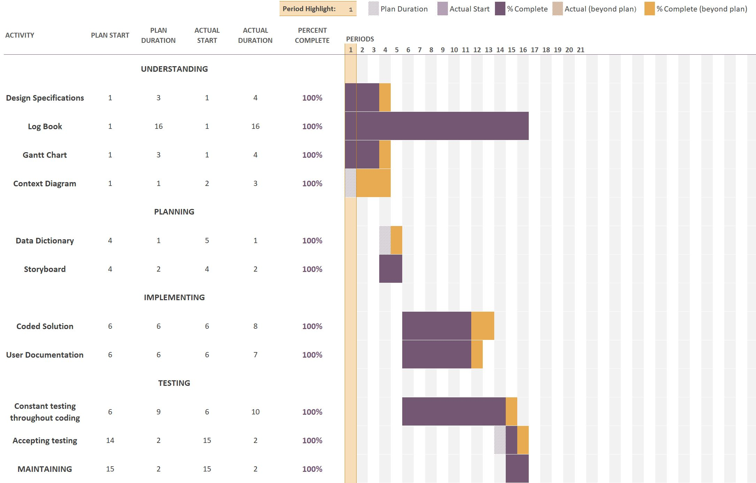

# Zombie Defence Context Diagram

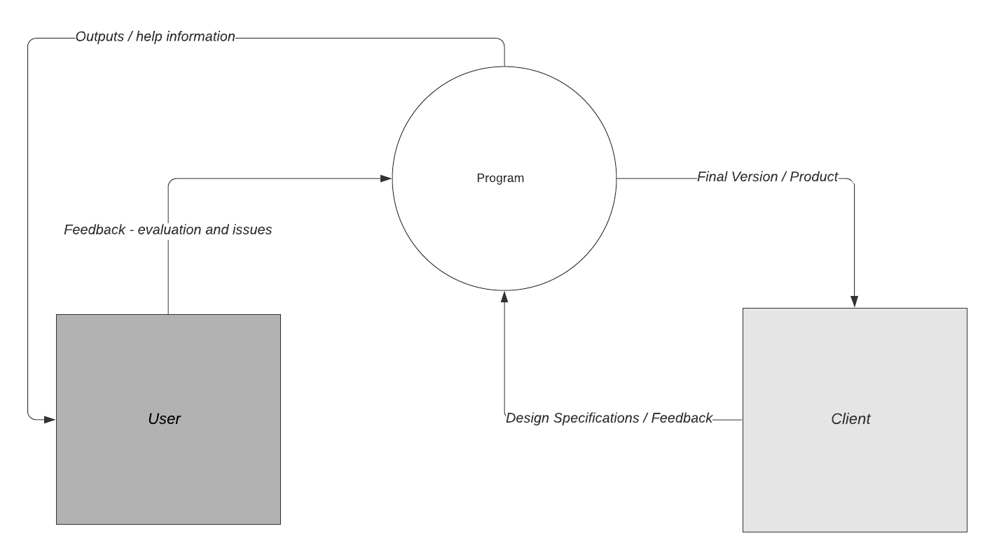

# Zombie Defence Data Dictionary

(embedded Excel Spreadsheet)

# Zombie Defence Storyboard

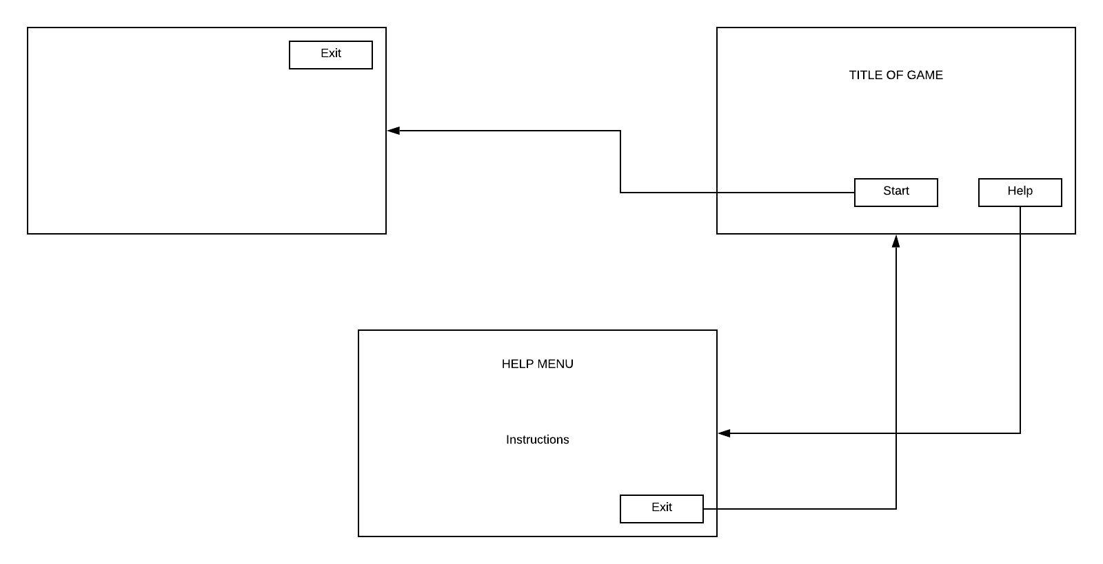

# Zombie Defence Test Report

|  |  |  |
| --- | --- | --- |
| Name | Laptop | PC |
| Aaron Davison | “Yeah definitely a little slower.” | “Runs much smoother on the PC.” |
| Shannon Davison | “Probably could be improved with some animation, like walking zombies or stabbing them…” | “Love the graphics.” |
| Caitlin Davison |  |  |

# Zombie Defence Evaluation of Solution

In reference to the developer and user specifications mentioned at the start of this document, all specifications have been met. The program is thoroughly documented, both within this document and with the program itself. The program features many clear, meaningful variables names and well-designed menus.

# Zombie Defence Maintenance Projection

A possibility for future maintenance is most definitely an introduction of new features, such as the attempted gun firing feature, or enhanced graphics. There are still slight errors and code inefficiency within the program that could be simplified for increased quality and speed.