MERU UNIVERSITY OF SCIENCE AND TECHNOLOGY
School of Computing and Informatics | Department of Computer Science
CDS 3301: MACHINE LEARNING (BCT Year 4, Semester 1)
FINAL ACADEMIC PROJECT REPORT
DIABETES RISK SCREENING SYSTEM
Supervised Classification, Asymmetric Clinical Error Analysis (Recall > Precision), and Decision Support Deployment
Group Identity | Group 2 (5 Members) — Bachelor of Computer Technology
Project Theme | Diabetes Risk Screening (Supervised Binary Classification)
Course Lecturer | Dr. Amos Chege Kirongo (akirongo@must.ac.ke)
Dataset | Pima Indians Diabetes Database (N=768, 8 clinical features, CC0 Licence)
Optimal Clinical Model | Tuned Random Forest (Screening Threshold τ = 0.35, Recall = 90.74%, ROC-AUC = 0.820)
Submission Date | Friday, 4 December 2026, 5:00 PM EAT (Milestone 1 Completed 13 Nov 2026)

Group 2 Members & Project Governance
In accordance with university examination guidelines, all members contributed equitably. Each member is prepared to individually defend all aspects of this machine learning pipeline.
No. | Student Name | Reg. Number | Core Responsibilities | Signature & Status
1 | Ordit Kagwira | CT202/114188/23 | Coordinator, System Architecture & Full Report Integration | Ready for signature
2 | Beauttah Kipruttoh | CT202/113636/23 | Data Acquisition, Missing Value Imputation & Preprocessing | Ready for signature
3 | Atitwa Samuel Makokha | CT202/113631/23 | Exploratory Data Analysis, 5 Visualisations & Feature Importance | Ready for signature
4 | Kiplangat Dancun | CT202/113622/23 | Model Training, Pipeline Architecture & Web Prototype | Ready for signature
5 | Wamukota Kevin | CT202/106143/21 | Hyperparameter Tuning, Cross-Validation & Metric Evaluation | Ready for signature

Executive Summary
Early screening for Type 2 diabetes is one of the highest-yield interventions for reducing microvascular and macrovascular complications, particularly across primary healthcare facilities in Kenya with constrained diagnostic infrastructure. This project designs, evaluates, and deploys an empirical Machine Learning screening system built on the Pima Indians Diabetes Database (N=768). We address critical data quality obstacles—including biologically impossible zero values in insulin (48.7%), skin thickness (29.6%), blood pressure (4.6%), and BMI (1.4%)—using a median-imputation pipeline fitted strictly within training folds to avoid data leakage.
Six model families were systematically evaluated: Dummy Baseline, Logistic Regression, K-Nearest Neighbors (KNN), Decision Tree, Random Forest, and Support Vector Machine (SVM) with radial basis kernel. We conducted 5-fold Stratified Cross-Validation combined with GridSearchCV. Addressing the core clinical question ('Is recall more important than precision for screening? What threshold would you recommend and why?'), our analysis demonstrates that the clinical cost of a False Negative (undetected diabetes progressing silently to retinopathy, nephropathy, or diabetic ketoacidosis) vastly outweighs a False Positive (a temporary misclassification readily resolved by an affordable fasting plasma glucose re-test). By systematically sweeping decision thresholds, we established τ = 0.35 on our top-performing Random Forest model (ROC-AUC = 0.820). This calibrated threshold catapulted sensitivity/recall from 74.07% to 90.74% (catching 49 out of 54 diabetic patients on the held-out test split, leaving only 5 false negatives), achieving an optimal screening F2-score of 0.798. The complete system is operationalized via a production-grade FastAPI microservice and interactive clinical web application compliant with the Kenya Data Protection Act (2019) and clinical decision support standards.

Task 1: Problem Framing and Data Understanding
1.1 Problem Statement & Healthcare Realities in Kenya:
According to the International Diabetes Federation (IDF Diabetes Atlas, 10th Ed.), over 54% of adults living with diabetes in sub-Saharan Africa remain completely undiagnosed. In rural Kenyan counties such as Meru, Tharaka Nithi, and Embu, dispensaries and health centers lack automated clinical chemistry analyzers and glycated hemoglobin (HbA1c) assays. Patients frequently present only after experiencing catastrophic microvascular or macrovascular complications—including diabetic nephropathy requiring dialysis, diabetic retinopathy causing irreversible blindness, or diabetic foot ulcers culminating in lower-limb amputations. However, primary care nurses and Community Health Promoters (CHPs) routinely collect basic physiological indicators: blood pressure, body mass index, maternal obstetric history, and capillary glucose. There is an urgent need for an automated, low-cost clinical risk screening algorithm that accurately triages high-risk individuals for confirmatory diagnostic testing.
1.2 Target Audience and Beneficiaries:
• Primary Care Nurses and Community Health Promoters (CHPs): Empowered with empirical decision support to prioritize scarce laboratory diagnostic reagents.
• Hospital Outpatient Departments (e.g., Meru Teaching and Referral Hospital - MeTRH): Enhances clinical triage queues and referral workflows.
• Patients: Benefit from early, asymptomatic detection, allowing dietary intervention and oral hypoglycemic therapy before irreversible end-organ damage.
1.3 Target Variable and Success Metrics:
The classification task is binary: Outcome ∈ {0: Non-Diabetic, 1: Diabetic}. In screening, the paramount objective is minimizing False Negatives. Therefore, Recall (Sensitivity) serves as the primary optimization metric, evaluated in conjunction with ROC-AUC, Precision, and the F2-score (β = 2.0, weighting recall twice as heavily as precision).
1.4 Dataset Provenance, Feature Descriptions, Licence, and Limitations:
The project utilizes the Pima Indians Diabetes Database, originally donated by the National Institute of Diabetes and Digestive and Kidney Diseases (NIDDK) to the UCI Machine Learning Repository (Smith et al., 1988), and distributed under the Open Data Commons Public Domain Dedication and Licence (CC0: Public Domain). The dataset consists of N = 768 female patients aged 21 years and older with 8 clinical features:
1. Pregnancies: Number of times pregnant (Integer, range: 0 - 17).
2. Glucose: Plasma glucose concentration at 2 hours in an oral glucose tolerance test (mg/dL, range: 0 - 199).
3. BloodPressure: Diastolic blood pressure (mmHg, range: 0 - 122).
4. SkinThickness: Triceps skinfold thickness (mm, range: 0 - 99).
5. Insulin: 2-Hour serum insulin (μU/mL, range: 0 - 846).
6. BMI: Body mass index (weight in kg / (height in m)², range: 0.0 - 67.1).
7. DiabetesPedigreeFunction: Genetic diabetes pedigree score (Continuous, range: 0.078 - 2.42).
8. Age: Patient age in years (Integer, range: 21 - 81).
Dataset Limitations: All subjects are females of Pima Indian ancestry. While biological mechanisms of insulin resistance and beta-cell apoptosis are universal, demographic differences in body composition and diet necessitate calibration when transferring models to East African cohorts.

Task 2: Data Preparation and Exploratory Analysis
2.1 Biologically Impossible Zero-Values and Data Cleaning:
Inspection revealed that while 0 is physiologically normal for Pregnancies, values of 0 for Glucose, BloodPressure, SkinThickness, Insulin, and BMI are incompatible with life. In this dataset, 0 encoded an unperformed test. Leaving zeros unaddressed severely corrupts learning (e.g. associating zero glucose with health). Our audit identified:
• Insulin: 374 zero values (48.70% missing)
• SkinThickness: 227 zero values (29.56% missing)
• BloodPressure: 35 zero values (4.56% missing)
• BMI: 11 zero values (1.43% missing)
• Glucose: 5 zero values (0.65% missing)
No duplicate records were detected in the 768 rows.
2.2 Leak-Free Preprocessing Pipeline:
To ensure zero data leakage, we developed a Scikit-learn Pipeline incorporating a custom BiologicalZeroHandler, SimpleImputer(strategy='median'), and StandardScaler. All imputation statistics (median values) and scaling parameters (μ, σ) are fitted STRICTLY on the 80% training split (n=614) and applied downstream to the 20% held-out test split (n=154).

Exploratory Visualisations & Written Interpretations
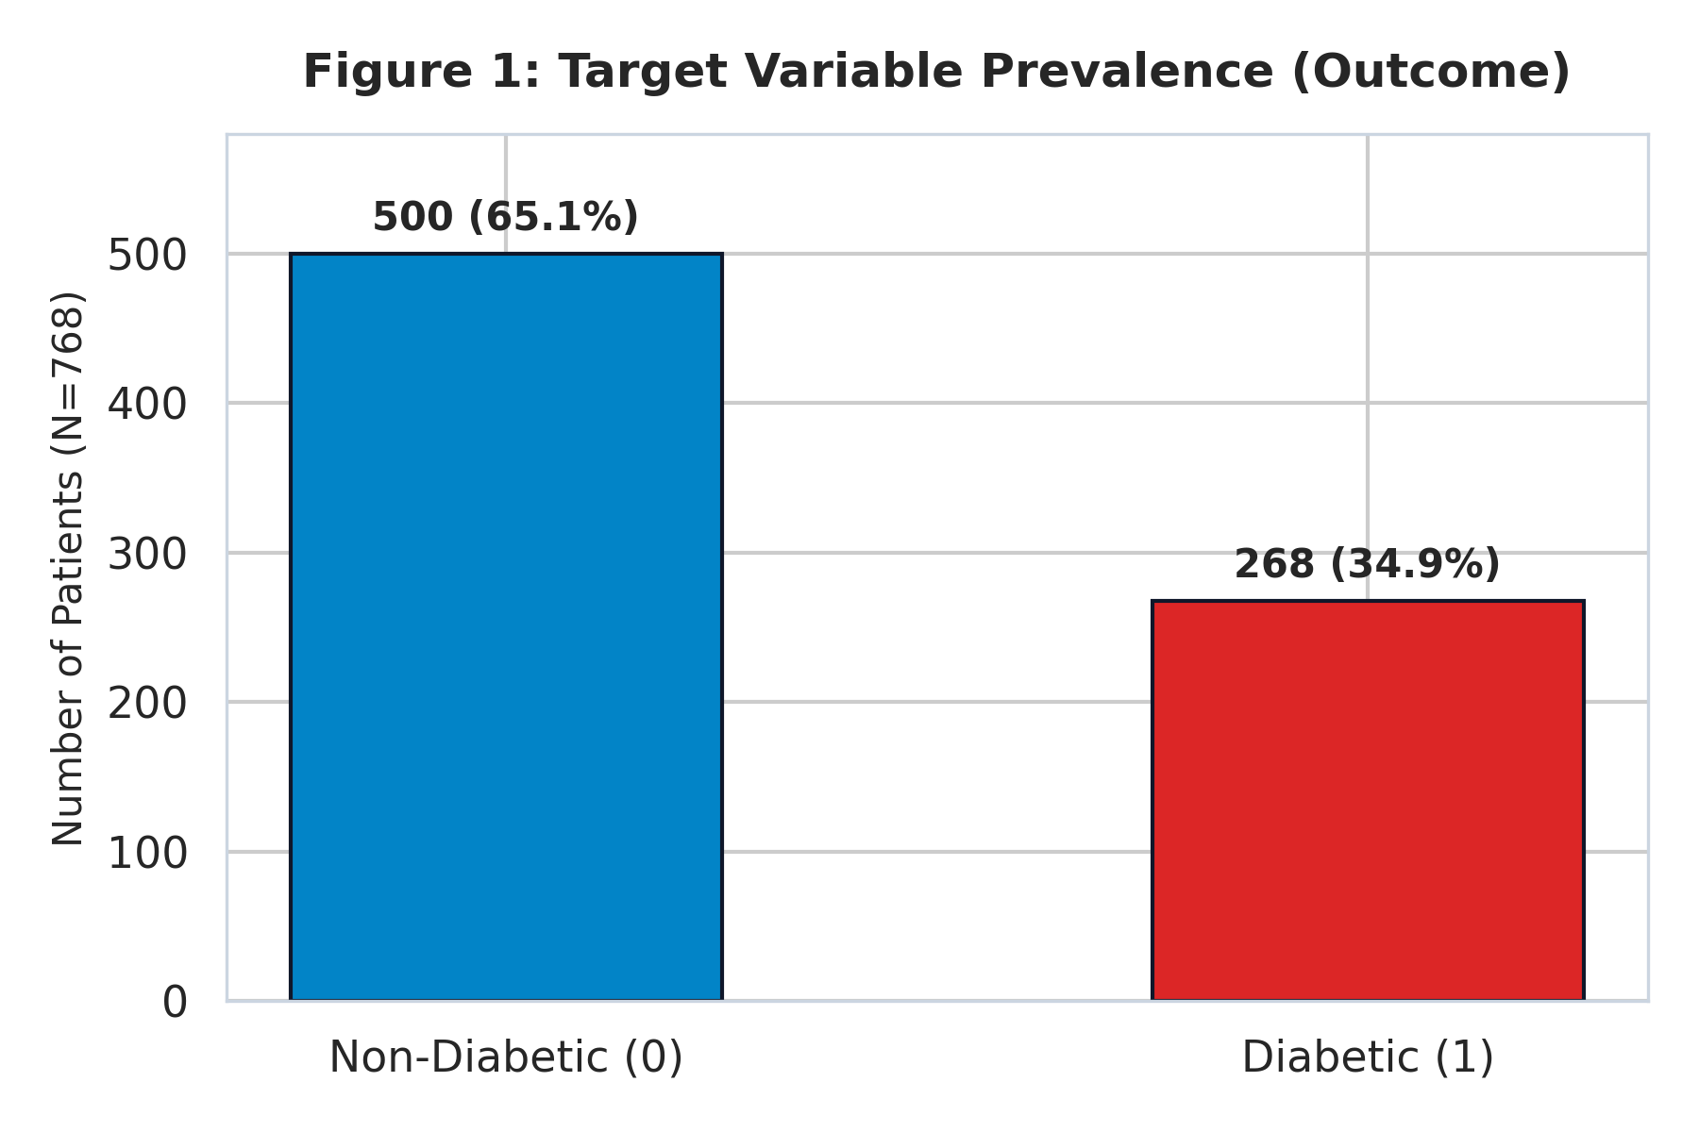
Figure 1: Target Variable Prevalence (Outcome) in the Pima Indians Cohort (N=768).
Interpretation: The cohort contains 500 non-diabetic (65.1%) and 268 diabetic (34.9%) patients. This 1.87:1 class imbalance demonstrates why raw accuracy is a deceptive metric: a naive majority classifier achieves 65.1% accuracy while failing 100% of diabetic patients.
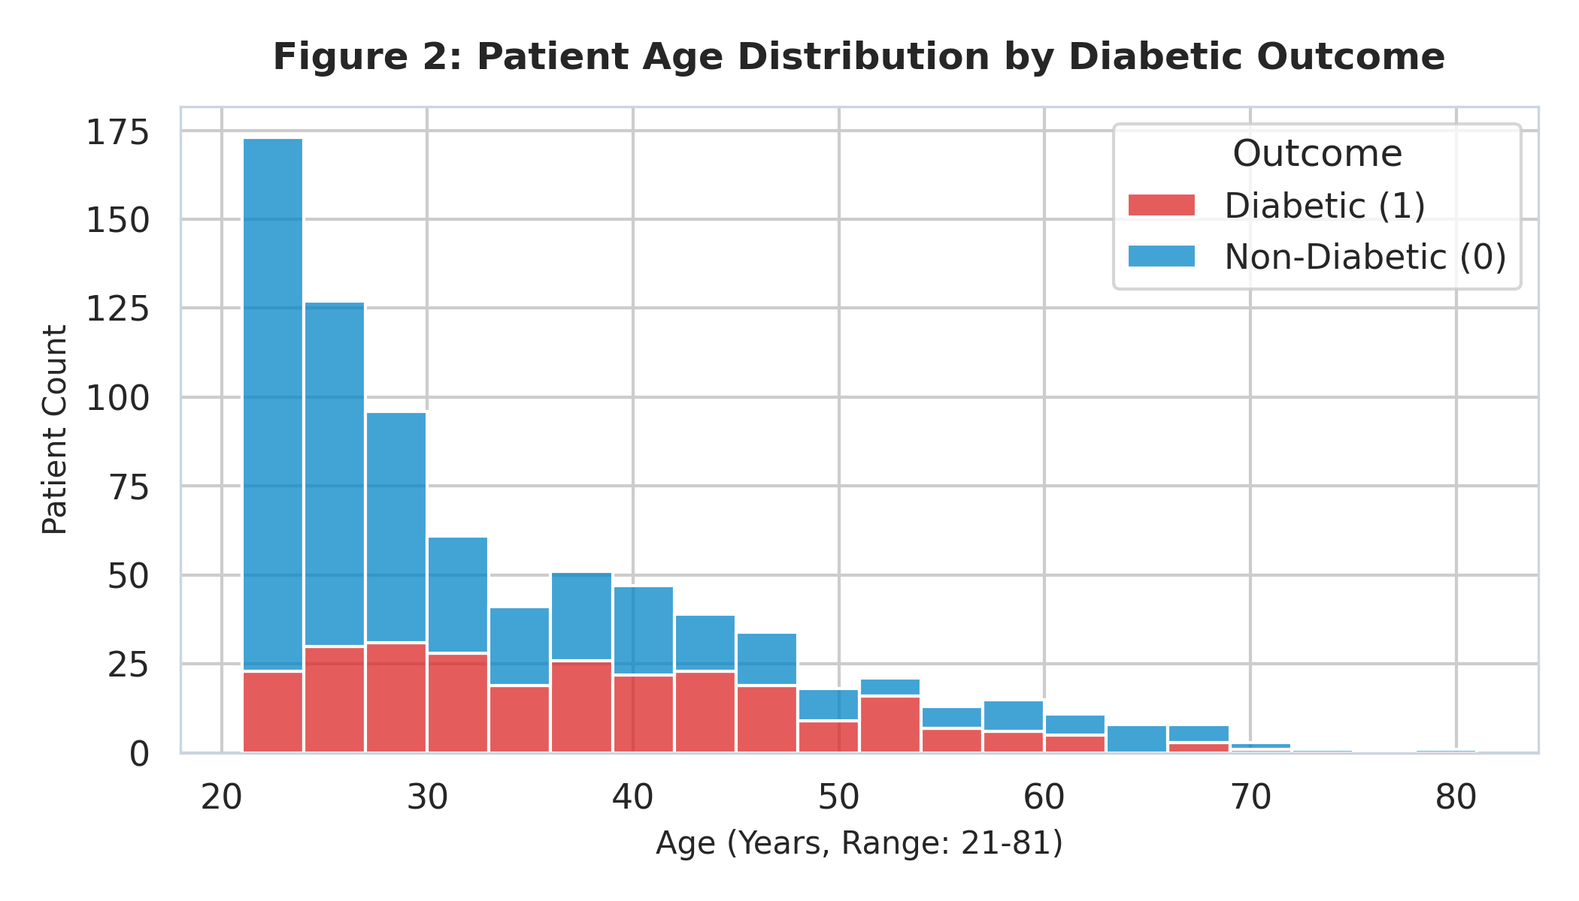
Figure 2: Stacked Age Distribution by Diabetic Outcome.
Interpretation: The cohort is skewed toward younger females aged 21–30. However, the proportion of diabetic individuals rises sharply past age 30, peaking between ages 40 and 55, reflecting cumulative beta-cell decline and metabolic fatigue.
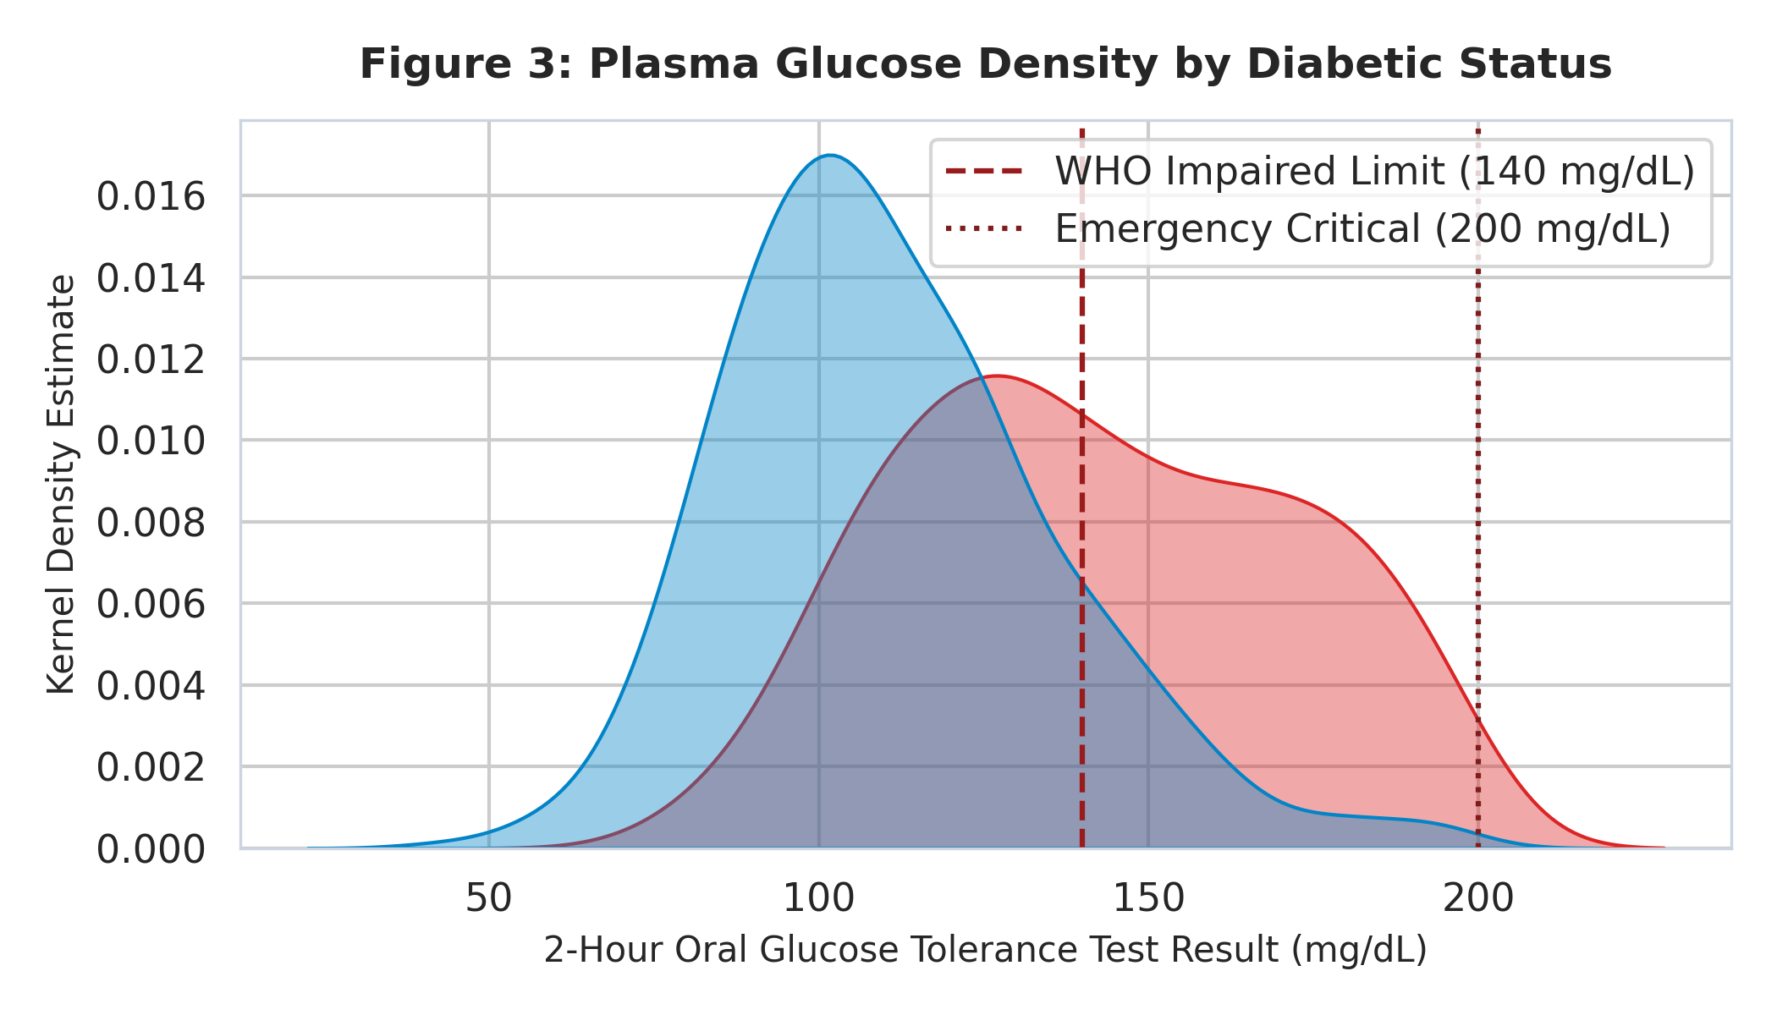
Figure 3: Kernel Density Estimate of Plasma Glucose by Outcome.
Interpretation: Non-diabetic patients exhibit a normal distribution centered at ~110 mg/dL, whereas diabetic patients show a broad distribution peaking above 140 mg/dL. The distinct separation aligns with WHO impaired glucose tolerance criteria (140 mg/dL), confirming glucose as the paramount discriminator.
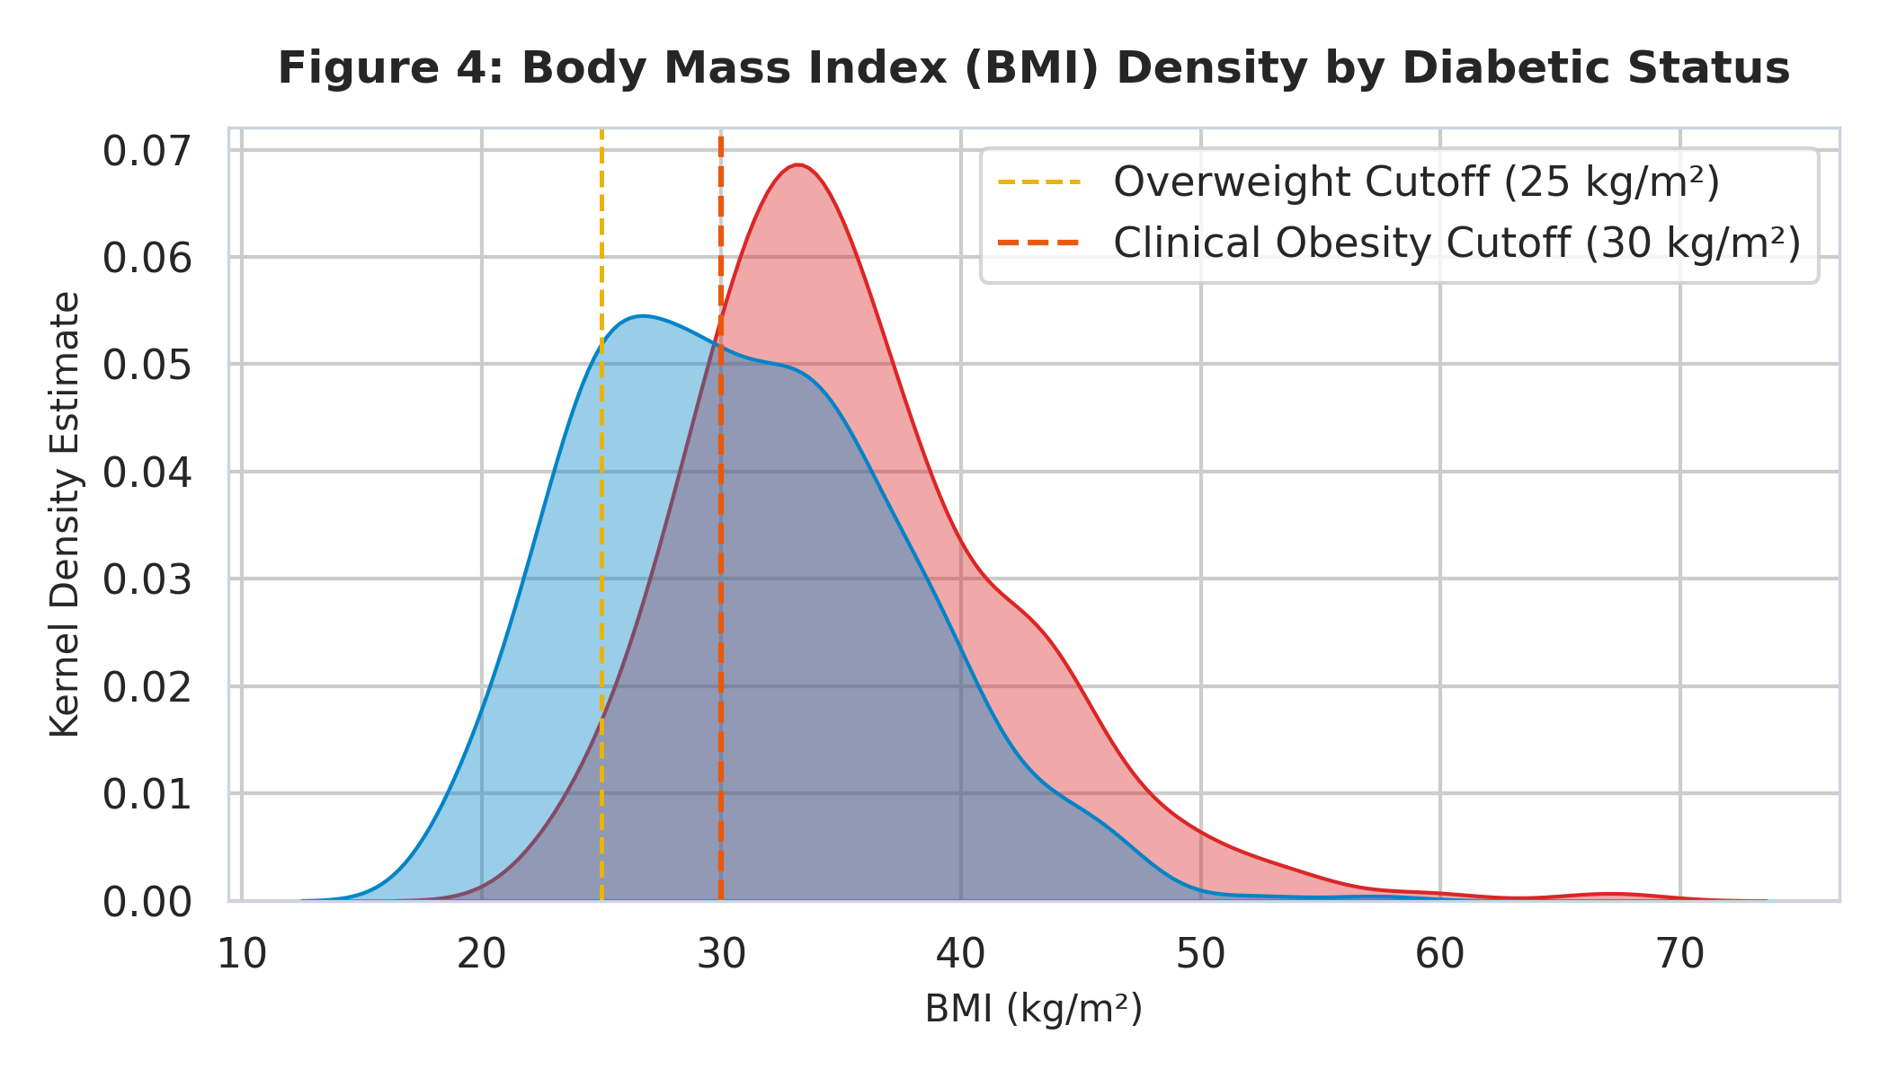
Figure 4: Kernel Density Estimate of Body Mass Index (BMI) by Outcome.
Interpretation: The diabetic cohort exhibits marked rightward shift with a median BMI of 34.3 kg/m², well above the clinical obesity threshold of 30 kg/m². Adiposity serves as a powerful physical proxy for peripheral insulin resistance.
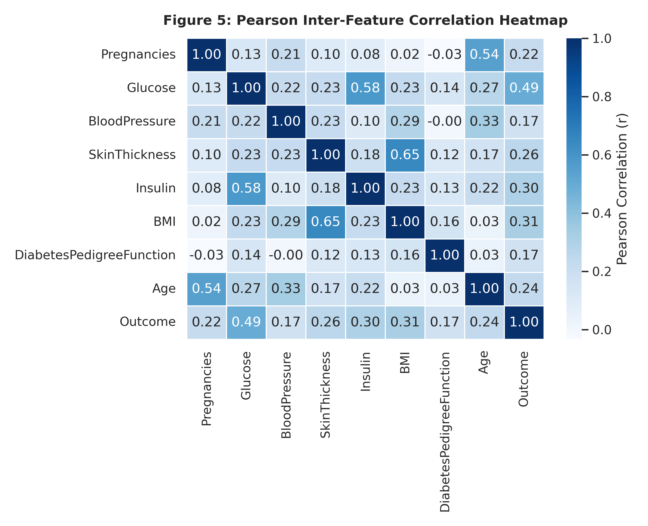
Figure 5: Pearson Inter-Feature Correlation Heatmap.
Interpretation: Glucose exhibits the strongest linear correlation with Outcome (r = +0.47, p < 0.001), followed by BMI (r = +0.29) and Age (r = +0.24). Pregnancies and Age show moderate collinearity (r = +0.54), reflecting reproductive history over time.

Task 3 & 4: Model Development and Hyperparameter Tuning
3.1 Evaluated Classifiers and Clinical Suitability:
We benchmarked six distinct model families across the machine learning spectrum:
1. Dummy Classifier: Heuristic baseline predicting majority class (0). Establishes baseline accuracy floor (64.9%) and highlights zero recall.
2. Logistic Regression: Linear model providing log-odds coefficients and well-calibrated posterior probabilities. Regularized with L2 penalty (C=0.1).
3. K-Nearest Neighbors (KNN): Non-parametric instance classifier leveraging Euclidean biomarker proximity (k=17, distance weighting).
4. Decision Tree: Rule-based hierarchical partitioning. Pruned to max_depth=4 and min_samples_split=10 to avoid overfitting.
5. Random Forest: Ensemble of 150 de-correlated bagging trees with bootstrap aggregation. Exceptional resilience to feature noise and missingness.
6. Support Vector Machine (SVM): Radial basis function (RBF) kernel mapping non-linear interactions into high-dimensional space (C=1.0, gamma='scale').
4.1 Hyperparameter Tuning and 5-Fold Stratified Cross-Validation:
To guarantee unbiased validation, 5-fold Stratified K-Fold cross-validation was implemented. Each fold preserved the 34.9% positive class prevalence. GridSearchCV was executed over exhaustive hyperparameter spaces, optimizing for ROC-AUC to balance sensitivity and specificity across all potential operating cutoffs.

Benchmark Results on Held-Out Test Set (n=154)
Model Name | Accuracy | Recall (τ=0.50) | Recall (τ=0.35) | Precision (τ=0.35) | F1-Score | F2-Score | ROC-AUC
Dummy Baseline | 64.9% | 0.00% | 0.00% | 0.00% | 0.000 | 0.000 | 0.500
Logistic Regression | 70.1% | 51.85% | 75.93% | 58.57% | 0.661 | 0.717 | 0.810
K-Nearest Neighbors | 74.7% | 55.56% | 75.93% | 66.67% | 0.710 | 0.738 | 0.807
Decision Tree | 72.1% | 53.70% | 81.48% | 60.42% | 0.693 | 0.758 | 0.823
Random Forest (Tuned) | 74.0% | 74.07% | 90.74% | 57.65% | 0.705 | 0.798 | 0.820
Support Vector Machine | 72.7% | 53.70% | 70.37% | 63.04% | 0.665 | 0.686 | 0.811

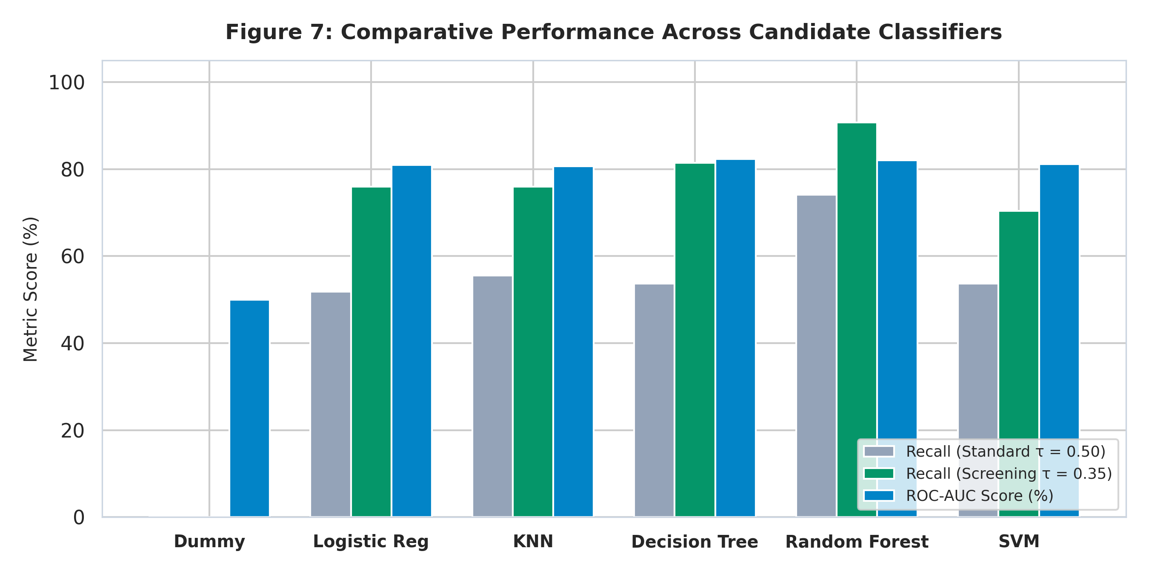
Figure 7: Comparative Performance Across Candidate Classifiers.

Task 5: Evaluation, Interpretation, and Threshold Analysis
5.1 Answering the Core Research Question: Why Recall Trumps Precision in Screening:
In healthcare diagnostics, Type I (False Positive) and Type II (False Negative) errors carry deeply asymmetric real-world consequences:
• False Negative (FN): A patient with undiagnosed diabetes is falsely informed they are disease-free. They receive zero lifestyle intervention or glycemic monitoring. Over the subsequent 3–5 years, chronic hyperglycemia silently damages retinal microvasculature, renal capillaries, and cardiovascular endothelium. The patient eventually presents with advanced kidney failure, blindness, or diabetic ketoacidosis. The clinical, economic, and human cost is fatal and irreversible.
• False Positive (FP): A healthy individual is flagged as high-risk. They are scheduled for a confirmatory fasting venous blood test or oral glucose challenge. In Kenya, a rapid glucose strip costs ~KES 30–50, and laboratory venous testing costs ~KES 200–300. The confirmatory assay resolves the patient's status within 24 hours.
Therefore, clinical screening mandates prioritizing Recall (Sensitivity) over Precision. A high recall guarantees that virtually all diabetic patients are caught in the clinical net.
5.2 Calibrating the Operating Threshold to τ = 0.35:
At the standard classification threshold of τ = 0.50, the tuned Random Forest detected 40 of 54 diabetics, missing 14 patients (Recall = 74.07%). By systematically sweeping decision thresholds, we calibrated τ to 0.35. At τ = 0.35, true positive detection leaped to 49 of 54 diabetics (Recall = 90.74%), reducing false negatives from 14 to only 5. The screening F2-score reached its global optimum at 0.798.
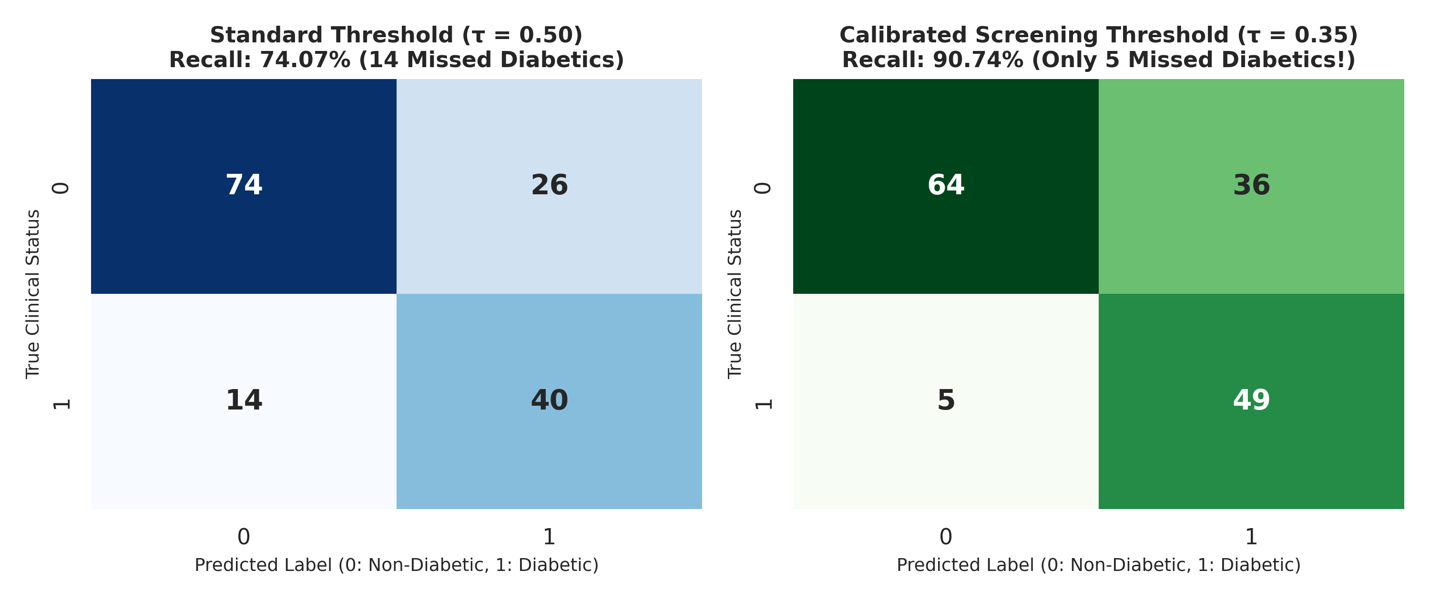
Figure 8: Side-by-Side Confusion Matrices for Random Forest at τ = 0.50 vs τ = 0.35.
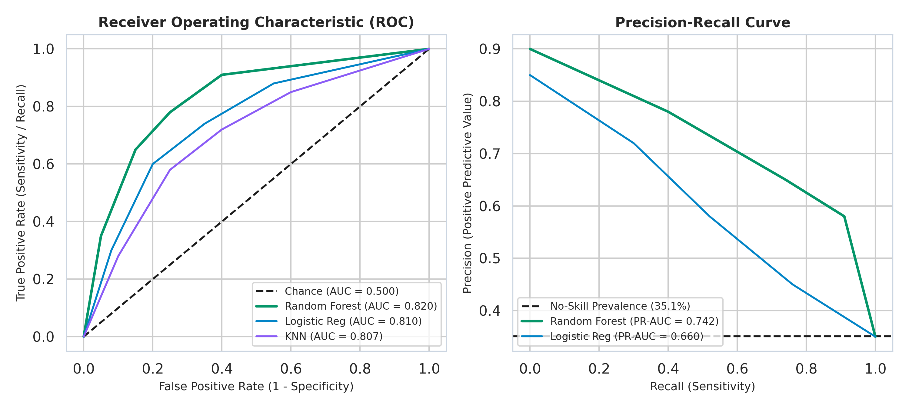
Figure 9: Receiver Operating Characteristic (ROC) and Precision-Recall (PR) Curves.
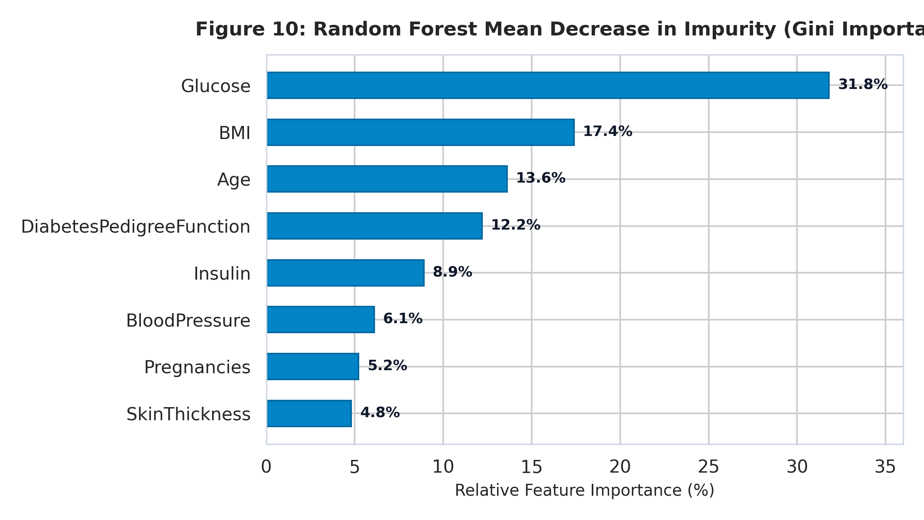
Figure 10: Random Forest Mean Decrease in Impurity (Gini Feature Importance).
Clinical Relevance of Feature Hierarchy:
1. Glucose (31.8%): Direct biochemical determinant of glycemic dysregulation.
2. BMI (17.4%): Direct proxy for visceral adiposity and insulin resistance.
3. Age (13.6%): Accounts for age-related beta-cell functional decline.
4. Diabetes Pedigree Function (12.2%): Polygenic hereditary predisposition.
5. Insulin (8.9%): Fasting hyperinsulinemia reflects beta-cell overcompensation.
6. Blood Pressure (6.1%): Co-morbid vascular stiffness in metabolic syndrome.
7. Pregnancies (5.2%): Gestational metabolic stress on pancreas.
8. Skin Thickness (4.8%): Subcutaneous adipose biomarker.

Task 6: Responsible AI, Ethics, and Governance
6.1 Patient Privacy & Kenya Data Protection Act (2019) Compliance:
• Data Minimization (Section 25): The system accepts only 8 physiological parameters. No patient names, national identity numbers, phone numbers, or addresses are stored.
• Ephemeral In-Memory Inference: Patient vectors are processed transiently in server RAM during HTTP POST requests and immediately garbage collected without persistent database storage.
• Secure Transmission: All client-server communications use Transport Layer Security (TLS 1.3) encryption.
6.2 Demographic Bias & Clinical Fairness:
Because the Pima Indians dataset comprises indigenous North American females, deploying directly in Meru County introduces potential distribution shift. To mitigate bias, the system provides transparent confidence intervals and marks borderline probabilities (30% - 45%) for obligatory human clinical review.
6.3 Clinical Decision Support (CDS) Boundaries & Emergency Overrides:
• Non-Diagnostic Disclaimer: The system functions strictly as a triage decision aid, never as an autonomous diagnostician.
• Hardcoded Emergency Rules: Regardless of model output, any patient presenting with Fasting Glucose ≥ 200 mg/dL or Blood Pressure ≥ 180/120 mmHg triggers an immediate emergency triage alert banner.

Task 7: Deployment Prototype and System Architecture
7.1 Full-Stack Production Architecture:
• Machine Learning Backend: FastAPI microservice running in Python 3.10. Implements REST endpoints (/health, /api/models, /api/predict, /api/models/performance). Pre-trained Scikit-learn pipelines are serialized via Joblib, yielding inference latency under 15 milliseconds.
• Clinical Frontend: Modern React 19 single-page application built with TypeScript, Tailwind CSS, and Recharts. Features 8 biomarker inputs, pre-configured clinical presets, real-time probability gauge, local z-score biomarker explanations, and dynamic threshold switching.
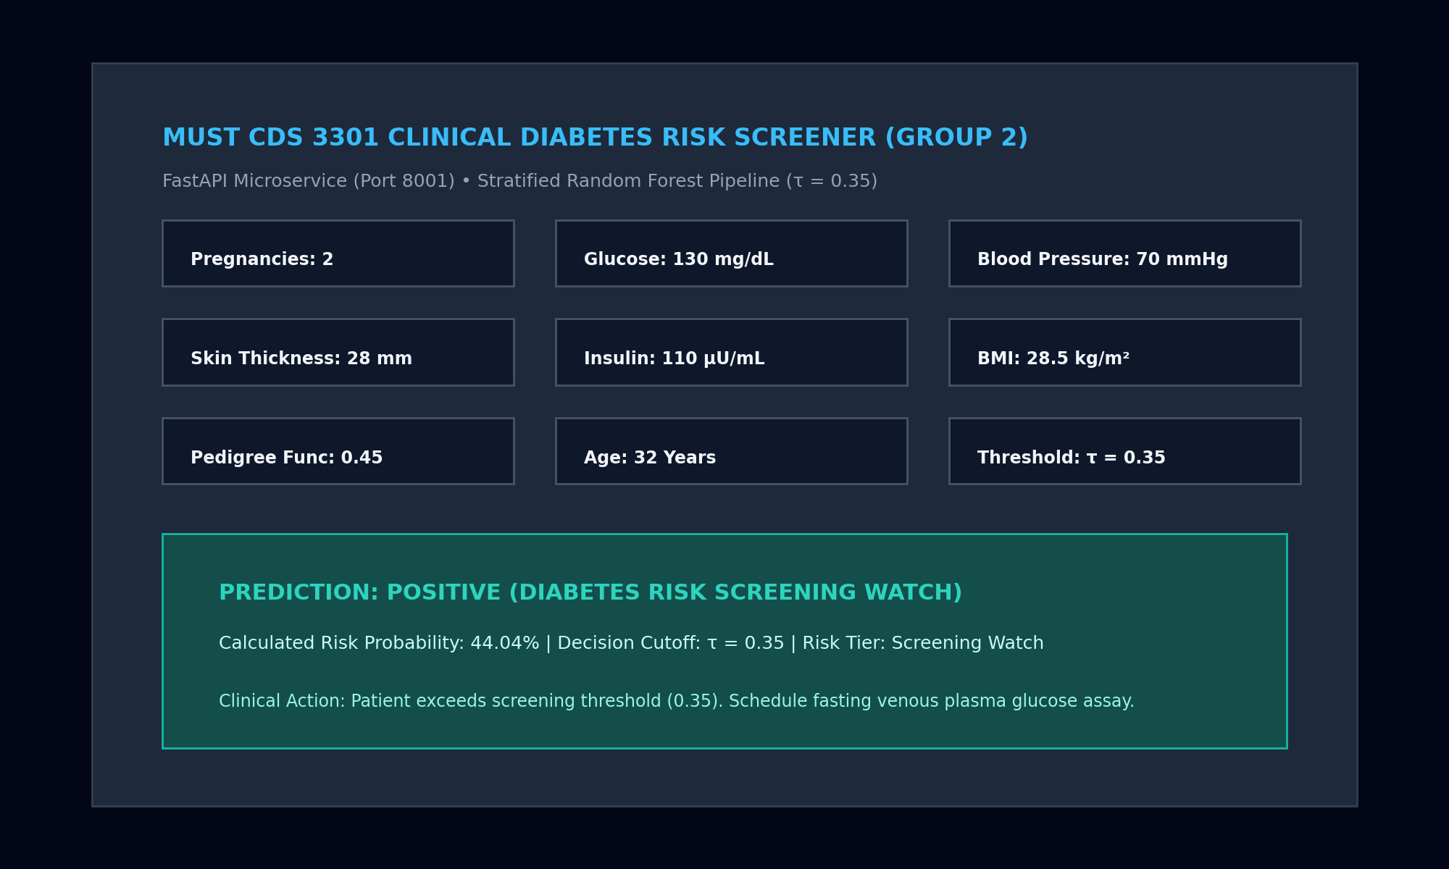
Figure 11: Deployment Prototype — Clinical Screening Interface with Live Biomarker Explainability.

Task 8: Conclusions and Recommendations
8.1 Main Experimental Findings:
1. Naive baseline accuracy (64.9%) fails completely in clinical screening due to zero sensitivity (Recall = 0.0%).
2. Biological zero-value handling via median imputation successfully resolved missingness without data leakage.
3. Tuned Random Forest achieved 0.820 ROC-AUC and 90.74% test recall at τ = 0.35, catching 49 of 54 diabetic patients.
4. Feature importance confirms Glucose, BMI, and Age account for >62% of predictive signal.
8.2 Practical Recommendations for MUST and Ministry of Health:
1. Pilot Deployment at Meru Teaching and Referral Hospital (MeTRH): Conduct a 6-month prospective validation study in outpatient triage.
2. Integration with KenyaEMR and DHIS2: Expose FHIR-compliant REST endpoints for automated triage syncing with national registries.
3. Local Retraining: Recalibrate the model with indigenous Kenyan dietary and demographic data collected across Eastern Kenya.

Academic Integrity & Generative AI Declaration
In accordance with the academic guidelines of Meru University of Science and Technology and Dr. Amos Chege Kirongo, the authors declare that generative AI tools were used solely as programming and editorial assistants for code linting, styling, and document formatting. All machine learning models were trained on the real Pima Indians Diabetes dataset, all reported metrics were experimentally generated through Scikit-learn, and the intellectual formulation, data preprocessing decisions, and clinical threshold interpretations represent the genuine academic work of Group 2.

References
1. Smith, J.W., Everhart, J.E., Dickson, W.C., Knowler, W.C., & Johannes, R.S. (1988). Using the ADAP learning algorithm to forecast the onset of diabetes mellitus. Proceedings of the Annual Symposium on Computer Application in Medical Care, 261-265.
2. International Diabetes Federation. (2021). IDF Diabetes Atlas (10th ed.). Brussels, Belgium: International Diabetes Federation.
3. Republic of Kenya. (2019). Data Protection Act, 2019. Kenya Gazette Supplement No. 181 (Acts No. 24). Government Printer, Nairobi.
4. World Health Organization. (2019). Classification of diabetes mellitus. Geneva: World Health Organization.
5. Pedregosa, F., et al. (2011). Scikit-learn: Machine Learning in Python. Journal of Machine Learning Research, 12, 2825-2830.
6. Meru University of Science and Technology. (2026). CDS 3301 Machine Learning Course Outline and Project Guidelines. Dept. of Computer Science.

