Sam Dirr
Assignment: APIs
CSD-325 Module 9

Tutorial Connection Test
The program first tests the connection to the Open Notify astronauts API and prints the HTTP status code.
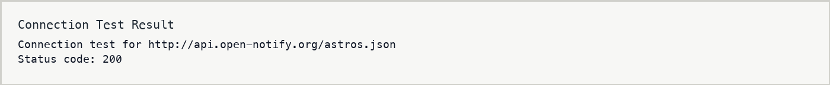

Current Astronauts Output
The tutorial code retrieves the current astronauts response and formats each person with their spacecraft.
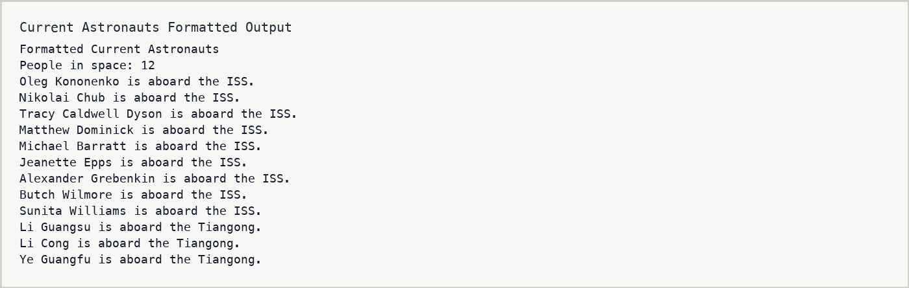

Simple API Program
The second API uses Zippopotam.us to retrieve information for ZIP code 68106. The program prints the raw response and then prints formatted output.
