Samuel Dirr
September 13, 2026 at 7:21 PM CDT

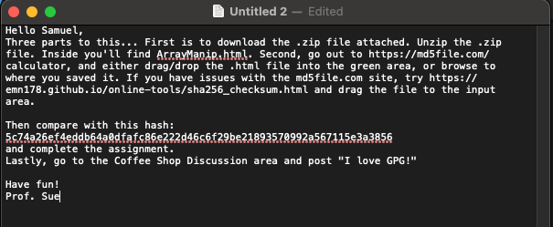

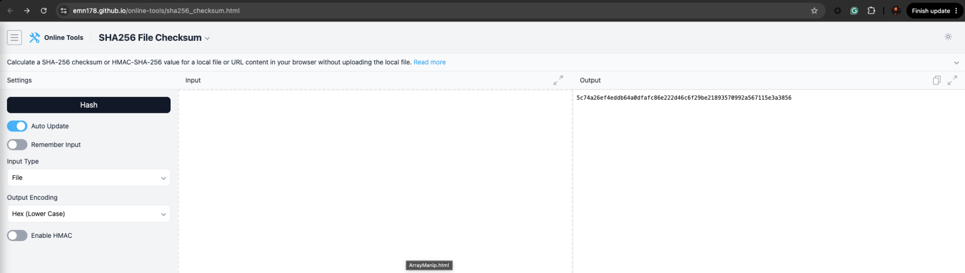

The digest matches.

