Restaurant Feedback JSP Documentation
Samuel Dirr | November 8, 2026
CSD 430 Server Side Development | Assignment 3.2
This application collects restaurant feedback and displays the submitted record in a separate JSP. It includes five required fields and five input types, documented Java scriptlets, an HTML results table, and a shared external stylesheet.
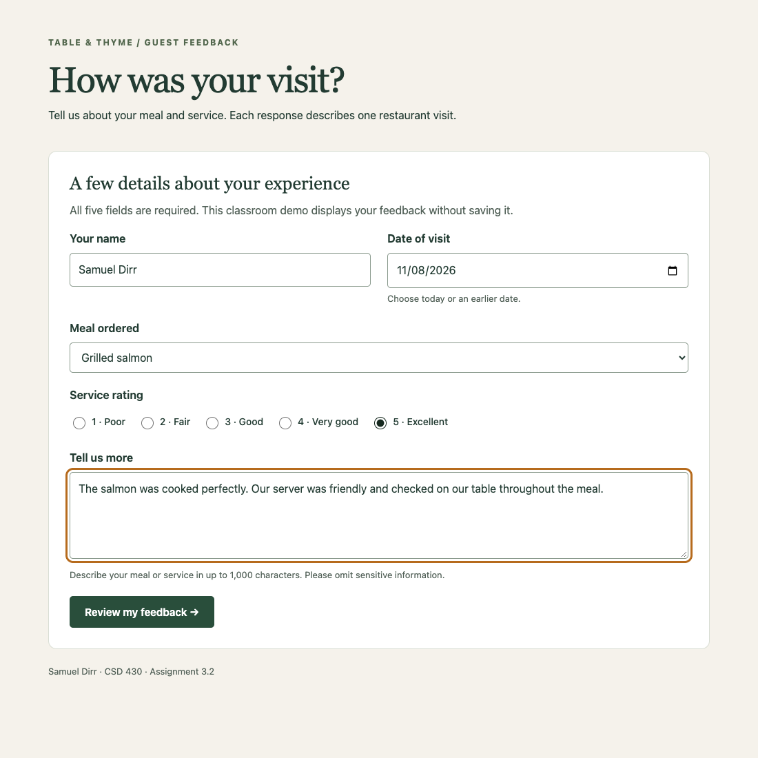
Figure 1. Completed form before POST submission to feedback-result.jsp. The example feedback is fictional.
The five data entry points are customer name, visit date, meal ordered, service rating, and comments. Their input types are text, date, select, radio, and textarea.

Submitted feedback and validation
The separate JSP reads the POST parameters with Java scriptlets. HTML markup remains outside those scriptlets; JSP expressions insert escaped values into the results table.
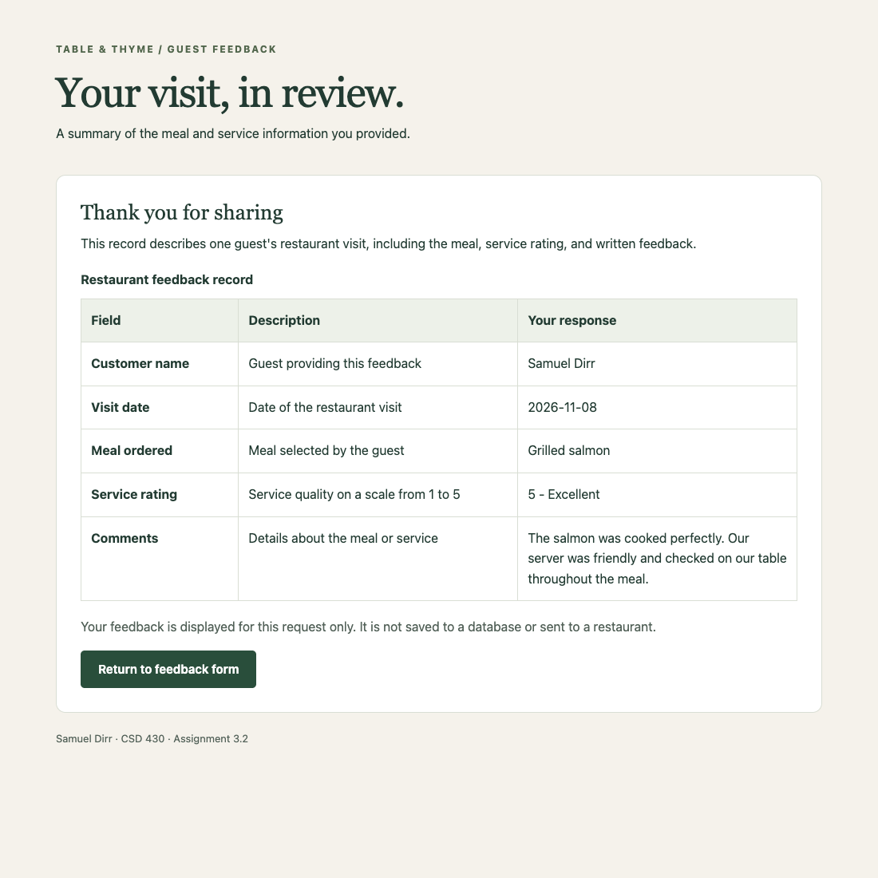
Figure 2. Actual JSP output served by Tomcat at 127.0.0.1:8083/csd430-module3/feedback-result.jsp.

Verification results
All 15 automated checks passed. They covered successful submission, five table rows, rating descriptions, blank and missing input, duplicate parameters, invalid and future dates, unknown meals, invalid ratings, oversized comments, escaped HTML with UTF-8 text, no-store caching, direct JSP navigation, and mobile form width.

Sources and AI assistance
Bellevue University (2024), M3_Code_Examples, Form_01.jsp and Form_04.jsp by Professor Darrell Payne, provided form-processing examples. OpenAI Codex generated the application and documentation and assisted with local testing on November 8, 2026. Samuel Dirr supplied the requirements and selected the topic. https://openai.com/codex/
Repository: https://github.com/samdirr/csd-430

Java and JavaFX configuration
Java 21.0.11, JavaFX 21.0.12, and Apache Tomcat 10.1.61 were verified on November 8, 2026. JavaFX was checked separately from the JSP web application.
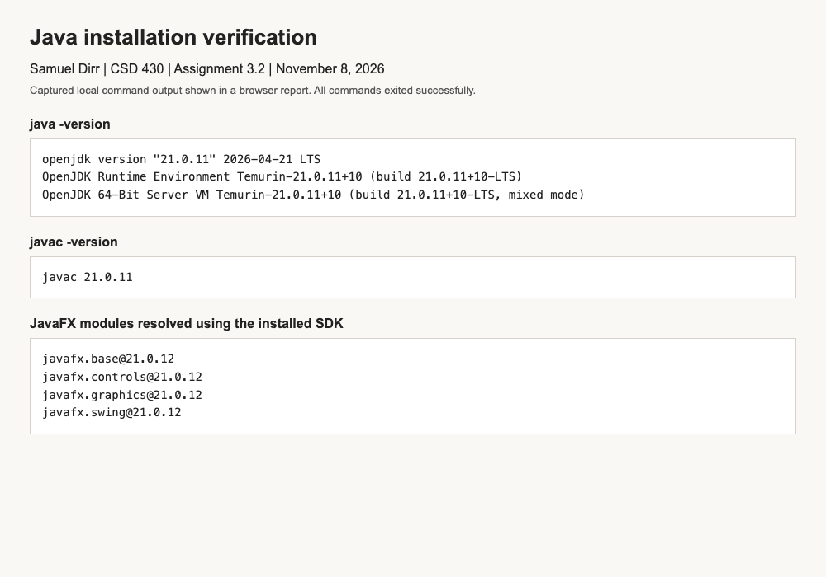
Figure 3. Browser screenshot of actual local Java runtime, compiler, and JavaFX module command output. All commands exited successfully.
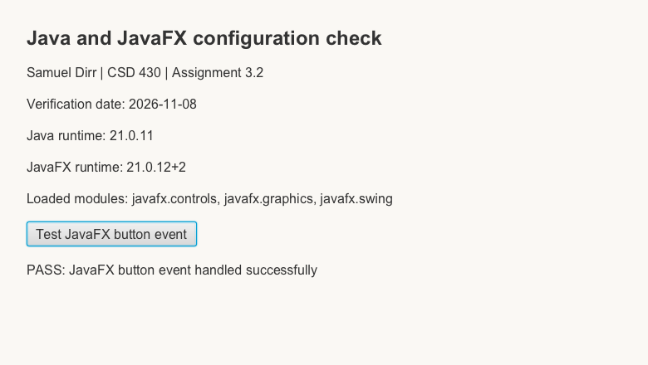
Figure 4. Fresh capture of the running JavaFX scene after an automated button-event test. The program compiled, rendered controls, handled the event, and saved this scene capture.

