Red Rising JSP Assignment
Samuel Dirr | November 1, 2026
CSD 430 Server Side Development | Module 2 Assignment 2
This assignment displays five character records from Pierce Brown’s Red Rising. Java scriptlets read the data and generate a table with three visible fields and three topical groups. All HTML tags are outside the scriptlets, and styling is supplied by an external CSS file.
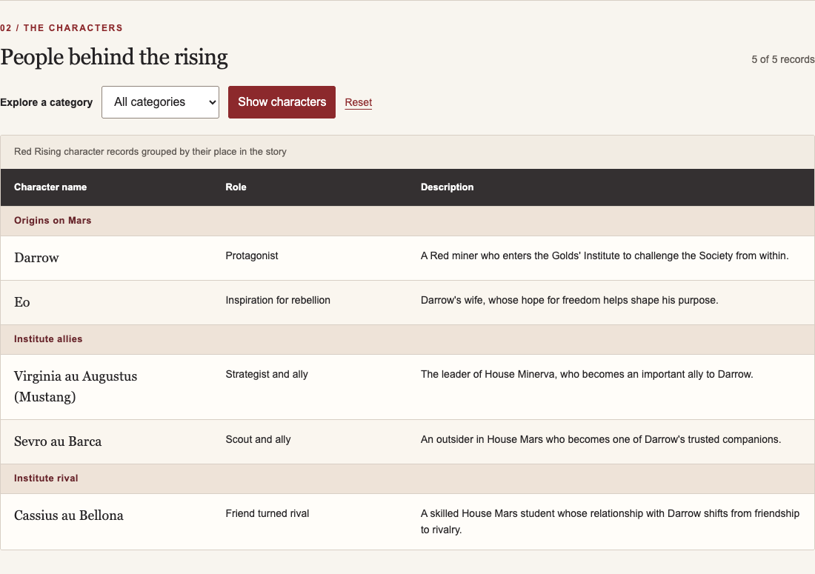
Figure 1. The complete table served by Apache Tomcat at localhost:8080/csd430-module2/index.jsp.
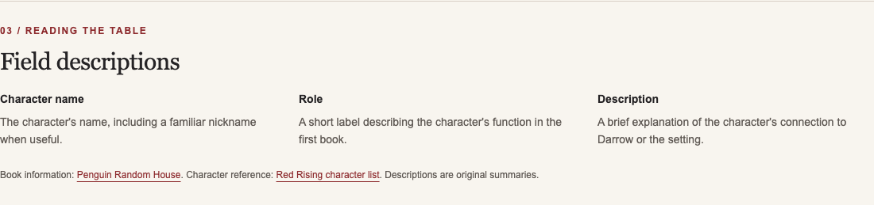
Figure 2. Visible field definitions explain how to read each character record.

Page context and dynamic behavior
The page identifies the book and its author and introduces the overall data. Descriptions focus on the first novel, with a brief notice about character and relationship spoilers.
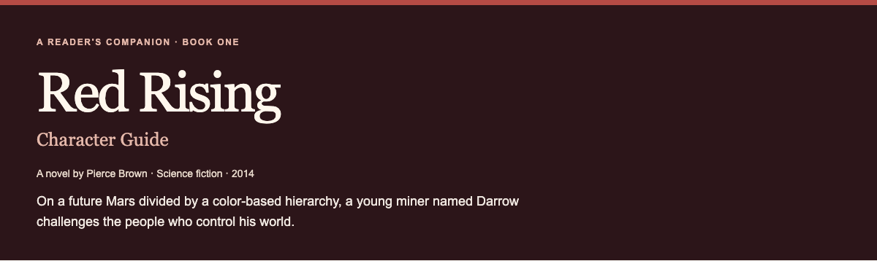
Figure 3. The title and overall description use the external stylesheet.
The category form sends a new request to the JSP. Selecting Institute allies shows only Mustang and Sevro; Reset restores all five records. The footer also displays a timestamp generated by Java.
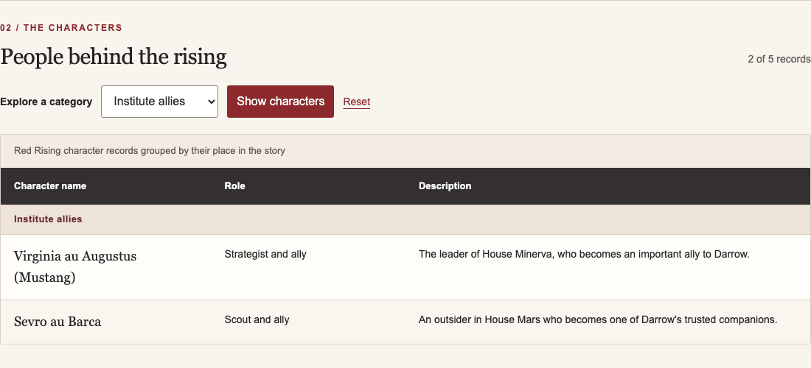
Figure 4. A category selection changes the table on the server without JavaScript.

Verification results
Local checks passed for category filtering, Reset, the server timestamp, external CSS, mobile layout, and invalid-category handling. The protected data file returns HTTP 404. HTML tags remain outside the scriptlets, and no browser JavaScript errors were reported.

AI assistance acknowledgment and reference
I used OpenAI Codex, an AI coding assistant, to generate the JSP, CSS, character summaries, and screenshot documentation, and to run local checks. I selected Red Rising as the topic and supplied the assignment requirements. Assistance used November 1, 2026.
OpenAI. (n.d.). Codex [AI coding assistant]. https://developers.openai.com/learn/codex
GitHub repository: github.com/samdirr/csd-430

Java and JavaFX configuration
Java 21.0.11 and JavaFX 21.0.12 were verified on November 1, 2026. The JSP ran on the existing Apache Tomcat 10.1.61 server. JavaFX was tested separately because it is explicitly requested in the documentation requirements.
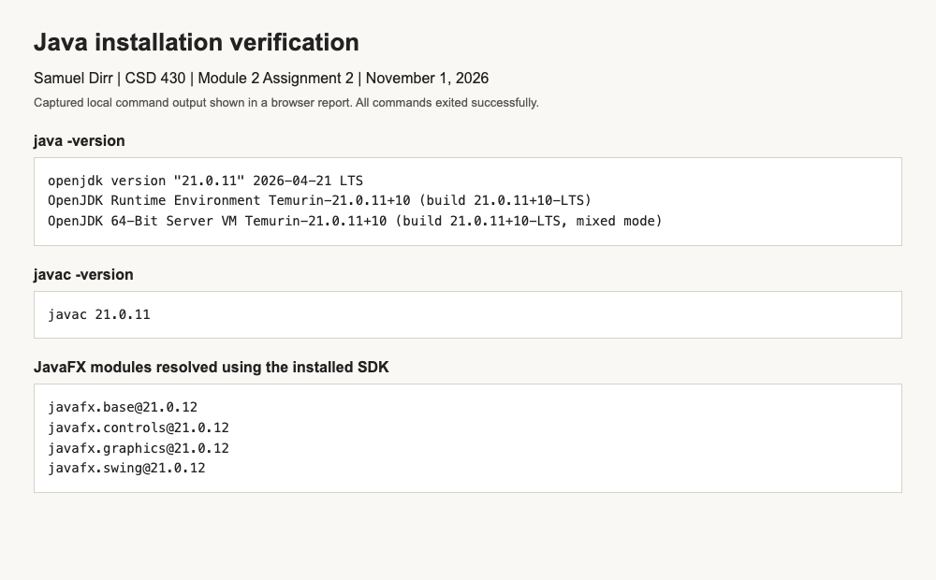
Figure 5. Browser screenshot of captured local command output. The Java runtime, compiler, and JavaFX modules are available.
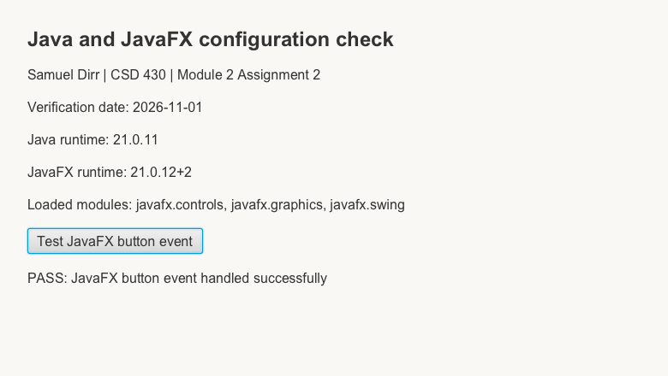
Figure 6. Capture of a rendered JavaFX scene after an automated button-event test. The test compiled with javac, ran successfully, and saved this scene capture using JavaFX.

