Sam Dirr | November 13, 2026 | CSD 430 | Assignment 4.2

Red Rising JavaBean and JSP
This application reuses the five character records from Module 2. The JSP reads each record into a serializable CharacterBean and retrieves its values through getters to display an HTML table. The fifth field, book title, supplements the original category, name, role, and description.
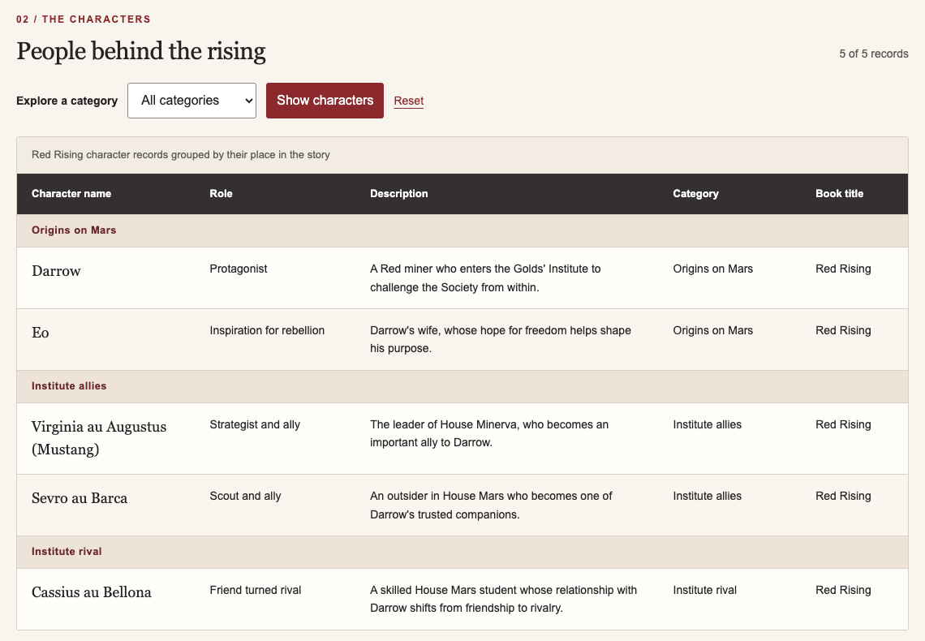
Figure 1. Actual JSP output served by Tomcat at http://127.0.0.1:8084/csd430-module4/index.jsp. All five bean fields appear in the table.

How the assignment requirements are met
CharacterBean implements java.io.Serializable and declares serialVersionUID. It has a public no-argument constructor and five private properties with getters and setters.
Java scriptlets read the protected TSV input, create bean objects, group records, and filter categories. HTML tags remain outside scriptlets, and JSP expressions display escaped getter values.
The page retains Module 2 styling in an external CSS file. It includes a title, overall data description, five field descriptions, and original summaries for each character.

Java and application verification
The application was compiled and tested on November 13, 2026 using Java 21.0.13 and Apache Tomcat 10.1.61. The bean is compiled for Java 11 or later. The screenshot below displays output captured from actual commands and HTTP checks, not manually entered pass results.
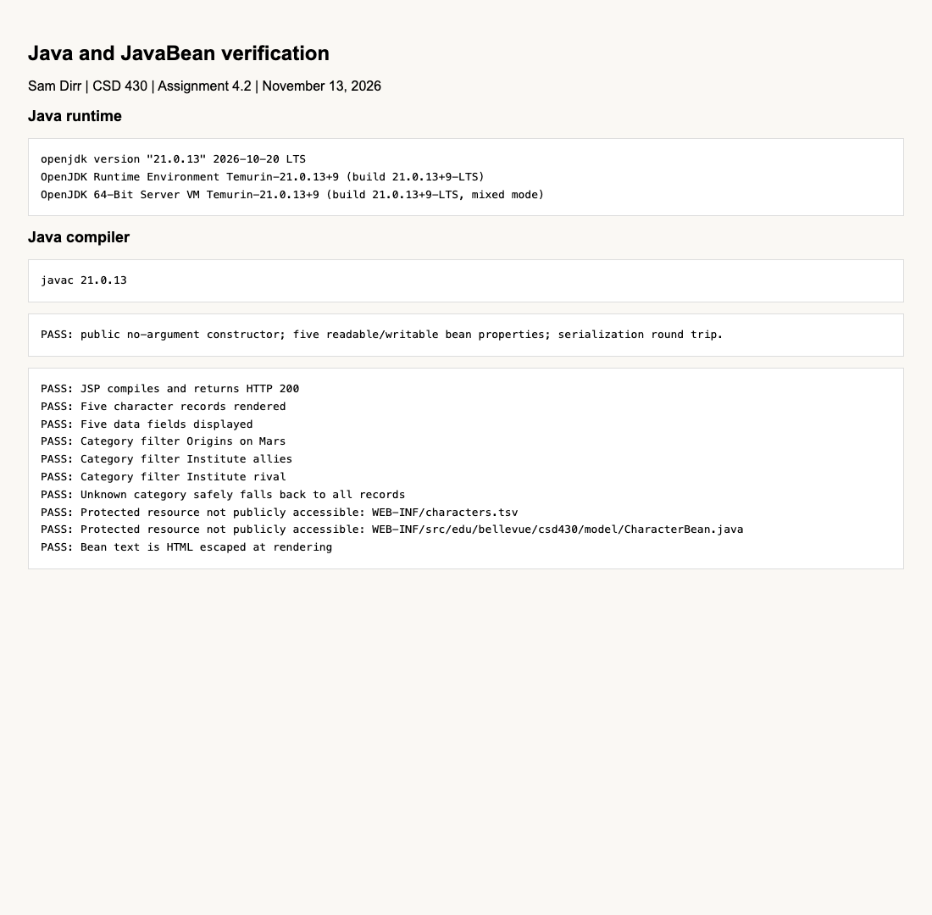
Figure 2. Java runtime/compiler versions, bean property and serialization checks, and ten successful HTTP checks.

JavaFX configuration
JavaFX 21.0.12 was checked separately using the installed SDK. A verification application rendered JavaFX controls, fired a button event, and captured its scene after the success message appeared. JavaFX is not required to run the JSP application.
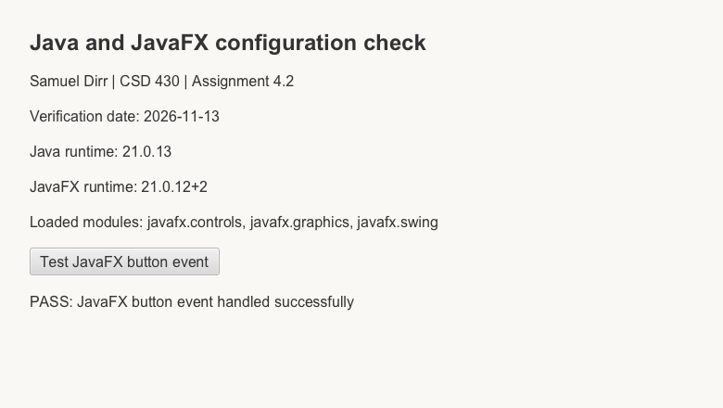
Figure 3. Actual JavaFX scene with runtime versions and a successful button event.

Run and review
The ZIP includes the Java source, compiled bean, JSP, stylesheet, five-field TSV, build script, and README. Deploy the module-4 directory as csd430-module4 under Tomcat webapps. See README.md for recompilation and deployment steps. JavaBean source: WEB-INF/src/edu/bellevue/csd430/model/CharacterBean.java.

Sources and assistance
Bellevue University (2024), M4_Code_Examples, demonstrates JavaBeans implementing Serializable and JSP property access. Sam Dirr supplied the Module 2 project, reused here for character data and styling. OpenAI Codex assisted with adaptation, documentation, and local verification on November 13, 2026. https://openai.com/codex/
Repository: https://github.com/samdirr/csd-430

