# GIT

## Create 2 separate branch from master

## Make changes in the same function of the source code in both the branches

## Merge branch1 into the master

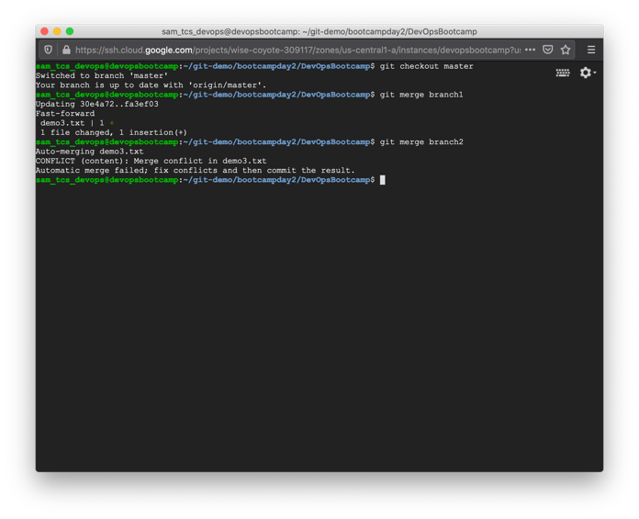

## Try and merge branch2 into the master (merge conflict should arise)

## Install a merge tool of your choice and resolve the merge conflict using git merge tool command

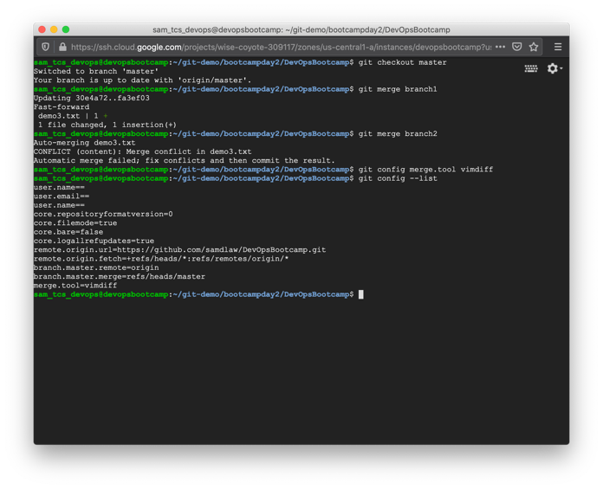

# Jenkins

## Create multiple freestyle project in Jenkins to checkout build, test package and deploy the web application in a tomcat9 server

1. Establish a build pipeline view with appropriate plugin installation
2. Configure maven as a tool in Jenkins environment
3. Attach the screenshot of the console output of each successful execution of the job

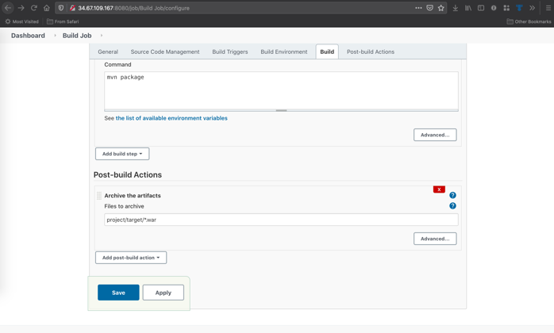

## Create a pipeline job and write the script to achieve the same tasks. Pipeline must be triggered with a Github webhook upon every commit

