# Assignment 1

Write Dockerfile to create docker image for this application using nginx as the base image

Push the docker image to the Docker Hub

Pull and run the docker containers on any remote instance

Access the application from the browser using appropriate url and port

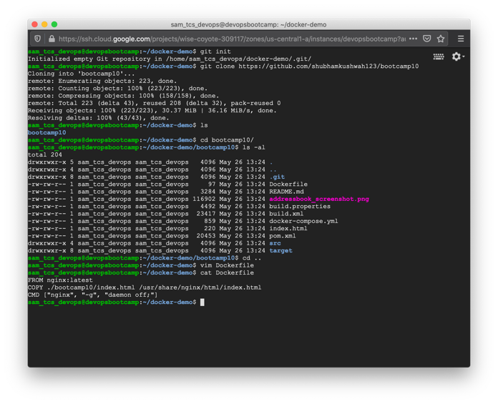

# Assignment 2

Write a docker-compose.yml file to run the above application container along with a mysql database container together

Connect to the mysql database container in the -it mode an create a table named test having id, name and age as attribute

