Spatial resolution estimation on Vision scanner
Kjell Erlandsson, Catherine Scott, Cameron Anderson, Kris Thielemans
INM, UCL/UCLH

Introduction
The spatial resolution of the Siemens Vision 600 scanner for brain studies was estimated using a Hoffman brain phantom scan.

Materials and methods
The phantom was filled with ¹⁸F-FDG: A=98 MBq at 2:15. The scan started at 17:21, and lasted for 35 min.
Images were reconstructed using four different protocols:
- PSF+TOF, 8 iterations, 5 subsets
matrix size: 440x440x159, voxel-size: 0.825x0.825x1.6456 mm
- PSF+TOF, 8 iterations, 5 subsets, Post-filter: Gaussian-4mm
matrix size: 440x440x159, voxel-size: 0.825x0.825x1.6456 mm
- OSEM3D+TOF, 8 iterations, 5 subsets, Post-filter: Gaussian-4mm
matrix size: 220x220x159, voxel-size: 1.65x1.65x1.6456 mm
- OSEM3D+TOF, 8 iterations, 5 subsets
matrix size: 220x220x159, voxel-size: 1.65x1.65x1.6456 mm
The images were processed to remove “extra-cerebral” activity and co-registered to a Hoffman template using the Nifti-reg/Aladin software (UCL).
Gaussian smoothing was applied to the template over a range of FWHM values with a step-size of 0.1 mm. This was done independently for the x/y- and z-dimensions. The best match in terms of sum-of-squared-differences was chosen as the estimated resolution.

Results
Figures 1-3 show the template, the realigned reconstructed image and the smoothed template, respectively, for the 1st reconstruction protocol.
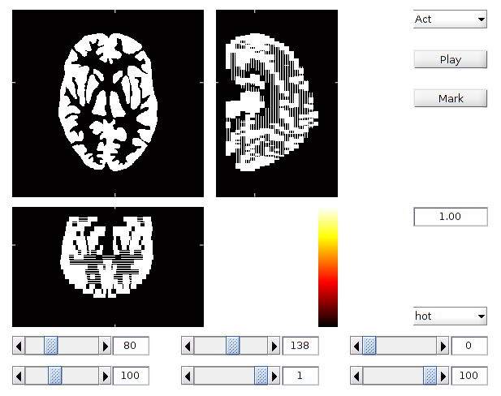Figure 1
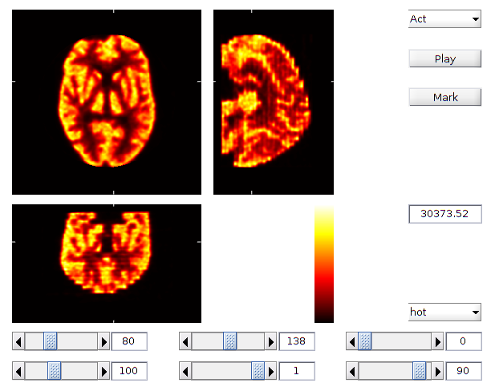Figure 2
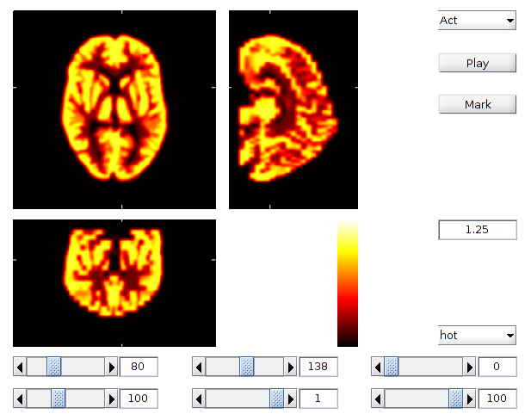Figure 3

The estimated resolutions were as follows:
Protocol-1 (x,y,z): (4.5,4.5,6.4) mm
Protocol-2 (x,y,z): (4.6,4.6,6.4) mm
Protocol-3 (x,y,z): (5.7,5.7,7.8) mm
Protocol-4 (x,y,z): (5.7,5.7,7.8) mm
(For protocole-2, the difference between 4.5 and 4.6 mm was minute.)

Conclusions
The spatial resolution was better with PSF than without, as expected. The Gaussian post-filter did not seem to make much difference in terms of resolution, although the images did look smoother.

