Christ’s College  
St Andrew’s Street  
Cambridge  
CB2 3BU

9th August 2021

HSBC Banking Ops-Mandates  
PO Box 6402  
Coventry  
CV3 9NA

Dear Sir/Madam,

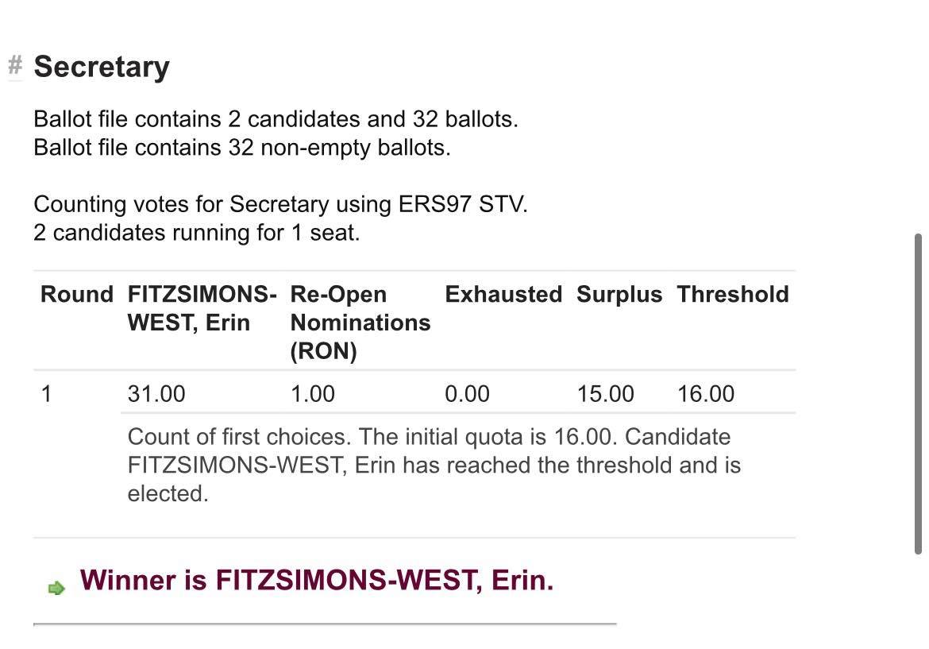I am writing to you on behalf of the Steering Committee of Christ’s College Boat Club, with supporting evidence for the request to add and remove signatories from our existing mandate (reference code VDH498). Please see the screenshot below showing Miss Erin Fitzsimons-West being elected in June 2021 to the position of Secretary for 2021-2022 via an online election. Our steering committee has not met since this online election and the next scheduled meeting is in October 2021, hence I cannot enclose meeting minutes confirming her election, as requested if the signing Secretary is not currently mandate.

Please get in touch if any further documents are required.

Yours faithfully,



Samuel Drury  
[spd38@cantab.ac.uk](mailto:spd38@cantab.ac.uk)  
Outgoing Treasurer of Christ’s College Boat Club