CECS-412-01

Summer 2014

Project #

Copyright 2017, Jack Dorne, Sam DuPlessis, Matt Elmlinger, Aryan Ghazipour, Logan Schaufler

|  |  |  |  |
| --- | --- | --- | --- |
| Name | Report  (20 Points) | Demo  (15 Points) | Quiz  (5 Points) |
| Group 8  Jack Dorne, Sam DuPlessis, Matt Elmlinger, Aryan Ghazipour, Logan Schaufler |  |  |  |

LAB 3

Group 8

CECS-412-01

Abstract

I/O communications through implemented drivers written in C are studied in this lab. This device onboard the A3BU that is used to accomplish this is through the Universal Synchronous Asynchronous Receiver Transmitted (USART), an I/O Peripheral device that permits serial I/O Communication. First, an RS232C serial interface circuit was built which allowed for asynchronous serial communication between the A3BU and a PC running terminal communication software, and an example driver was flashed onto the board to initialize the USART. If done correctly, ASCII characters would be communicated from the PC terminal to the A3BU, and then echoed back to be displayed on the terminal. Next, LCD synchronous communications were investigated through the PORT D Serial Peripheral Interface (SPI) and the LCD ST7565R MCU. Another example driver was flashed onto the A3BU to initialize the port. This time, lines were first drawn across the screen and then the screen was rolled. Finally, the two example drivers were integrated into one driver called SYSTEM, and a MAIN was written to receive ASCII characters from the keyboard to be displayed on the LCD. Through the successful completion of this lab, basic communication between an MCU and external hardware is understood.

Body

# Part 1

The Tera Term software was downloaded for aid in every portion of the lab. Tera Term was used as the chosen terminal program to display procedures that would be carried out to the ATxMEGA256A3BU Xplained board. To interface the A3BU board, a RS232C serial interface circuit (Schematic located in “Schematics” Section) was implemented. The circuit was then assembled and inspected. Once the circuit was set up, the program USART_EXAMPLE was built and stored on the A3BU board. The function of USART was to communicate to the A3BU board by way of TxD and RxD asynchronously (of header J1). Pin PC3 served as the TxD pin and PC2 served as the RxD pin on the A3BU board.

Serial port configuration settings next had to be configured. The number of data bits was set to 8, BAUD RATE to 9600, one stop bit used, and no parity bit was necessary in the C program (Tara Term would also follow these settings).

The program outputted a “Hello World” message on the Tera Term screen. This was possible by the translation of ASCII characters from the terminal back to the terminal by way of Tera Term.

The code was then re-written. The new program allowed for two single digit numbers to be added together. Again, ASCII values were translated, this time to single digit values. Since 0 has an ASCII value of 48, 48 had to be subtracted from the result of the addition of the two digits (any addition would result in a “c” output rather than the true sum value). This displays the true value of the new digit. This is an example of when digits “3” and a “6” are inputted through Tera Term, which results in their sum, 9.

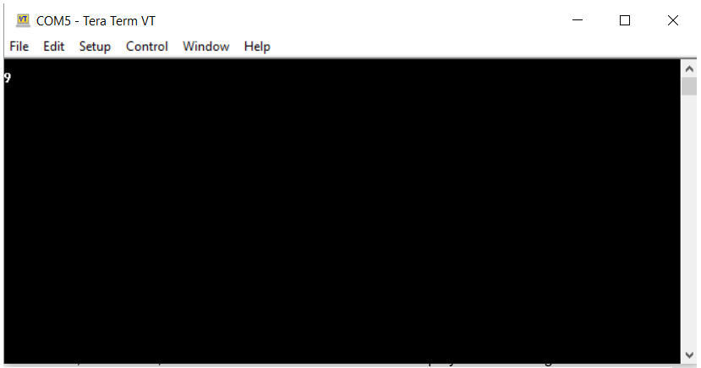

An ASCII table was necessary for reference in part 1:

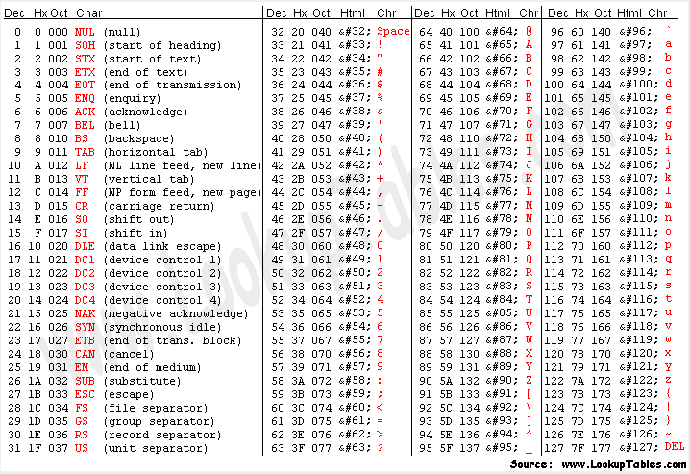

The rate at which bits are communicated between the PC and the A3BU is called “BAUD rate.” The RS232 aids by allowing both the PC and A3BU to know when bits are being communicated, and subsequently when this processes is stopping. A higher BAUD rate allows for data to transferred faster, however this comes with risk as data can be misinterpreted. A lower BAUD rate may run at a slower rate, but data is rarely, if ever, misinterpreted.

A chart of the USART registers that were involved in the program:

|  |  |
| --- | --- |
| Register | Purpose |
| UDR | 16-bit USART Data Register. The Transmit Data Buffer Register (TXB) is where UDR received data is stored. |
| UBRRH | Stands for USART Baud Rate Register High. The first 8 bits of the 16-bit BAUD rate register are stored here. |
| UBRRL | Stands for USART Baud Rate Register Low. The last 8 bits of the 16-bit BAUD rate register are stored here. |
| UCSRA | 8-bit USART Control and Status Register A. The flag bit is set by the CPU when unread data is in the Receive Buffer, and then cleared by the CPU when the Buffer is empty. |
| UCSRB | 8-bit USART Control and Status Register B. The UCSRB enables interrupts, receiver, transmitter, and third bit character size. |
| UCSRC | 8-bit USART Control and Status register C. Allows for stop bits, Asynchronous or Synchronous mode, parity type, selection of registers, and selection of two bits of character size. |

(The USART of the AVR » MaxEmbedded)

# Part 2

Source Code (Software)

/* Lab 3 part 1 */

#include <conf_usart_example.h>

#include <asf.h>

// some variables to store simple characters

static *uint8_t* newLine = '\n';

static *uint8_t* carriageReturn = '\r';

static *uint8_t* numberOne = '1';

static *uint8_t* ConvertToInt(*uint8_t* numberToConvert) {

return numberToConvert - '0';

}

static *uint8_t* ConvertToAscii(*uint8_t* numberToConvert) {

return numberToConvert + '0';

}

static void DisplayNumber(*uint8_t* numberToDisplay_integer) {

*uint8_t* numberToDisplay_Ascii;

// Start a new Line

usart_putchar(USART_SERIAL_EXAMPLE, newLine);

// Make sure the cursor is at the beginning of that line

usart_putchar(USART_SERIAL_EXAMPLE, carriageReturn);

// If the number is greater than 9 the code needs to display 2 digits

if (numberToDisplay_integer >= 10) {

// Convert integer to ASCII

// Only save the last digit

// (subtracting 10 removes the first digit)

numberToDisplay_Ascii = ConvertToAscii(numberToDisplay_integer) -10;

// Display leading 1 as first digit

usart_putchar(USART_SERIAL_EXAMPLE, numberOne);

// Display second digit

usart_putchar(USART_SERIAL_EXAMPLE, numberToDisplay_Ascii);

}

else

{

// Convert integer to ASCII

numberToDisplay_Ascii = ConvertToAscii(numberToDisplay_integer);

// Display the digit

usart_putchar(USART_SERIAL_EXAMPLE, numberToDisplay_Ascii);

}

}

int main(void)

{

// variables for storing data at different

// stages of the conversion process

*uint8_t* receivedByte_Asc;

*uint8_t* return_num;

*uint8_t* convertedNum_prev;

*uint8_t* convertedNum_rec;

/* Initialize the board.

* The board-specific conf_board.h file contains the configuration of

* the board initialization.

*/

board_init();

sysclk_init();

// USART options.

static usart_rs232_options_t USART_SERIAL_OPTIONS = {

.baudrate = USART_SERIAL_EXAMPLE_BAUDRATE,

.charlength = USART_SERIAL_CHAR_LENGTH,

.paritytype = USART_SERIAL_PARITY,

.stopbits = USART_SERIAL_STOP_BIT

};

// Initialize usart driver in RS232 mode

usart_init_rs232(USART_SERIAL_EXAMPLE, &USART_SERIAL_OPTIONS);

// This loop runs forever

while (true) {

// Receive characters asynchronously from Tera Term

receivedByte_Asc = usart_getchar(USART_SERIAL_EXAMPLE);

// Convert ASCII number to an integer

convertedNum_prev = ConvertToInteger(receivedByte_Asc);

// If the number is between 0 and 9 then enter the next loop

if (convertedNum_prev >= 0 && convertedNum_prev <= 9) {

while(true) {

// Receive characters asynchronously from Tera Term

receivedByte_Asc = usart_getchar(USART_SERIAL_EXAMPLE);

// Convert ASCII number to an integer

convertedNum_rec = ConvertToInt(receivedByte_Asc);

// Add the two numbers

return_num = convertedNum_rec + convertedNum_prev;

// Display the number on the LCD screen

DisplayNumber(return_num);

// After the number has been displayed break

// out of second loop and enter the top level loop

break;

}

}

}

}

/* Lab 3 Part 2 */

#include <board.h>

#include <sysclk.h>

#include <st7565r.h>

#include <gfx_mono.h>

#include <gfx_mono_text.h>

#include <sysfont.h>

#include <gpio.h>

static void ClearLcdScreen(void) {

// This function clears the screen by writing 0x00 over

// and over again which turns off every pixel

for (int page_address = 0; page_address <= 4; page_address++) {

st7565r_set_page_address(page_address);

for (int column_address = 0; column_address < 128; column_address++) {

st7565r_set_column_address(column_address);

st7565r_write_data(0x00);

}

}

}

static void InitializeLcdScreen(void) {

// Initialize the board and clock

board_init();

sysclk_init();

// Initialize the interface (SPI), ST7565R LCD controller and LCD

st7565r_init();

// Set addresses at beginning of display

st7565r_set_page_address(0);

st7565r_set_column_address(0);

// Initialize gfx functionality

gfx_mono_init();

// Turn on backlight

gpio_set_pin_high(LCD_BACKLIGHT_ENABLE_PIN);

ClearLcdScreen();

}

static void DrawWord(char *word, int wordLength) {

// The starting location is (10,10)

int x = 10;

int y = 10;

for (int i = 0; i < wordLength; i++) {

gfx_mono_draw_char(*word, x, y, &sysfont);

// Increment the X coord

x += 7;

// Increment the pointer so that it points to the next char

word = word + 1;

}

}

int main(void)

{

InitializeLcdScreen();

// Declare a the word to display

char word[5] = {'H','e','l','l','o'};

// Display the word to the LCD screen

DrawWord(word, 5);

}

/* Lab 3 Part 3 */

#include <board.h>

#include <sysclk.h>

#include <conf_usart_example.h>

#include <st7565r.h>

#include <gfx_mono.h>

#include <gfx_mono_text.h>

#include <sysfont.h>

#include <gpio.h>

static void ClearLcdScreen(void) {

// This function clears the screen by writing 0x00 over

// and over again

for (int page_address = 0; page_address <= 4; page_address++) {

st7565r_set_page_address(page_address);

for (int column_address = 0; column_address < 128; column_address++) {

st7565r_set_column_address(column_address);

st7565r_write_data(0x00);

}

}

}

static void FlashScreen(void) {

// Turn the backlight off

gpio_set_pin_low(LCD_BACKLIGHT_ENABLE_PIN);

// Delay for 4 milliseconds

delay_ms(4);

// Turn the backlight back on

gpio_set_pin_high(LCD_BACKLIGHT_ENABLE_PIN);

}

static void InitializeLcdScreen(void) {

// initialize the board and clock

board_init();

sysclk_init();

// Initialize the interface (SPI), ST7565R LCD controller and LCD

st7565r_init();

// Set addresses at beginning of display

st7565r_set_page_address(0);

st7565r_set_column_address(0);

// Initialize gfx functionality

gfx_mono_init();

// Turn on backlight

gpio_set_pin_high(LCD_BACKLIGHT_ENABLE_PIN);

ClearLcdScreen();

}

int main(void)

{

char receivedByte_Ascii;

InitializeLcdScreen();

static usart_rs232_options_t USART_SERIAL_OPTIONS = {

.baudrate = USART_SERIAL_EXAMPLE_BAUDRATE,

.charlength = USART_SERIAL_CHAR_LENGTH,

.paritytype = USART_SERIAL_PARITY,

.stopbits = USART_SERIAL_STOP_BIT

};

// Initialize usart driver in RS232 mode

usart_init_rs232(USART_SERIAL_EXAMPLE, &USART_SERIAL_OPTIONS);

// The first location for the text to appear

// is (0,0) or the top left of the LCD screen

int x = 0;

int y = 0;

while (true) {

// Asynchronously receive ASCII character

receivedByte_Ascii = usart_getchar(USART_SERIAL_EXAMPLE);

// Flash the screen once after a character is received

FlashScreen();

// If the enter key was pressed then clear the screen

// and put the location for text back to (0,0)

if (receivedByte_Ascii == '\r') {

ClearLcdScreen();

x=0;

y=0;

}

// If any other key was pressed then display it

else {

gfx_mono_draw_char(receivedByte_Ascii, x, y, &sysfont);

// Then increment x so that there is room

//for the next character

x += 7;

}

// The screen only fits 18 characters

// So if x gets above 18*7 then go to the next line

// by incrementing y

if ( x == 18 * 7)

{

x = 0;

y += 8;

}

}

}

Schematics (Hardware)

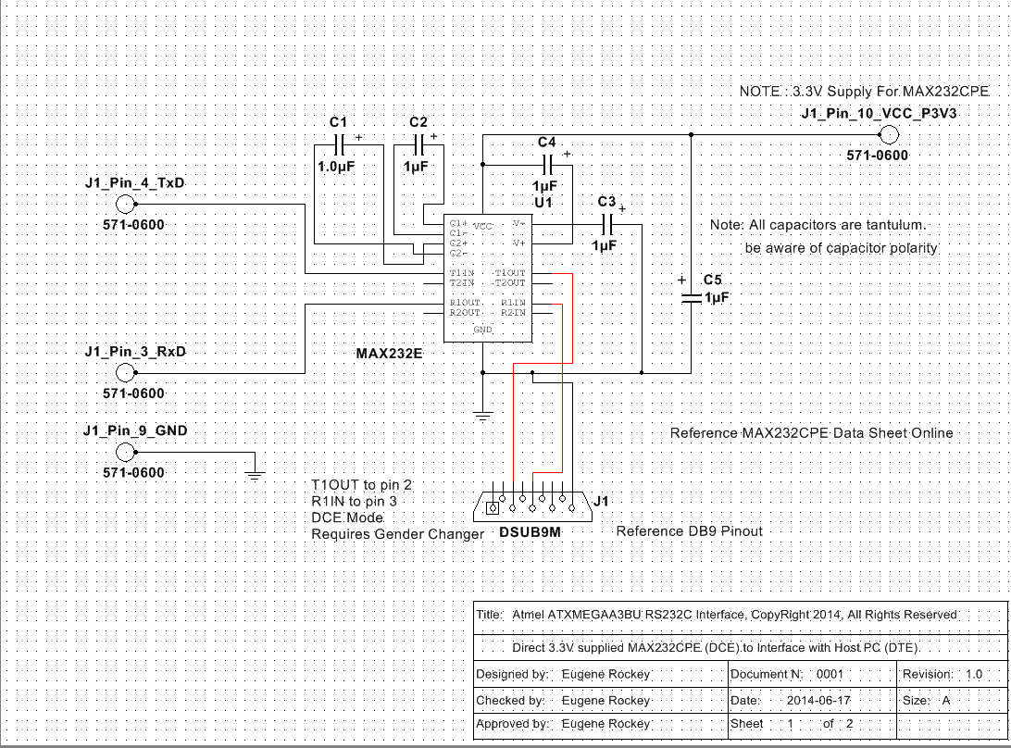

Analysis

Conclusion

References

1. "The USART of the AVR » MaxEmbedded." *MaxEmbedded*. N.p., 04 Nov. 2015. Web. 23 June 2017.