INFS7202 Web Information Systems

GeoMetaAssist
Design Document
AI-Powered Geospatial Metadata Editor
STAC-compliant metadata generation powered by RAG

Submitted by
Student: Dwiputra Sam Mulia
Student ID: s4980498
Course: INFS7202 — Web Information Systems
Instructor: Dr. Aneesha Bakharia
Date: April 14, 2026

Table of Contents
1 Project Overview & Key Features 1
1.1 Key Features 2
2 Database Design 3
2.1 Design Rationale of implementing BCNF instead of 3NF 4
2.2 Design Rationale for JSON as field types 4
3 HTML Mockup 6
4 Technology Research 9
4.1 Decision 1: Metadata Standard — STAC 1.0.0 vs ISO 19115 9
4.2 Decision 2: GeoJSON Metadata Extraction — Client-side (Turf.js) vs Server-side (GeoPandas) 10
5 Accessibility 12
5.1 WCAG 2.1 Overview 12
5.2 WCAG 2.1 Example of Criteria Applied to GeoMetaAssist 12
5.3 Cognitive Accessibility 14
5.4 Accessibility Testing Strategy 14
6 Security 15
6.1 Authentication 15
6.2 Authorisation and Role-Based Access Control (RBAC) 15
6.3 Object-Level Permission Enforcement 16
6.4 Subscription Quota Enforcement 17
6.5 CSRF Protection 17
6.6 Cross-Site Scripting (XSS) Prevention 17
6.7 File Upload Security 18
6.8 Security Headers and HTTPS 18
6.9 DEBUG Mode and Secret Key Management 19
References iv
Use of Generative AI and Other Tools vi

Project Overview & Key Features
GeoMetaAssist is a cloud based SaaS solution developed to automate the production of standardized geospatial metadata for spatial datasets. GeoMetaAssist was created to address an ongoing inefficiency in the geospatial community regarding the manual time consuming process of generating metadata records compliant with open catalogue standards. Specifically GeoMetaAssist supports the SpatioTemporal Asset Catalog (STAC) format as its target catalogue standard.
Problem Domain. The routine requirement for geospatial professionals is to have structured metadata accompany their dataset so it can be discovered, shared across different systems and comply with open data framework requirements. However, this manual process is very labour intensive, prone to errors and requires an intimate knowledge of the target catalogue schema. Current tools do provide little assistance to help guide the practitioner and also do not use artificial intelligence (AI) to assist the practitioner complete all the fields in the catalogue document. Therefore, geospatial practitioners will continue to need to read through large volumes of information contained within specification documents individually.
Target audience: The main users of GeoMetaAssist are geospatial data engineers, GIS analysts and those responsible for managing datasets prior to publishing them or archiving them. This also include Research Organizations and Government Agencies which are required to publish STAC compliant metadata, and Spatial Data Consultancy companies which produce metadata deliverable products for their client base.
Platform Purpose. GeoMetaAssist takes in GeoJSON Files as input, and outputs STAC item in JSON. GeoMetaAssist uses a combination of automated extraction of technical metadata field values using programmable methods and a retrieval-augmented generation (RAG) pipeline built on top of an index of STAC specification documentation to suggest descriptive metadata fields based upon the context of user's interaction with the system and assist users in navigating through the appropriate context-based fields by way of an interactive AI chat bot

Key Features
- User authentication and subscription management. Users can enter their information in order to sign up and/or login to the application with an e-mail address and a password. A two-tiered software as a service (SaaS) is used; the free version offers a limited number of projects and has limitations on uploads and number of requests made to the AI portion. In addition, there is an administrator portal available for employees to create, update and archive a registered subscriber’s subscription account.
- Project management. Registered users have the ability to create, read, write and delete projects containing geo-data. These are considered units of organization for uploading one or more GeoJSON data sets along with related metadata.
- GeoJSON data set and technical metadata extraction. Once uploaded into the platform, the geojson data sets will trigger the automatic extraction of the coordinate reference system (CRS/EPSG) , spatial bounding box, geometry type, feature count, and attribute schema; these extracted parameters populate the technical field of the STAC item record without requiring any manual entry.
- AI-assisted descriptive metadata generation. Using RAG pipeline and operating on top of the STAC specification, the system will suggest values for descriptive fields (title, description, keywords) generated from the dataset's attribute names and geometry characteristics. Additionally, RAG also generates recommended values for fields dependent upon context such as temporal extent.
- Interactive Metadata Chatbot. An AI-powered chatbot running on top of the STAC specification via RAG will guide users inserting fields that cannot be inferred programmatically, such as license, providers, and external links.
- Metadata review/edit/export. In addition to reviewing all of the AI-generated and auto-extracted values in a structured edit interface prior to exporting the fully populated record as a valid STAC-item json file. All exported records remain in storage and can be viewed from within the project dashboard for potential editing and re-exporting.

Database Design
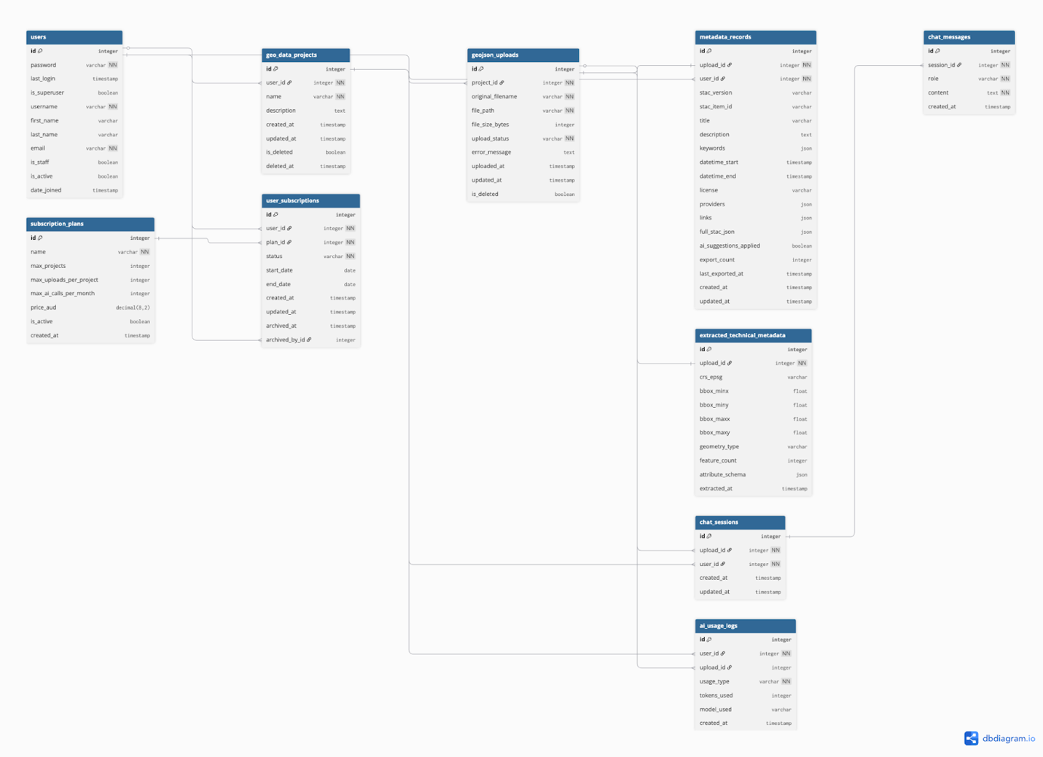

Design Explanation
This database is modelled with a system that make every user/subscriber will have only one subscription that is actively in use at any given time and that subscription will always belong to a specific plan level. Every user may create projects, each project may contain from one or many GeoJSON files. For each file uploaded into the platform it will generate both the technical metadata for the upload and the STAC metadata for the file. All metadata created by uploading files will be associated with a single chat session that contains all of the conversations between the users and the AI chatbot metadata assistant. Usage of the AI will be tracked on a per-user basis so that there are quotas enforced on subscriptions based on total number of RAGs and Chatbot interactions.

Design Rationale of implementing BCNF instead of 3NF
GeoMetaAssist's database schema is structured to follow the standards of Boyce Codd Normal Form (BCNF), as opposed to use the 3NF. Although 3NF removes transitive dependency and can meet the needs of most applications, BCNF represents a stronger assurance, specifically it assures that each determinant within each table will be a candidate key. Therefore, this ensures that no anomaly type (insert/update/delete) will exist due solely to structural issues in the schema, and establishes clear ownership boundaries between users, projects, uploads, and metadata records. Additionally, because multiple users access the same database in a SaaS model, and data isolation between subscribers must be implemented via the database schema, GeoMetaAssist has established these strong assurances through its use of a surrogate integer primary key in each table as the sole determinant of non-key attributes. Therefore, based upon structural characteristics alone, insert, update, and delete anomalies will never occur.

Design Rationale for JSON as field types
Some fields (attribute_schema, keywords, providers, links, and full_stac_json) have been defined using JSON. Due to the fact that there is no fixed number of attributes and their name and data type will be different for each and every GeoJSON file within the system, normalization on attribute_schema will neither be practical nor possible in the "traditional" sense.
All of the other JSON fields; keywords, providers, links, and full_stac_json were determined due to the use of the STAC specification. These are defined as arrays and/or nested objects in the STAC Item schema. The addition of relational table decomposition for these fields would introduce unnecessary join complexities. Also, no benefits can arise from this additional decomposition since the application does not read/write the JSON fields individually and never performs filtering/aggregation on individual sub-fields at the SQL level. Prior to writing the JSON fields to the database, all JSON fields are validated at the application level to ensure data integrity. Attribute_schema is programmatically populated by GeoPandas with an assured structure. Keywords, Providers, Links are also validated against the STAC specification schema prior to saving the metadata record.

HTML Mockup
The full list of pages created can be seen on these files inside the repository:
# | Page | Template File | Route
1 | Base layout (authenticated) | base.html | Layout only — no route
2 | Base layout (public) | base_public.html | Layout only — no route
3 | Landing page | landing.html | /
4 | Login | login.html | /accounts/login/
5 | Register | register.html | /accounts/register/
6 | Dashboard | dashboard.html | /dashboard/
7 | Create project | project_create.html | /projects/create/
8 | Edit project | project_edit.html | /projects/<id>/edit/
9 | Project detail | project_detail.html | /projects/<id>/
10 | Upload GeoJSON | upload_geojson.html | /projects/<id>/upload/
11 | Upload detail | upload_detail.html | /projects/<id>/uploads/<id>/
12 | Metadata editor | metadata_editor.html | /projects/<id>/uploads/<id>/metadata/
13 | Export success | export_success.html | /projects/<id>/uploads/<id>/export/
14 | Admin subscriptions | admin_subscriptions.html | /admin-portal/subscriptions/
15 | Admin subscription edit | admin_subscription_edit.html | /admin-portal/subscriptions/<id>/edit/

All pages for the mockup of this project is developed in Django Templates and Bootstrap CSS Framework Version 5.3.3

Below are several screenshot examples of the pages:
dashboard.html
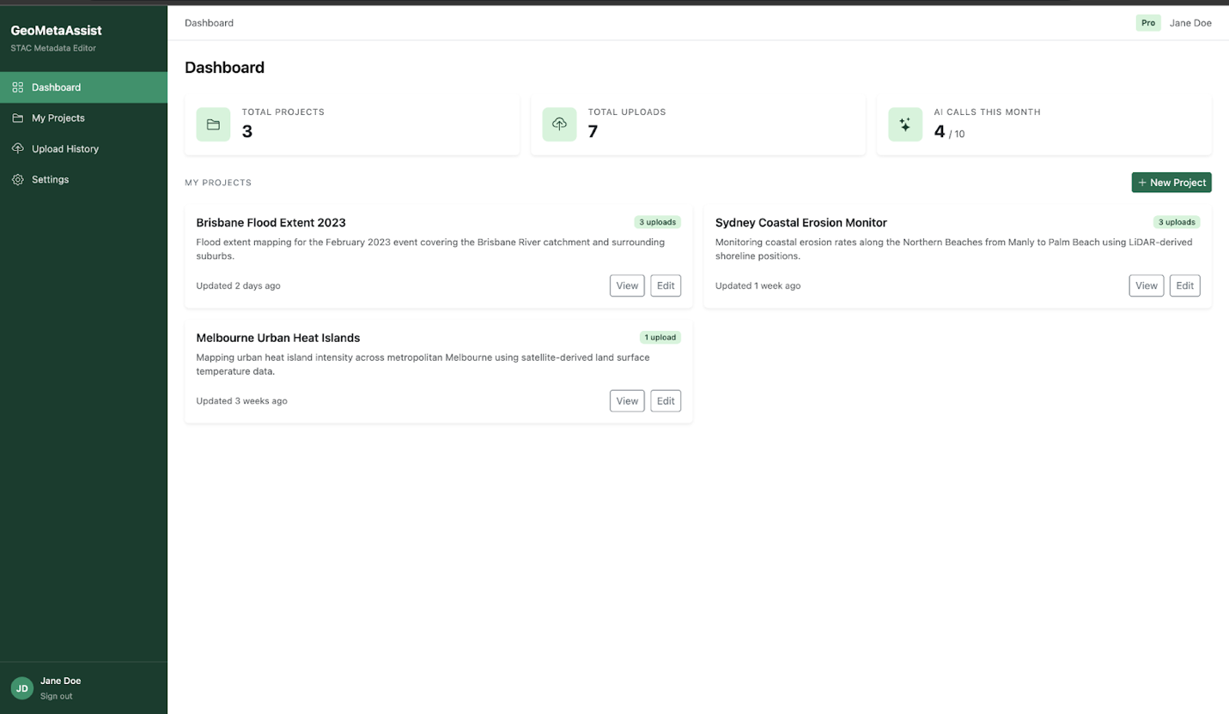

project_create.html
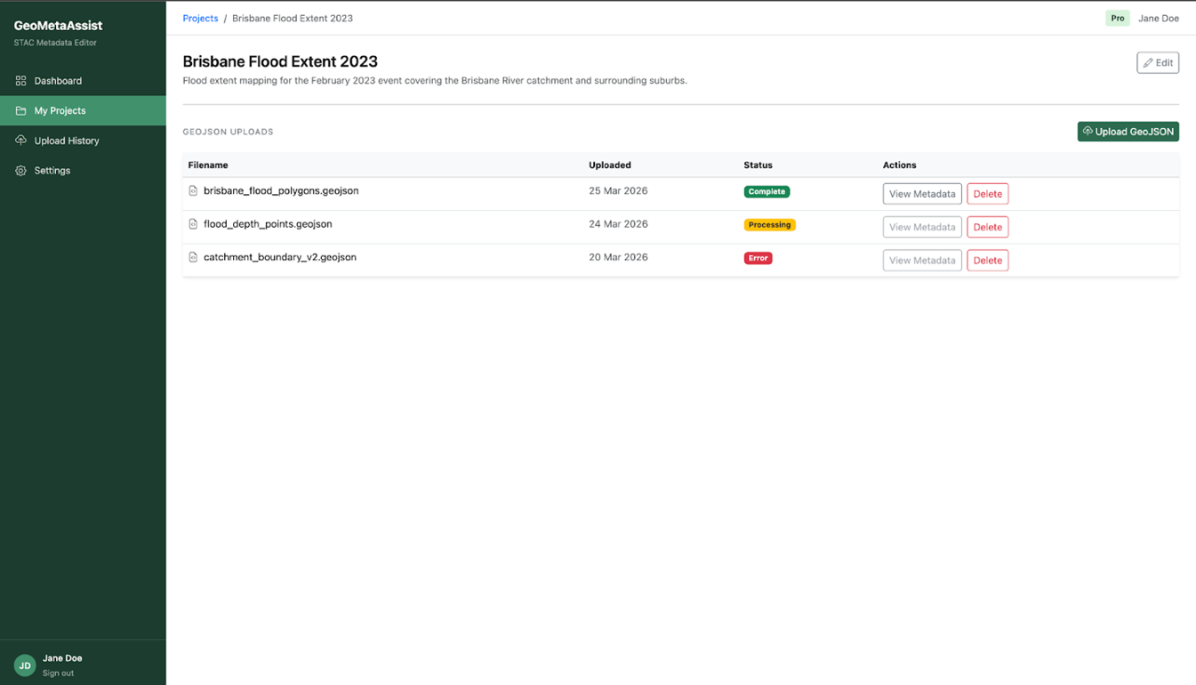

project_detail.html 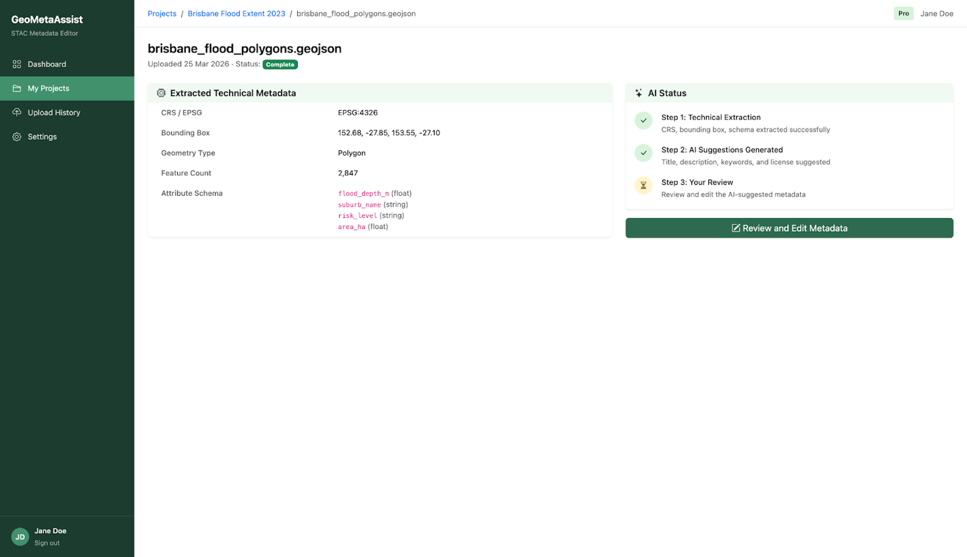
metadata_editor.html
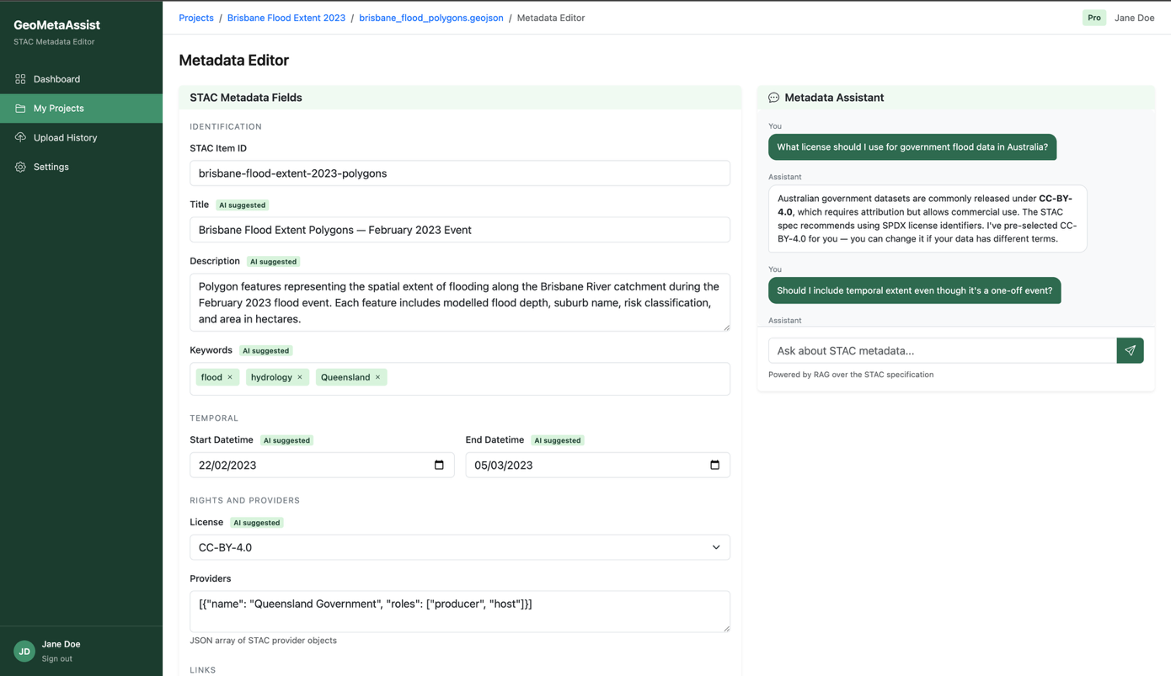

Technology Research
GeoMetaAssist evaluates two key technology choices. Both are reviewed based on their ability to satisfy GeoMetaAssist's requirements and an appropriate selection based upon those evaluations is made at the end of this section.

Decision 1: Metadata Standard — STAC 1.0.0 vs ISO 19115
GeoMetaAssist’s first evaluation involves the determination of the metadata standard to be used by GeoMetaAssist. The platform will support single metadata standard to be chosen as its output. A review of two standards has been conducted, which are ISO 19115, which is the international standard for geographic information metadata, and the SpatioTemporal Asset Catalog (STAC) Specification.

Criteria | STAC 1.0.0 | ISO 19115
Output format | JSON (STAC Item) | XML (ISO 19139)
Web-native | Yes, designed for cloud and web APIs | No, XML-based and tooling-heavy
Complexity | Moderate. Core spec is concise and well-documented | High. Full standard spans hundreds of fields and multiple profiles
Tooling and ecosystem | Growing rapidly. Strong support in AWS, Google Earth Engine, Microsoft Planetary Computer | Mature but heavyweight. Common in government and enterprise GIS
Machine readability | Excellent. JSON is natively consumable by web apps and APIs | Need to parse XML format
Minimum required fields | Small, well-defined core set with optional extensions | Large mandatory field set requiring significant domain knowledge
Community adoption trend | Rapidly growing in modern cloud-native geospatial platforms | Stable but declining in cloud-native contexts
Suitability for SaaS web app | High. JSON output integrates directly with Django and frontend | Low. XML output adds unnecessary parsing overhead

Decision: STAC 1.0.0
Based on these reviews, STAC 1.0.0 was determined to be the best fit for use as the output from GeoMetaAssist. The native JSON format of STAC 1.0.0 fits well into the design structure of a Django-based Web Application. Furthermore, the concise nature of STAC 1.0.0 provides sufficient support for AI-Driven Field Completion. Finally, because many cloud geospatial platforms have adopted STAC 1.0.0, it is believed to represent the more relevant metadata standard for the intended user community of geospatial data engineers. In contrast, ISO 19115 provides additional complexity over what is required for a Web-Native SaaS delivery model.

Decision 2: GeoJSON Metadata Extraction — Client-side (Turf.js) vs Server-side (GeoPandas)
In order to determine which architecture would best suit GeoMetaAssist's needs, both client-side and server-side architectures approaches for extracting technical metadata from uploaded GeoJSON files (such as bounding box, CRS, geometry type, feature count, and attribute schema) were examined.

Criteria | Client-side (Turf.js) | Server-side (GeoPandas)
CRS support | None. Turf.js assumes WGS84 (EPSG:4326) only. Cannot detect or handle other coordinate systems. | Full. GeoPandas detects any EPSG code and supports reprojection.
File size handling | Limited. Large GeoJSON files (50MB+) risk browser memory crashes and slow UI. | Robust. Server handles arbitrarily large files independently of user device.
Attribute schema inference | Fragile. JavaScript loose typing makes precise data type detection unreliable. | Reliable. GeoPandas infers typed attribute schema (float, int, string) precisely.
Server compute cost | None. All computation is offloaded to the user browser. | Low to moderate. Scales with file size but manageable for a SaaS platform.
Data privacy at extraction stage | High. File never leaves the user machine during extraction. | Lower. File must be uploaded to the server before extraction begins.
Integration with backend | Poor. Extracted values require a separate API call to be sent back to the server. | Seamless. Extracted values are written directly to the database in the same pipeline.
RAG pipeline compatibility | Incompatible. The file must be on the server for the AI suggestion pipeline to process it. | Compatible. File is already on the server. Extraction and AI suggestion run in sequence.
Persistence of results | Requires an additional client-server round-trip to save extraction results. | Direct. Results are saved to the database immediately after extraction completes.

Decision: Server-side extraction with GeoPandas
GeoPandas is chosen for the extraction process in GeoMetaAssist, based on two limiting factors which prevent a viable client-side extraction solution from being used regardless of its benefits. First, because the GeoJSON file must be uploaded to the server in order to execute the RAG-based AI suggestion pipeline, it will be available at the server-side prior to any metadata extraction can begin anyway. Second, since the extracted technical metadata must be stored permanently in the database as a record associated with the uploaded file, executing the extraction from the server with GeoPandas will eliminate unnecessary client-server round trip and provide better CRS management capabilities, more reliable attribute schema type checking and no limitations on file size due to memory constraints on browsers.

Accessibility
GeoMetaAssist will follow the standards of WCAG 2.1 Level AA in its design to meet the Australian government’s requirement [1] and the commonly used standard for all professional websites. Accessibility is treated as a design constraint throughout the development process rather than being added after completion.

WCAG 2.1 Overview
WCAG 2.1 provides guidelines on what accessibility means in terms of how accessible your site needs to be as defined by four guiding principles: Perceivable, Operable, Understandable, and Robust (POUR). The POUR principles each have Success Criteria that can be tested for conformance to three different levels of compliance with WCAG: A (minimum); AA (standard; this is where GeoMetaAssist will focus); and AAA (Enhanced). All accessibility barriers within a site will generally try to comply at least at Level AA [2].

WCAG 2.1 Example of Criteria Applied to GeoMetaAssist
Ten example criteria below are selected based on relevance to the platform's various UI components, such as the sidebar navigation, the GeoJSON upload zone, the multi-section metadata editor form, the AI chatbot panel, and the dynamic processing status indicators.

Criterion | Level | Example Application to GeoMetaAssist | Implementation
1.1.1 Non-text Content | A | Sidebar navigation uses icon-only links (Bootstrap Icons). These carry no visible text and must expose a text alternative to screen readers. | aria-label on all icon-only buttons and links.
1.3.1 Info and Relationships | A | The metadata editor groups fields into logical sections (Identification, Temporal, Rights). Structure must be conveyed programmatically, not by visual layout alone. | <fieldset> and <legend> wrapping each form group.
1.4.1 Use of Colour | A | Upload status badges (Complete, Processing, Error) and AI-suggested field indicators use colour as a primary differentiator. Colour alone is insufficient. | Text labels accompany all colour-coded badges. No information conveyed by colour only.
1.4.3 Contrast (Minimum) | AA | Primary colour pairing is dark green (#1a3c2e) on white (#ffffff), yielding a contrast ratio of ~14.7:1. All custom colour pairs must meet the 4.5:1 minimum for normal text. | All design system colour pairs verified using WebAIM Contrast Checker.
1.4.10 Reflow | AA | The two-column metadata editor (form + chatbot) must reflow to a single column at 320px viewport width without horizontal scrolling. | Bootstrap 5 responsive grid collapses to single column below the md breakpoint. rem units throughout.
2.1.1 Keyboard | A | The drag-and-drop upload zone is mouse-only by default. All features must be operable without a pointer device, including the chatbot send action. | Standard <input type="file"> fallback provided. All interactive elements reachable and operable via Tab and Enter.
2.4.1 Bypass Blocks | A | The sidebar navigation repeats on every authenticated page. Keyboard users must be able to skip repeated navigation to reach the main content directly. | Skip-to-main-content link as the first focusable element on every authenticated page.
2.4.6 Headings and Labels | AA | All form fields in the metadata editor must have visible, descriptive labels. Placeholder text is not a substitute as it disappears on input and is not reliably announced by screen readers. | Explicit <label for="..."> elements on every form input. No input relies solely on placeholder text [3].
3.3.1 Error Identification | A | Upload failures (wrong format, size exceeded), metadata form validation errors, and AI pipeline errors must be identified in text describing the specific issue. | Inline error messages below the relevant field or component. Django form validation errors passed to template context [4]
4.1.2 Name, Role, Value | A | The chatbot panel and AI processing status card update dynamically. These state changes must be communicated to assistive technologies without requiring a page reload. | aria-live="polite" on the chatbot message container and AI status card [5].

Cognitive Accessibility
Beyond what is required by formal WCAG guidelines, GeoMetaAssist will uses principles of cognitive accessibility to reduce the level of user expertise needed to utilize this application by people who have no prior knowledge of the STAC Specification. To accomplish this, the metadata editor organizes similar or related fields together under specific section headers. Additionally, when requested by the user, the chatbot will provide contextually-based explanations of what each field represents, and the chatbot's AI-based suggested answers assist users to avoid having to remember all possible field format requirements. In addition, error messages within this system are provided as simple statements that identify both an error condition and how to take corrective actions. These methods align with the W3C suggestions regarding cognitive accessibility [6].

Accessibility Testing Strategy
The following methods will be used to verify compliance prior to submission:
• Automated scan for WCAG compliance such as colour contrast verification for all custom colour pairs using IBM Equal Access Accessibility Checker [7].
• Keyboard navigation manual test on all interactive components: sidebar, file upload, metadata form, chatbot, and export flow.

Security
GeoMetaAssist addresses two aspects of security, which are the standard web application security to protect both the user’s data and the integrity of the application, and subscription-based access controlling the SaaS business logic. The two aspects are implemented at a framework-level via the use of built-in mechanisms for security as part of the Django Framework [8] plus explicit application layer controls that are not covered by the Django Framework.

Authentication
GeoMetaAssist authentication will rely on Django's built-in authentication framework. By default GeoMetaAssist will utilize Django's default password hasher PBKDF2 with SHA-256 and a random salt [9], hence plain text passwords are never stored or logged.
Additionally, following configs will be applied on top of Django's defaults:
• Password validation: AUTH_PASSWORD_VALIDATORS config will enforces minimum length (8 characters), rejects entirely numeric passwords, and blocks passwords too similar to the user's email address [9].
• Secure session cookies: SESSION_COOKIE_HTTPONLY = True config will prevents JavaScript from reading the session cookie, mitigating session theft via XSS. Furthermore, SESSION_COOKIE_SECURE = True config will ensure cookies are only transmitted over HTTPS [10].
• Session invalidation: Logout operation will call request.session.flush(), which will destroys the server-side session record rather than only clearing the client cookie [11].
• Brute-force protection: Django does not throttle login attempts by default, therefore django-axes will be configured to lock accounts after a set number of consecutive failed attempts, protecting against credential stuffing [12].

Authorisation and Role-Based Access Control (RBAC)
GeoMetaAssist implements three roles using Django's built-in user flags, enforced at the view layer [13].
• Authenticated User (is_staff=False): standard subscriber. Access is restricted to their own projects, uploads, and metadata records only.
• Staff (is_staff=True): platform administrator. Access to the subscription management portal. Cannot access other users' project or metadata data.
• Superuser (is_superuser=True): full Django admin access. Reserved for platform maintenance only.

The table below defines enforced permissions across all major resources:
Resource | Unauthenticated | Authenticated User | Staff (is_staff) | Superuser
Landing / Login / Register | Read | Redirect home | Redirect home | Redirect home
Dashboard | Deny (302) | Own data only | Own data only | All data
Geo Data Projects (CRUD) | Deny (302) | Own only | Own only | All
GeoJSON Uploads (CRUD) | Deny (302) | Own only | Own only | All
Metadata Editor + Export | Deny (302) | Own records | Own records | All
AI Chatbot (RAG) | Deny (302) | Quota-gated | Quota-gated | Unlimited
Subscription Management | Deny (302) | Deny (403) | Full access | Full access
Django Admin Panel | Deny (302) | Deny (302) | Limited | Full access

Object-Level Permission Enforcement
Django's @login_required decorator will check and confirms if a user is authenticated, but it would not prevent one user from accessing another user's resources by guessing a URL (horizontal privilege escalation). GeoMetaAssist will addresses this issue by filtering every object retrieval by both primary key and the authenticated user's ID:
Example:
project = get_object_or_404(GeoDataProject, pk=pk, user=request.user)

A request for /projects/2/ from a user who does not own project 2 returns a 404, not a 403, to avoid confirming that the resource exists.

Subscription Quota Enforcement
Server-side validation will be performed to enforce free-tier usage limits at the view-layer, prior to creation of any resource or triggering of an AI pipeline. Additionally The ai_usage_logs table is queried at the start of every RAG or chatbot request to verify the monthly call count before proceeding.

CSRF Protection
By default, CsrfViewMiddleware config is enabled within Django. Consequently, All forms generated using Django templates include a csrf_token field embedded within the template. A token is issued during the session and validated upon receipt of all POST, PUT, patch, and delete requests. Any request submitted without a valid token is rejected with a http status code 403 [14].

Cross-Site Scripting (XSS) Prevention
As a result of its use of a template engine, Django automatically escapes all variables passed to it. As such, the user-supplied content cannot be interpreted as HTML or JavaScript [15], thus providing protection against XSS attack. The one area requiring explicit attention is the STAC JSON export preview rendered in a <pre> block, which must apply the escape filter explicitly even though the content is system-generated, as a defence-in-depth measure.
SQL Injection Prevention
the ORM APIs employed by Django by default construct parameterized queries at the driver level. No user supplied data should ever be concatenated or inserted directly into a SQL string [15]. Raw SQL queries can still be executed in order to perform optimizations; however, they must always employ the parameterized format of cursor.execute(SQL, [params]), while ensuring that the user-input data does not contain any string formatting [16].

File Upload Security
The GeoJSON upload endpoint potentially presents risks such as malicious file content, or oversized files. In order to anticipate those risks, the following handlings will be applied:
• MIME type and extension validation: files are validated server-side against an allowlist (application/geo+json, .geojson). The client-supplied Content-Type header will not be trusted.
• File size limit: 50MB enforced at the view layer. DATA_UPLOAD_MAX_MEMORY_SIZE config will be configured to reject oversized requests before they reach the view.

Security Headers and HTTPS
The following Django settings will be applied for the UQCloud Zone production deployment:
• SECURE_SSL_REDIRECT = True config which useful to redirects all HTTP requests to HTTPS [15].
• SESSION_COOKIE_SECURE and CSRF_COOKIE_SECURE = True, which will enforce cookies transmitted over HTTPS only [15].
• X_FRAME_OPTIONS = "DENY", which will prevents iframe embedding, mitigating clickjacking [17].
• SECURE_CONTENT_TYPE_NOSNIFF = True, which will prevents MIME-type sniffing [18].
• Lastly, the Web server (NGINX) will e configured with Strict-Transport-Security (HSTS) max-age of 31536000 seconds (1 year) to make sure all connections are using HTTPS in the network level [19].

DEBUG Mode and Secret Key Management
DEBUG = False is set in production. In debug mode, Django exposes stack traces and settings values that may provide information leak [10]. SECRET_KEY is stored as an environment variable on the server and loaded via os.environ.get("SECRET_KEY") [10]. It is never committed to version control. The .env file is listed in .gitignore.

References
[1] “Standards and Guidelines on digital accessibility | Australian Human Rights Commission.” Accessed: Apr. 05, 2026. [Online]. Available: https://humanrights.gov.au/resource-hub/by-resource-type/guidelines-and-standards/guides-and-standards-disability-rights/chapter-3-standards-and-guidelines-digital-accessibility
[2] World Wide Web Consortium, “Web Content Accessibility Guidelines (WCAG) 2.1.” Accessed: Apr. 05, 2026. [Online]. Available: https://www.w3.org/TR/WCAG21/
[3] “<label>: The Label element - HTML | MDN,” MDN Web Docs. Accessed: Apr. 05, 2026. [Online]. Available: https://developer.mozilla.org/en-US/docs/Web/HTML/Reference/Elements/label
[4] “Working with forms | Django documentation,” Django Project. Accessed: Apr. 05, 2026. [Online]. Available: https://docs.djangoproject.com/en/5.0/topics/forms/
[5] “ARIA live regions - ARIA | MDN,” MDN Web Docs. Accessed: Apr. 05, 2026. [Online]. Available: https://developer.mozilla.org/en-US/docs/Web/Accessibility/ARIA/Guides/Live_regions
[6] W. W. A. Initiative (WAI), “Cognitive Accessibility at W3C,” Web Accessibility Initiative (WAI). Accessed: Apr. 05, 2026. [Online]. Available: https://www.w3.org/WAI/cognitive/
[7] “IBM Accessibility Toolkit.” Accessed: Apr. 05, 2026. [Online]. Available: https://www.ibm.com/able/toolkit/www.ibm.com/able/requirements/requirements
[8] “Security in Django | Django documentation,” Django Project. Accessed: Apr. 05, 2026. [Online]. Available: https://docs.djangoproject.com/en/5.0/topics/security/
[9] “Password management in Django | Django documentation,” Django Project. Accessed: Apr. 05, 2026. [Online]. Available: https://docs.djangoproject.com/en/5.0/topics/auth/passwords/
[10] “Settings | Django documentation,” Django Project. Accessed: Apr. 05, 2026. [Online]. Available: https://docs.djangoproject.com/en/6.0/ref/settings/
[11] “How to use sessions | Django documentation,” Django Project. Accessed: Apr. 05, 2026. [Online]. Available: https://docs.djangoproject.com/en/6.0/topics/http/sessions/
[12] “3. Usage — django-axes 0.1.dev1+gb14b78a16 documentation.” Accessed: Apr. 05, 2026. [Online]. Available: https://django-axes.readthedocs.io/en/latest/3_usage.html
[13] “Using the Django authentication system | Django documentation,” Django Project. Accessed: Apr. 05, 2026. [Online]. Available: https://docs.djangoproject.com/en/5.0/topics/auth/default/
[14] “Cross Site Request Forgery protection | Django documentation,” Django Project. Accessed: Apr. 05, 2026. [Online]. Available: https://docs.djangoproject.com/en/5.0/ref/csrf/
[15] “Security in Django | Django documentation,” Django Project. Accessed: Apr. 05, 2026. [Online]. Available: https://docs.djangoproject.com/en/6.0/topics/security/
[16] “Performing raw SQL queries | Django documentation,” Django Project. Accessed: Apr. 05, 2026. [Online]. Available: https://docs.djangoproject.com/en/6.0/topics/db/sql/
[17] “Clickjacking Protection | Django documentation,” Django Project. Accessed: Apr. 05, 2026. [Online]. Available: https://docs.djangoproject.com/en/6.0/ref/clickjacking/
[18] “Middleware | Django documentation,” Django Project. Accessed: Apr. 05, 2026. [Online]. Available: https://docs.djangoproject.com/en/6.0/ref/middleware/
[19] “HTTP Strict Transport Security (HSTS) and NGINX – NGINX Community Blog.” Accessed: Apr. 05, 2026. [Online]. Available: https://blog.nginx.org/blog/http-strict-transport-security-hsts-and-nginx

Use of Generative AI and Other Tools
Tool | Prompt (Main Goal) | Section Affected | What I Learned
Claude (claude.ai) | Refine the project overview, problem domain, and target audience. Claude also help me draft the list of key features for GeoMetaAssist | Section 1: Project Overview & Key Features | How to frame a SaaS product description clearly, separating problem domain, audience, and feature scope.
Claude (claude.ai) | Help to critically assess the normalization, integrate with the Django user entity, rationale of the entity and relationships, and also making sure my design follow the STAC specification. | Section 2: Database Design | DBML syntax, AbstractUser field inheritance in Django, BCNF design principles, and how to model SaaS subscription tiers relationally.
Claude Code | Initialise a Django project and help me build HTML mockups templates for all pages using Bootstrap 5 with realistic placeholder content (mock data). | Section 3: HTML Mockups | Django project and app structure, Bootstrap 5 grid and component usage. Claude Code was used heavily to assist with CSS and responsive layout implementation.
Claude (claude.ai) | Client-side (Turf.js) vs server-side (GeoPandas) GeoJSON metadata extraction across relevant criteria and produce a justified decision for each. | Section 4: Technology Research | The technical and architectural trade-offs between client-side and server-side extraction.
Claude (claude.ai) | Criticize the accessibility section, help me assess what 10 most relevant criteria for GeoMetaAssist, and help me map each to a specific UI component with relevant accessibility consideration. | Section 5: Accessibility | WCAG 2.1 structure, the POUR principles, and how specific criteria such as ARIA live regions, skip links, and colour contrast apply to a real application interface.
Claude (claude.ai) | Criticize my draft on security key points that I made mostly based on Django docs, and give ideas on what other security consideration other than what Django provides. | Section 6: Security | Distinction between role-level and object-level permission, HSTS and its role in preventing SSL stripping attacks, and why returning a 404 instead of a 403 on unauthorised object access avoids confirming resource existence to an attacker.

Note: the prompts listed above represent the main goal of each interaction, not the complete prompt sequence. Each section involved multiple follow-up exchanges to refine, correct, and adjust the output before it was incorporated into the design document.

