TODO

General
- Order rest of supplies
  - Batteries?
  - Power switches
- How to use Vscode instead of arduino IDE?
- Create more streamlined UI to interact with the ESP32 over WiFi

Software
- Its only logging every 2 seconds? How to get back to 1hz
- Set emissivity of canopy in software
- Writes to one big file right now, 4gb max
  - Need to split and write a second file when the first gets too big
- Organize code and upload to github
- Add documentation (requirements.txt)
- Add python GUI for selecting ROIs
  - Details below

Hardware
- Replace temperature and humidity sensor
  - Find one that is more accurate?
- How to wire everything to breadboard more effectively?
  - Use pin terminals like for power?
- Power switch outside housing?
- Battery
  - Phone battery pack?
  - 3.3v direct input?
  - Needs 5v for card reader?
- Organize and take stock of components

Mounting/other
- Mount temperature and humidity sensor without
- Drill holes in housing
- Figure out how to mount everything

Table of contents
Contents
Background and functionality 3
MLX90640 IR camera 3
Other components 5
Hardware setup 6
Tutorial 7
Setup and flashing code 7
Operation and setup 8
Future plans/ideas 9

Background and functionality

MLX90640 IR camera
Minicam et measures thermograms from the MLX90640 IR sensor array. It can measure multiple ROIs in a larger field of view to produce data that can run wavelet and TSEB models.
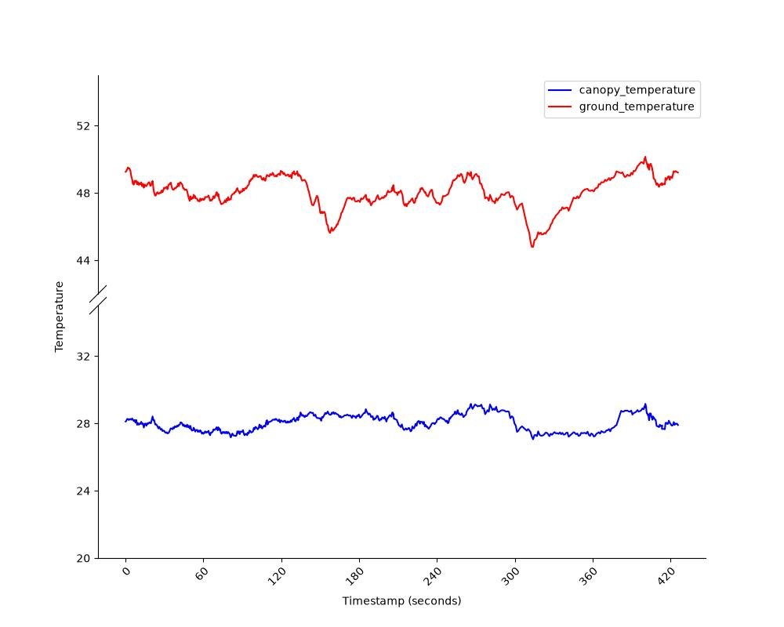
Figure 1: Example output from sensor from two selected ROIs in timeseries
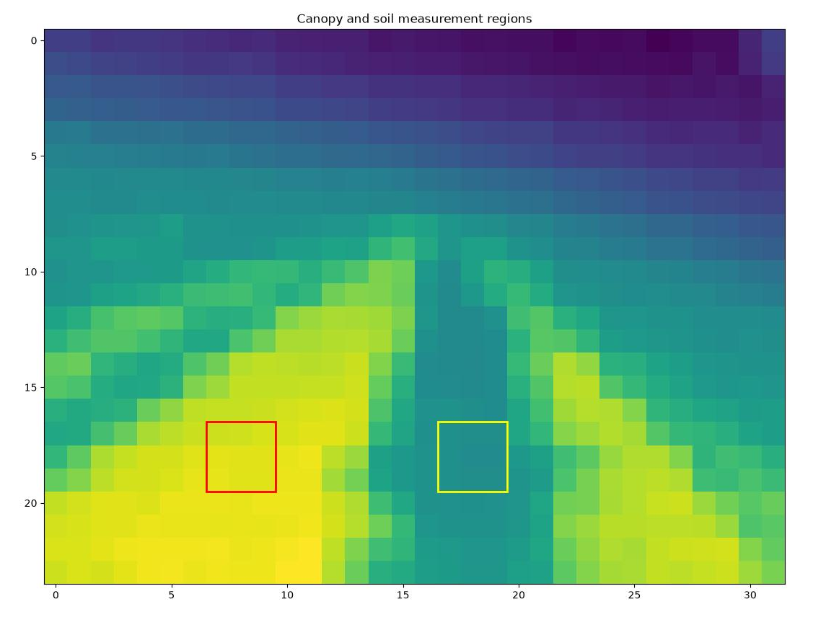
Figure 1: Example thermogram with ROIs outlined
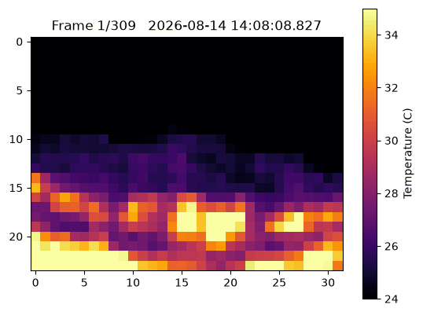
Figure 2: animation of camera output over timeseries

Other components
Other modules provide output to successfully support the thermal data to be able to run models
- Temperature and relative humidity sensor: Records temperature and relative humidity to keep track of
- Real time clock (RTC) module: Runs off battery power to keep track of timestamps to link with real time to calculate et

Hardware setup
ESP32 is brain and connects to multiple components
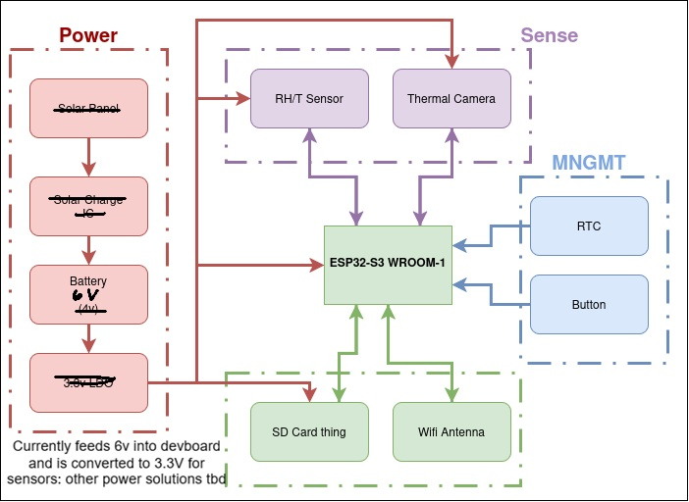
Current setup of prototype
6V input powered by 4 disposable AA batteries wired in series

Tutorial

Setup and flashing code

Can connect and flash new code 2 ways
- Physical wired connection to box plugging in
- WiFi Connection

Physical wired connection:
IMPORTANT: Do not connect computer to the board while it has power going to it from the battery. It will fry the board and break everything
- After power is disconnected, plug in computer to ESP32
- Use Arduino IDE to flash program to the ESP32 (arrow button in top left corner of IDE)
- Wait for it to compile and upload

WiFi connection
Create a functionality so that for 1 minute after boot up or reset you are able to connect to WiFi and flash new code. After the 1 minute is done it will turn off WiFi and continue logging offline to save battery
- Must flash with wifi capability once initially to activate wifi to be able to continue to update code via WiFi
- After power is disconnected flash script with WiFi to ESP32
- To update code, power cycle or reset the system to activate WiFi again
- Connect to WiFi within 1 minute of restarting system
- In Arduino IDE go to tools > ports > and select the WiFi port
- Then you can send and compile the new code

Operation and setup

Future plans/ideas
Wants/needs

Needs
- ESP32
  - Wifi and bluetooth capability
- MLX90640 IR camera
- T/RH sensor (DHT 11 currently, needs to be switched) (maybe I2c temperature and humidity sensor instead)
- MicroSD module (that runs on true 3.3v)
- Real time clock (RTC) module
- Power setup
  - Solar to battery to 3.3v
  - Power switch on outside

- PCB that wires everything up
- Capability to plug in computer/connect to bluetooth while chip is on without frying board
- Power button/switch

Wants
- Custom board for camera integrated into PCB
  - Camera sensor without board is much less expensive ($30 vs $70)
  - Can just replace the camera sensor (plug in 4 pins) without having to replace the board
  - Plugs into a terminal at the end of a wire that is soldered/attached to the board
- Ability to wire a fine wire thermocouple if we want to

UI

Python GUI using Tkinter or Pyqt6 I will create a GUI that interfaces with the C++ code and flashes the ESP32 with the correct code. The user will be able to define some parameters in GUI
Parameters
- What frequency of logging? TSEB or Wavelet?
- Save entire image or ROI? One or two ROIs
  - If ROI, send example image to the GUI and the user can draw where they want to measure

After setting parameters, the python script sends parameters via JSON to the ESP32 which reads it and implements in the code (I think?)

Meeting 8/18

Questions
- TSEB calculates the sensible heat flux
  - Can you use the output of TSEB to estimate the empirical coefficient for wavelet?
  - Would require net radiometer instead of EC flux tower
  - Still expensive, but far more affordable, and potentially reasonable for some applications
- How many towers have net radiometers on them? All of them?
  - How many could we run TSEB for?
  - Calculate error in estimating alpha coefficient from TSEB
  - Do this for many towers all that can compute TSEB

To do
- This fall
  - Mount a few cameras on a tower
  - Robust validation
    - Panels of known temperature (thermocouples and IRTs)
    - Blackbody radiation calibration in the lab
  - Compare calculations
    - Compare IRT to camera
    - Compare TSEB of all methods to measured fluxes from the tower
    - Compare results of Wavelet with tower computed alpha vs TSEB computed alpha
    - Compare results of wavelet with estimated net radiation instead of using the net rad
- This winter (summer in chile)
  - Deploy many in fields around chile with varying cropping systems/
    - Compare results to satellite calculated ET (openET approach)

