The Art Dealer Game User Manual

Live Link to Game:<https://cs4500-hw4-team4.gitlab.io/art-dealer/game.html>

Table of Contents

Introduction

Chapter 1. Installation

Chapter 2. Easy Explanation on Gameplay

Chapter 3. Main components of gameplay

Chapter 4. How to win

Chapter 5. Who created the game?

Introduction

The game is played with a deck of cards which simulate artworks for sale. The player selects 4 cards to offer for sale. The dealer chooses whether to buy each card according to a secret rule. After several rounds, the player gathers information necessary to determine the rule the dealer is following.

Game consists of three modes

1. K-2:
   1. Patterns include: all red, all black, all one suit, all one face or number
2. 3-5:
   1. Patterns include single-digit primes, sum=9, ace + blackjack
3. 6-8:
   1. Patterns include poker hands
   2. Also allows for a PVP between two players

Chapter 1: Installation

The program is published as a client-side web app. It can be run locally by downloading the files into a local directory and loading the game.html file. Or it can be run remotely by loading the URL. Running locally allows it to be used without an active internet connection, whereas running remotely allows it to be used without taking up disk space on the user's machine. You may use any web browser to open the game, although we recommend Mozilla Firefox or Google Chrome. To play the game type the following link into your web browser.

<https://cs4500-hw4-team4.gitlab.io/art-dealer/game.html>

Chapter 2: Easy explanation on how to play

How to play:

The goal is to guess the dealer’s pattern of buying

1. Select a game mode: K-2 is least difficult and 6-8 is most difficult

2. Choose 4 cards and see what the dealer buys

3. Your score is updated with how many cards the buyer bought

4. When the dealer buys 4 cards choose an option in the dropdown

5. Click check solution under the dropdown you selected

Clicking how to play button will toggle between show/hide of the how to play box

1.You Will see this game menu first, read how to play and choose a mode based on your grade level

3.You will then see this screen. The top shows how to play that you can refer to, the cards shown are all the possibilities of cards you can choose. The status shows important messages that you may refer to. The 0000 shows your score which updates when the dealer buys a card. Next allows you to submit your hand for review and see what the dealer bought and making it your turn again. All the possibilities for the dealer’s pattern are shown in the three dropdowns.

4.Start choosing cards, they will show up under the score

5.When you are happy with your cards choose next to submit them for review and see what the dealer bought. Below the deck is History which will show bought cards with a check cards meaning that the dealer purchased that cards, and cards not bought will have an X next to them. This means that the checked cards are part of the pattern that they are buying in. When you are ready to guess the pattern, choose any option from the dropdown shown and click check solution below the dropdown.

6. If you are correct in your guess You win and, you will be taken back to the menu to play again. If you are incorrect, you will continue to play. The below shows the pop ups for both win and lose.

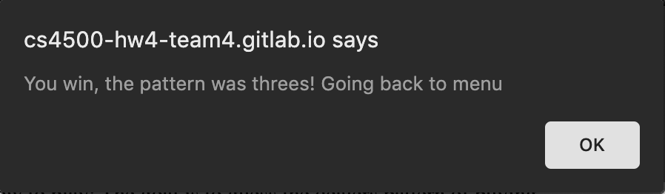

7. PVP mode

Player 1 (the user) selects 4 cards and player 2 (the buyer) accepts cards by clicking on them, which adds a check next to them. To reject a card, they do nothing. Player 1 then hits next when the buyer is done and selects new cards. The Game continues like this until Player 1 cn solve.

Chapter 3: Main components of gameplay

Start Menu

The starting game menu will allow the user to select which mode they want to play. User can choose (K-2), (3-5), (6-8)-regular or PVP mode. The user will choose which mode they want to play and then be transitioned into playing the game.

Playing the game

Each turn consists of the Seller's turn (Player 1) followed by the Dealer's turn (computer/Player 2).

During the Seller's turn, player clicks on 4 cards from the Deck which are copied to the Board. Player may click on the cards on the Board to remove them and select different cards. The turn ends when Player clicks 'next'.

The Dealer’s turn depends upon the game mode.

In the regular modes, the computer will choose all, some, or none of the cards to buy according to the preset condition. The accepted cards will be highlighted until the Player clicks ‘next’.

In PVP mode, Player 2 will act as the Dealer and click cards to choose which ones to buy. The turn ends when Player 2 clicks ‘next’.

Chapter 4: How to win

Winning

The buyer will have a preset win condition before each round starts (backend). The difficulty is based on the game mode that is selected at the beginning.

K-2: all red, all black, all one suit, all one face or number

3-5: single-digit primes, sum=9, ace + blackjack

6-8: poker hands

The goal of the User is to select cards (refer to running description) until they are able to describe the pattern of the buyer. The user will see highlighted cards in history if they have been bought by the dealer in a previous turn. If the buyer 'buys' all 4 cards the user will have the option to ‘solve’ meaning that they will have won, the game. Once the user has solved and has won the game, the user will be taken back the to the start menu.

Strategy tip: Your score will update if a card is purchased by the art buyer. Once your score gets to 4 this means 4 cards have been purchased. Once 4 cards have been purchased this means that you have all the information required to win. So, at this point you should analyze the cards purchased and attempt to solve. You may solve with a score below or above 4 but 4 is the maximum number required to have all information needed to win.

Chapter 5: Who created the game

David Richards

dlrz85@mail.umsl.edu

Michael Joshua Ryan

mjryan@mail.missouri.edu

Michael Dyer

mdxrf@mail.umsl.edu

Samed Ganibegovic

sg93f@mail.umsl.edu