Credit Card Program (Input/Output)

#include <iostream>

#include <iomanip>

using namespace std;

//Credit Card Program

//Mohammed Ansari- Programmer

int main() {

//Declaring Variables

char answer = 'Y', card = 'Y', again = 'Y';

double credit = 0.0, tax = 0.0;

const double rate = 0.06;

double discountOne= 0.05, discountTwo= 0.10;

// Declaring loop statement

while (again=='Y' || again=='y')

{

//Entering data to be processed

cout << "Is this a credit card purchase? (Y/N)\t";

cin >> card;

cout << "Please enter the total purchase: \t";

cin >> credit;

//Adding discounts

if (credit >= 100.00 && (card == 'N' || card == 'n'))

credit *= (1.00 - discountOne);

if (credit >= 20.00 && (card == 'Y' || card == 'y'))

credit *= (1.00 - discountTwo);

//Output Settings

cout << setiosflags(ios::fixed | ios::showpoint);

cout << setprecision(2);

//Processing of Data and Output generation

cout << "\nThe subtotal is: \t$" << credit << endl;

tax = credit * 0.06;

cout << "The tax is: \t$" << tax << endl;

credit += tax;

cout << "The total due is: \t$" << credit << endl;

//Thank you Comment

cout << "\nThank you for your purchase\n\n";

//Executing Loop

cout << "Enter another purchase(Y or N)?\n";

cin >> again;

cout << "\n";

}

tax = 0.0;

system("Pause");

return 0;

}

Outputs:-

Run-1

Purchase amount- $50.00

Purchase type - Cash

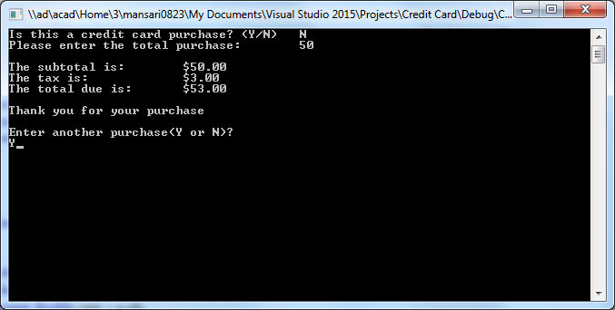

Run-2

Purchase amount- $75.00

Purchase type - Credit card

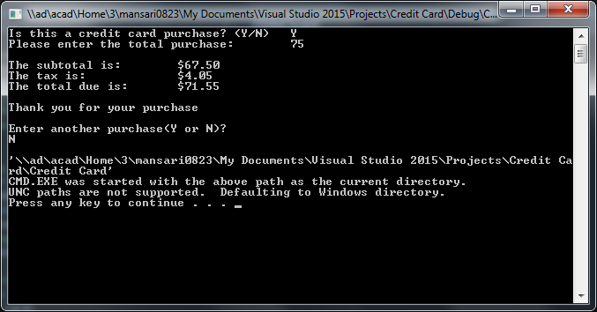

Run-3

Purchase amount- $200.00

Purchase type - Cash

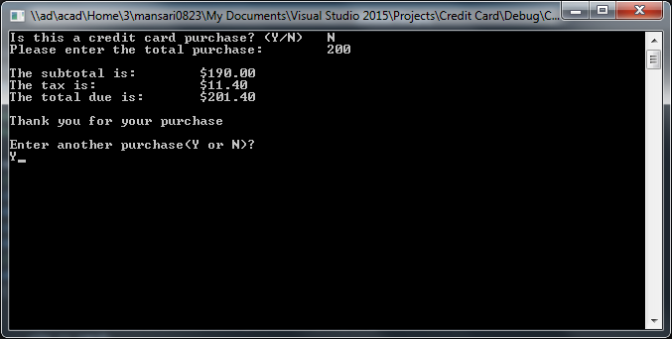

To View Code Hold Ctrl and Click here

Run-4

Purchase amount- $300

Purchase type - Credit card

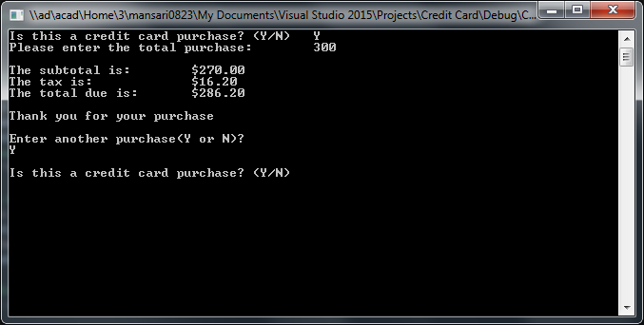

To View Code Hold Ctrl and Click here