Program that writes data to text file

Program code –

//(1) write the preprocessing directives

#include <iostream> //cin, cout

#include <cstring> //string variables

#include <fstream> //file processing

#include <conio.h> //clear screen

using namespace std;

//(2) open the scope of the main() method

int main() {

//(3) declare and initialize the variables

static char chrName[100]; //employee name

double myExpenses; //individual expense

char myLabels[100]; //expense label

int index = 0; //loop control variable

int number = 0; //number of expense items

double Totalexpense = 0;

ofstream fout; //file stream output

//(4) file variable initialization

fout.open("data.txt");

//(5) clear the screen

system("CLS");

//(6) request the employee name

cout << "Enter the employee name: " << endl;

cin.getline(chrName, 100);

//(7) request the number of expense items

cout << "Enter the number of expense items: " << endl;

cin >> number;

cin.ignore(); //skip [Enter] entry from keyboard;

fout <<"Expense Report:\n"<<"Employee name: " <<chrName << endl;

//(8) open the looping structure

while (index < number)

{

index++;

//(9) request the user for an expense item

cout << "Enter the type of expense: " << endl;

cin.getline(myLabels, 100);

cout << "Enter the amount of expense: " << endl;

cin >> myExpenses;

//(10) getting total expenses

Totalexpense += myExpenses;

//(11) write the data to a text file

fout << myLabels

<< " expenses: $" << myExpenses << endl;

cin.ignore(); //skip [Enter] entry from keyboard;4

//(12) close the scope of the while() loop

}

cout << "Total expenses:$" << Totalexpense << endl;

fout << "Total expenses:$" << Totalexpense << endl;

//(13) close out file

fout.close();

system("pause");

//(14) close the scope of the main() method

}

Program run –

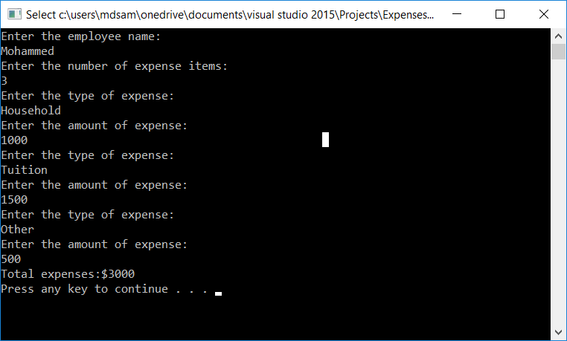

Text File –

