Program to Compute Simple Interests (Input/Output)

#include <iostream>

#include <iomanip>

using namespace std;

//Mohammed Ansari, Student Programmer

int main()

{

//declare the variables and initialize their values

double amount = 0, earnings = 0, principal = 0;

double rate = 0, time = 0;

char answer = 'y';

//enter the looping structure to repeat the process

do

{

//prompt the user for data and read the values

cout << "Compute simple interest and total amount\n" << endl;

cout << "Enter the deposit amount (no $ or comma)" << endl;

cin >> principal;

cout << "Enter the annual interest rate as a decimal" << endl;

cin >> rate;

cout << "Enter the time of deposit" << endl;

cin >> time;

//perform the computations

earnings = principal * rate * time;

amount = principal + earnings;

//display the computations

cout << "Amount in Account = "

<< setiosflags(ios::fixed | ios::showpoint)

<< setprecision(2) << amount << endl;

cout << "Simple Interest = " << setprecision(2) << earnings << endl;

cout << "\nWould you like to run another calculation?" << endl;

cout << "(Y/N)?\n";

cin >> answer;

} while (answer == 'y' || answer == 'Y');

return 0;

}

**(a)** *Principal* $ 3, 000. 00

*Interest Rate* 0.065

*Time* 4 years

*Interest Earnings* ______780.00_______

*Amount in Account* ______3780.00____

**(b)** *Principal* $ 4, 550. 00

*Interest Rate* 1. 75 %

*Time* 5 years

*Interest Earnings* _______398.13________

*Amount in Account* ______4948.13_______

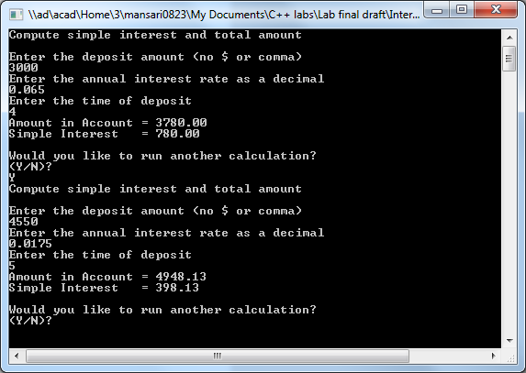

**To view the code. Hold CTRL and click** **here**

**(c)** *Principal* $ 650. 50

*Interest Rate* 5. 25 %

*Time* 1 year

*Interest Earnings* ______34.15_________

*Amount in Account* _______684.65______

**(d)** *Principal* $ 25, 600. 00

*Interest Rate* 6. 30 %

*Time* 10 years

*Interest Earnings* ______16128.00_________

*Amount in Account* ______41728.00________

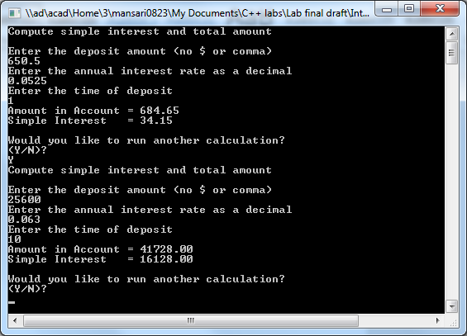

**To view code. Hold CTRL and click** **here**

**(e)** *Principal* $ 9, 286. 42

*Interest Rate* 2. 75 %

*Time* 9 months

*Interest Earnings* ______191.53_________

*Amount in Account* _______9477.95________

**(f)** How much interest will Jane Windsor earn on an $ 800.00 investment at 8.50 % simple interest for 2 years? What will be the amount in her account after 2 years?

*Interest Earnings* _______136.00________

*Amount in Account* ______936.00________

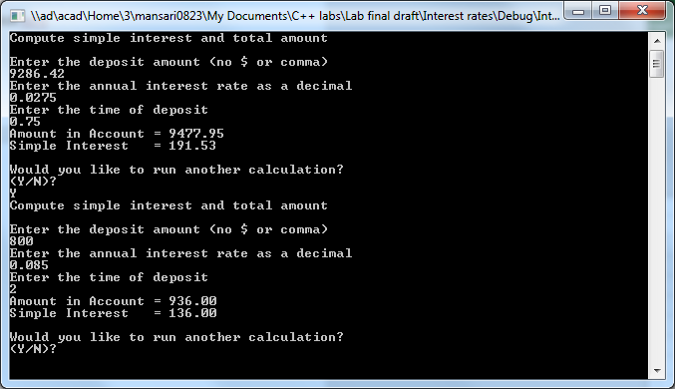

**To view code. Hold CTRL and click** **here**