Program for user input of Two Dimensional Matrix along with Transpose of the matrix

Code:-

#include <iostream>

#include<cstring>

#include<math.h>

using namespace std;

char answer = 'y';

int main()

{

//initiating looping structure

do {

int array_A[2][2];

int i = 0, j = 0;

int m, n = 0;

int trace = 0;

int determinant = 0;

//Input for number of rows and columns

cout << "Please enter the number of rows = " << endl;

cin >> m;

cout << "Please enter the number of columns = " << endl;

cin >> n;

//Type of matrix declaration

if (m == n)

cout << "This is a square matrix\n\n ";

else if (m!=n)

cout << "This is not a square matrix\n";

//Reading the matrix values

for (i = 0; i < m; ++i)

{

for (j = 0; j < n; ++j)

{

cout << "Enter element " << i << " " << j << " ";

cin >> array_A[i][j];

}

}

//Displaying the given matrix

cout << "The given matrix is :: \n\n";

for (i = 0; i < m; ++i)

{

for (j = 0; j < n; ++j)

{

cout << "\t" << array_A[i][j];

}

printf("\n\n");

}

//Transpose the matrix values

for (j = 0; j < n; ++j)

for (i = 0; i < m; ++i)

{

cout << "element " << i << " " << j << " "

<< array_A[i][j] << endl;

//Condition logic to get trace value

if (i == j)

trace = trace+ array_A[i][j];

}

//Displaying the user with trace and determinant values

cout << "Trace result is " << trace << "\n";

determinant = (array_A[0][0] * array_A[1][1]) - (array_A[0][1] * array_A[1][0]);

if (i != 2 && j != 2)

cout << "There is no determinant" << endl;

else

cout << "Determinant is " << determinant << endl;

cout << "Would you like to calculate another matrix? " << endl;

cout << "(Y/N)\n";

cin >> answer;

}while (answer == 'y' || answer == 'Y');

system("pause");

return 0;

}

Programs Runs: -

To show trace and determinant

Sample run 1 (With Square matrix) –

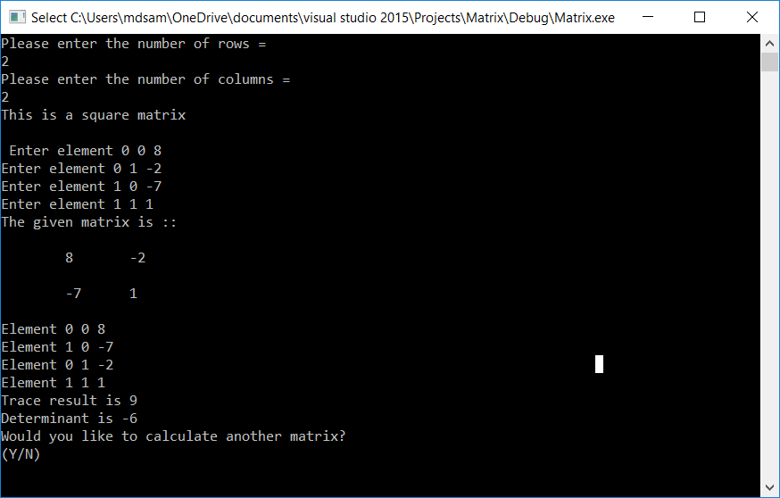

Sample Run 2-

(For not square matrix)

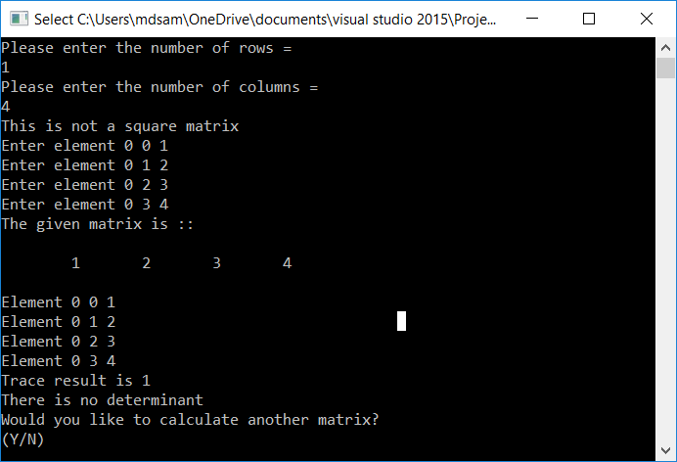

Program Run 3-

