Program to Compute commissions

Initial Program: -

//Commission Application: Mohammed- Student Programmer

#include <iostream>

using namespace std;

//place function prototype here

double Compute(int, double, double);

int main()

{

//declare local variables

char name[30];

/*char month[20];*/ (For 2nd scenario)

int num = 0; double commission = 0;

double salary = 0; double sales = 0;

cout << "Welcome to the commission application\n";

//place call to the function here

cout << "Enter the employee name \n";

cin.getline(name, 30);

cout << "Enter the employee id number \n";

cin >> num;

cout << "Enter the employee salary \n";

cin >> salary;

cout << "Enter the employee sales \n";

cin >> sales;

/*cout << "Please enter the month of sale\n"; (For 2nd scenario)

cin >> month;*/

cout << "\n";

commission = Compute(num, salary, sales);

cout << "Commission report for ";

cout << name << "\n";

cout << "id number \t" << num << endl;

cout << "monthly salary \t" << "$" << salary << endl;

cout << "monthly sales \t" << "$" << sales << endl;

cout << "commission \t" << "$" << commission << endl;

/*cout << "Month of sales\t" << "$" << month << endl;*/ (For 2nd scenario)

cout << "\n";

system("pause");

return 0;

}

//place function definition here

double Compute(int number, double salary, double gross_sales)

{

cout << "commission report for employee " << number << endl;

if (gross_sales > 15000)

return gross_sales * 0.05;

/*else if(gross_sales <= 15000)

return(gross_sales*0.05) + 200;*/ (For 2nd scenario)

return 0;

}

Program: -

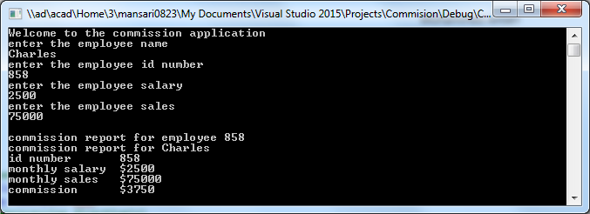

Modified Code: -

//Commission Application: Mohammed-Student Programmer

#include <iostream>

using namespace std;

//place function prototype here

double Compute(int, double, double);

int main()

{

//declare local variables

char name[30];

char month[20];

int num = 0; double commission = 0;

double salary = 0; double sales = 0;

cout << "Welcome to the commission application\n";

//place call to the function here

cout << "Enter the employee name \n";

cin.getline(name, 30);

cout << "Enter the employee id number \n";

cin >> num;

cout << "Enter the employee salary \n";

cin >> salary;

cout << "Enter the employee sales \n";

cin >> sales;

cout << "Please enter the month of sale\n";

cin >> month;

cout << "\n";

commission = Compute(num, salary, sales);

cout << "Commission report for ";

cout << name << "\n";

cout << "Id number \t" << num << endl;

cout << "Monthly salary \t" << "$" << salary << endl;

cout << "Monthly sales \t" << "$" << sales << endl;

cout << "Commission \t" << "$" << commission << endl;

cout << "Month of sales\t"<< month << endl;

cout << "\n";

system("pause");

return 0;

}

//place function definition here

double Compute(int number, double salary, double gross_sales)

{

cout << "Commission report for employee " << number << endl;

if (gross_sales > 15000)

return gross_sales * 0.05;

else if(gross_sales <= 15000)

return(gross_sales) + 200;

return 0;

}

Program: -

