Program to execute an RPG game (Input/Output)

Code :- (Program run images at the bottom)

There are many more scenarios. Just displayed some of them.

Please give me your feedback professor.

/*Program for RPG game

Mohammed Ansari- Student Programmer

*Written by Mohammed*/

#include <iostream>

#include <cstring>

#include<iomanip>

using namespace std;

int main()

{

int selection = 0;

int health = 0;

char role[100];

char msg[100];

char answer='y';

do {

cout << "welcome to the world of the Incursion";

cout << "please select a role";

cout << "\n choose ... " << endl;

cout << "1 for Count Doom" << endl;

cout << "2 for the Countess of Crime" << endl;

cout << "3 for the Spartan Warrior" << endl;

cout << "4 for the Messenger of Incursion" << endl;

cout << "5 for The Student" << endl;

cout << "Beware! Make sure to choose right or you will be lost in an infinite loop" << endl;

cin >> selection;

switch (selection)

{

case 1:

{

strcpy_s(role, "Count Doom");

strcpy_s(msg, "welcome ");

strcat_s(msg, role);

cout << msg << endl;

cout << "We hope your role will be successful!\n";

cout << "you have ... 100% health" << endl;

health += 100;

break;

}

case 2:

{

strcpy_s(role, "Countess of Crime");

strcpy_s(msg, "Welcome ");

strcat_s(msg, role);

cout << msg << endl;

cout << "May you achieve your objectives!\n";

cout << "you have ... 75% health" << endl;

health += 75;

break;

}

case 3:

{

strcpy_s(role, "Spartan Warrior");

strcpy_s(msg, "Welcome ");

strcat_s(msg, role);

cout << msg << endl;

cout << "May you achieve your objectives!\n";

cout << "you have ... 50% health" << endl;

health += 50;

break;

}

case 4:

{

strcpy_s(role, "Messenger Of Incursion");

strcpy_s(msg, "Welcome ");

strcat_s(msg, role);

cout << msg << endl;

cout << "May you achieve your objectives!\n";

cout << "you have ... 25% health" << endl;

health += 25;

break;

}

case 5:

{

strcpy_s(role, "The Student");

strcpy_s(msg, "Welcome ");

strcat_s(msg, role);

cout << msg << endl;

cout << "You fell into the pit of no reutrn\nAll your objectives have been BLOWN TO SMITHEREENS!\n";

cout << "you have ... 0% health" << endl;

health += 0;

system("pause");

return 0;

}

default:

cout << "invalid entry ... try again later" << endl;

}

//part 2 ... choosing a mission

cout << "please select an objective";

cout << "\n choose ... " << endl;

cout << "1 for \"Get the Gold\"" << endl;

cout << "2 for \"Capture the Fortress\"" << endl;

cout << "3 for \"Enter the City\"" << endl;

cout << "4 for \"Forest of Frenzy\"" << endl;

cout << "5 for \"Battle for Midland\"" << endl;

cout << "Beware! Make sure to choose right or you will be lost in an infinite loop" << endl;

cin >> selection;

int treasure = 0;

switch (selection) {

case 1: {

treasure += 10;

health += 10;

cout << "Your mission is to retrieve the gold." << endl;

cout << "Your initial score: " << treasure << endl;

cout << "We wish that your mission is a success!" << endl;

bool active = true;

char motion = ' ';

//game play keys defined

cout << "Let the Games begin!" << endl << endl;

cout << "Use these keyboard keys for game play." << endl;

cout << endl;

cout << "Press w a s d and Enter for movement" << endl;

if (active == true)

//open loop block

{

//commence game play

cout << endl;

cout << "Enter the building (w) or" << endl;

cout << "Bypass building and reach the Entrance of the Forest (a or d)" << endl;

cout << endl;

cin >> motion;

//update game points

if (motion == 'w' || motion == 'W')

{

cout << "\nYou have entered the building and its empty"

<< "\nYou decide to exit the building and end up at the entrance of the forest" << endl;

treasure += 20;

}

else

cout << "\nYou are at the entrance of the forest" << endl;

treasure += 5;

health += 5;

//display current game points

cout << "your treasure score : " << treasure << endl;

cout << "your health : " << health << endl;

//continue game play

cout << endl;

cout << "Enter into forest (w) or" << endl;

cout << "Bypass forest and walk to the river (a)" << endl;

cout << "Bypass forest and go to the mountains (d)" << endl;

cout << "Run away (s)" << endl;

cout << endl;

cin >> motion;

}

if (motion == 'w' || motion == 'W')

{

cout << "You entered the forest and encountered your nemesis!\n"

<< "Get ready for battle" << endl;

cout << "You draw your sword\n" << endl;

cout << "Your nemesis dashes towards you and swings his sword\n"

<< "What should you do?\n"

<< "Press w for Striking back at the same time\n"

<< "Press d to jump to the right and slash your nemesis\n"

<< "Press a to jump to the left and slash your nemesis\n"

<< "Press s to do nothing\n" << endl;

cin >> motion;

if (motion == 'w' || motion == 'w')

{

cout << "You strike back and kill him but take damage at the same time." << endl;

health -= 30;

cout << "THE NEMESIS DROPS SOMETHING.\n" << "You pick it up.\n"

<< "You got the Goblet of gold." << endl;

treasure += 100;

}

else if (motion == 'd' || motion == 'D')

{

cout << "You dodge the attack and slash your nemesis\n"

<< "THE NEMESIS DROPS DEAD\n"

<< "You check the nemesis and get the Goblet of Gold\n" << endl;

health += 10;

treasure += 100;

}

else if (motion == 'a' || motion == 'A')

{

cout << "You dodge the attack and slash your nemesis\n"

<< "THE NEMESIS DROPS DEAD\n"

<< "You check the nemesis and get the Goblet of Gold" << endl;

health += 10;

treasure += 100;

}

else if (motion == 's' || motion == 'S')

{

cout << "Your nemesis slashes you\n"

<< "You lose all your health and your treasure is taken\n" << endl;

treasure = 0;

health = 0;

}

}

else if (motion == 'a' || motion == 'A')

{

cout << "You are at the bank of the river"

<< "\nThe Gold is on the other side of the river"

<< "\nThe current seems really strong"

<< "\nWhat should you do"

<< "\nSwim accross the river(Press w)"

<< "\nBuild a raft using 50 of your treasure(Press a)"

<< "\nTry to make the jump accross the river(Press d)"

<< "\nDo nothing and camp" << endl;

cin >> motion;

if (motion == 'w' || motion == 'W')

{

cout << "You managed to swim accross but the currents were too strong so you lost your health\n" << endl;

health -= 30;

cout << "Congratulations you found the Loot" << endl;

treasure += 100;

}

else if (motion == 'a' || motion == 'A')

{

cout << "You get accross without any trouble and lose no health"

<< "\nCongratulations you found the Loot" << endl;

treasure += 100;

}

else if (motion == 'd' || motion == 'D')

{

cout << "Are you serious? Like really, out of all the options you choose to jump."

<< "\nYou get pulled away by the current and drown" << endl;

health = 0;

treasure -= 20;

}

else if (motion == 's' || motion == 'S')

{

cout << "Your nemesis jumps at you and kills you"

<< "\nYou are dead" << endl;

treasure -= 30;

health = 0;

}

}

else if (motion == 'd' || motion == 'D')

{

cout << "You are at the foot of the mountain\n"

<< "The gold is at the top"

<< "\nWhat do you want to do" << endl;

cout << "\nPress w for climbing the mountain"

<< "\na to smash the mountain"

<< "\nd to go around the mountain"

<< "\ns to do nothing" << endl;

cin >> motion;

if (motion == 'w' || motion == 'W')

{

cout << "\nYou have climbed the mountain but lose some health" << endl;

treasure += 100;

health -= 20;

cout << "You have retrieved the Gold" << endl;

}

else if (motion == 'a' || motion == 'A')

{

cout << "\nYou really want to destroy the mountain? You serious? Since this is a game ill let it slide"

<< "\nYou smashed the mountain and the gold drops to the ground "

<< "\nYou picked it up" << endl;

cout << "\nCongratulations you got the gold" << endl;

treasure += 100;

health += 10;

}

else if (motion == 'd' || motion == 'D')

{

cout << "\nYou keep going around the mountain for all eternity"

<< "\nYou lose" << endl;

treasure = 0;

health = 0;

}

else if (motion == 's' || motion == 'S')

{

treasure += 5;

cout << "your nemesis has defeated you!" << endl;

cout << "MUAHAHAHAH THERE IS NO STANDING AROUND DURING YOUR MISSION" << endl;

health = 0;

}

}

else if (motion == ' ') {

cout << "Invalid entry";

}

break;

}

case 2: {

char motion = ' ';

treasure += 20;

health += 20;

cout << "Your mission is to secure the fortress." << endl;

cout << "Your initial score: " << treasure << endl;

cout << "Would you like to enter the fortress" << endl;

cout << "Press w to enter" << endl;

cin >> motion;

if (motion == 'a', 's', 'd', 'w' || motion == 'W', 'S', 'A', 'D')

cout << ' '; {

if (motion == 'w' || motion == 'W')

{

cout << "You have entered the Fortress"

<< "\nThe Lich King is guarding the fortress"

<< "\nGet ready to battle" << endl;

cout << "You draw your sword" << endl;

cout << "The Lich King moves swiftly and attacks from above" << endl;

cout << "Press w to defend above\n"

<< "a and d to defend your sides\n"

<< "s to defend your back" << endl;

cin >> motion;

if (motion == 'w' || motion == 'W')

{

cout << "You successfully defend the Lich King's attack"

<< "\nDo you want to move in for the strike?" << endl;

cout << "Hit w to strike" << endl;

cin >> motion;

if (motion == 'w' || motion == 'W')

{

cout << "You move in fast for the attack but\n"

<< "The Lich King swings his sword\n" << endl;

cout << "Press w a s d to dodge" << endl;

cin >> motion;

if (motion == 'w', 'a', 's', 'd' || motion == 'W', 'A', 'S', 'D')

{

cout << "You dodged and striked the Lich King in his heart\n"

<< "You won the battle and captured the fortress" << endl;

treasure += 100;

health += 10;

}

}

}

else if (motion == 'a', 's', 'd' || motion == 'A', 'S', 'D')

{

cout << "The Lich King slashes you and you are dead" << endl;

health = 0;

}

}

}

break;

}

case 3: {

char motion = ' ';

treasure += 30;

health += 30;

cout << "Your mission is to find out what is raging havok in the city and eliminate the threat." << endl;

cout << "Your initial score: " << treasure << endl;

cout << "Are you ready to enter the city?" << endl;

cout << "Press w to enter" << endl;

cin >> motion;

if (motion == 'w' || motion == 'W')

{

cout << "You have entered the city"

<< "\nThe Big Bad Wolf is destroying the city and you have to stop him"

<< "\nYou approach him and he jumps at you with his claws from above"

<< "\nTime to battle" << endl;

cout << "You draw your sword quick" << endl;

cout << "The Big Bad Wolf moves swiftly and attacks from above" << endl;

cout << "Press w to defend above\n"

<< "a and d to defend your sides\n"

<< "s to defend your back" << endl;

cin >> motion;

if (motion == 'w' || motion == 'W')

{

cout << "You successfully defend the Wolf's attack"

<< "\nDo you want to move in for the strike?" << endl;

cout << "Hit y for yes" << endl;

cin >> motion;

if (motion == 'y' || 'Y')

{

cout << "You move in fast for the attack but\n"

<< "The Wolf swings his claws\n" << endl;

cout << "Press w a s d to dodge" << endl;

cin >> motion;

if (motion == 'w', 'a', 's', 'd' || motion == 'W', 'A', 'S', 'D')

{

cout << "You dodged his claws and strike him in the stomach\n"

<< "The Big Bad Wolf is still moving and you need to deliver another blow" << endl;

cout << "The Wolf hits you away and you fall to the ground\n" << endl;

cout << "The Wolf jumps on you with his claws"

<< "\nWhat do you do?"

<< "\nPress w to roll up"

<< "\nPress a or d to roll on the side"

<< "\nPress s to roll down" << endl;

cin >> motion;

if (motion == 'w', 'a', 's', 'd' || motion == 'W', 'A', 'S', 'D')

{

cout << "You rolled away and stabbed he Wolf in his chest\n"

<< "You won the battle and now the city is at peace" << endl;

treasure += 100;

health += 10;

}

else

{

cout << "The Wolf slashes you and you are dead" << endl;

health = 0;

}

}

}

}

}

else

{

cout << "IVALID ENTRY" << endl;

}

break;

}

case 4: {

treasure += 40;

health += 40;

char motion = ' ';

cout << "Your mission is to survive the forest." << endl;

cout << "Your initial score: " << treasure << endl;

cout << "Press w to swoop through the forest and get the gold" << endl;

cin >> motion;

if (motion == 'w' || motion == 'W')

cout << "You succesfully passed the forest and survived" << endl;

treasure += 50;

break;

}

case 5: {

treasure += 50;

health += 50;

char motion = ' ';

cout << "Your mission is to attack Midland." << endl;

cout << "Your initial score: " << treasure << endl;

cout << "Press any key to attack and secure the Midland" << endl;

cin >> motion;

if (motion == ' ')

cout << "Congratulation you secured the Midland" << endl;

treasure += 50;

break;

}

}

//display current game points

cout << "Mission is done" << endl;

cout << "your treasure score : " << treasure << endl;

cout << "your health : " << health << endl;

cout << endl;

cout << "the Game is over ... " << "time for homework" << endl;

cout << "Do you want to replay the game?" << endl;

cout << "Y/N" << endl;

cin >> answer;

}while (answer == 'y' || 'Y');

system("pause");

return 0;

}

Sample Run:-

Case 1:- Get The Gold

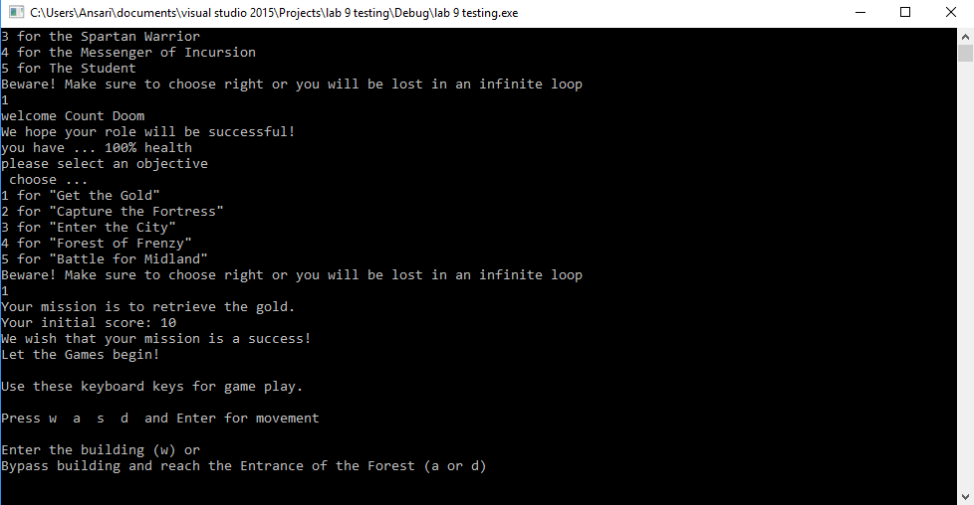

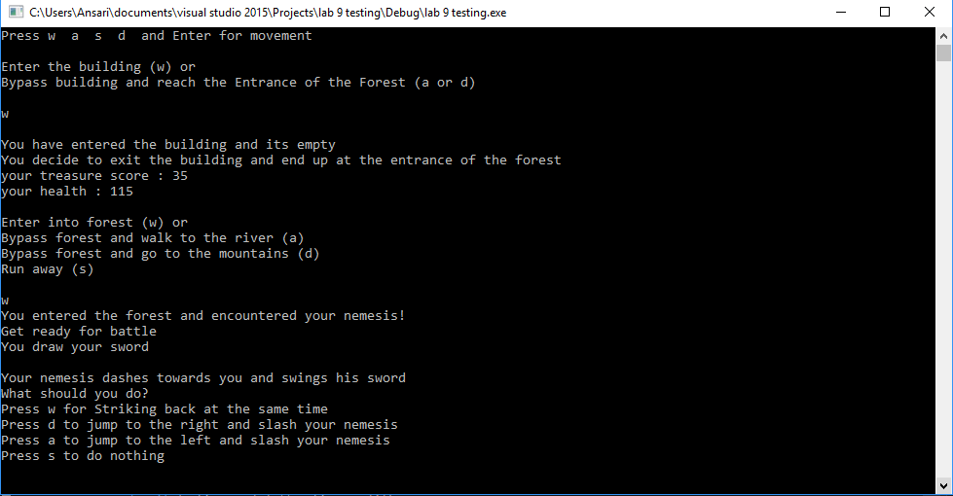

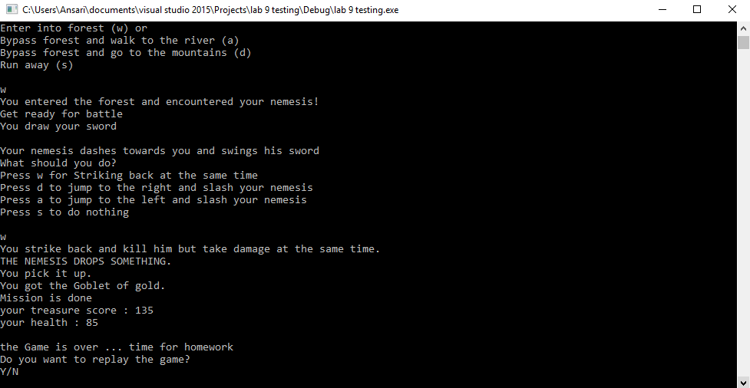

Case 2:- Fortress

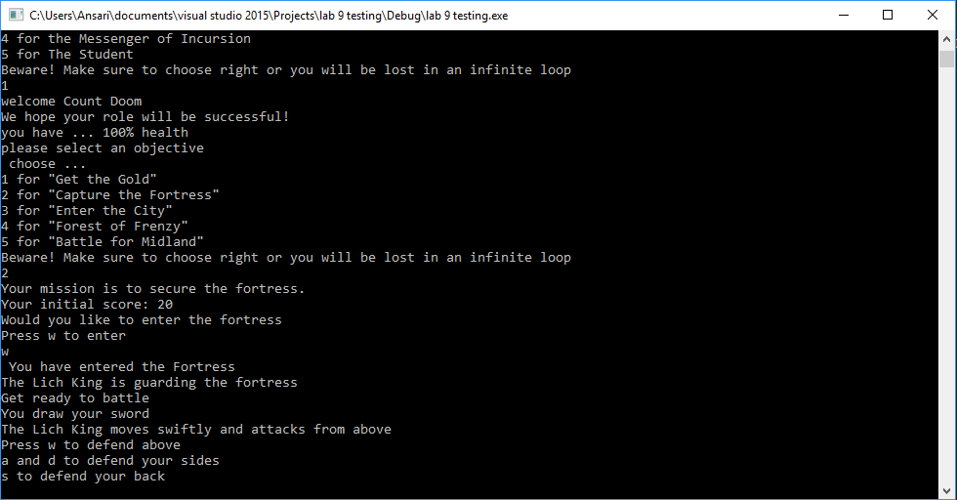

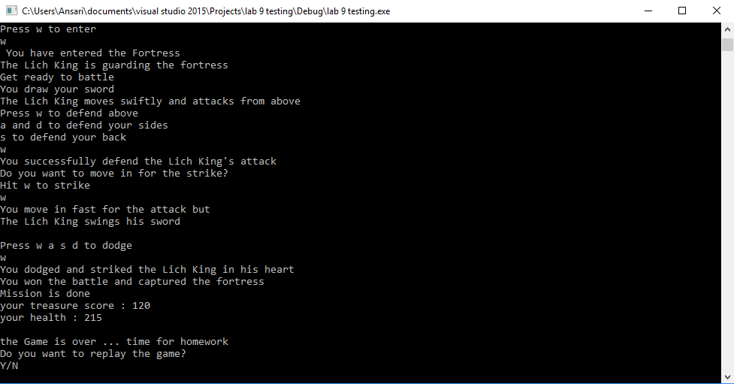

Case 2:- If wrong selection

