Docker-Based ML Deployment
Task 1:
Model Training:
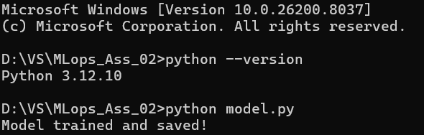
Task 2:
Build Image:
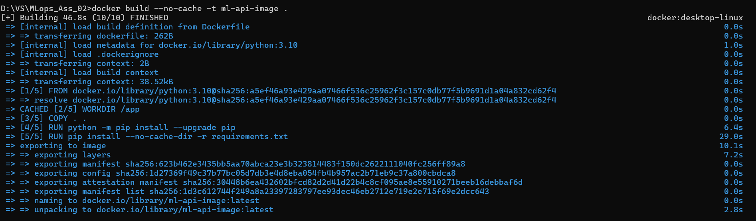
Task 3:
Running Container:
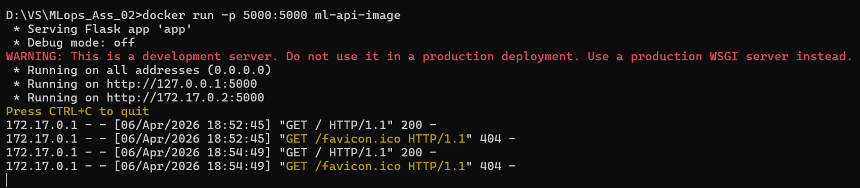
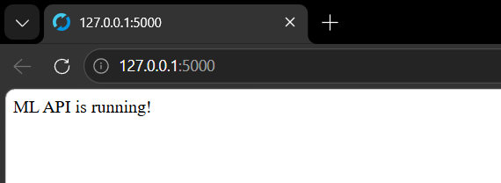
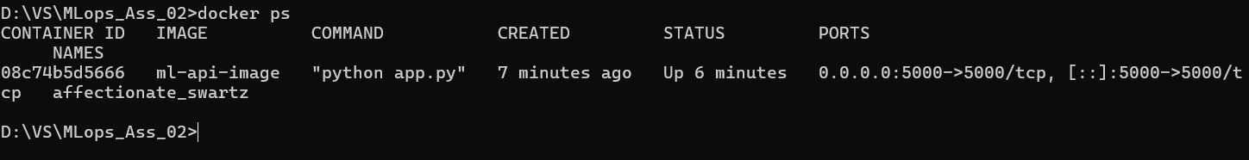
Task 4:
API prediction result:
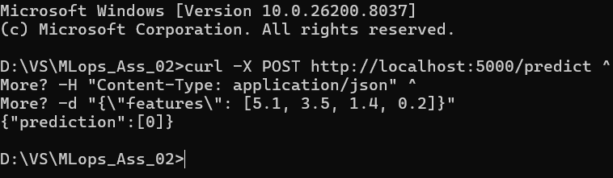
Task 5:
Docker Images List:
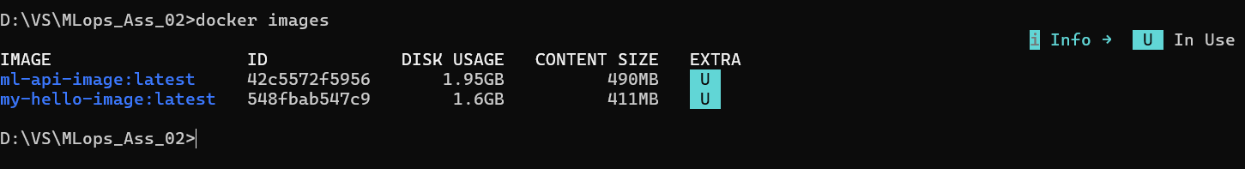
Task 6:
Login:
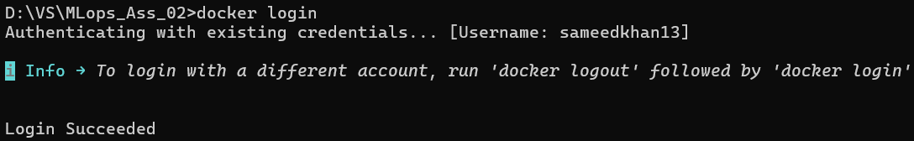

Task 7:
Push:
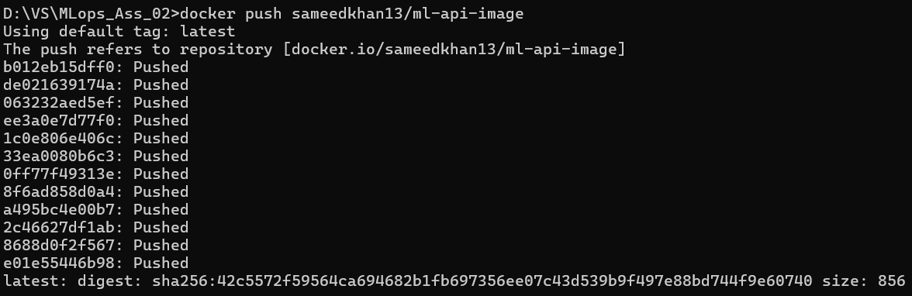
Task 8:
Pull Image:
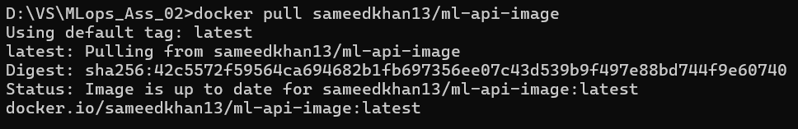
All Executable Commands:
:Train the ML model
python model.py
:Output: Model trained and saved!

:Build Docker image
docker build -t ml-api-image .

:Run container (maps container port 5000 → host port 5000)
docker run -p 5000:5000 ml-api-image
:: Leave this running in one CMD window

:Open another CMD window for checking
:Check images
docker images

:Check running containers
docker ps

:Login to Docker Hub
docker login
:Enter your credentials

:Tag image with your Docker Hub username
docker tag ml-api-image sameedkhan13/ml-api-image

:Push image to Docker Hub
docker push sameedkhan13/ml-api-image

:Pull image (from another PC or to test)
docker pull sameedkhan13/ml-api-image

:Run pulled image
docker run -p 5000:5000 sameedkhan13/ml-api-image
: Leave this running to test API

: Test API with curl (in another CMD window)
curl -X POST http://localhost:5000/predict ^
-H "Content-Type: application/json" ^
-d "{\"features\": [5.1, 3.5, 1.4, 0.2]}"
:Should return JSON: {"prediction":[0]}

