Code Output:
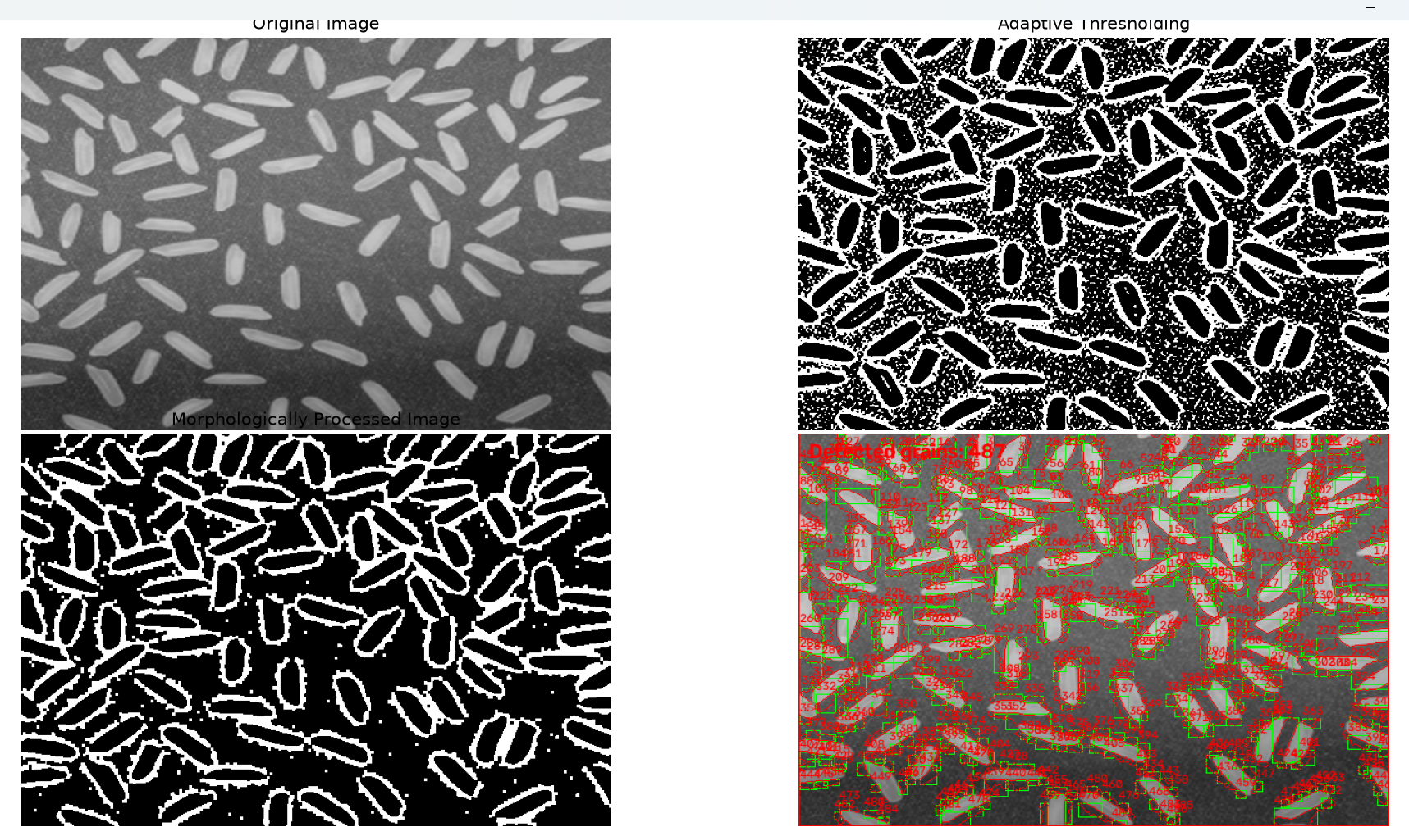

1. Required Analysis
Why was Opening or Closing selected?
Opening was selected first because it removes small white noise regions using erosion followed by dilation. Closing was then applied to fill small holes and narrow gaps inside the grains. The 3 × 3 structuring element is a starting choice that is small enough to reduce noise without aggressively changing grain shapes.
What happened when the structuring-element size was increased?
A larger structuring element affects a larger neighborhood. Opening can remove more noise but may also erase small grains or thin parts of real grains. Closing can fill larger gaps, but it may join nearby grains together. Therefore, increasing the size does not always improve the count.
Did morphology remove any actual rice grains?
It may remove real grains if they are small, thin, or weakly separated from the background. The minimum-area filter can also discard real small grains. The result should be checked against the original image, and MIN_GRAIN_AREA can be adjusted for the image.
How did touching grains affect the final count?
Touching grains can form one connected foreground region. Distance transform and watershed attempt to split that region, but they may fail when the gap between grains is unclear. If two grains remain one region, the count is too low; if one grain is split into multiple regions, the count is too high.
What limitation does the applied method have?
The method is sensitive to lighting, contrast, grain overlap, image resolution, threshold settings, the foreground-ratio setting, and the minimum-area filter. Watershed is not guaranteed to separate every touching grain. The reported value is an estimated number of detected regions, not a guaranteed exact count.

2. Conclusion
Morphological opening and closing improve a thresholded image by reducing small noise and filling small gaps. Distance transform and watershed provide a more suitable attempt at separating touching grains than connected-component counting alone. Accuracy still depends on the input image and parameter tuning, so the final detections should be visually compared with the original image.

