Project Management
Plan/Charter

By: Syeda Umema Hani

PROJECT MANAGEMENT PLAN TEMPLATE

Date: 4/December/ 2021

Release #: 1st
Project Manager: Syeda Umema Hani
Approvals:

Project Manager

State Organization Management User Management- HR

Department of Finance Other:
1. Project Summary
Information in the project summary areas was started during the project concept phase and should be included here.
Project Name: | Rental Car System | Start Date: | 03/03/2022

State Organization: | PAF Kiet University | Submitted by: | Group Leader

Prime Contractor: | University | Date Awarded: | 23/03/2022

Current Stage of Project: | Development Life Cycle – RAD

Project is On Schedule: | Yes:  ✓ No:   Details: On Schedule | Project is within Budget: | Yes:  ✓ No:   Comments: On Schedule

Project Summary - Continued
Points of Contact (Stake holder)
This should be the list of individuals that will be involved with the project during the execution phase.
Position | Name/Organization | Phone | E-mail
Project Manager | Dr. Umema Hani/ PAF KIET |  | Dr.umema@pafkiet.edu.pk
Sponsor | PAF KIET
Customers: | Car Booking Person  Car Purchasing Person  Car Selling Person
Other Stakeholders: | M.Saad Haleem | 03442883644 | muhammadsaad9531@gmail.com
 | Sameed Ahmed Khan | 03330281272 | Sameed1999.ahmed@gmail.com
 | Hafiz Hibar | 03462383007 | Hafizhibar786@gmail.com
2. Project Charter
Business Problem.
All projects start with a business problem/issue to solve.

Conduction of business tasks manually, lack of efficiency, low performance time consuming activities.

Statement of Work (Goal).
The statement should be short and to the point. It should not contain language or terminology that might not be understood.

This product aims to replace the current manual system with the automated solution. The main system will comprise of 6 major sub-systems or Modules the integration of theses sub-system will form the main system. All the sub-systems will be tightly integrated so as to give unanimity to user. The current client setup does not have any automation. Therefore, every department and the section will be developed from scratch as all departments are currently working manually. In this document we are covering “Rental Car System” only.
- Module 1 Login
- Module 2 Car Management
- Module 3 Sales Cars
- Module 4 Purchasing Status
- Module 5 Managers
- Module 6 Vendors Details

2. Project Charter, continued
Project Objectives:
Provide a brief, concise list of what the project is to accomplish.
The software for General International is an ERP System, which enables automation of centralized system. This system will integrate all the departments of the company. The main divisions of the system are:
- Module 1 Login (Create, Review, Update, Delete, Search).
- Module 2 Car Management (Create, Review, Update, Delete, Search).
- Module 3 Sales Cars (Create, Review, Update, Delete, Search).
- Module 4 Purchasing Status (Create, Review, Update, Delete, Search).
- Module 5 Managers (Create, Review, Update, Delete, Search).
- Module 6 Vendors Details (Create, Review, Update, Delete, Search).

Success Factors:
List factors that will be used to determine the success of the project.
1. Complete deployment of all 4 modules
2. Smooth integration between all systems
3. A Tested Product
Project Dependencies/Constraints:
- Project completion is expected in less than 4 months duration
- All requirements will be 100% available during requirement phase
- Maximum team strength 5,
- Average loading = 1.2,
- E= 5
3. Project Tradeoff Matrix & Status Summary
Schedule/Time | Scope/ Modules | Resources/Effort/People
CONSTRAINED | CONSTRAINED / ACCEPTED | CONSTRAINED / Need to be IMPROVED (need reduction) / ACCEPTED  (Cocomo Effort = 10 -15 not acceptable our constraint is max 5 members in 3 months)
 |  | E = 5, S = 4, per month 5 persons, 3 months 5 to 6 persons = est 5 person
Identify variable to be CONSTRAINED, IMPROVED, ACCEPTED
Comments:

Accepted

4. Project Organization
Provide an organization chart that defines the person responsible for at least the following functions: project manager, development manager, quality assurance, and configuration management.
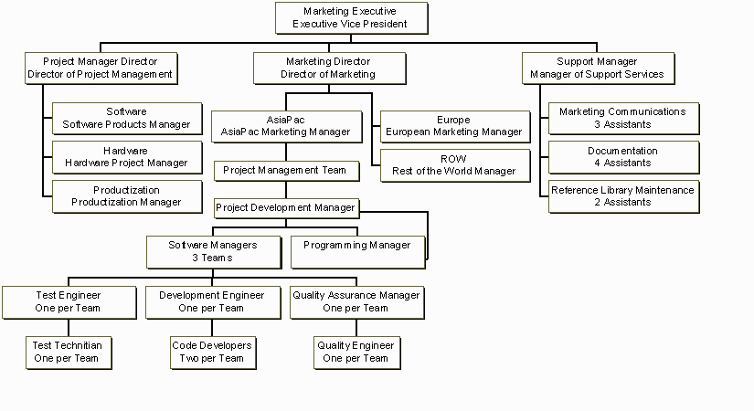
RE team
5 SOFTWARE ENGINEERS
Co-PM or Team lead/ GL
UNIVERSITY
Project Manager / Faculty/ Reviewer
Project Management Teams Section-Wise

SDLC Process Model:

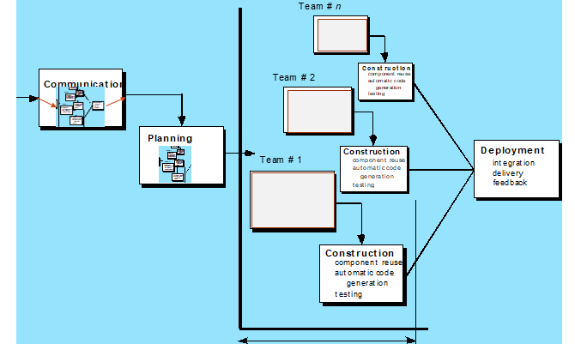
5
Communication & Modeling

5. Activity List (Work Breakdown Structure)

Provide an activity list (work breakdown structure) that describes each task required by the project, with a reference to the statement of work. For large projects, work packages might be included that describe in detail how specific tasks will be completed by specific project teams. These work packages describe required schedule, identify requirements to be completed and describe specific work to be performed
- First Estimating FP then from it E and S

Software Size Estimation using Function Point Method
- Detail of 5 Transaction Types, at most 5 under each category
 | Write down exact Screen or Forms names, or Tables, or Reports name for each count value.
EI | 1. user 2. Car Management 3. Sales Car 4 Purchasing Status 5. Vendors Details
EO | 1. Admin 2. Car Management 3. Sales Car 4 Purchasing Status 5. Vendors Details
EQ | 1. Managers 2. Car Management 3. Sales Car 4 Purchasing Status 5. Booking
ILF | 1. Vendors 2. New Cars 3. Sales Car 4 Purchasing Status 5. Availability
ELF | 1. 9 2. 1 3. 1 4. 0 5. _____0_____

- Unadjusted Function Point Value calculation
Definition of Complexities: Your Transactions which are derived from only from 1 Table are to be categorized as Low and if they are derive from 2 tables they can be categorized in Mid-level complexity, and in case of >= 3 they will be placed under High level of complexity.

 | Count for screens of Low level complexity (C) | Multiplier  Low level complexity (M) | V1 = C * M | Count for screens of Mid-level complexity (C) | Multiplier  Mid-level complexity (M) | V2 = C * M | Count for screens of High-level complexity (C) | Multiplier  High-level complexity (M) | V3 = C * M | Category wise sum  V1+V2+V3
EI | 1 | 3 | 3 | 1 | 4 | 4 | 0 | 6 | 0 | 7
EO | 1 | 4 | 4 | 0 | 5 | 0 | 1 | 7 | 7 | 11
EQ | 1 | 3 | 3 | 0 | 7 | 0 | 0 | 6 | 6 | 3
ILF | 1 | 7 | 7 | 1 | 0 | 0 | 0 | 15 | 0 | 7
ELF | 1 | 5 | 5 | 0 | 7 | 0 | 1 | 10 | 10 | 15
Unadjusted Function Point Value = |  |  |  |  |  |  |  |  |  | 43

C) Value Adjustment Factor (VAF) calculation
Note: Calculate Value Adjustment Factor, where any 5 "General System Characteristics (GSC) must have a value above 2. Also show respect Quality Characteristic mapping of these 5 factors.
 | Quality Characteristic | Weight  (0-5) |  | Quality Characteristic | Weight  (0-5)
 |  | 5 |  |  | 3
 |  | 2 |  |  | 0
 |  | 0 |  |  | 4
 |  | 4 |  |  | 1
 |  | 1 |  |  | 1
 |  | 0 |  |  | 2
 |  | 1 |  |  | 0
Value Adjustment Factor (VAF) = 24

D) Technology Complexity Factor calculation

TCF = 0.65 + (VAF * 0.01)
= 0.65 +(24*0.01)
= 0.89

E) Adjusted Function Point Value (AFPV) or Function Point Value (FP) Calculation

AFPV = _ Unadjusted Function Point * TCF
= 43 * 0.89
= 38.27

F) Conversion of AFPV in to LOC Size metric

the number of LOCs per FP for C# language 54 and check other languages from https://www.qsm.com/resources/function-point-languages-table, ASP 51 and VB.net 52, python 48

Project Size in LOC = AFPV * LOC/FP
Project Size in LOC = 38.27 * 51 = 1951.77 LOC
G) Software Size: 1951.77
Software Size for COCOMO: 1.95177 KLOC
Software Type: Business/ Utility/Embedded
Model Mode: Cocomo I – Basic – ORGANIC (0 – 50 KLOC) / Semi detached/ Embedded
- Effort Estimation: Equation
2.4 * 1.95177 ^ 1.05 = E = 4.8 = 5 persons month
- Schedule Estimation: Equation
2.5 * E ^ 0.38 months = S = 3 months
- Productivity Estimation: Equation
Loc/E = 390.354
- Average Loading Estimation: Equation
E/S = 1.2
- Average Salary of Technical Staff (AS): Equation
Assume = 50,000 RS
- Cost for Salary (Cs): Equation
E * Avg salary = 250000
- Budgeted Cost of Project (Cb): Equation
Cs + Cs * X% = 275000
- Calculate the phase-wise percentage distribution wise E and S values as given in detailed COCOMO detailed model.
H) Distribution of Effort and Schedule among Different phases of SDLC
E = ____5___________________________
S = _____4__________________________
Plan and Requirement (E | S) |  | Modeling / System Design & Detailed Design (E | S) |  |  | Module Coding and Unit Testing (E | S) |  |  |  | Integration & Deployment (E | S)
0.06 * 5= 0.3 | 0.10 * 4 = 0.4 |  | (0.16+0.26) * 5 = 2.1 | (0.19+0.24) 4=1.72 |  | 0.42 * 5 = 2.1 | 0.39 * 4 = 1.56 | 0.16 * 5 = 0.8 |  | 0.18 * 4=0.72

- Now adding percentage distribution as given in detailed COCOMO model in the WBS phase-wise. <Write exact E/S values after multiplying with distribution percentages>
1.
HRPRL Development
100% Effort
100% Schedule

1.3
Elaboration/Modeling/ System Analysis and Design
0.42% E = 2.1
0.43% S = 1.72

1.3.1
System Architecture Design

1.3.2
Software Requirement Analysis

1.3.3
Design patterns and Algorithms and Component Design

1.3.4
Software Detail Design (SDD) – (Already DONE with SRS in OOAD)

1.4
Construction/Coding and Testing
0.43% E = 2.15
0.39% S = 1.56

1.4.1
Develop Software Components and code

1.4.2
Unit Test Components

1.4.3
Integrate Components /Module

1.4.4
Test Software Modules (Test Report)

1.2
Project Planning
0.03% E = 0.05
0.05% S = 0.2

1.2.1
Initiate Plan

1.2.2
Develop Plan

1.2.3
Monitor progress and Update Plan (PMP)

1.5
Integration and Deployment
0.16% E = 0.8
0.18% S = 0.72

1.5.1
Integrate System

1.5.2
Test System

1.5.3
Delivery and Installation

1.5.4
Accept Installed System
(Final Project Report & Demo)
1.1
Inception/ RE
0.03% E = 0.15
0.05% S = 0.2

1.1.1
Initial Feasibility

1.1.2
Cost Benefit Analysis

1.1.3
System requirement Analysis SRS

M1
1.1.3.1
0.03 E

M5
1.1.3.5

0.03 E

M1
1.4.4.1
0.43 E
0.48 S

M5
1.4.4.5
0.43 E
0.48 S
M1
1.2.3.1
0.03 E

M5
1.2.3.5

0.03 E

M1
1.3.4.1
0.42 E
0.344 S

M5
1.3.4.5
0.42 E
0.344 S

By Team Lead
0.8 E
0.72 S

Now convert above WBS contents in a Tabular format in order to make a GANTT CHART.
22 days are taken from COCOMO detailed model’s Schedule Distribution done in Class for Project Planning and Requirement Engineering Phase. Where 40% of 22 goes in RE and 60% in Planning.

Activity # | Activity Name | Activity Name Description | # of Days | Start Date | Dependency on previous tasks | Milestone
1.1 | RE | Requirement Engineering | 8-9 | 23/11/2021 | none | 30/11/2021
1.1.1 | Initial Feasibility |  | 1
1.1.2 | Cost Benefit Analysis |  | 2
1.1.3 | System requirement Analysis SRS |  | 3
1.1.3.1 | System requirement Analysis SRS for Module 1 |  | 3
1.1.3.2 | System requirement Analysis SRS for Module 2 |  | 3
1.1.3.3 | System requirement Analysis SRS for Module 3 |  | 3
1.1.3.4 | System requirement Analysis SRS for Module 4 |  | 3
1.1.3.5 | System requirement Analysis SRS for Module 5 |  | 3
1.1.3.6 | Merging of all parallel Modules 1,2,3,4,5 |  | 1-2
1.1.4 | Milestone (SRS) and Review meeting |  | 0
1.2 | Project Planning | Project Management Planning | 14 Days | 11/12/2021 | 1.1 | 18/12/2021
1.2.1 | Initial Feasibility |  | 1
1.2.2 | Project Management Plan PMP |  | 8
1.2.2.1 | Project Management Plan PMP for Module 1 |  | 8
1.2.2.2 | Project Management Plan PMP for Module 2 |  | 8
1.2.2.3 | Project Management Plan PMP for Module 3 |  | 8
1.2.2.4 | Project Management Plan PMP for Module 4 |  | 8
1.2.2.5 | Project Management Plan PMP for Module 5 |  | 8
1.2.2.6 | Meeting Review |  | 1
1.3 | Modeling | Done in SRS now ERD with Implementation |  | 18/12/202 | 1.1 | 25/12/2021
1.3.1 | Initial Feasibility |  | 1
1.3.2 | Project Design Document SDD |  | 11
1.3.2.1 | Project Design Document SDD for Module 1 |  | 11
1.3.2.2 | Project Design Document SDD for Module 2 |  | 11
1.3.2.3 | Project Design Document SDD for Module 3 |  | 11
1.3.2.4 | Project Design Document SDD or Module 4 |  | 11
1.3.2.5 | Project Design Document SDD for Module 5 |  | 11
1.3.2.6 | Merging of all parallel Modules 1,2,3,4,5 |  | 2
1.3.4 | Milestone (SDD) and Review meeting |  | 0
1.4 | Implementation and Testing | Database and Code, Test Report |  | 18/05/2022 | 1.1 | 25/12/2021
1.4.1 | Initial Feasibility |  | 1
1.4.2 | Project Testing Report PTR |  | 15
1.4.2.1 | Project Testing Report PTR for Module 1 |  | 15
1.4.2.2 | Project Testing Report PTR for Module 2 |  | 15
1.4.2.3 | Project Testing Report PTR for Module 3 |  | 15
1.4.2.4 | Project Testing Report PTR for Module 4 |  | 15
1.4.2.5 | Project Testing Report PTR for Module 5 |  | 15
1.4.2.6 | Merging of all parallel Modules 1,2,3,4,5 |  | 2
1.4.4 | Milestone (PTR) and Review meeting |  | 0
1.4.1 | Initial Feasibility |  | 2
1.5 | Deployment/Demo | Demo and Report |  | 25/1/2022 | 1.1 | 1/1/2022
1.5.1 | Initial Feasibility |  | 1
1.5.2 | Project Release Document PRM |  | 23
1.5.2.1 | Project Release Document PRM for Module 1 |  | 23
1.5.2.2 | Project Release Document PRM for Module 2 |  | 23
1.5.2.3 | Project Release Document PRM for Module 3 |  | 23
1.5.2.4 | Project Release Document PRM for Module 4 |  | 23
1.5.2.5 | Project Release Document PRM for Module 5 |  | 23
1.5.2.6 | Merging of all parallel Modules 1,2,3,4,5 |  | 2
1.5.4 | Milestone (PRM) and Review meeting |  | 0
6. Work Product Identification
Provide a list of all deliverables required by the project, the date due and the person responsible for the deliverable. Pick Last activities from each phase they are deliverables.

Deliverable Name | Due Date | Date Delivered | Point of Contact
SRS by Sameed | 13/3/2022 | 19/3/2022 | 10121
SRS by Saad | 13/3/2022 | 19/3/2022 | 10182
SRS by Hafiz | 13/3/2022 | 19/3/2022 | 61505
PMP by Sameed | 20/4/2022 | 22/4/2022 | 10121
PMP by Saad | 20/4/2022 | 22/4/2022 | 10182
PMP by Hafiz | 20/4/2022 | 22/4/2022 | 61505
Design (DB+GUI) by Sameed | 26/4/2022 | 9/5/2022 | 10121
Design (DB+GUI) by Saad | 26/4/2022 | 9/5/2022 | 10182
Design (DB+GUI) by HafizHibar | 26/4/2022 | 9/5/2022 | 61505

7. SCHEDULE
Provide the project schedule, using a Gantt chart. The schedule must include milestones, task dependencies (predecessors), task duration, work product delivery dates, quality milestones (reviews/audits/inspections), configuration management milestones, and action items (with deadlines and responsibilities). (in order to keep the project (T | C |S) in CONTROLL.
<MUST IMPLEMENT GANTT CHART ON ANY SOFTWARE OR WEBAPPLICATION>
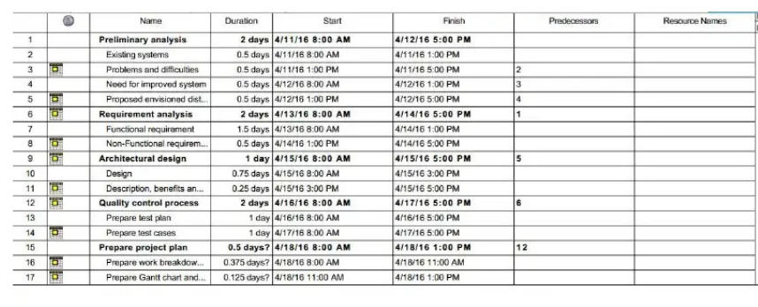

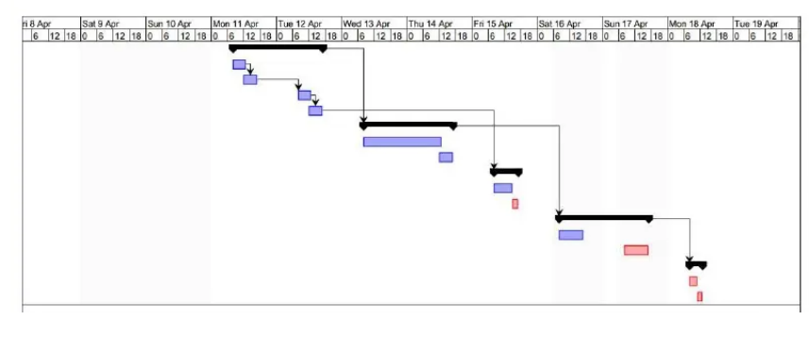
8. Estimated Cost at Completion
Provide an estimated cost at completion, which is an assessment of the total effort at completion of the contract.

Analysis in Hours / Cost
WBS No. | Activity Description | Budget Hours  B | Actual Hours  A | Est. to Complete the remaining work – milestone-wise  ETC  B - A  EAC – A | Est. @ Completion  EAC  A + ETC | Variance (+ = More)  V = (A-B/A)
1st milestone |  | 8 working days  60 | 40 | 60 – 40 = 20 | 40 + 20 = 60 | (-1 -- 0 -- +1)  ( 40 - 60)/ 40 = - 0.5  Under the budget 20V  60-60 / 60 = 0/60 = 0  100% completion 0V  (70 – 60)/70 = + .14  Ahead of budget 20V
2nd milestone |  | 8 working days  8 x 7.5 = 60 hours | 50 | 60 – 50 = 10 | 50 + 10 = 60 | ( 50-60)/ 50 = -0.2  Under the budget 20V
3rd  ^{milestone} |  | 12 working days  12 x 7.5 = 90 hours | 115 | 153 – 115 = 20 | 115 + 20 = 135 | (115 – 135)/115 =  -0.17  Under the budget 17V
9. Resource Loading Profiles - Staffing
Provide a staffing plan that shows the number of personnel, by type, that will be required on the project on a monthly basis.

Resource Loading Profiles
E = 5
S = 4

Avg Loading = 2 person per month

Since loading gives same value of effort for all months, therefore, we have used Detailed COCOMO’s Effort distribution as already done in part 5.2

Plan and Requirement |  | Modeling / System Design & Detailed Design |  | Module Coding and Unit Testing |  | Integration & Deployment
0.06 * E = 0.3 | 0.10 * S = 0.4 | (0.16+0.26) * E = 2 | (0.19+0.24) S = 3 | 0.06 * E = 0.3 | 0.10 * S = 0.4 | (0.16+0.26) * E = 2 | 0.18 * S = 1.2
Designation: PM, BA, Domain Expert = 0.3 person |  | BA, Analyst, Domain Expert=2 |  | Coders and Testers 2 |  | Senior Tester, TL 0.8
Job Description: Assisting in building SPMP, SRS and prototype, as well as doing the necessary requirement and risk analysis for the project |  | Job Description: A Domain Expert is an expert in the domain of Spice management. |  | Job Description:  They are involved in performing automated and manual tests to ensure the software created by developers is fit for purpose. Some of the duties include analysis of software, and systems, mitigate risk and prevent software issues. |  | Job Description:  Senior Tester will be responsible for quality process in a project. Tasks will include test case design, test planning, testing of systems developed by the company, test automation and reporting of test results.
Contact information: email:sameed1999.ahmed  @gmail.com mobile: 03330281272 |  | Contact information:  Email:muhammadsaad  9531@gmail.com  Mobile : 03442883644 |  | Contact information: email:hafizhibar786@gmail.com  Mobile: 03462383007

11. Risk Identification
Provide a description of all risks identified for the project. A risk is anything that might detrimentally affect the successful completion of the project if left unaddressed. The contractual, management, and technical risks associated should be identified and assessed as to the probability of the risk occurring, the cost to correct if the risk occurs, the impact of the risk on the project, and the suggested mitigation activities and cost of mitigation.

Risk Worksheet

Risk Management Steps:

1 | Identify the project’s top10 risk items
2 | Present a plan for resolving each risk item
3 | Update list of top risk items, plan, and results monthly
4 | Highlight risk-item status in monthly project reviews.  Compare with previous month’s ranking status
5 | Initiate appropriate corrective actions

Top 10 Risk Items
Risk Items | Risk Management Techniques
Personnel Shortfalls | Staffing with top talent, job matching; team building; morale building; cross training; pre-scheduling key people
Unrealistic schedules and budgets | Detailed, multi-source cost and schedule estimation; design to cost; incremental development; software reuse; requirement scrubbing
Developing the wrong software functions | Organizational analysis; mission analysis; ops-concept formulation; user surveys; prototyping; early users' manuals
Developing the wrong user interface | Task analysis; prototyping; scenarios; user characterization (functionality, style, workload)
Gold Plating | Requirement scrubbing; prototyping; cost-benefit analysis; design to cost
Continuing stream of requirement changes | High change threshold; information hiding; incremental development (defer changes to later increments)
Shortfalls in externally furnished components | Benchmarking; inspections; reference checking; compatibility analysis
Shortfalls in externally performed tasks | Reference checking; pre-award audits; award-fee contracts; competitive design or prototyping team building
Real-time performance shortfalls | Simulation; benchmarking; modeling; prototyping; instrumentation; tuning
Straining computer-science capabilities | Technical analysis; cost-benefit analysis; prototyping; reference checking

 | Potential Risk | Risk Monitoring  Preventive measures | Risk Management and mitigation | Risk Exposure  = Probability of Risk Occurrence * Cost of Risk | Prioritize  Till next Review
 | Size of the software being very large and larger number of users than planned due to using eval SDLC and no confirmation of Requirements in RE phase.  (Fp→Loc→Effort) | Reviewing constant feedbacks from the customers in project meetings | Being flexible in the software design to accommodate the necessary changes | Cost * Probability of Risk Occurrence  = Salary for 2 programmer for 1 month * 0.8  = 60000 *0.8 | 0.4  =48000 | 24000
 | The software not being accepted by the CRM | Response from the CRM, reviewed on every project meeting | Early and intensive interaction with the customer for the success of project. | Cost * Probability of Risk Occurrence  = Salary for 1 project manager for 1 month * 0.3  = 60,000 *0.3 = 18000
 | Cost factor involved in this project | Reviewing reports on expenditure and other cost related to the estimated cost in the SPMP | Have additional funding allocated for it in advance and using it in case of emergencies. | Cost * Probability of Risk Occurrence  = Salary for financial officer for 1 month * 0.5  = 50,000 *0.5=25,000
 | Customer requirements may change | CRM participation in design process and reviewing feedback information in group meetings | A new prototype will replace the previous one to accommodate the change | Cost * Probability of Risk Occurrence  = Salary for Project manager for 1 month * 0.4  = 60,000 *0.4  =24,000
 | Technology will not meet expectation | Constantly reviewing project progress reports by Project Development Manager and software managers | Exploring alternatives for the outdated technologies | Cost * Probability of Risk Occurrence  = Salary for technologist for 1 month * 0.7  = 50,000 *0.7  =35,000
 | Lack of training on tools and staff being inexperienced | Reviewing progress report by software managers to determine the status of the project | Providing adequate training that is necessary for the completion of the project | Cost * Probability of Risk Occurrence  = Salary for job hirer for 1 month * 0.6  = 50,000 *0.6  =30,000
 | The prototype not being delivered on time | Constant reviews among team members to ensure continuous progress on the prototype | Setting deadline before the actual time for submission of the project | Cost * Probability of Risk Occurrence  = Salary for project manager for 1 month * 0.2  = 60,000 *0.2 =12,000

12. Configuration Management Plan
Provide a configuration management plan that defines the person responsible for project configuration management, the procedures that will be used, the planned configuration items, planned release dates for configuration items, and resources required to conduct CM.

CCB members: Sameed Ahmed
Resources: Quality Assurance Software

Configuration Items: Ensure that CM is implemented throughout the project’s life cycle.
No. | Item | Comments
1. | SRS | Updated after New Requirements
2. | PMP | PMP According To Additional Requirements
3. | MODELING | PMP Due To The Change In Team

Ensure that project has a repository for storing configuration items and associated CM records. Briefly describe.
https://github.com/sameed0909/RENTAL-CAR-SYSTEM
13. Quality Plan
Provide a quality plan that defines the person responsible for project quality assurance, the procedures that will be used and resources required to conduct quality assurance.

QA Manager and Staff: Saad Haleem & Hafiz Hibar
Procedures: Identification, control, audit, and status accounting will be done.
Resources: Quality Assurance Software

Planned Quality Event: Ensure that QA is implemented throughout the project’s life cycle. Dates include QA audits and reviews, design walkthroughs and other project activities that QA staff will participate in.
No. | Item | Comments
1. | SRS | Reviewed SRS For Quality Checking
2. | PMP | Reviewed PMP For Quality Checking
3. | PTR | Reviewed PTR After Testing of Project

Ensure that project has a repository for storing configuration items and associated QA records.
Ensure that QA audits the baselines and CM activities on a regular basis.

