[cloud-computing-characteristics](https://www.cloudwards.net/cloud-computing-characteristics/)

[Network Security Devices & tools](https://networkinterview.com/types-of-network-security-devices-tools/)

**Relationship Between Attributes and Cloud or Data Center**

In-House IT Professionals: Data Center

[Data centers typically require in-house IT professionals to manage and maintain the infrastructure4](https://talentbattle.in/company-specific-previous-year-questions/accenture-network-security-cloud-computing-previous-year-questions" \t "https://edgeservices.bing.com/edgesvc/_blank).

Co-Location Makes Failure Dependent: Cloud

This is incorrect. [Co-location refers to hosting your servers in a third-party data center, which does not inherently make failures dependent on the cloud4](https://talentbattle.in/company-specific-previous-year-questions/accenture-network-security-cloud-computing-previous-year-questions" \t "https://edgeservices.bing.com/edgesvc/_blank).

Instant Scalable: Data Center

This is incorrect. [Data centers are not typically instantly scalable; scaling usually involves significant time and resources4](https://talentbattle.in/company-specific-previous-year-questions/accenture-network-security-cloud-computing-previous-year-questions" \t "https://edgeservices.bing.com/edgesvc/_blank).

Pay as per Use: Cloud

[Cloud services often operate on a pay-as-you-go model, allowing businesses to pay only for the resources they use](https://www.cloudwards.net/cloud-computing-characteristics/" \t "https://edgeservices.bing.com/edgesvc/_blank)[4](https://talentbattle.in/company-specific-previous-year-questions/accenture-network-security-cloud-computing-previous-year-questions" \t "https://edgeservices.bing.com/edgesvc/_blank).

On-Premises: Data Center

[Data centers are often on-premises, meaning they are physically located within the business’s facilities4](https://talentbattle.in/company-specific-previous-year-questions/accenture-network-security-cloud-computing-previous-year-questions" \t "https://edgeservices.bing.com/edgesvc/_blank).

Remote Hardware: Cloud

[Cloud services provide remote hardware resources, which are accessed over the internet4](https://talentbattle.in/company-specific-previous-year-questions/accenture-network-security-cloud-computing-previous-year-questions" \t "https://edgeservices.bing.com/edgesvc/_blank).

Business Pays per Use: Data Center

This is incorrect. [Traditional data centers usually involve upfront costs and ongoing maintenance expenses, rather than a pay-per-use model](https://talentbattle.in/company-specific-previous-year-questions/accenture-network-security-cloud-computing-previous-year-questions" \t "https://edgeservices.bing.com/edgesvc/_blank)

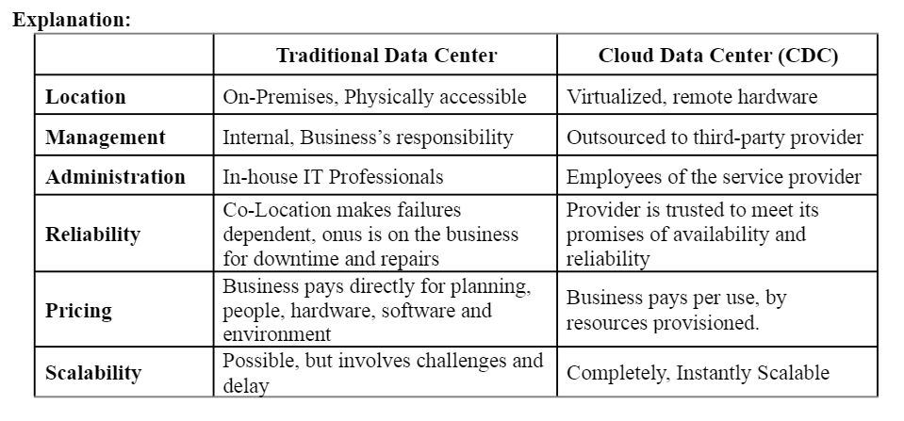

[Cloud Service Providers Comparison](https://www.datamation.com/cloud/cloud-service-providers/)

Data Encryption Standard (DES)

DES is a symmetric-key algorithm for the encryption of digital data. It uses a 56-bit key and operates on 64-bit blocks of data. [DES is not typically associated with the use of IVs in the same way as stream ciphers like RC41](https://www.cs.fsu.edu/~duan/classes/cnt5412/lectures/lecture6_stream_cipher.pdf" \t "https://edgeservices.bing.com/edgesvc/_blank).

Rivest Cipher 5 (RC5)

RC5 is a symmetric-key block cipher notable for its simplicity and flexibility. It uses variable-length keys and operates on variable-length blocks of data. [RC5 does not use the specific combination of a 40-bit key and a 24-bit IV1](https://www.cs.fsu.edu/~duan/classes/cnt5412/lectures/lecture6_stream_cipher.pdf" \t "https://edgeservices.bing.com/edgesvc/_blank).

Advanced Encryption Standard (AES)

AES is a symmetric-key algorithm that uses key sizes of 128, 192, or 256 bits and operates on 128-bit blocks of data. [Like DES, AES is a block cipher and does not use the specific combination of a 40-bit key and a 24-bit IV1](https://www.cs.fsu.edu/~duan/classes/cnt5412/lectures/lecture6_stream_cipher.pdf" \t "https://edgeservices.bing.com/edgesvc/_blank).

Rivest Cipher 4 (RC4)

RC4 is a stream cipher designed by Ron Rivest. It uses a variable-length key (from 1 to 256 bytes) and is known for its simplicity and speed. [In the context of WEP (Wired Equivalent Privacy), RC4 uses a 40-bit key concatenated with a 24-bit IV to generate the keystream](https://people.csail.mit.edu/alinush/cse508-spring-2011/02-03-hacking-wep.pdf" \t "https://edgeservices.bing.com/edgesvc/_blank)

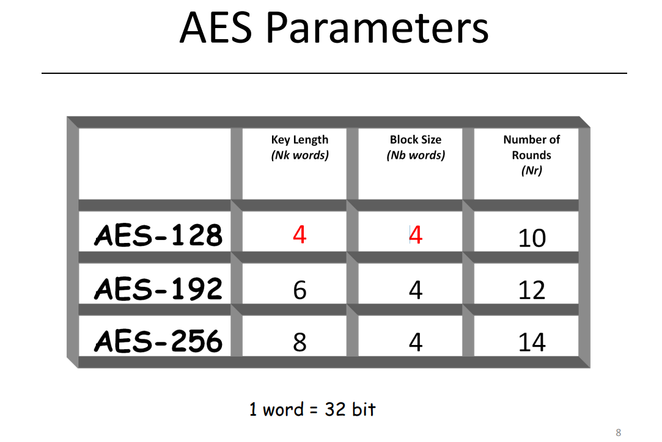

[differnet cyber attacks](https://www.crowdstrike.com/cybersecurity-101/cyberattacks/most-common-types-of-cyberattacks/)

[ACL - video](https://www.youtube.com/watch?v=6gq16PfwRyU)