In p2b, I first ran the following code snippet to have each of the labels be next to their respective review. In this code, it goes through each of the files and reads it in. In each file, if there are incomplete labels for a review, it will add “No violation” to the other columns. After doing this, it will go through the file’s columns and rename them to be the filename + The Violation. If this is the first file in the isMerged dataset, it will set the isMerged dataframe to the file. If the isMerged dataFrame already has data in it, it will merge the new file into isMerged based on the ‘title’ and ‘review’ columns.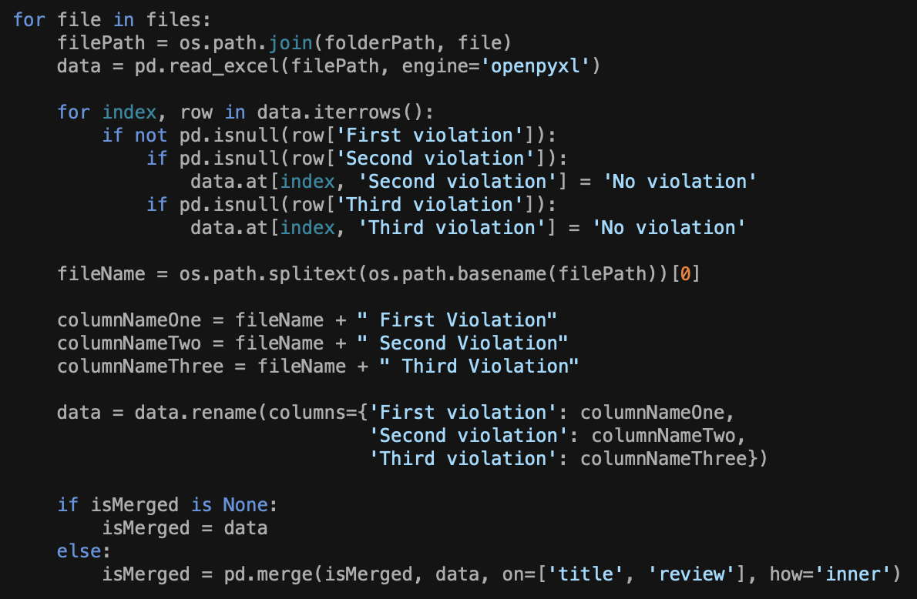

After making the initial excel sheet, I go through each review from the review column and map each category to a number. Afterwards, it loops through three consecutive labels for a file for a review and compares it to the next three consecutive labels for a file to find cohen kappa scores. As long as the cohen kappa for two files on a review is not null, it will add the score to its file’s fileKappaScores array and keep count of how many kappascores have been added for a file. After it goes through each review and every label, it will calculate the average kappa score for each file and remove the top five files with the lowest kappa scores.

Afterwards, the program will make a word cloud for each of the prominent categories that are in the final excel file. Each word cloud shows the top words used in each of the prominent categories.

Part 2: Argumentation

1. 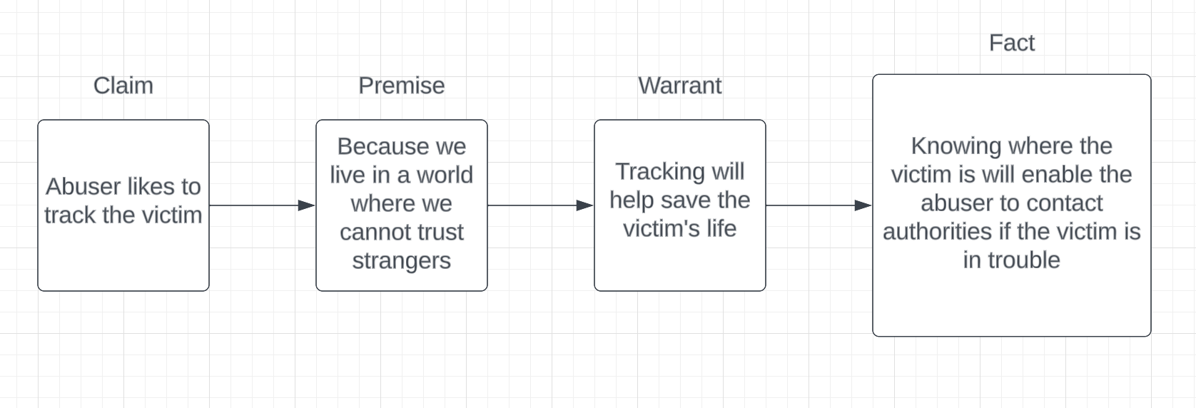

In the perspective of the abuser, the abuser wants to track the victim because they believe that the world is a dangerous place where we cannot trust strangers. Because of this, tracking will help the save the victim’s life if anything was to happen to the victim because the abuser will be monitoring them. Because the abuser is monitoring the victim, the abuser will be acble to contact authorities if the victim is in trouble. The reviews in columns 386, 437, 440, 443, 482, 547, 644, 829, 853, 921, 938, 1009, 1036, 1080, 1109, 1114, 1159, 1163, 1191, 1246, 1329, and 1425 satisfy this argument. These reviews showcase perspectives from the abuser’s perspective and the victim’s perspective on why the abuser continues to use the app.

1. 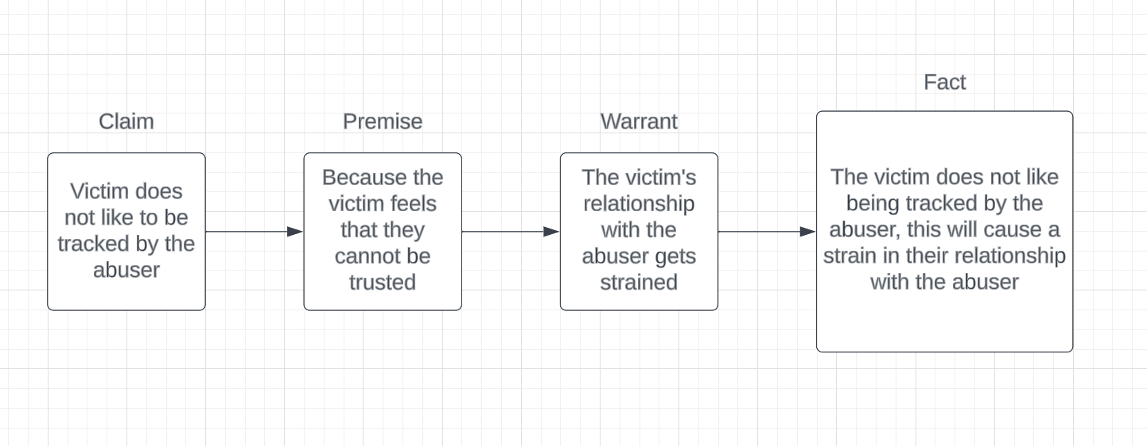In the perspective of the victim, the victim does not like to be tracked by the abuser because they feel that the abuser does not trust them. Because of this, the victim’s relationship with the abuser gets strained. Because the victim does not like being tracked by the abuser, this will cause a strain in their relationship with the abuser. The reviews in columns 997, 1066, 1079, 1120, 1333, 1389, 1433, 1437, 1440, 1450, 1479, 1484, 1485, 1510, 1530, 1557, 1613, 1622, 1626, and 1655 satisfy this argument. These reviews show the perspective of the victim and how they feel towards the abuser.
2. 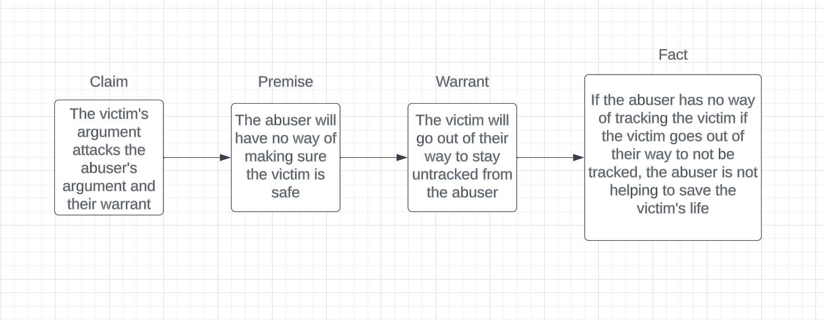

The victim’s argument attacks the abuser’s argument and their warrant. This is because the abuser will have no way of making sure the victim is safe if the victim goes out of their way to stay untracked from the abuser. Because of this, if the abuser has no way of tracking the victim, the abuser is unable to help save the victim’s life in the scenario where the victim is in potential danger.