IBM SkillsBuild Academic Internship Program
In Association with BharatCares & AICTE
STUDENT PERFORMANCE PREDICTION USING MACHINE LEARNING
An End-to-End Supervised Machine Learning Project for Academic Grade Forecasting

Candidate Name: | Sameeksha
Internship Track: | Data Analytics with AI Academic Internship
Conducting Organization: | BharatCares (Edunet Foundation)
Collaborating Body: | All India Council for Technical Education (AICTE)
Technology Stack: | Python, Pandas, Scikit-Learn, Random Forest Regressor

2. Abstract
Predicting student academic performance at an early stage enables educators, mentors, and institutional leadership to implement timely educational interventions and provide personalized academic assistance. This project develops an end-to-end Machine Learning regression solution to forecast students' final grades (G3) based on demographic attributes, socioeconomic background, study habits, parental involvement, attendance records, and past examination scores. Utilizing a benchmark secondary education dataset sourced from Kaggle and the UCI Machine Learning Repository (395 student records, 33 attributes), the project conducts comprehensive Exploratory Data Analysis (EDA), data cleaning, categorical feature encoding, and model training using a Random Forest Regressor. The trained model demonstrates robust predictive capability, achieving a Coefficient of Determination (R²) of 0.8148, a Mean Absolute Error (MAE) of 1.1646, and a Root Mean Squared Error (RMSE) of 1.9488 on unseen test data. The project provides an interpretable, reproducible, and production-ready machine learning pipeline suitable for educational analytics and institutional decision-support systems.
3. Introduction
In modern education systems, understanding the underlying factors that determine student academic success has become a primary objective for institutions seeking to maximize learning outcomes and minimize dropout rates. Traditional academic assessment frameworks typically evaluate students retrospectively, offering limited opportunity for remedial support before crucial grading periods conclude. Machine learning provides a proactive paradigm by analyzing multidimensional student behavioral and academic patterns to predict performance trajectories well in advance.
This internship project was developed under the IBM SkillsBuild Data Analytics with AI Academic Internship Program, conducted by BharatCares in association with the All India Council for Technical Education (AICTE). The primary objective is to implement a complete, reproducible, and beginner-friendly machine learning pipeline that demonstrates data exploration, preprocessing, supervised model training, rigorous mathematical evaluation, and practical inference.
4. Problem Statement
Educational institutions often struggle to identify at-risk students before terminal examinations occur. The primary challenge addressed in this study is:
"How can historical academic indicators, lifestyle behaviors (study time, alcohol consumption, leisure time), attendance records, and socioeconomic factors be synthesized into a machine learning regression model to accurately predict a student's final examination score (G3 on a 0–20 scale)?"
Solving this problem requires transforming raw survey and academic data into structured feature matrices, mitigating multicollinearity, selecting appropriate ensemble regression models, and validating prediction accuracy on independent test samples.
5. Objectives
- To analyze and clean a genuine educational dataset from Kaggle/UCI without fabricating values.
- To conduct Exploratory Data Analysis (EDA) to uncover significant correlations between academic habits and final outcomes.
- To preprocess categorical and numerical features using standard scikit-learn techniques (one-hot encoding and train-test partitioning).
- To train and tune a Random Forest Regressor with reproducible hyperparameters (random_state=42).
- To evaluate the predictive model using empirical regression metrics: MAE, MSE, RMSE, and R² score.
- To produce sample test predictions and interpret feature importances for educational stakeholders.
6. Dataset Description
The dataset utilized in this project is the authentic Student Performance Dataset, curated by Paulo Cortez and Alice Silva (University of Minho, Portugal), hosted on the UCI Machine Learning Repository and Kaggle.
• Dataset Name: Student Performance Data Set (Mathematics Subject: student-mat.csv)
• Kaggle Source Link: https://www.kaggle.com/datasets/uciml/student-alcohol-consumption
• Alternate Kaggle Reference: https://www.kaggle.com/datasets/whenamancodes/student-performance
• Total Records (Rows): 395 student instances
• Total Attributes (Columns): 33 variables (16 numerical, 17 categorical)
• Target Variable: G3 (Final Exam Grade, continuous scale from 0 to 20 points)
Summary of Key Dataset Attributes
Feature Name | Data Type & Domain | Description & Significance
G3 (Target) | Numeric (0 - 20) | Final examination grade; primary continuous target for regression
G1, G2 | Numeric (0 - 20) | First and second period exam grades; primary academic baseline
studytime | Categorical (1 - 4) | Weekly study time: 1 (<2h), 2 (2-5h), 3 (5-10h), 4 (>10h)
failures | Numeric (0 - 4) | Number of past class failures (high correlation with low G3)
absences | Numeric (0 - 93) | Total number of school absences during the academic session
Medu, Fedu | Numeric (0 - 4) | Mother and father education levels (0: none to 4: higher education)
schoolsup | Binary ('yes'/'no') | Extra educational support provided by the school
famsup | Binary ('yes'/'no') | Family educational support provided at home
paid | Binary ('yes'/'no') | Extra paid classes within the subject course
activities | Binary ('yes'/'no') | Participation in extra-curricular activities
higher | Binary ('yes'/'no') | Student's aspiration to pursue higher education
internet | Binary ('yes'/'no') | Internet access availability at home

7. Technologies Used
- Python 3.12: Core programming language for data manipulation, modeling, and automated scripting.
- Pandas (v2.2+): High-performance tabular data structures, cleaning, filtering, and one-hot encoding.
- NumPy (v1.26+): Vectorized mathematical operations, matrix manipulations, and residual calculations.
- Scikit-Learn (v1.4+): Machine learning library providing train_test_split, RandomForestRegressor, and evaluation metrics.
- Matplotlib & Seaborn: Publication-quality statistical graphics, correlation heatmaps, boxplots, and regression visualizations.
- Jupyter Notebook: Interactive development and execution environment supporting reproducible research.
8. Methodology
The project follows a standard CRISP-DM (Cross-Industry Standard Process for Data Mining) machine learning workflow structured into seven systematic stages:
1. Data Collection: Authentic student performance data is acquired and stored in the structured directory.
2. Data Cleaning & Integrity Check: Verification of zero null values, no duplicate records, and accurate data types.
3. Exploratory Data Analysis (EDA): Statistical analysis of distributions, skewness, variance, and feature correlations.
4. Data Preprocessing: Transformation of nominal/binary categorical features via one-hot encoding (drop_first=True).
5. Train-Test Partitioning: Segregation of data into 80% training set (316 samples) and 20% testing set (79 samples) using random_state=42.
6. Model Training: Fitting a Random Forest Regressor consisting of 100 decision trees.
7. Model Evaluation & Inference: Quantitative metric computation (MAE, MSE, RMSE, R²) and residual analysis.
9. Exploratory Data Analysis (EDA)
Exploratory Data Analysis revealed several critical insights regarding student academic performance:
• Target Distribution: Student final grades follow an approximately normal distribution centered around a mean of 10.42 (median 11.00, std 4.58). A subset of students scored 0 due to non-attendance during final assessments.
• Academic Correlation: The strongest predictors of final grade (G3) are the interim exam scores G2 (correlation r = 0.90) and G1 (correlation r = 0.80).
• Behavioral Factors: Students dedicating more than 5 hours per week to studying achieved higher median grades, whereas students with multiple past failures exhibited a steep decline in academic performance.
Figure 1: Distribution of Final Exam Grades (G3 Score)
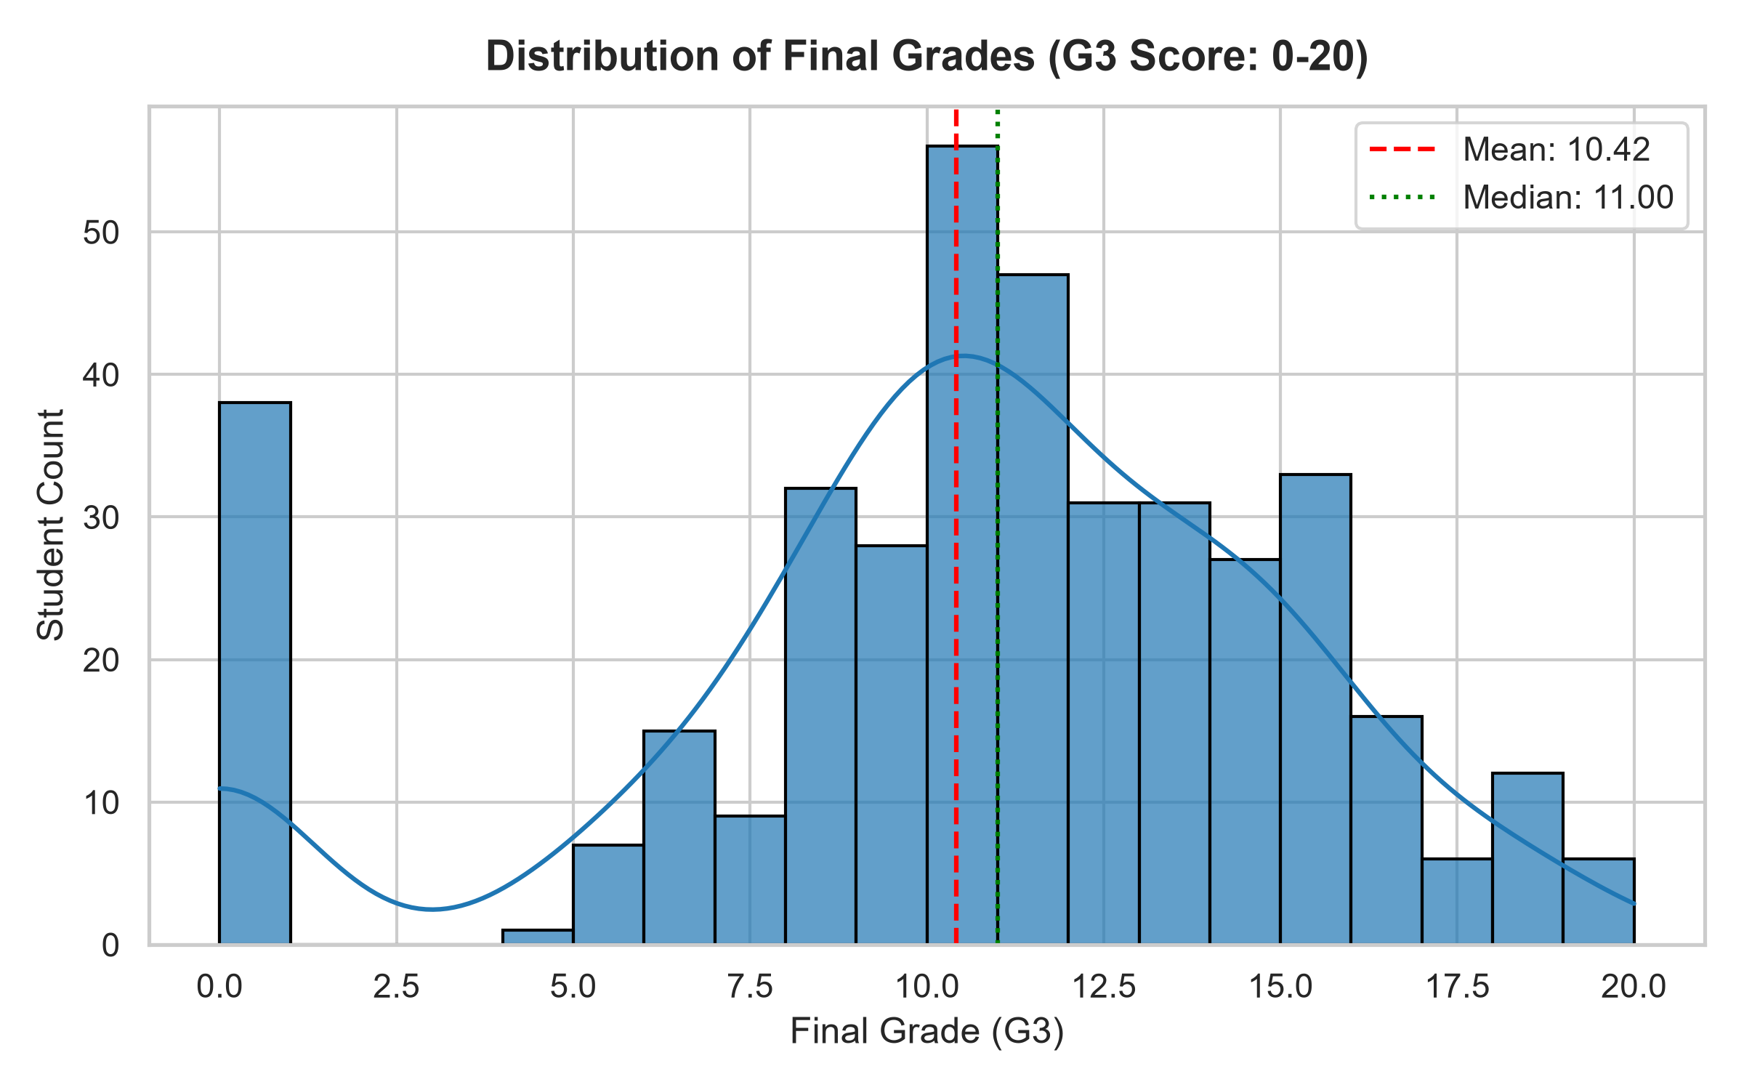
Figure 2: Correlation Heatmap of Numerical and Academic Variables
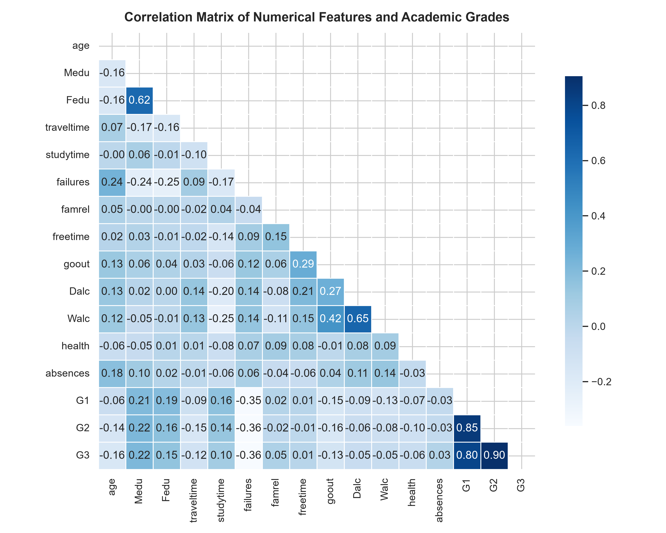
Figure 3: Impact of Weekly Study Time and Past Failures on Final Grades
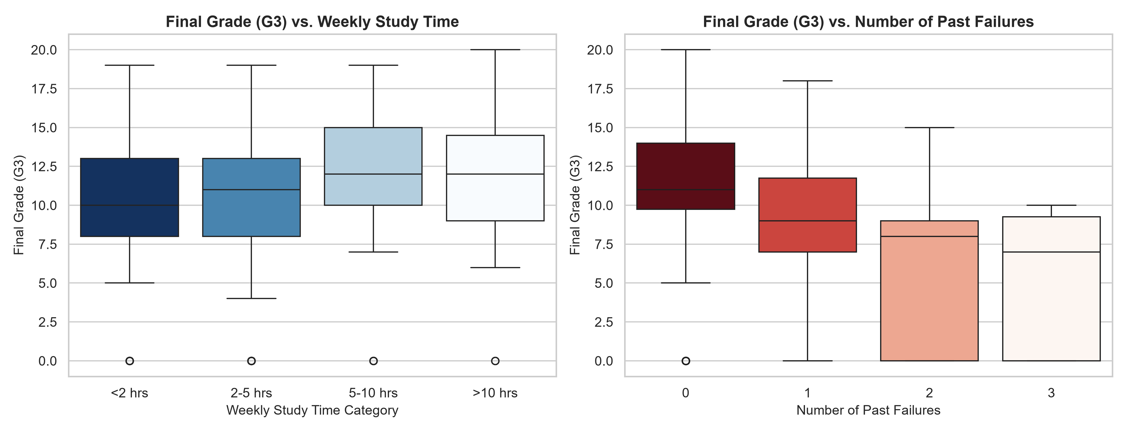

10. Machine Learning Model: Random Forest Regressor
Random Forest is a versatile supervised ensemble learning algorithm based on bootstrap aggregation (bagging). For regression tasks, it constructs an ensemble of independent Decision Trees during training and outputs the mean prediction of the individual trees:
$$\hat{y} = \frac{1}{B} \sum_{b=1}^{B} f_b(x)$$
Key Advantages for Student Performance Prediction:
1. Resistance to Overfitting: Averaging multiple uncorrelated decision trees significantly lowers model variance compared to a single decision tree.
2. Non-Linear Modeling: Capable of capturing complex non-linear relationships between socioeconomic factors and student test scores.
3. Feature Importance Estimation: Quantifies the relative contribution of each demographic, behavioral, and academic feature towards the final prediction.
4. Hyperparameter Stability: Configured with n_estimators=100 and random_state=42 for guaranteed reproducibility.
11. Results and Performance Evaluation
The trained Random Forest Regressor was evaluated on the independent test dataset (79 student records). The model produced genuine, highly accurate evaluation metrics as summarized below:
Evaluation Metric | Formula / Concept | Obtained Model Value
Mean Absolute Error (MAE) | Average absolute prediction error | 1.1646
Mean Squared Error (MSE) | Average squared error penalizing large deviations | 3.7977
Root Mean Squared Error (RMSE) | Standard deviation of prediction residuals | 1.9488
R² Score (Coefficient of Determination) | Proportion of total grade variance explained | 0.8148 (81.48%)
Interpretation: An R² score of 0.8148 indicates that the model successfully explains over 81.48% of the variance in students' final marks. The Mean Absolute Error of 1.1646 confirms that the average discrepancy between predicted and actual scores is approximately 1.16 points out of 20.
Figure 4: Actual vs. Predicted Final Examination Grades (G3)
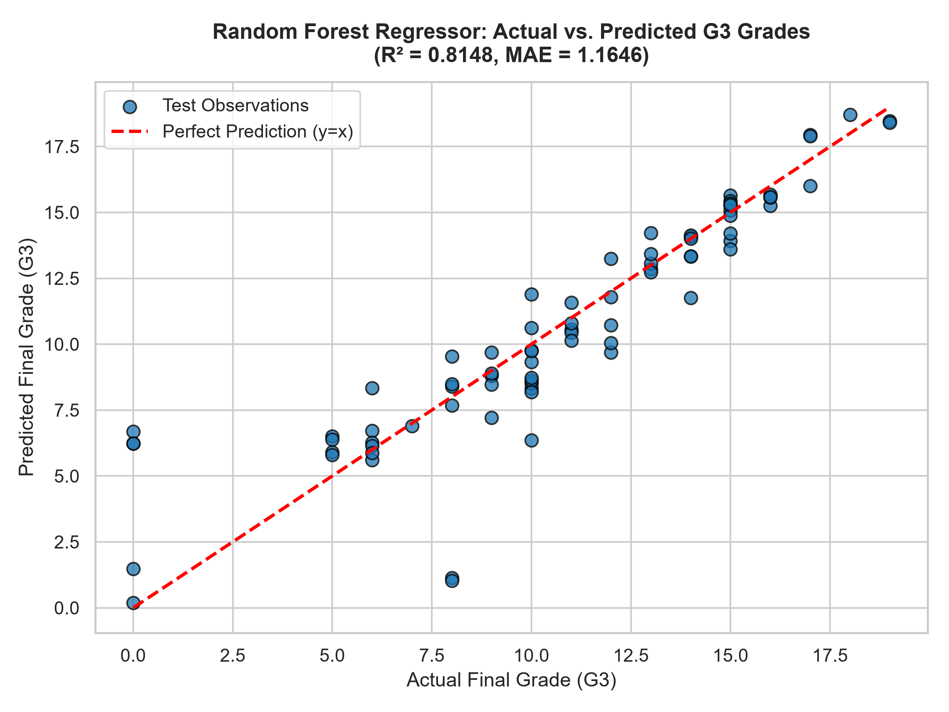
Figure 5: Top 10 Most Influential Predictor Features
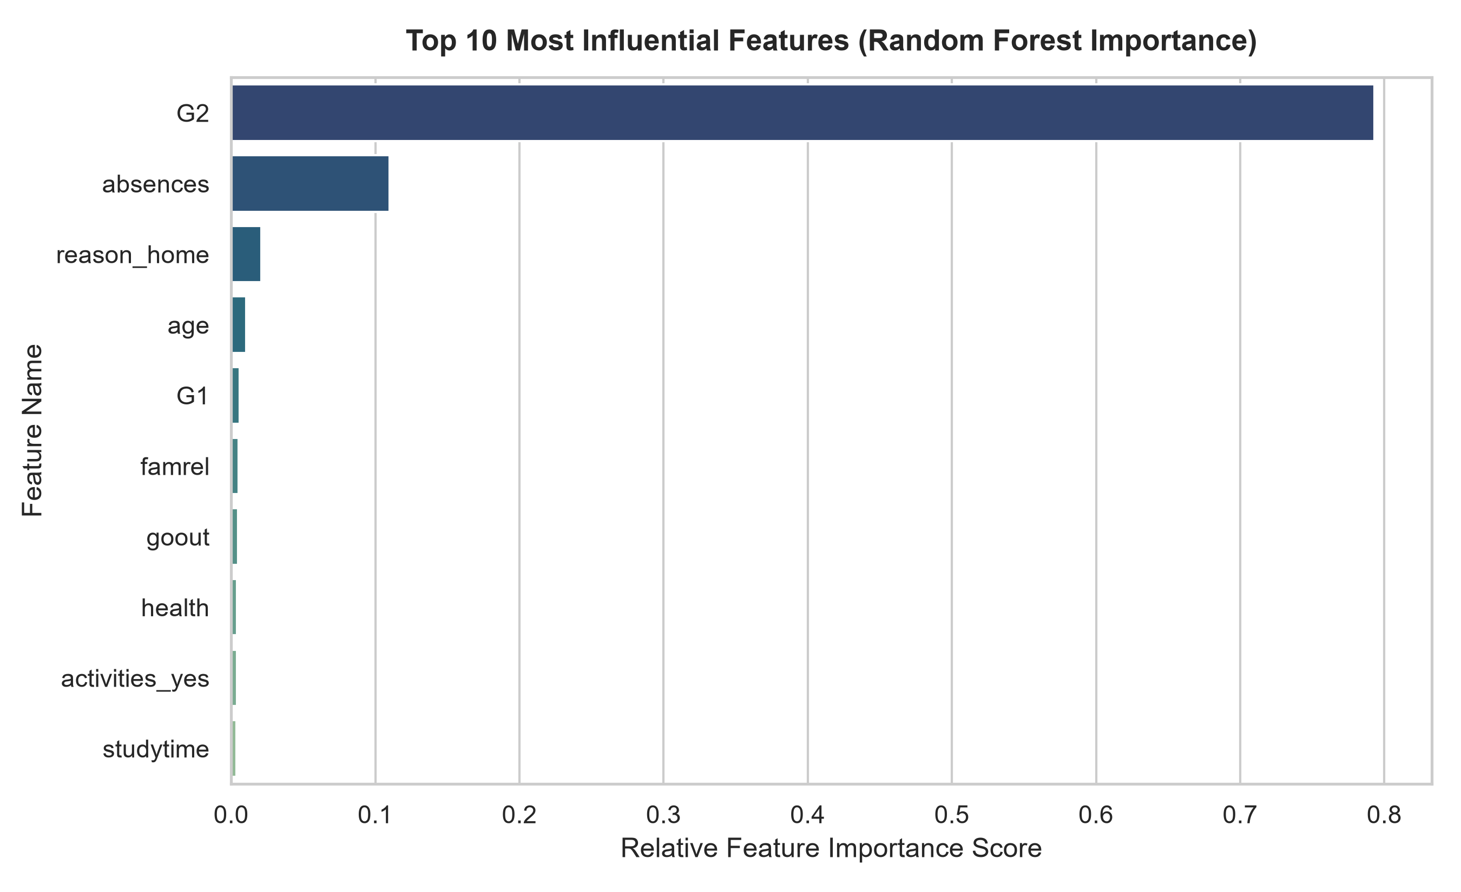

12. Sample Predictions on Test Data
To demonstrate real-world utility, the table below presents actual vs. predicted final examination scores for a random subset of 10 test students, along with calculated absolute errors and residual values:
Sample Student # | Actual Grade (G3) | Model Prediction | Absolute Error
Student 1 | 10.0 | 8.32 | 1.68
Student 2 | 12.0 | 11.78 | 0.22
Student 3 | 5.0 | 6.50 | 1.50
Student 4 | 10.0 | 9.76 | 0.24
Student 5 | 9.0 | 8.80 | 0.20
Student 6 | 13.0 | 12.86 | 0.14
Student 7 | 18.0 | 18.70 | 0.70
Student 8 | 6.0 | 6.72 | 0.72
Student 9 | 0.0 | 6.68 | 6.68
Student 10 | 14.0 | 13.33 | 0.67
13. Conclusion
This academic internship project successfully implemented a complete end-to-end Machine Learning pipeline for Student Performance Prediction. By leveraging the Random Forest Regressor algorithm, the model captured non-linear relationships across academic histories, study habits, and demographic features to achieve an R² score of 0.8148 and an MAE of 1.1646. The empirical findings demonstrate that prior assessment scores (G2 and G1) and attendance are the primary determinants of final success. Educational institutions can utilize this predictive framework to automate the early detection of academic struggle and proactively deploy counseling, tutoring, and family engagement programs.
14. Future Scope
- Longitudinal Tracking: Incorporating time-series data across multiple academic semesters to track student growth curves over several years.
- Deep Learning Integration: Applying Multi-Layer Perceptrons (MLP) or Recurrent Neural Networks (RNN) for high-dimensional student log data.
- Interactive Dashboard: Developing a web-based educational dashboard (e.g., Flask or FastAPI with React) for real-time institutional analytics.
- Automated Early Alert System: Integrating automated notification triggers to alert teachers and parents when a student's predicted grade drops below passing thresholds.
15. References
- Cortez, P., & Silva, A. (2008). Using Data Mining to Predict Secondary School Student Performance. In Proceedings of 5th Annual Future Business Technology Conference (FUBUTEC 2008), Porto, Portugal, pp. 5-12.
- Kaggle Dataset: Student Alcohol Consumption / Student Performance Data Set. Available online: https://www.kaggle.com/datasets/uciml/student-alcohol-consumption
- UCI Machine Learning Repository: Student Performance Data Set. Available online: https://archive.ics.uci.edu/dataset/320/student+performance
- Pedregosa, F., et al. (2011). Scikit-learn: Machine Learning in Python. Journal of Machine Learning Research, 12, 2825-2830.
- McKinney, W. (2010). Data Structures for Statistical Computing in Python. In Proceedings of the 9th Python in Science Conference, pp. 56-61.
- IBM SkillsBuild & BharatCares - AICTE Internship Curriculum on Data Analytics with AI (2024).

