Jaypee Institute of Information Technology
Department of Computer Science & Engineering



VendorAI: An Explainable Multi-Agent Business Intelligence Platform for MSMEs

Course Name: Project-Based Learning
Program: M. Tech. CSE 3st Sem
(Session: 2025-27)

Name: SAMEEKSHA GOUR
Enrollment: 2503030020

INTRODUCTION
Small vendors and local businesses often face difficulties in managing GST records, invoices, purchases, sales, inventory, and financial information efficiently. Many of these activities are still performed manually or through multiple disconnected tools, which can lead to data-entry errors, time consumption, and difficulty in understanding business performance.
Vendor AI is an AI-powered vendor management platform designed to simplify and centralize these activities in a single system. The platform combines GST management, invoice processing, vendor management, purchase and inventory tracking, and business analytics to reduce manual effort and improve record accuracy.
A key feature of Vendor AI is the integration of Artificial Intelligence and Optical Character Recognition (OCR) for invoice processing. The system can extract relevant information from uploaded invoices, structure the extracted data, perform GST-related validation, and store the information for further use. The platform can also provide meaningful business insights through an AI assistant, helping small vendors understand their transactions, inventory, and overall business performance.
The primary objective of Vendor AI is to make GST and business management simpler, more automated, accessible, and intelligent for small vendors, even for users with limited technical or accounting knowledge.

ABSTRACT
Vendor_AI is the name of a Vendor and Procurement Management System that involves AI and enables businesses to automate their processes and make decisions based on the results of data analysis. This is a one-stop-shop online solution that includes vendor management, product management, inventory, purchase orders, invoices, and business analytics.
This system was developed using the MERN technology stack with Next.js (React) being responsible for the front-end development and Node.js and Express.js being used for the backend services and RESTful API development, while MongoDB serves as a business information storage database. This platform has a modular architecture that enables easy communication between the client side, backend services, database, and AI modules. One of the distinctive features of the Vendor_AI platform is the presence of an AI Business Copilot that lets users interact with business data via natural language.
As opposed to the classical approach, VENDOR_AI emphasizes intelligent procurement and business intelligence in regard to AI recommendations, predictions, and conversation.

PROBLEM STATEMENT
Vendor AI solves the problem of fragmented and manual GST and business management for small vendors by providing one AI-powered platform for GST records, invoices, purchases, sales, inventory, validation and intelligent business assistance.

MOTIVATION

It is important to note that, for businesses, especially Micro, Small, and Medium Enterprises (MSMEs), the issue of effectively handling vendors, inventories, procurement orders, invoices, purchases, and all other procurement-related activities remains a big problem. Many MSMEs use manual registers, spreadsheets, or multiple independent software programs to handle such activities. The above approach results in data duplication, inaccurate recording of activities, inefficient processes, delay in making decisions, high operation costs, and errors made by humans. With increase in transaction volumes, it becomes increasingly difficult to keep the information accurate and current, thus reducing the ability of organizations to react to changes in their market environment and operational processes.

While there are plenty of software solutions related to vendor management, accounting, ERP, and other business operations, they usually concentrate on record keeping, transaction processing, and generation of standard reports. The above functionalities are quite helpful in handling daily routine, however, sometimes they do not offer enough intelligence to guide small vendors on the reason for certain trends in business or how to react to these trends. In such cases, the user receives information related to sales, purchases, inventories, finances, etc., and has to interpret such information and make decisions on own. Moreover, the existing systems may be quite complicated for small vendors with limited IT knowledge.

With the rapid advancement of Artificial Intelligence (AI), Large Language Models (LLMs), Optical Character Recognition (OCR), and data analytics, there is an opportunity to move beyond traditional vendor and procurement management systems and create more intelligent and user-friendly business platforms. AI can help automate repetitive tasks such as invoice information extraction, identify patterns in business data, validate relevant information, generate insights, and allow users to interact with their business information using natural language. Instead of simply presenting data through static reports, an intelligent system can interpret that data and assist users in understanding their business operations.

This motivation led to the development of VENDOR_AI, an AI-based vendor and procurement management platform that combines conventional business-management functionalities with intelligent decision support. The platform aims to centralize vendor, inventory, purchase, invoice, and related business information while using AI and automation to reduce manual effort and improve operational efficiency. Through features such as AI-assisted invoice processing, OCR-based data extraction, GST-related validation, inventory monitoring, business analytics, and an AI business assistant, VENDOR_AI aims to transform raw business data into meaningful and actionable information.

LITERATURE SURVEY:-

Research Paper | Author(s) & Year | Research Paper Objective | Methodology / Techniques | Limitations
Building an Intelligent Brain Platform for SMEs using ChatGLM and Multi-Agent Systems | Daohong Yuan (2026) | To develop an “Enterprise Intelligent Brain” platform for SMEs that improves semantic understanding, task handling, and knowledge-based services using large language models. | ChatGLM (LLM), Multi-Agent Systems, Enterprise Knowledge Graphs, Domain-specific fine-tuning | Primarily functions as a smart Q&A and assistant system. Lacks strong operational decision simulation, what-if analysis, and depth in tax, inventory, and cash-flow decision support.
Towards an Evaluative AI Framework for Hypothesis-Driven Strategic Decision-Making in SMEs | Gines Molina-Abril, Laura Calvet, (2026) | To propose an adaptive, hypothesis-driven Evaluative AI framework that helps SMEs test strategic business hypotheses using multi-agent generative systems. | Multi-Agent Generative Systems, Open-source LLMs, Vector storage, Shared memory, Hypothesis evaluation agents, Companies House API | Focused mainly on high-level strategic decision-making. Remains largely conceptual with limited operational simulation and no specialization in GST, inventory, or daily business operations.
Balancing Intelligence and Intuition: A Human-AI Decision Support Model for Strategic Technology Adoption in SMEs | C. Gupta, V. Gupta (2025) | To design a hybrid human-AI decision support model that helps SMEs make better technology adoption decisions by combining AI recommendations with human intuition. | Hybrid AI-Human framework (HAI-HDM), SHAP + LIME (Explainable AI), Machine Learning ranking, Reinforcement Learning, Dynamic weighting | Very narrow scope — limited only to technology adoption decisions. Does not support ongoing operational business decisions such as pricing, inventory, tax, or finance.
Credit Risk Analysis for SMEs Using Graph Neural Networks in Supply Chain | Zizhou Zhang, Qinyan Shen, Zhuohuan Hu, Qianying Liu, Huijie Shen (2025) | To improve credit risk assessment of SMEs by modelling supply-chain and transactional relationships using Graph Neural Networks. | Graph Neural Networks (GNN), Large-scale transaction and social graphs, Supply-chain network modeling | Designed for external parties (banks and lenders) to predict loan defaults. Not intended for MSME owners to make internal business decisions.
Retrieval-Augmented Reasoning for Chartered Accountancy (CA-ThinkFlow) | Jatin Gupta, Akhil Sharma, Saransh Singhania, Ali Imam Abidi (2026) | To build a parameter-efficient Retrieval-Augmented Generation system capable of accurately answering complex Indian Chartered Accountancy and tax-related questions. | Parameter-efficient RAG, 14B quantized reasoning model (DeepSeek-R1), Layout-aware document extraction (Docling), Chain-of-Thought reasoning | Excellent for knowledge-based Q&A but remains limited to question answering. Weak in multi-step business simulation, adaptive learning, and full operational decision support.

SIMILAR API DIFFERENCES:-
Capability Domain | Atlas Vendor AI | Zoho Inventory | TallyPrime | Vyapar | Odoo
Conversational AI Decision Support | Provides a natural-language business copilot that allows users to query operational data, receive contextual recommendations, and obtain decision guidance through interactive dialogue. | Does not offer conversational AI or natural-language querying of business data. | Does not support natural-language interaction or AI-driven conversational decision support. | Does not provide AI-based conversational interfaces for business queries. | Does not incorporate conversational AI or natural-language decision support.
Intelligent Vendor Recommendation | Generates AI-driven vendor recommendations based on historical performance, pricing patterns, risk indicators, and business context. | Relies on manual vendor selection and basic filtering; does not apply predictive or generative recommendation models. | Supports basic vendor master data management without intelligent recommendation algorithms. | Maintains vendor records with limited analytical ranking; lacks AI-based recommendation engines. | Provides vendor management with basic rating and filtering; does not employ advanced AI recommendation models.
Predictive Purchase Intelligence | Forecasts purchase requirements using historical patterns, seasonal trends, and business signals to support proactive procurement decisions. | Offers demand forecasting at a basic level without deep AI-driven purchase prediction. | Focuses on transactional recording and does not provide predictive purchase modelling. | Limited predictive capability; primarily reactive inventory and purchase tracking. | Supports basic forecasting modules that can be extended; native predictive depth is moderate.
Composite Business Health Scoring | Computes a multi-dimensional business health score integrating financial, operational, vendor, and risk indicators into a single interpretable metric. | Does not generate a composite AI-based business health score. | Does not compute holistic business health indicators. | Lacks multi-factor business health scoring. | Does not provide a native composite business health score.
Prescriptive Profit & Expense Intelligence | Delivers AI-generated suggestions for profit improvement and detailed expense pattern analysis with actionable recommendations. | Provides standard expense and inventory reports without prescriptive AI recommendations. | Offers accounting reports and basic analysis without generative profit-improvement suggestions. | Supports basic expense tracking and reporting; lacks AI-driven profit optimisation advice. | Provides analytical reports; prescriptive AI recommendations are not native.
Core Transactional Modules | Includes vendor management, product and inventory management, purchase order processing, invoice handling, payment tracking, and GST-compliant billing. | Fully supports inventory, purchase, vendor, and billing operations with strong multi-channel capabilities. | Strong in accounting, inventory, and GST compliance with robust transactional depth. | Focused on simple inventory, billing, and GST compliance for small businesses. | Comprehensive ERP coverage including inventory, purchase, accounting, and modular extensions.
Governance, Security & Process Control | Currently lacks native multi-user role hierarchies, granular role-based permissions, formal approval workflows, comprehensive audit logging, and systematic notifications (planned for future releases). | Provides mature multi-user roles, permissions, approval mechanisms, audit trails, and notification systems. | Offers multi-user access control, audit features, and structured workflows appropriate for accounting environments. | Supports multi-user access with basic role differentiation and limited workflow controls. | Mature multi-user roles, permissions, approval workflows, and audit logging.

ARCHITECTURE:-

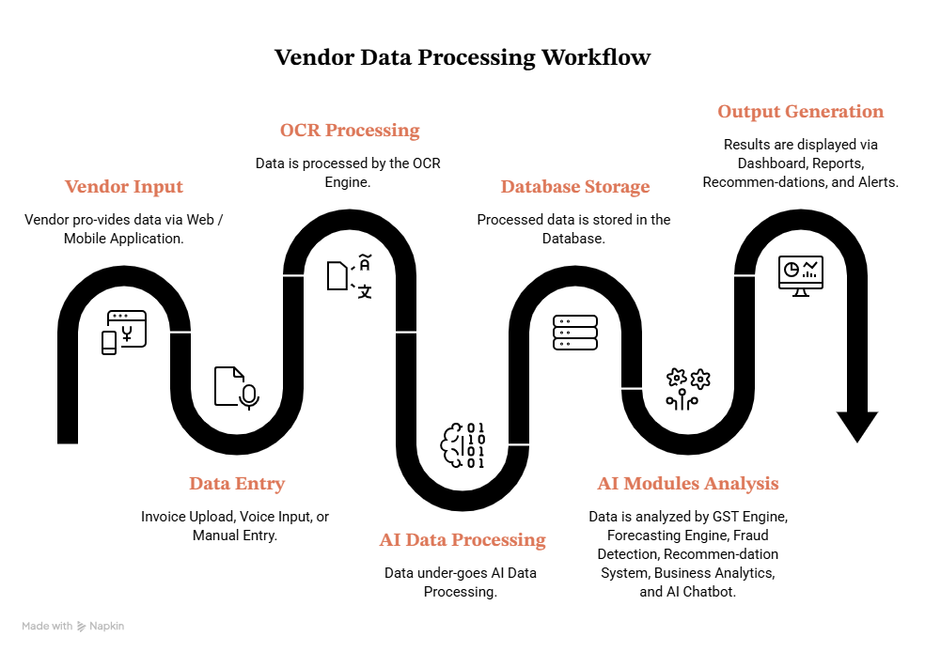
Fig. 1: Showing external criteria of API

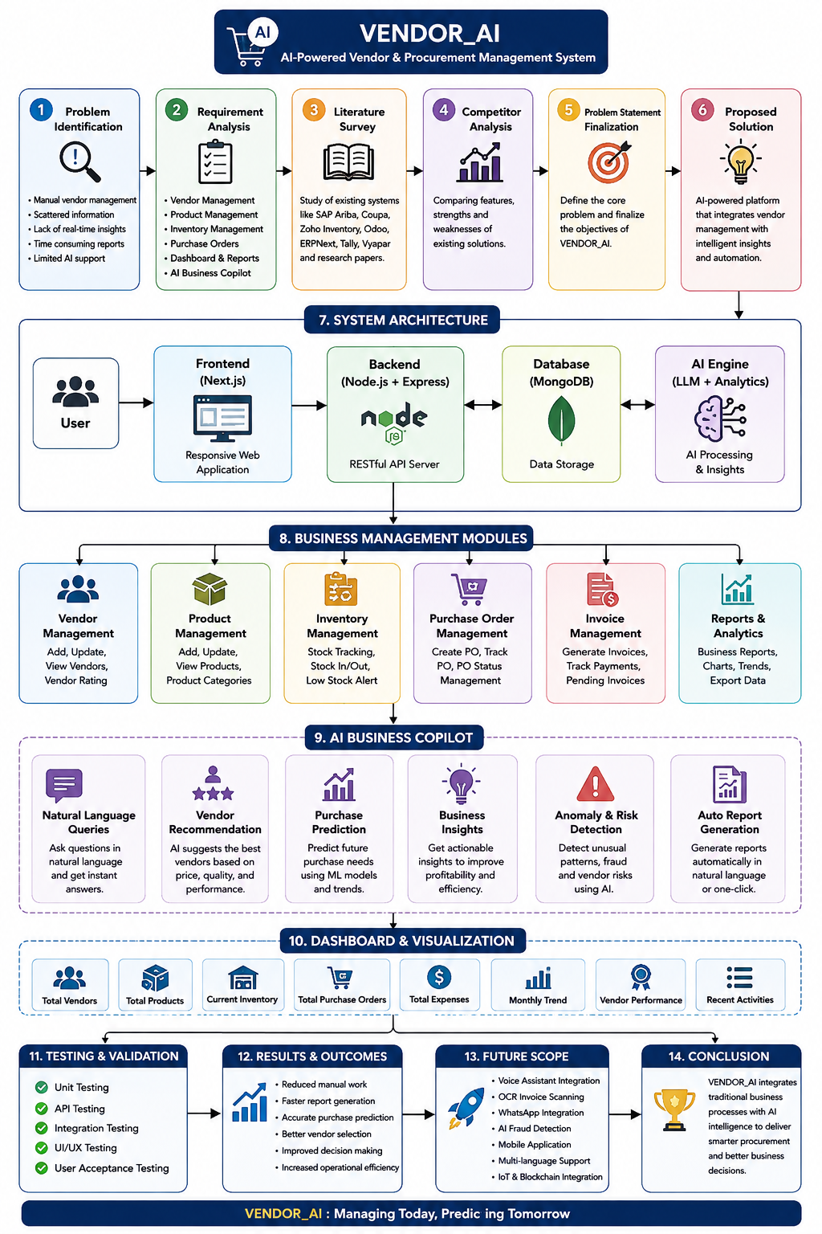
Fig 2: Showing API framework

GHANT CHART:-
Phase / Task | Week 1 | Week 2 | Week 3 | Week 4 | Status | Progress
1. Project Ideation & Planning
Project idea finalization | Yes |  |  |  | Completed | 100%
Requirement gathering | Yes |  |  |  | Completed | 100%
Competitor analysis (Zoho, SAP Ariba, Coupa, Odoo, etc.) | Yes |  |  |  | Completed | 100%
Technology stack selection (Next.js, Node.js, Express, MongoDB, AI) | Yes |  |  |  | Completed | 100%
Database planning | Yes |  |  |  | Completed | 100%
UI wireframe planning | Yes |  |  |  | Completed | 100%
2. Frontend Development
Frontend setup using Next.js |  | Yes |  |  | Completed | 100%
Sidebar Navigation |  | Yes |  |  | Completed | 100%
Dashboard UI |  | Yes |  |  | Completed | 100%
Vendor Management UI |  | Yes |  |  | Completed | 100%
Product Management UI |  | Yes |  |  | In Progress | 50%
Inventory UI |  | Yes |  |  | In Progress | 50%
Routing between pages |  | Yes |  |  | In Progress | 50%
Responsive design |  | Yes |  |  | In Progress | 50%
3. Backend Development & Architecture
Backend architecture planning |  |  | Yes |  | In Progress | 40%
Express server setup |  |  | Yes |  | In Progress | 40%
MongoDB connection |  |  | Yes |  | In Progress | 40%
REST API structure planning |  |  | Yes |  | In Progress | 30%
Authentication planning (JWT) |  |  | Yes |  | Pending | 20%
Folder structure finalized |  |  | Yes |  | Pending | 20%
API integration planning |  |  | Yes |  | Pending | 10%
AI module architecture |  |  | Yes |  | Pending | 10%
4. AI Features, Documentation & Presentation
AI feature planning (Business Copilot) |  |  |  | Yes | Pending | 0%
Dashboard analytics planning |  |  |  | Yes | Pending | 0%
Vendor recommendation logic design |  |  |  | Yes | Pending | 0%
Purchase prediction planning |  |  |  | Yes | Pending | 0%
Project documentation |  |  |  | Yes | Pending | 0%
Feature comparison with existing applications |  |  |  | Yes | Pending | 0%
Presentation preparation |  |  |  | Yes | Pending | 0%
Future roadmap planning |  |  |  | Yes | Pending | 0%

CONCLUSION:-
VendorAI is not just another vendor management software.
It is an AI-powered Business Intelligence Platform designed specifically for MSMEs.
It combines vendor management, procurement, inventory, financial analytics, and Artificial Intelligence into one unified platform.
The project aims to reduce manual effort, improve operational efficiency, support intelligent decision-making, and help businesses grow using explainable AI.

RESEARCH GAPS AND DIFFERENCE WITH PRESENT WORK:-
[1]Yuan (2026) developed an intelligent platform for SMEs using ChatGLM and multi-agent systems. However, the system primarily functions as a conversational assistant with limited decision simulation and insufficient depth in operational areas such as tax, inventory, and cash-flow management. Present Work: The proposed system is designed as a complete Decision Engine that incorporates multi-domain agents, decision simulation, explainable recommendations, and adaptive learning tailored for Indian MSMEs.
[2] Molina-Abril et al. (2026) proposed a hypothesis-driven evaluative AI framework for strategic decision-making in SMEs. The work remains largely conceptual and focuses on high-level strategic analysis rather than daily operational decisions. Present Work: The system emphasizes operational decision support covering pricing, inventory, GST liability, and cash flow through concrete multi-agent simulation.
[3]Gupta and Gupta (2025) presented a hybrid human-AI model for technology adoption decisions in SMEs. The scope is restricted to one-time technology selection and does not address ongoing business operations. Present Work: The project supports the complete business decision lifecycle, including tax, inventory, finance, risk, and pricing decisions.
[4]Zhang et al. (2025) applied Graph Neural Networks for SME credit risk assessment from the perspective of external lenders. The approach is not intended for internal decision-making by business owners. Present Work: Graph-based intelligence is utilized to help MSME owners understand internal business relationships and operational impacts.
[5]Gupta et al. (2026) developed a retrieval-augmented system for answering Chartered Accountancy and tax-related queries. While effective for knowledge retrieval, it lacks multi-step business simulation and adaptive decision support.Present Work: Retrieval-augmented knowledge of GST regulations is integrated as one component within a broader multi-agent decision support platform.

RESEARCH PAPERS:-
[1]Building an Intelligent Brain Platform for SMEs using ChatGLM and Multi-Agent Systems Yuan, D. (2026) https://journals.plos.org/plosone/article?id=10.1371/journal.pone.0340964
[2] Towards an Evaluative AI Framework for Hypothesis-Driven Strategic Decision-Making in SMEs Molina-Abril, G., Calvet, L., & Riera, D. (2026) https://link.springer.com/chapter/10.1007/978-3-032-10486-1_34
[3]Balancing Intelligence and Intuition: A Human-AI Decision Support Model for Strategic Technology Adoption in SMEs Gupta, C., & Gupta, V. (2025) https://peerj.com/articles/cs-3341/
[4]Credit Risk Analysis for SMEs Using Graph Neural Networks in Supply Chain Zhang, Z., Shen, Q., Hu, Z., Liu, Q., & Shen, H. (2025) https://arxiv.org/abs/2507.07854
[5]Retrieval-Augmented Reasoning for Chartered Accountancy (CA-ThinkFlow) Gupta, J., Sharma, A., Singhania, S., & Abidi, A. I. (2026) https://arxiv.org/abs/2605.00257

