
Department of Computer Engineering · DBMS Mini Project (CECS202)
Phase II — Complex SQL Queries: Joins, Aggregates & Subqueries (Exp 8)
Project: Surplus Food Rescue | Batch: B2
Sameel Kazi (2025300107) · Pradhyun Kembhavi (2025300109) · Adeeb Khan (2025300110)
――――――――――――――――――――――――――――――――――――――――――――――――――――――――――――
Note on Query Execution Context: All queries are executed on the normalized 'food_rescue' database with a standardized demo clock SET @at = '2026-11-05 20:30:00' (Thursday evening rush) and GPS coordinates @my_lat = 19.1215, @my_lng = 72.8348 (Andheri West, Mumbai). This ensures perfectly deterministic and verifiable results matching all sample batches.
Part A. Relational Joins (Queries Q1 to Q7)
Q1: Verified Donors and Verifying Admin
Objective: List all active food rescue donors and the municipal admin staff member who verified their FSSAI registration. Explanation: Demonstrates an INNER JOIN between Donor and Admin on a.admin_id = d.verified_by, filtering strictly for verified establishments.
SELECT d.donor_id, d.name AS donor, d.donor_type, d.area, a.name AS verified_by, d.verified_at
FROM Donor d
INNER JOIN Admin a ON a.admin_id = d.verified_by
WHERE d.status = 'VERIFIED'
ORDER BY d.verified_at;
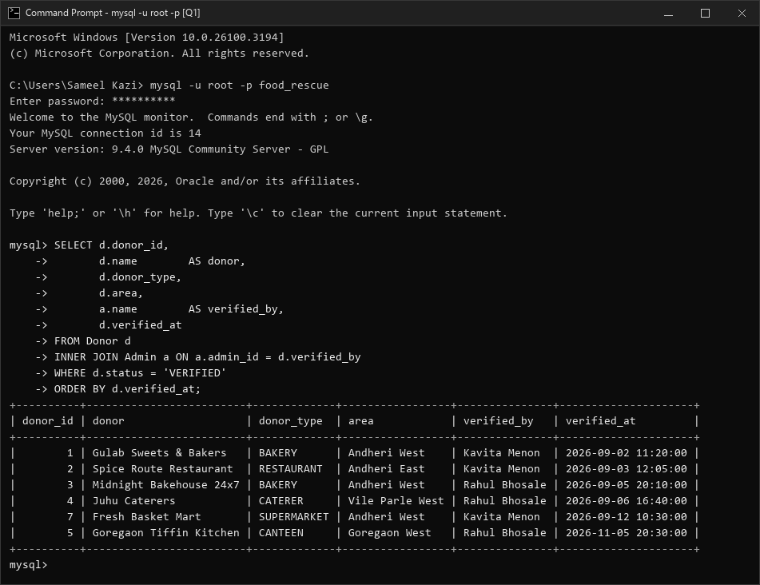
MySQL Output: Q1 execution result
Q2: Donor Review Status Audit
Objective: Inspect all registered food businesses and audit whether they have been reviewed, and by whom. Explanation: Uses a LEFT JOIN between Donor and Admin with COALESCE to capture pending/unassigned donors without losing unreviewed rows.
SELECT d.name AS donor, d.status, COALESCE(a.name, 'Not reviewed yet') AS reviewed_by
FROM Donor d
LEFT JOIN Admin a ON a.admin_id = d.verified_by
ORDER BY FIELD(d.status, 'PENDING', 'REJECTED', 'VERIFIED'), d.name;
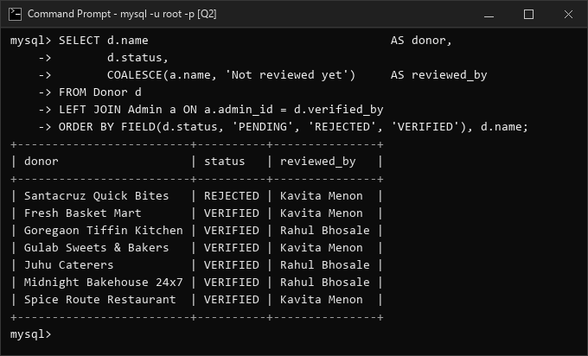
MySQL Output: Q2 execution result
Q3: Complete Reservation Receipt & Breakdown
Objective: Display a comprehensive receipt for reservation #6, showing receiver, donor, item breakdown, and computed 45-minute hold expiry. Explanation: Performs a five-table join (Reservation, Receiver, Donor, Reservation_Item, Food_Item) with a derived datetime attribute.
SELECT r.reservation_id, rc.name AS receiver, rc.receiver_type, dn.name AS donor,
r.reserved_at, r.reserved_at + INTERVAL 45 MINUTE AS hold_expires_at,
fi.item_name, ri.quantity, fi.unit, ri.price_at_reservation,
ri.quantity * ri.price_at_reservation AS line_total
FROM Reservation r
JOIN Receiver rc ON rc.receiver_id = r.receiver_id
JOIN Donor dn ON dn.donor_id = r.donor_id
JOIN Reservation_Item ri ON ri.reservation_id = r.reservation_id
JOIN Food_Item fi ON fi.item_id = ri.item_id
WHERE r.reservation_id = 6;
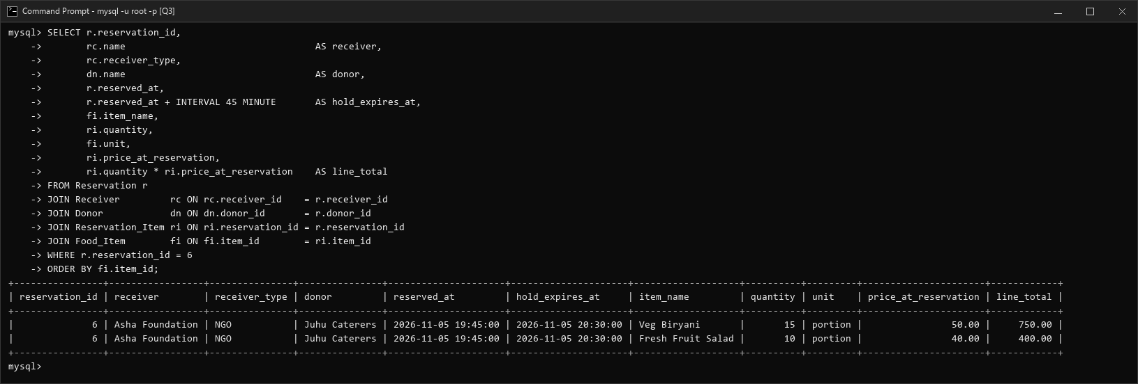
MySQL Output: Q3 execution result
Q4: Allergen Transparency Sheet
Objective: Produce an allergen safety report for every catalog food item for receiver health compliance. Explanation: Resolves the M:N relationship through junction table Item_Allergen and aggregates tags using GROUP_CONCAT.
SELECT fi.item_name, fi.category, fi.diet_type,
COALESCE(GROUP_CONCAT(al.allergen_name ORDER BY al.allergen_name SEPARATOR ', '),
'None declared') AS contains_allergens
FROM Food_Item fi
LEFT JOIN Item_Allergen ia ON ia.item_id = fi.item_id
LEFT JOIN Allergen al ON al.allergen_id = ia.allergen_id
GROUP BY fi.item_id, fi.item_name, fi.category, fi.diet_type;
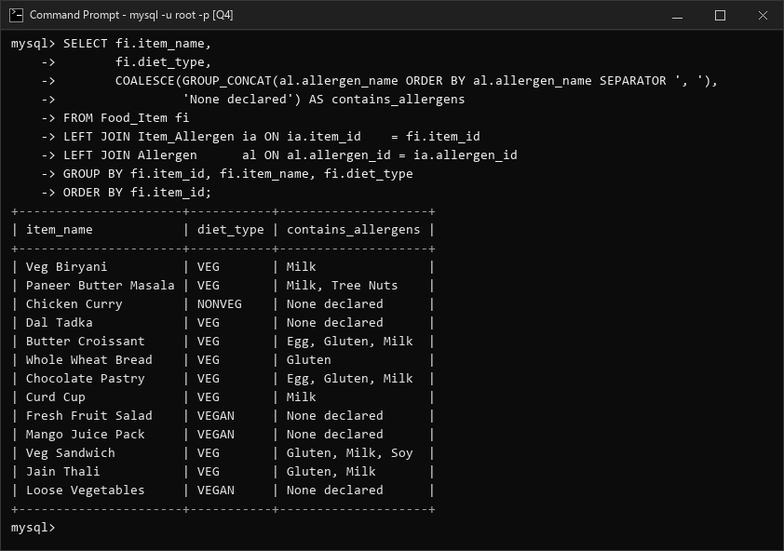
MySQL Output: Q4 execution result
Q5: Colocated Donors in the Same Locality
Objective: Identify pairs of verified food donors in the same neighborhood for joint pickup logistics. Explanation: Implements a SELF JOIN on Donor d1 and Donor d2 matching area with strict inequality d1.donor_id < d2.donor_id to prevent duplicate or reflexive pairs.
SELECT d1.area, d1.name AS donor_1, d2.name AS donor_2
FROM Donor d1
JOIN Donor d2 ON d1.area = d2.area AND d1.donor_id < d2.donor_id
WHERE d1.status = 'VERIFIED' AND d2.status = 'VERIFIED'
ORDER BY d1.donor_id, d2.donor_id;
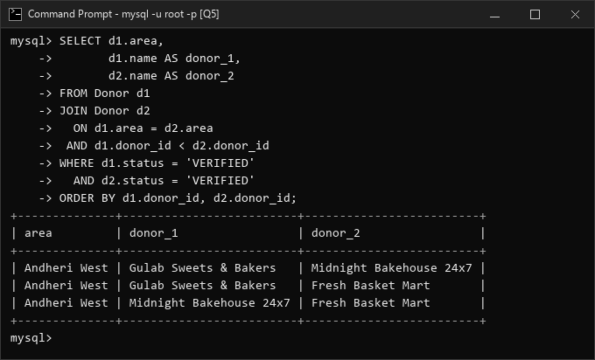
MySQL Output: Q5 execution result
Q6: Unlisted Food Items (Anti-Join)
Objective: Find food items in the central catalog that no active donor has ever listed for rescue. Explanation: Employs an anti-join pattern: LEFT JOIN Listing l ON l.item_id = fi.item_id WHERE l.item_id IS NULL.
SELECT fi.item_id, fi.item_name, fi.category
FROM Food_Item fi
LEFT JOIN Listing l ON l.item_id = fi.item_id
WHERE l.item_id IS NULL
ORDER BY fi.item_id;
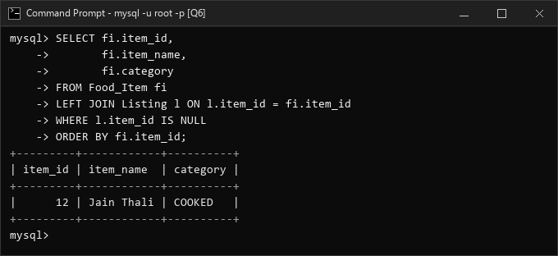
MySQL Output: Q6 execution result
Q7: Core Surplus Search: Nearest Open Donors with Safe Stock
Objective: Find where a receiver standing at Andheri West can get 'Veg Biryani' right now within open pickup hours. Explanation: A 5-table join computing Haversine radial distance, summing non-expired batches, applying flash discounts, and verifying pickup window validity.
SELECT d.name AS donor, d.area, d.phone,
ROUND(6371 * 2 * ASIN(SQRT(
POWER(SIN(RADIANS(d.latitude - @my_lat) / 2), 2)
+ COS(RADIANS(@my_lat)) * COS(RADIANS(d.latitude))
* POWER(SIN(RADIANS(d.longitude - @my_lng) / 2), 2))), 2) AS distance_km,
SUM(b.quantity) AS available_qty, l.price_per_unit,
ROUND(l.price_per_unit * (1 - CASE WHEN l.discount_valid_till IS NULL OR l.discount_valid_till >= @at
THEN l.discount_percent ELSE 0 END / 100), 2) AS final_price,
h.pickup_to AS pickup_till,
ROUND(TIMESTAMPDIFF(MINUTE, @at, MIN(b.best_before)) / 60, 1) AS earliest_batch_hours_left
FROM Food_Item fi
JOIN Listing l ON l.item_id = fi.item_id
JOIN Food_Batch b ON b.donor_id = l.donor_id AND b.item_id = l.item_id
JOIN Donor d ON d.donor_id = l.donor_id
JOIN Donor_Hours h ON h.donor_id = d.donor_id AND h.day_of_week = DAYOFWEEK(@at)
AND TIME(@at) BETWEEN h.pickup_from AND SUBTIME(h.pickup_to, '00:30:00')
WHERE fi.item_name = 'Veg Biryani' AND d.status = 'VERIFIED' AND b.best_before > @at
GROUP BY d.donor_id, d.name, d.area, d.phone, d.latitude, d.longitude,
l.price_per_unit, l.discount_percent, l.discount_valid_till, h.pickup_to
HAVING SUM(b.quantity) > 0
ORDER BY distance_km;
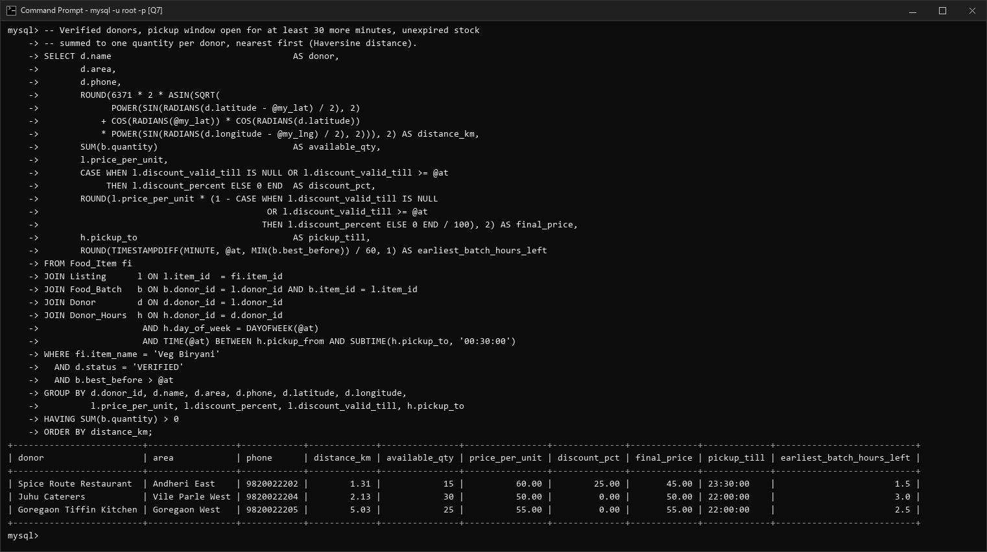
MySQL Output: Q7 execution result
Part B. Aggregate Functions & GROUP BY (Queries Q8 to Q13)
Q8: Live Inventory Valuation per Donor
Objective: Summarize unexpired rescue stock items, unit totals, and gross commercial value by donor. Explanation: Combines COUNT(DISTINCT), SUM, and computed monetary valuation filtered for unexpired batches.
SELECT d.name AS donor, COUNT(DISTINCT b.item_id) AS items_in_stock,
SUM(b.quantity) AS total_units,
ROUND(SUM(b.quantity * l.price_per_unit), 2) AS stock_value_rs
FROM Donor d
JOIN Listing l ON l.donor_id = d.donor_id
JOIN Food_Batch b ON b.donor_id = l.donor_id AND b.item_id = l.item_id
WHERE d.status = 'VERIFIED' AND b.best_before > @at
GROUP BY d.donor_id, d.name
ORDER BY stock_value_rs DESC;
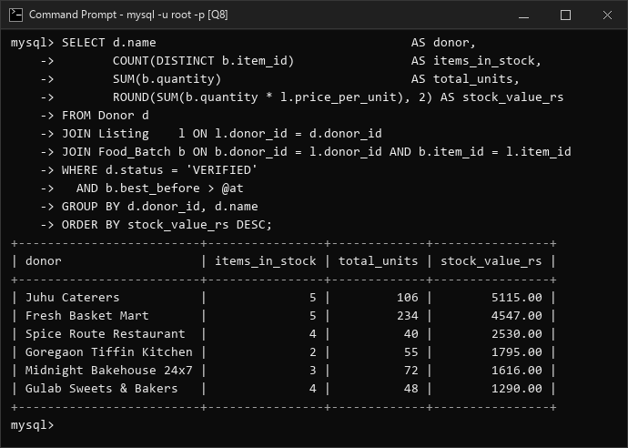
MySQL Output: Q8 execution result
Q9: Price Dispersion & Item Comparison
Objective: Compare price spread (MIN, MAX, AVG final price) for items offered by multiple donors. Explanation: Aggregates over a subquery calculating discounted pricing, applying HAVING COUNT(*) >= 2 to isolate competitive food items.
SELECT fi.item_name, fi.unit, COUNT(*) AS donors,
ROUND(MIN(fp.final_price), 2) AS cheapest,
ROUND(MAX(fp.final_price), 2) AS costliest,
ROUND(AVG(fp.final_price), 2) AS average_price
FROM (
SELECT l.item_id,
l.price_per_unit * (1 - CASE WHEN l.discount_valid_till IS NULL OR l.discount_valid_till >= @at
THEN l.discount_percent ELSE 0 END / 100) AS final_price
FROM Listing l JOIN Donor d ON d.donor_id = l.donor_id WHERE d.status = 'VERIFIED'
) AS fp
JOIN Food_Item fi ON fi.item_id = fp.item_id
GROUP BY fi.item_id, fi.item_name, fi.unit
HAVING COUNT(*) >= 2
ORDER BY (MAX(fp.final_price) - MIN(fp.final_price)) DESC;
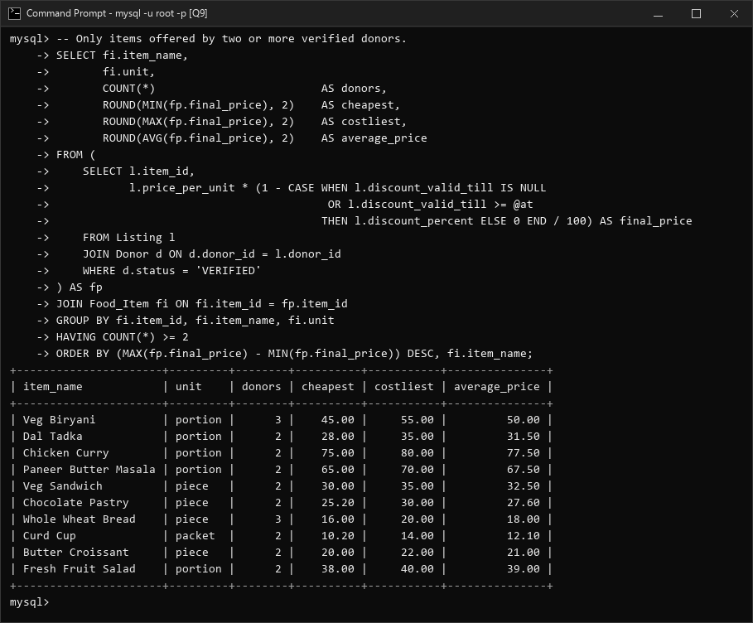
MySQL Output: Q9 execution result
Q10: Reservation Pipeline Breakdown
Objective: Count reservations across all operational statuses (COLLECTED, ACTIVE, CANCELLED, EXPIRED). Explanation: GROUP BY on categorical status column with COUNT(*) and deterministic ordering.
SELECT status, COUNT(*) AS reservations
FROM Reservation
GROUP BY status
ORDER BY reservations DESC, status;
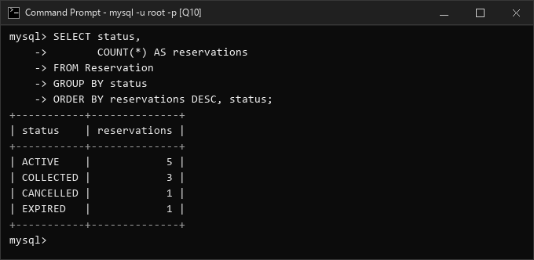
MySQL Output: Q10 execution result
Q11: Imminent Expiry Alert (< 3 Hours Left)
Objective: Detect perishable batches expiring within 3 hours so donors can initiate flash discounts or emergency donation. Explanation: Filters best-before within @at AND @at + INTERVAL 3 HOUR with MIN timestamp and SUM quantity.
SELECT d.name AS donor, COUNT(*) AS batches_expiring,
SUM(b.quantity) AS units_at_risk, MIN(b.best_before) AS earliest_best_before
FROM Food_Batch b
JOIN Donor d ON d.donor_id = b.donor_id
WHERE d.status = 'VERIFIED' AND b.best_before > @at AND b.best_before <= @at + INTERVAL 3 HOUR
AND b.quantity > 0
GROUP BY d.donor_id, d.name
ORDER BY earliest_best_before;
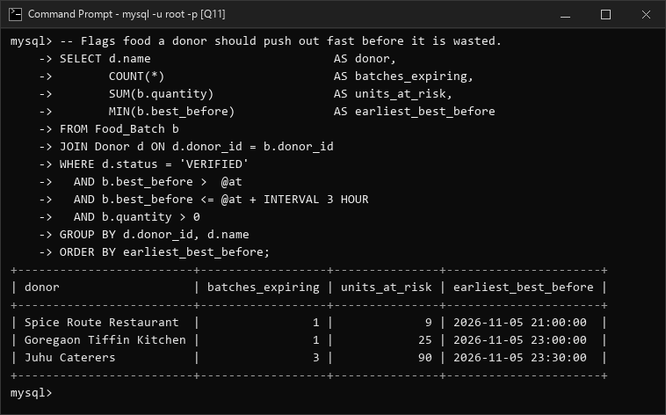
MySQL Output: Q11 execution result
Q12: Search Demand and Unmet Queries
Objective: Rank most sought-after food items and identify searches yielding zero results. Explanation: Aggregates Search_Log with conditional summation SUM(CASE WHEN donors_found = 0 THEN 1 ELSE 0 END).
SELECT fi.item_name, COUNT(*) AS searches,
SUM(CASE WHEN sl.donors_found = 0 THEN 1 ELSE 0 END) AS searches_with_no_result,
COUNT(DISTINCT sl.receiver_id) AS logged_in_searchers
FROM Search_Log sl
JOIN Food_Item fi ON fi.item_id = sl.item_id
GROUP BY fi.item_id, fi.item_name
ORDER BY searches DESC, fi.item_name
LIMIT 5;
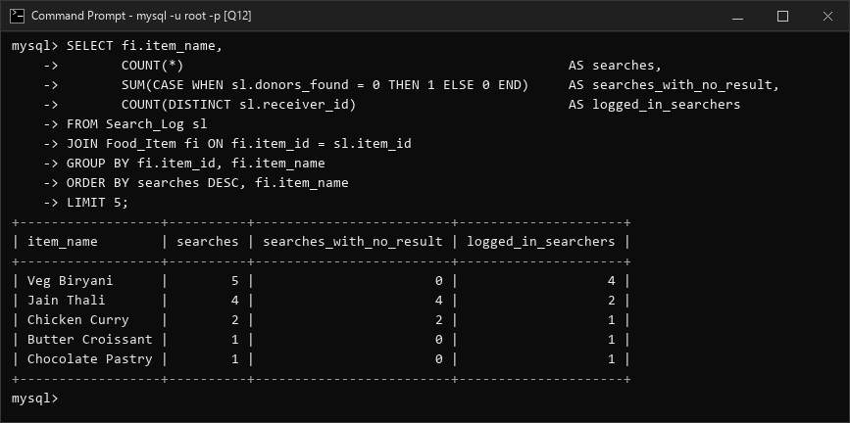
MySQL Output: Q12 execution result
Q13: Rescue Volume, Revenue & Feedback Rating
Objective: Summarize successfully collected orders, rescued food portions, total revenue, and average star ratings per donor. Explanation: Joins Reservation, Reservation_Item, and Feedback for COLLECTED status with AVG(rating).
SELECT d.name AS donor, COUNT(DISTINCT r.reservation_id) AS collected_orders,
SUM(ri.quantity) AS units_rescued,
SUM(ri.quantity * ri.price_at_reservation) AS sales_rs,
ROUND(AVG(f.rating), 1) AS avg_rating
FROM Reservation r
JOIN Donor d ON d.donor_id = r.donor_id
JOIN Reservation_Item ri ON ri.reservation_id = r.reservation_id
LEFT JOIN Feedback f ON f.reservation_id = r.reservation_id
WHERE r.status = 'COLLECTED'
GROUP BY d.donor_id, d.name
ORDER BY units_rescued DESC;
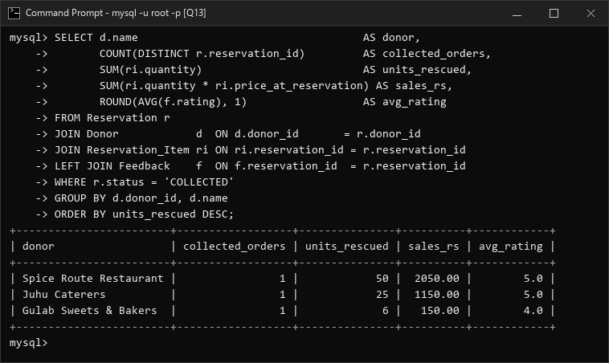
MySQL Output: Q13 execution result
Part C. Subqueries & Advanced SQL (Queries Q14 to Q20)
Q14: Cheapest Listing (Scalar Subquery)
Objective: Pinpoint the absolute cheapest verified donor listing for Veg Biryani. Explanation: Uses two nested scalar subqueries in WHERE: one for item_id and another for MIN(price_per_unit).
SELECT d.name AS donor, d.area, l.price_per_unit
FROM Listing l
JOIN Donor d ON d.donor_id = l.donor_id
WHERE d.status = 'VERIFIED'
AND l.item_id = (SELECT item_id FROM Food_Item WHERE item_name = 'Veg Biryani')
AND l.price_per_unit = (
SELECT MIN(l2.price_per_unit)
FROM Listing l2 JOIN Donor d2 ON d2.donor_id = l2.donor_id
WHERE d2.status = 'VERIFIED' AND l2.item_id = (SELECT item_id FROM Food_Item WHERE item_name = 'Veg Biryani'));
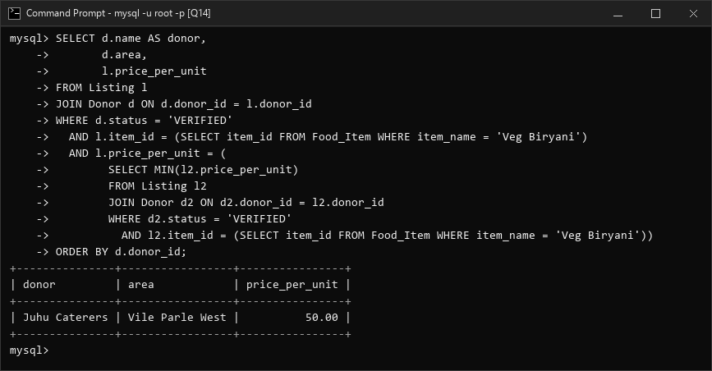
MySQL Output: Q14 execution result
Q15: Premium-Priced Listings (Correlated Subquery)
Objective: Find donor listings whose base price exceeds the city-wide average price for that specific item. Explanation: Employs a correlated subquery in WHERE that dynamically re-computes AVG(price_per_unit) for outer row l.item_id.
SELECT d.name AS donor, fi.item_name, l.price_per_unit,
(SELECT ROUND(AVG(l2.price_per_unit), 2)
FROM Listing l2 JOIN Donor d2 ON d2.donor_id = l2.donor_id
WHERE l2.item_id = l.item_id AND d2.status = 'VERIFIED') AS item_average
FROM Listing l
JOIN Donor d ON d.donor_id = l.donor_id
JOIN Food_Item fi ON fi.item_id = l.item_id
WHERE d.status = 'VERIFIED'
AND l.price_per_unit > (
SELECT AVG(l2.price_per_unit)
FROM Listing l2 JOIN Donor d2 ON d2.donor_id = l2.donor_id
WHERE l2.item_id = l.item_id AND d2.status = 'VERIFIED')
ORDER BY fi.item_name, l.price_per_unit DESC;
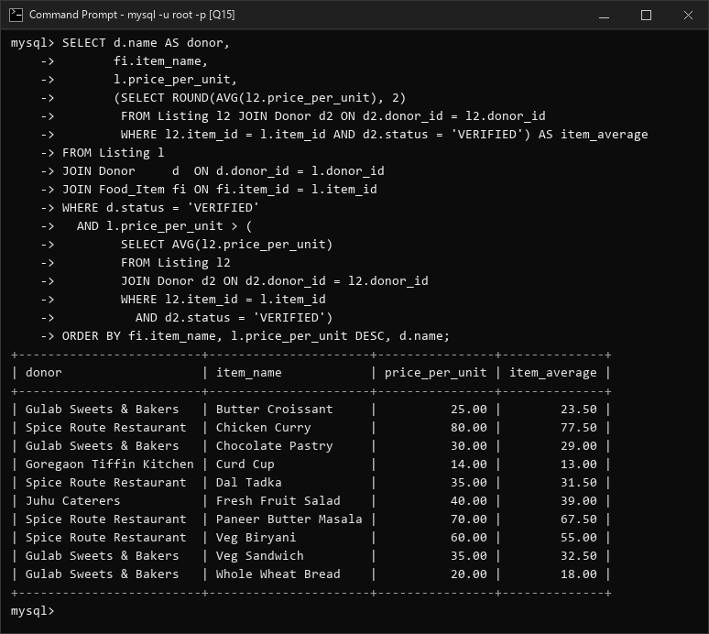
MySQL Output: Q15 execution result
Q16: Inactive Receivers (NOT EXISTS Subquery)
Objective: Identify registered beneficiaries who have never submitted any food reservation hold. Explanation: Demonstrates correlated NOT EXISTS subquery testing absence of matching rows in Reservation.
SELECT rc.receiver_id, rc.name, rc.receiver_type, rc.phone
FROM Receiver rc
WHERE NOT EXISTS (
SELECT 1 FROM Reservation r WHERE r.receiver_id = rc.receiver_id
)
ORDER BY rc.receiver_id;
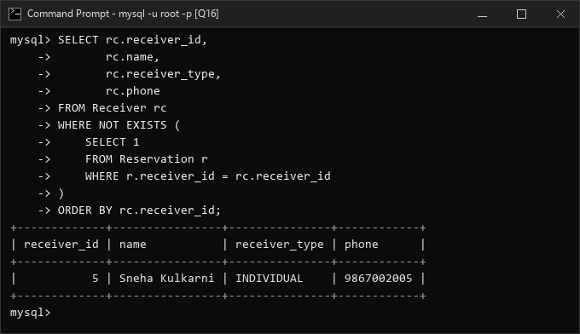
MySQL Output: Q16 execution result
Q17: Top-Rated Donors (Triple-Nested IN)
Objective: List donors who have received a perfect 5-star customer feedback review. Explanation: Three-level nested IN subquery: Feedback -> Reservation -> Donor.
SELECT d.name, d.donor_type, d.area
FROM Donor d
WHERE d.donor_id IN (
SELECT r.donor_id FROM Reservation r WHERE r.reservation_id IN (
SELECT f.reservation_id FROM Feedback f WHERE f.rating = 5
)
)
ORDER BY d.donor_id;
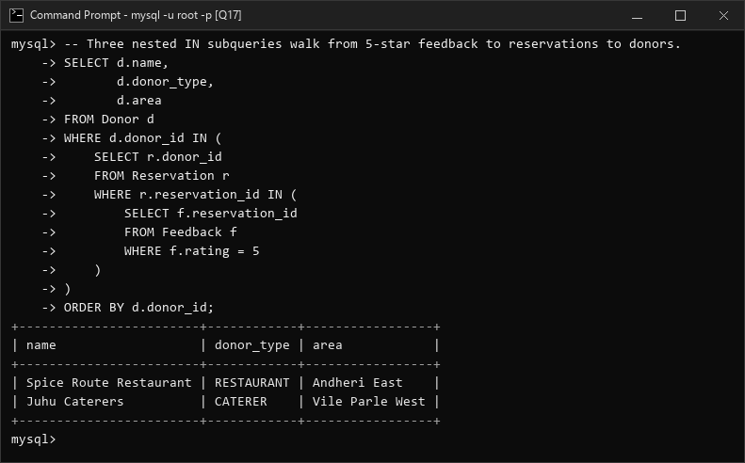
MySQL Output: Q17 execution result
Q18: Above-Average Stock Donors (Derived Table)
Objective: Identify donors holding unexpired stock quantities exceeding the overall donor average. Explanation: Subquery in FROM aggregates stock per donor; a second derived subquery in WHERE calculates the city-wide donor mean.
SELECT inv.donor, inv.total_units
FROM (
SELECT d.name AS donor, SUM(b.quantity) AS total_units
FROM Donor d JOIN Food_Batch b ON b.donor_id = d.donor_id
WHERE d.status = 'VERIFIED' AND b.best_before > @at
GROUP BY d.donor_id, d.name
) AS inv
WHERE inv.total_units > (
SELECT AVG(t.total_units) FROM (
SELECT SUM(b.quantity) AS total_units
FROM Donor d JOIN Food_Batch b ON b.donor_id = d.donor_id
WHERE d.status = 'VERIFIED' AND b.best_before > @at
GROUP BY d.donor_id
) AS t
)
ORDER BY inv.total_units DESC;
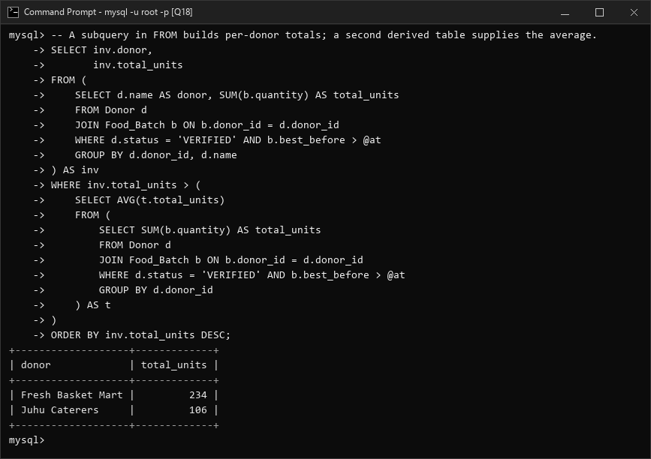
MySQL Output: Q18 execution result
Q19: Bulk Order Refill (Relational Division via HAVING COUNT)
Objective: Find which verified donors can supply ALL food items requested in bulk Reservation #1 (items 1 and 4). Explanation: Implements relational division using GROUP BY and HAVING COUNT to find donors whose count of matched distinct items equals the total item count in Reservation #1.
SELECT d.donor_id,
d.name AS donor_name,
d.area,
COUNT(DISTINCT l.item_id) AS items_matched
FROM Donor d
JOIN Listing l ON d.donor_id = l.donor_id
WHERE l.item_id IN (
SELECT item_id
FROM Reservation_Item
WHERE reservation_id = 1
)
AND d.status = 'VERIFIED'
GROUP BY d.donor_id, d.name, d.area
HAVING COUNT(DISTINCT l.item_id) = (
SELECT COUNT(*)
FROM Reservation_Item
WHERE reservation_id = 1
)
ORDER BY d.donor_id;
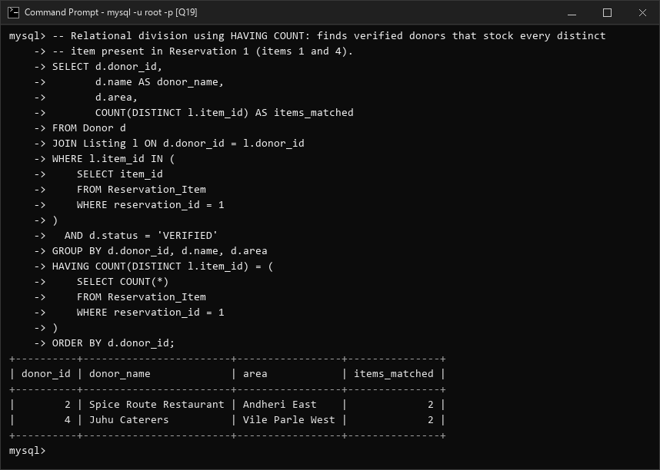
MySQL Output: Q19 execution result
Q20: Neighborhood Demand Intelligence (Correlated Geo-Subquery)
Objective: Identify items searched within 2 km of 'Gulab Sweets & Bakers' that the bakery does NOT currently stock. Explanation: Combines geospatial Haversine proximity on Search_Log with a NOT EXISTS anti-join on Listing to surface latent commercial demand.
SELECT fi.item_name, fi.category, COUNT(*) AS nearby_searches, MAX(sl.searched_at) AS last_searched
FROM Search_Log sl
JOIN Food_Item fi ON fi.item_id = sl.item_id
JOIN Donor d ON d.name = 'Gulab Sweets & Bakers'
WHERE sl.searched_at >= @at - INTERVAL 30 DAY
AND 6371 * 2 * ASIN(SQRT(
POWER(SIN(RADIANS(sl.latitude - d.latitude) / 2), 2)
+ COS(RADIANS(d.latitude)) * COS(RADIANS(sl.latitude))
* POWER(SIN(RADIANS(sl.longitude - d.longitude) / 2), 2))) <= 2
AND NOT EXISTS (
SELECT 1 FROM Listing l WHERE l.donor_id = d.donor_id AND l.item_id = sl.item_id
)
GROUP BY fi.item_id, fi.item_name, fi.category
ORDER BY nearby_searches DESC, fi.item_name;
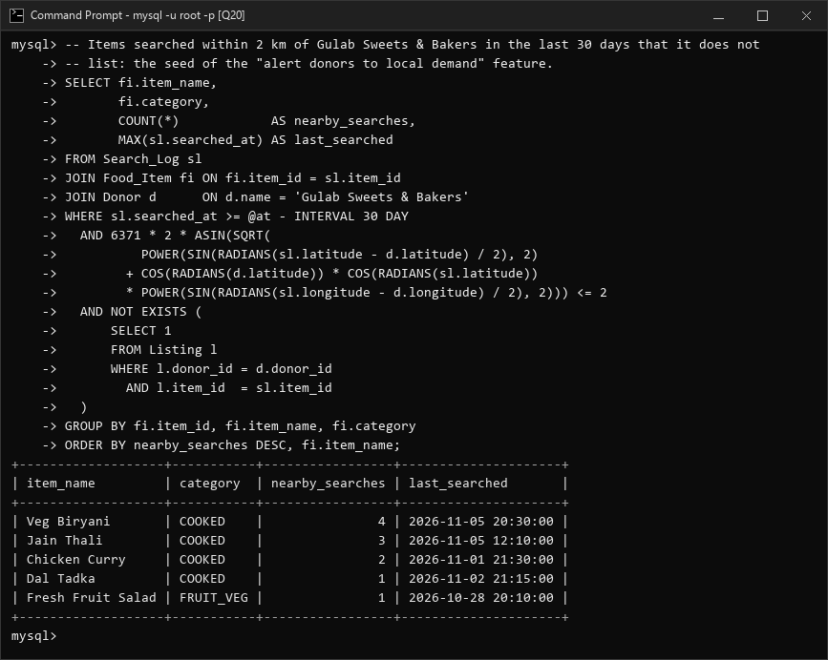
MySQL Output: Q20 execution result

