
Department of Computer Engineering · DBMS Mini Project (CECS202)
Phase I — Problem Statement, ER Modeling, Relational Schema, Normalization & DDL/DML
Project: Surplus Food Rescue | Batch: B2
Sameel Kazi (2025300107) · Pradhyun Kembhavi (2025300109) · Adeeb Khan (2025300110)
――――――――――――――――――――――――――――――――――――――――――――――――――――――――――――
1. Problem Statement
Every evening, restaurants, bakeries, caterers, and supermarkets across Indian cities end their business day with large quantities of perfectly prepared, safe-to-eat food that cannot be sold tomorrow: biryani cooked for peak evening orders, bread and croissants baked at dawn, sandwiches and salads nearing their safe shelf-life window. Most of this food is binned into landfills. Concurrently, nearby non-governmental organizations (NGOs) running shelters, orphanages, college students living in hostels on tight allowances, and low-income families would gratefully collect this food, but neither party has a dependable mechanism to discover the other in real time.
Unlike medicines, books, or packaged dry goods, prepared food perishes in hours, not months. A portion of freshly cooked chicken curry prepared at 3:00 PM becomes bacteriologically unsafe by 9:00 PM. Thus, pickup must occur strictly within a synchronized operational window, donors must have immediate visibility into batches approaching expiration, and receivers must be guaranteed safe-to-eat freshness with strict allergen transparency.
1.1 Existing Systems and Their Drawbacks
Existing Platform | Operating Model | Critical Drawbacks & Operational Gaps
Zomato Hyperpure / Swiggy Instamart | Sell and deliver fresh commercial inventory from partner dark stores. | Not a surplus rescue channel; cannot accommodate independent small kitchens or daily perishable leftovers.
Too Good To Go (EU/US model) | Consumers purchase uninspected 'surprise bags' of end-of-day leftovers. | Blind surprise bags only; lacks item-level search, zero live portion counts, negligible presence across Indian cities.
Feeding India / Robin Hood Army | Volunteer networks manually collect surplus food and transport to distribution spots. | Coordinated ad-hoc over WhatsApp and phone; lacks real-time inventory visibility, shelf-life validation, or nearest-donor indexing.
WhatsApp Groups & Instagram Stories | Donors publish broadcast stories (e.g. '20 portions biryani available'). | Unindexed; no live stock tracking, no automatic reservation hold, zero audit trail of wasted vs rescued portions.
Google Maps / Justdial | Directory listing addresses, phone numbers, and general store hours. | Contains zero live inventory, pricing, or perishability data. Receivers must call establishments one by one.
The Shared Drawback: No neutral, real-time relational platform tells a receiver which nearby donor possesses a specific surplus food item, within its safe-to-eat shelf life, open for immediate pickup right now. This mini project completely eliminates that gap.
1.2 Proposed System Architecture and User Roles
User Role | Permitted Actions and Architectural Responsibilities
Receiver (Individual, Student, NGO) | Search surplus food without pre-registration; view nearest open verified donors via straight-line Haversine distance, discounted rescue price, allergen warnings, and freshness urgency; reserve items for a strict 45-minute hold; cancel reservations; submit feedback and ratings upon collection.
Donor (Restaurant, Bakery, Caterer) | Register with verified 14-digit FSSAI licence; define weekday pickup windows; maintain item catalog and stock by batch (batch no, preparation timestamp, best-before timestamp, portion quantity); set rescue price and flash discounts; monitor expiring-soon alerts; mark collected orders.
Admin | Verify or reject new donor registrations based on FSSAI credentials; only VERIFIED donors are exposed to public search queries; execute system-wide hygiene sweeps.
System / Daemon | Automatically log all stock adjustments in Batch_Log; release expired 45-minute reservations back to original batches; record search logs to capture unmet neighborhood demand; enforce shelf-life constraints directly inside MySQL.
1.3 Objectives, Scope, and Business Rules
Objectives: (1) Design a fully normalized (3NF) relational schema with 15 tables; (2) Implement efficient geospatial Haversine proximity queries; (3) Enforce data integrity and food safety through database constraints, triggers, and stored procedures; (4) Ensure ACID-compliant atomic multi-item reservations with FEFO stock allocation; (5) Enforce role-based access control with granular MySQL user privileges.
Core Business Rules:
1. Quantity is strictly non-negative; price per unit is >= 0 (0 = complimentary food rescue); flash discount is between 0% and 100%.
2. All stock quantities and prices utilize the item's standard measurement unit (portion, piece, packet, kg, litre).
3. A batch cannot be created if its best-before timestamp is already in the past (enforced via trigger).
4. A batch's shelf life can never exceed the maximum safe shelf life defined on Food_Item (e.g. Cooked Chicken <= 6 hours; enforced via trigger).
5. Expired batches and unverified or closed donors never appear in receiver search results (public views).
6. Food allocation strictly follows First-Expiry-First-Out (FEFO) ordering so the nearest expiring batch is dispatched first.
7. Anti-Hoarding Rule: Individuals and students may hold at most 6 active units concurrently; verified NGOs are exempt.
8. Reservations endure for exactly 45 minutes; uncollected reservations are automatically released back to their origin batches.
9. Price at reservation is permanently saved in Reservation_Item to insulate receivers from subsequent donor price adjustments.
10. Closed reservations (COLLECTED, CANCELLED, EXPIRED) can never be mutated, and ratings can only be submitted for COLLECTED reservations.
2. Entity-Relationship Modeling & Schema Architecture
The conceptual model comprises 12 primary entities, 2 weak entities (Donor_Hours, Food_Batch), and 4 associative/junction relations (Listing, Item_Allergen, Reservation_Item, Reservation_Batch) that cleanly resolve M:N relationships.
Table Name | Entity Type & Purpose | Primary & Foreign Keys
Admin | Strong Entity: Municipal or platform review staff. | PK: admin_id | U: email
Donor | Strong Entity: Food businesses listing surplus inventory. | PK: donor_id | U: fssai_no | FK: verified_by -> Admin
Donor_Hours | Weak Entity: Daily pickup windows per weekday. | CPK: (donor_id, day_of_week) | FK: donor_id -> Donor
Food_Item | Strong Entity: Canonical catalog of food products. | PK: item_id | U: item_name
Allergen | Strong Entity: Recognized dietary allergens. | PK: allergen_id | U: allergen_name
Item_Allergen | Junction Table: M:N relationship (Food_Item - Allergen). | CPK: (item_id, allergen_id) | FKs to Food_Item, Allergen
Listing | Associative Entity: M:N relationship (Donor - Food_Item). | CPK: (donor_id, item_id) | FKs to Donor, Food_Item
Food_Batch | Weak Entity: Physical perishable lots with expiry. | CPK: (donor_id, item_id, batch_no) | FK -> Listing
Batch_Log | Strong Entity: Immutable audit ledger of stock adjustments. | PK: log_id | FKs to Donor, Food_Item
Receiver | Strong Entity: Beneficiaries reserving surplus food. | PK: receiver_id | U: phone, email
Reservation | Strong Entity: Order envelope for food rescue. | PK: reservation_id | FKs to Receiver, Donor
Reservation_Item | Junction Table: M:N holds (Reservation - Food_Item). | CPK: (reservation_id, item_id) | FKs to Reservation, Food_Item
Reservation_Batch | Associative Entity: FEFO attribution to specific batches. | CPK: (reservation_id, item_id, batch_no) | FK -> Food_Batch
Search_Log | Strong Entity: Geolocation-tagged search demand logs. | PK: search_id | FKs to Receiver (NULL allowed), Food_Item
Feedback | Strong Entity: 1:1 post-collection ratings & reviews. | PK: feedback_id | U, FK: reservation_id -> Reservation

2.1 Complete Architectural ER Diagram (15 Relational Tables)
Below is the architectural Entity-Relationship Diagram illustrating all 15 relational tables, primary keys, composite keys, foreign key references, and cardinalities (1:1, 1:N, M:N):
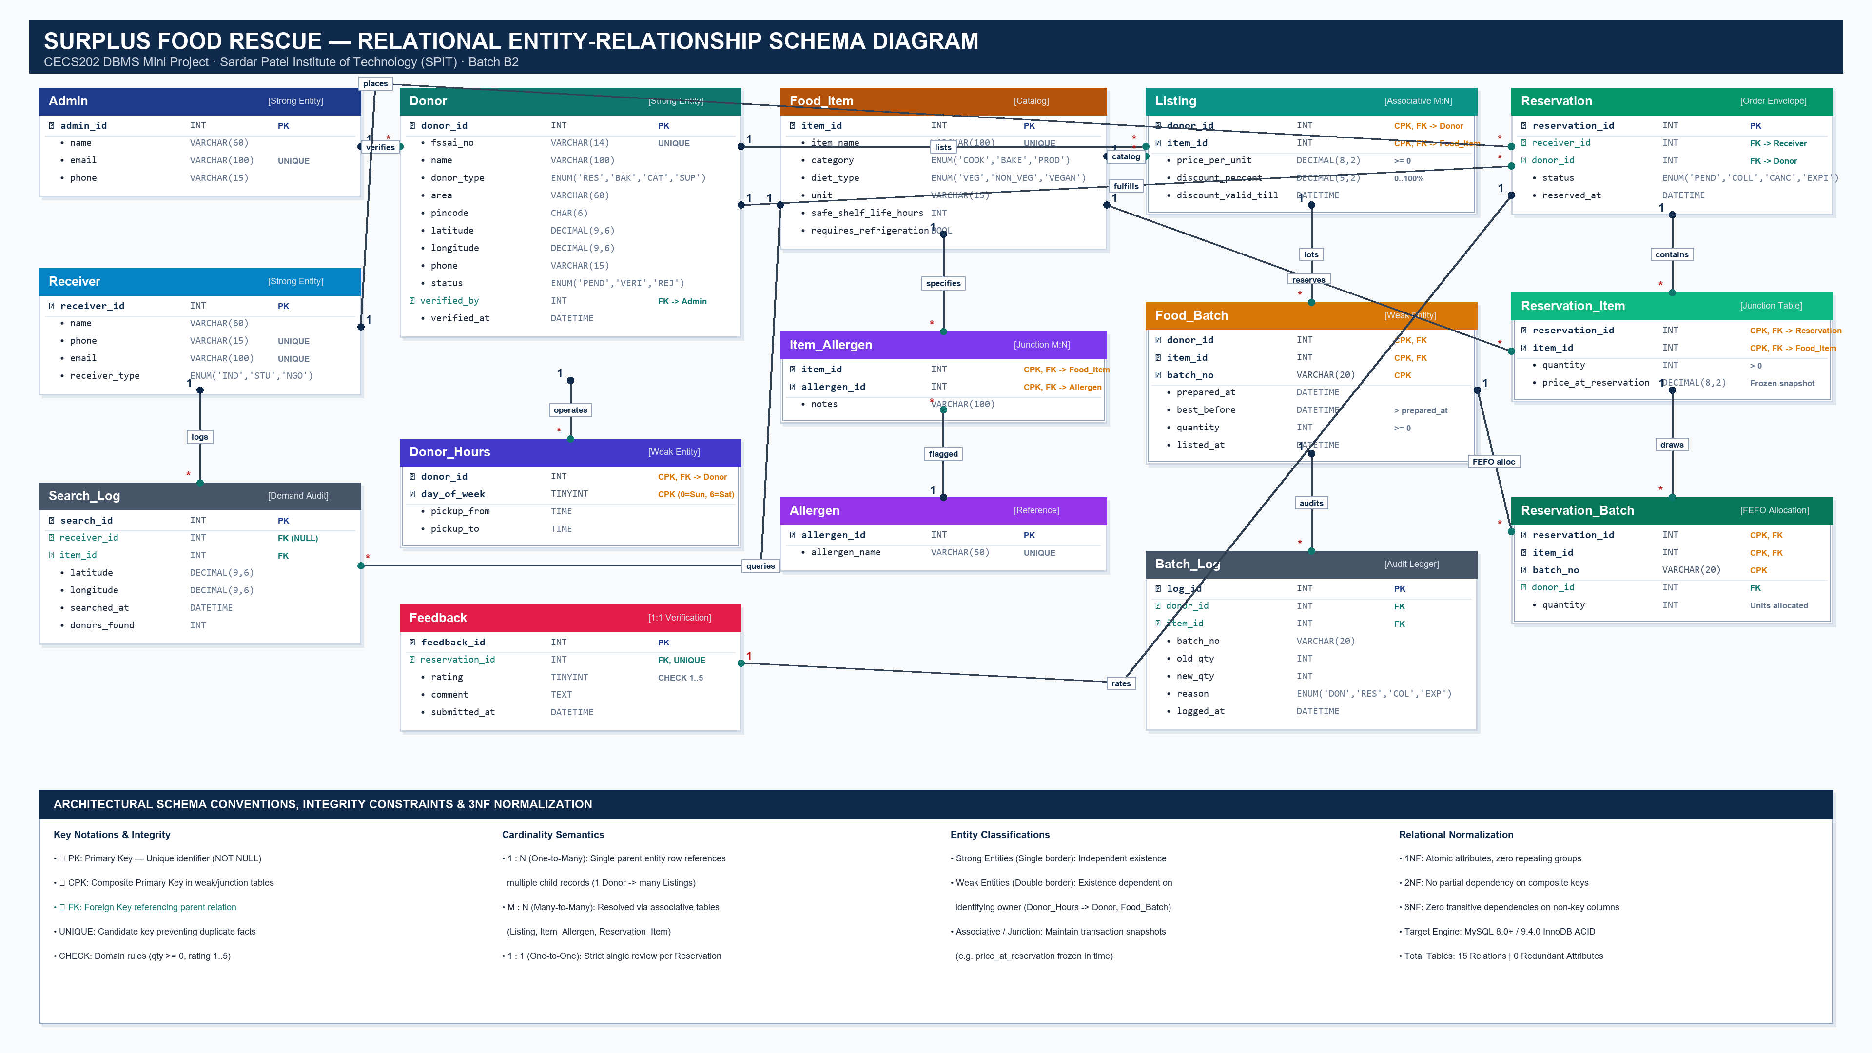
Figure: Complete High-Resolution ER Diagram with Cardinalities & Keys for Surplus Food Rescue

2.2 Relational Schema Specifications (Exact Entity-Attribute Mapping)
Below is the vector-rendered schema specification for all 15 relational tables, defining the primary key, foreign key references, and column types:
Relation | Primary Key (PK) | Attributes & Types | Foreign Keys (FK) & Integrity
Admin | admin_id (PK) | name VARCHAR(60), email VARCHAR(100) UNIQUE, phone VARCHAR(15) | None
Donor | donor_id (PK) | fssai_no VARCHAR(14) UNIQUE, name VARCHAR(100), donor_type ENUM, address VARCHAR(200), area VARCHAR(60), pincode CHAR(6), latitude DECIMAL(9,6), longitude DECIMAL(9,6), phone VARCHAR(15), status ENUM, verified_at DATETIME | verified_by -> Admin(admin_id)
Donor_Hours [Weak] | donor_id, day_of_week (CPK) | pickup_from TIME, pickup_to TIME | donor_id -> Donor(donor_id) ON DELETE CASCADE
Food_Item | item_id (PK) | item_name VARCHAR(100) UNIQUE, category ENUM, diet_type ENUM, unit VARCHAR(15), safe_shelf_life_hours INT, requires_refrigeration BOOL | None
Allergen | allergen_id (PK) | allergen_name VARCHAR(50) UNIQUE | None
Item_Allergen [Assoc] | item_id, allergen_id (CPK) | notes VARCHAR(100) | item_id -> Food_Item, allergen_id -> Allergen
Listing [Assoc] | donor_id, item_id (CPK) | price_per_unit DECIMAL(8,2), discount_percent DECIMAL(5,2), discount_valid_till DATETIME | donor_id -> Donor, item_id -> Food_Item
Food_Batch [Weak] | donor_id, item_id, batch_no (CPK) | prepared_at DATETIME, best_before DATETIME, quantity INT, listed_at DATETIME | (donor_id, item_id) -> Listing ON DELETE CASCADE
Batch_Log [Audit] | log_id (PK) | donor_id INT, item_id INT, batch_no VARCHAR(20), old_qty INT, new_qty INT, reason ENUM, logged_at DATETIME | donor_id -> Donor, item_id -> Food_Item
Receiver | receiver_id (PK) | name VARCHAR(60), phone VARCHAR(15) UNIQUE, email VARCHAR(100) UNIQUE, receiver_type ENUM | None
Reservation | reservation_id (PK) | status ENUM, reserved_at DATETIME | receiver_id -> Receiver, donor_id -> Donor
Reservation_Item [Assoc] | reservation_id, item_id (CPK) | quantity INT, price_at_reservation DECIMAL(8,2) | reservation_id -> Reservation, item_id -> Food_Item
Reservation_Batch [Assoc] | reservation_id, item_id, batch_no (CPK) | donor_id INT, quantity INT | Links to Food_Batch (FEFO allocation)
Search_Log | search_id (PK) | latitude DECIMAL(9,6), longitude DECIMAL(9,6), searched_at DATETIME, donors_found INT | receiver_id -> Receiver (NULL allowed), item_id -> Food_Item
Feedback | feedback_id (PK) | rating TINYINT (1-5), comment TEXT, submitted_at DATETIME | reservation_id (UNIQUE) -> Reservation
3. Relational Schema & Normalization (Up to 3NF)
Every relation is rigorously checked against First Normal Form (1NF), Second Normal Form (2NF), and Third Normal Form (3NF).
3.1 First Normal Form (1NF)
A relation is in 1NF if every attribute contains only atomic (indivisible) values and there are no repeating groups. In our design:
• A donor's 7 daily pickup schedules are decomposed into 7 separate rows in Donor_Hours, rather than comma-separated lists or repeating columns (e.g. mon_open, tue_open).
• Multiple physical food lots are recorded as individual rows in Food_Batch instead of array columns.
• Multiple allergens linked to a food item are resolved via individual rows in Item_Allergen.
• Multi-item reservations are normalized into rows in Reservation_Item.
Conclusion: All 15 relations satisfy First Normal Form (1NF).
3.2 Second Normal Form (2NF)
A relation is in 2NF if it is in 1NF and contains NO partial functional dependencies — i.e., no non-prime attribute depends on a proper subset of any candidate key. Relations with single-column primary keys (Admin, Donor, Food_Item, Allergen, Batch_Log, Receiver, Reservation, Search_Log, Feedback) are in 2NF by definition. The relations with composite primary keys each satisfy 2NF:
• Donor_Hours (donor_id, day_of_week): pickup_from and pickup_to depend on both the donor AND the specific day. Neither attribute can be determined by donor_id alone or day_of_week alone.
• Listing (donor_id, item_id): price_per_unit, discount_percent, and discount_valid_till describe the offering of that specific item at that specific donor. Neither depends on donor_id or item_id in isolation.
• Food_Batch (donor_id, item_id, batch_no): prepared_at, best_before, quantity, and listed_at describe that specific lot at that specific establishment.
• Item_Allergen (item_id, allergen_id): notes specifies that item's specific allergen presence.
• Reservation_Item (reservation_id, item_id): quantity and price_at_reservation depend on both keys.
• Reservation_Batch (reservation_id, item_id, batch_no): quantity drawn from that batch.
Conclusion: All relations have zero partial dependencies and satisfy Second Normal Form (2NF).
3.3 Third Normal Form (3NF)
A relation is in 3NF if it is in 2NF and contains NO transitive functional dependencies — i.e., for every non-trivial functional dependency X -> Y, either X is a superkey or Y is a prime attribute. In our schema:
• In Donor: area and pincode do not determine each other (multiple areas share pincodes in Mumbai). verified_by is a foreign key, but does not transitively dictate donor fields.
• In Food_Item: category and diet_type describe independent classifications of the item; neither determines the other.
• In Reservation: reserved_at, status, donor_id, and receiver_id depend directly on reservation_id.
Deliberate Architectural Choices: price_at_reservation in Reservation_Item captures the point-in-time quoted price at the moment of reservation hold. It represents an immutable historical fact and does not create a transitive dependency on Listing.price_per_unit.
Derived Attributes: final_price and best_before urgency are intentionally computed dynamically via stored functions rather than stored in tables, preventing update anomalies.
Conclusion: All 15 tables are strictly in Third Normal Form (3NF).
4. Table Creation (DDL) & Constraint Enforcement
The database schema enforces relational integrity using MySQL 8.0/9.0 constraints: Primary Keys (PK), Foreign Keys (FK) with cascading or restricted integrity, UNIQUE constraints, NOT NULL constraints, DEFAULT values, and CHECK constraints.
Constraint Name | Target Table | Enforced Invariant / Rule
chk_donor_type | Donor | donor_type IN ('RESTAURANT','BAKERY','CATERER','CANTEEN','SUPERMARKET')
chk_donor_status | Donor | status IN ('PENDING','VERIFIED','REJECTED')
chk_item_category | Food_Item | category IN ('COOKED','BAKED','DAIRY','PRODUCE','BEVERAGE','PACKAGED')
chk_diet_type | Food_Item | diet_type IN ('VEG','NON_VEG','VEGAN','EGG')
chk_listing_price | Listing | price_per_unit >= 0.00 AND discount_percent BETWEEN 0.00 AND 100.00
chk_batch_quantity | Food_Batch | quantity >= 0 AND best_before >= prepared_at
chk_receiver_type | Receiver | receiver_type IN ('INDIVIDUAL','STUDENT','NGO')
4.1 MySQL Terminal Screenshots of Database & Table Creation
Below are actual screenshots from the MySQL command line client confirming database creation and table structures:
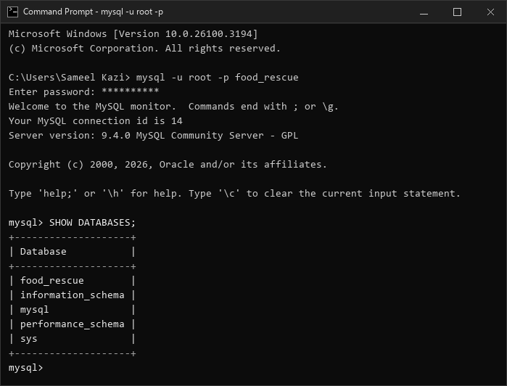
Figure: MySQL Terminal: Verification of 'food_rescue' database creation
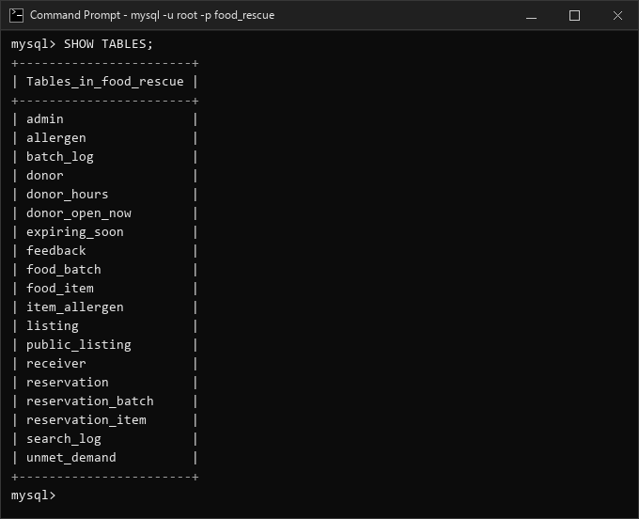
Figure: MySQL Terminal: Verification of all 15 tables created in 'food_rescue'
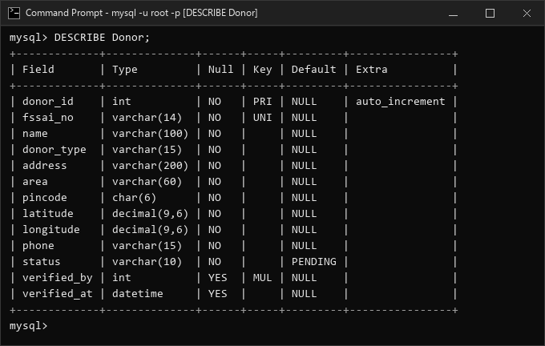
Figure: MySQL Terminal: DESCRIBE Donor showing PK, FK, and status defaults
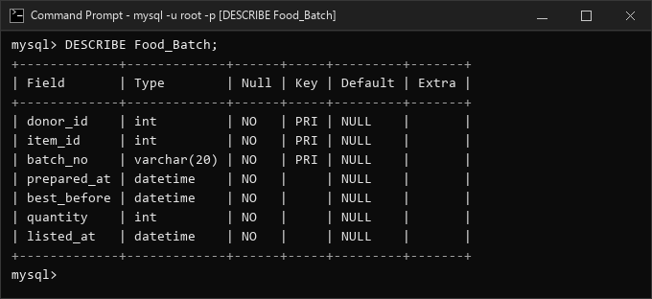
Figure: MySQL Terminal: DESCRIBE Food_Batch showing composite PK and timestamp fields
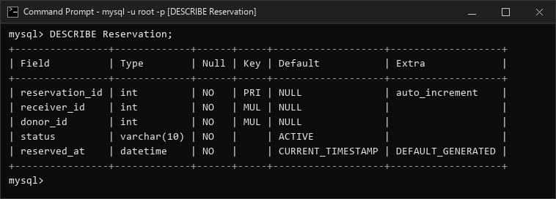
Figure: MySQL Terminal: DESCRIBE Reservation showing FKs and status constraints
5. Sample Data Population (DML) & Verification
Sample data was designed to cover comprehensive operational edge cases: (1) Multiple donor types (restaurants, bakeries, caterers, supermarkets); (2) Donor status variations (VERIFIED, PENDING verification, and REJECTED); (3) Real-world shelf-life distributions (batches expiring in 2 hours, today, and tomorrow); (4) Mixed reservation statuses (ACTIVE holds, COLLECTED, CANCELLED, and EXPIRED); (5) Zero-result search scenarios to test demand logging.
5.1 MySQL Terminal Screenshots of Sample Data Verification
Below are actual MySQL terminal execution screenshots confirming row population across all 15 tables:
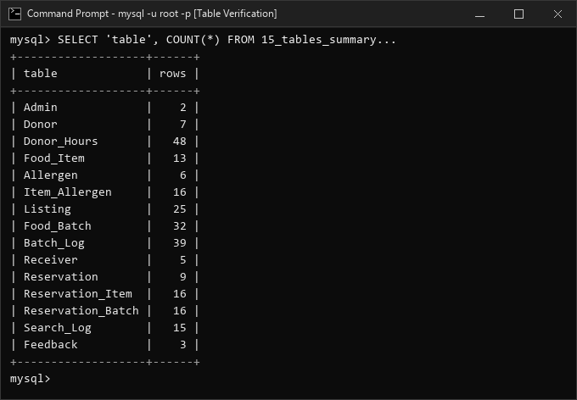
Figure: MySQL Terminal: Row count verification across all 15 normalized tables
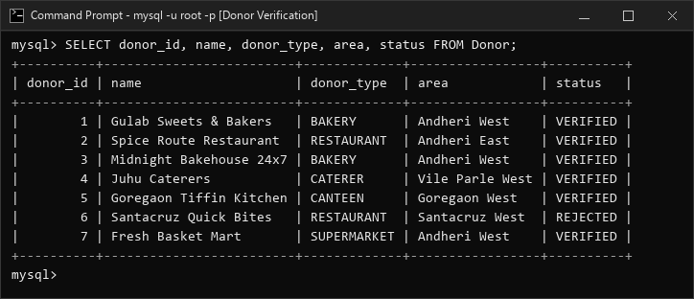
Figure: MySQL Terminal: Sample donor records showing status and classification distribution

