Now I have a thorough understanding of the entire application. Here is the complete feature list:

LendCard — Complete Feature List for Backend & Database Implementation

1. Authentication & User Management
Phone-based OTP Authentication
- Send a 6-digit OTP to a Pakistani (+92) phone number
- Verify OTP with a countdown timer (e.g. resend after 45 seconds)
- Session creation upon successful verification
User Profile
- Store: full name, phone number, avatar initials/color
- KYC verification status flag (verified/unverified)
- Device binding — associate account to a specific device
- Biometric login toggle (stored as a user preference, enforced on device)
- Transaction PIN — set, update, verify
- Two-factor auth toggle
- Sign out / session revocation

2. Card Management
Add Card (via Stripe tokenization)
- Accept card number, expiry, CVV, cardholder name, bank name
- Submit directly to Stripe; store only the Stripe token — never raw PAN
- Store: masked card number (last 4 digits), expiry month/year, bank name, cardholder name, Stripe token reference
Card State
- Active / Frozen status per card
- Tokenized status flag
- Last used timestamp and last virtual card summary
Card Sharing Settings (per card)
- Allow requests toggle
- Auto-approve trusted contacts toggle
- Require biometric per approval toggle
- Per-transaction limit (PKR amount)
- Monthly cap (PKR amount)
- Fixed incentive per transaction (e.g. PKR 80)
Discount Offers (per card)
- Merchant name (e.g. Netflix, Uber Eats, Careem)
- Discount type: percentage (e.g. 30%) or flat amount (e.g. PKR 200)
- Active/inactive flag per offer
- CRUD for discount entries

3. Trusted Circle (Social Graph)
Circle Contacts
- Add contact by phone number + optional nickname
- Invite flow: send invite → pending → accepted/rejected
- Status per contact: Active / Pending / Removed
Per-Contact Permissions
- Auto-approve requests toggle
- Cards the contact can access (whitelist of card IDs)
- Per-transaction limit for this contact
- Monthly limit for this contact
Contact Stats
- Total transactions with this contact
- Total amount earned from this contact (card owner perspective)
- Total amount saved by this contact (requester perspective)

4. Payment Request & Escrow
Create Request (by the discount requester)
- Select circle contact (the card owner)
- Select merchant
- Enter full price
- System calculates: discounted price, platform fee, card holder incentive, total payable
- Attach optional note
Escrow Payment
- Requester pays the full calculated amount upfront before the request is sent
- Funds held in escrow and not released until virtual card charges successfully
- Full refund if card owner declines
Request Lifecycle States
- pending_payment → payment_held → pending_approval → approved / declined → virtual_card_generated → charged / failed → settled / refunded
Approval Flow (by card owner)
- View incoming pending requests with full breakdown
- Biometric confirmation step before approval
- Decline action with immediate refund trigger

5. Virtual Card Generation
Per-Transaction Virtual Card
- Generated only after escrow is confirmed and card owner approves
- Linked to: one merchant, one amount cap, one Stripe token (real card)
- Validity window: 15 minutes from generation
- Auto-expires immediately after successful charge or on timeout
- Store: virtual card token/ID, amount, merchant lock, generated_at, expires_at, status (live / used / expired)
Auto-Charge
- Trigger charge to virtual card immediately upon generation
- On success: mark virtual card used, release escrow, credit card owner incentive to wallet
- On failure: expire virtual card, refund requester
Audit Trail
- Full log per virtual card: generated_at, charged_at, expired_at, charge_status, amount, merchant

6. Wallet
Balance
- Per-user wallet balance (PKR)
- Credit events: incentive earned per approved transaction
- Debit events: withdrawal to bank account
Withdrawal
- Request withdrawal to linked bank account
- Withdrawal status tracking (pending / processed)
Wallet Stats
- Total earned (all time)
- Total saved (as a requester, all time)

7. Transaction History
Transaction Records
- Type: earned (you were the card owner) or saved (you were the requester)
- Merchant name + icon category
- Amount charged, amount saved, amount earned
- Counterparty (circle contact name)
- Card used (masked)
- Timestamp
- Virtual card reference
- Monthly grouping
Aggregate Stats
- Total earned (wallet balance source)
- Total saved (across all requests made)
- Transaction count this month
- Number of active cards

8. Notifications (implied by pending badge on nav)
- New payment request received
- Request approved / declined
- Escrow payment confirmed
- Virtual card charged successfully
- Incentive credited to wallet
- Circle invite received / accepted

9. Fee & Pricing Engine
- Platform fee (flat, e.g. PKR 150 per transaction)
- Card holder incentive (flat, e.g. PKR 80 per transaction)
- Discount percentage or flat amount (per card–merchant offer)
- Real-time breakdown calculation: original price → discounted price → add platform fee → add incentive → total requester pays → net card owner receives

10. Compliance & Security
- SBP (State Bank of Pakistan) compliance flag/audit log
- End-to-end encryption note — enforce TLS on all API calls
- Device binding record per user (device ID, registered_at)
- Per-transaction audit log (who, what card, what virtual card, what amount, timestamp)
- KYC status management (verified / unverified / under review)

Core Database Entities (Summary)
Entity | Key Fields
users | id, phone, name, kyc_status, wallet_balance, device_id, biometric_enabled, 2fa_enabled, pin_hash
cards | id, user_id, stripe_token, last4, expiry, bank_name, holder_name, status, settings (limits, toggles)
card_discounts | id, card_id, merchant, discount_type, discount_value, active
circle_contacts | id, owner_user_id, contact_user_id, nickname, status, auto_approve, per_txn_limit, monthly_limit
circle_card_access | id, circle_contact_id, card_id
payment_requests | id, requester_id, card_owner_id, card_id, merchant, full_price, discounted_price, platform_fee, incentive, total_paid, note, status, created_at
escrow_payments | id, request_id, amount, status, held_at, released_at, refunded_at
virtual_cards | id, request_id, card_id, vc_token, amount, merchant_lock, generated_at, expires_at, status
wallet_transactions | id, user_id, type, amount, reference_id, created_at
withdrawals | id, user_id, amount, bank_details, status, requested_at, processed_at
notifications | id, user_id, type, payload, read, created_at
audit_logs | id, user_id, action, entity_type, entity_id, metadata, created_at

KYC:
KYC Verification Status
KYC = Know Your Customer.
It's a legal requirement in Pakistan (mandated by SBP) that any financial app must verify who the user actually is before letting them move real money. For LendCard it means:
- User submits their CNIC number + a selfie (or a photo of the CNIC)
- A KYC provider (like NADRA Verisys, or a third-party like Trulioo / IDWise) confirms the identity is real
- Only after that can the user add cards, hold escrow funds, or withdraw to a bank
In the database it's just a status field: unverified → pending → verified → rejected. You wouldn't let anyone touch real money until they're verified.

Device binding:
Device binding means: after first login, you record the unique ID of that specific phone. Every subsequent API call is checked — is this request coming from the registered device?
If someone tries to log in from a different phone, they get blocked and the real user gets an alert. It's basically "this account is locked to your phone."
In the database it's just storing: device_id, device_model, registered_at — one row per user.

But what if the mobile itself is hacked?
Then simply we have to rely on the phone number verification, nothing else

Token:
There are actually two types of tokens in LendCard — this is important:
Token Type 1 — Stripe Card Token (tok_...) A random string that represents the user's real card on Stripe's servers. Stored in your cards table. Used whenever you need to generate a virtual card or charge the real card.
Token Type 2 — Virtual Card Token (the disposable card) When a request is approved, LendCard uses the Stripe card token to generate a brand-new temporary virtual card — with its own 16-digit number, CVV, and expiry. This virtual card is:
- Locked to one merchant (e.g. Netflix only)
- Capped at one amount (e.g. PKR 1,470 max)
- Valid for 15 minutes only
- Destroyed immediately after it's charged
So the requester (Sara) never sees the real card. She gets a one-time ghost card that can only be used for exactly what was agreed. Even if she screenshots it, it's dead in 15 minutes.

Why Stripe?
Because you cannot store raw card numbers yourself. Period.
Storing a card number (PAN) means you fall under PCI-DSS compliance — an extremely expensive, audited security standard. Almost no startup can afford it.
Stripe solves this completely:
- The card number goes directly from the user's phone to Stripe's servers
- Stripe gives you back a token (a random string like tok_hbl_x9q2)
- You store only that token — it's useless to a hacker
- When you need to charge the card, you send the token to Stripe and they handle the real card
You never see, touch, or store the actual card number. This is why the app says "your card number never touches our systems."

Card tokenization
→ Partner bank's API (HBL/MCB/Meezan)
or Safepay (they handle PCI compliance for you)

Virtual card generation
→ Direct bank partnership (the hard business problem)
This needs a formal agreement with a bank

Escrow / holding funds
→ Your own wallet system in your database
Backed by a trust account at a partner bank

Wallet withdrawals to bank
→ Raast / IBFT via 1Link
Through Safepay or direct bank API

SMS / OTP
→ Local providers: TPS Engage, Inbox, or Jazz Business SMS

KYC / CNIC verification
→ NADRA Verisys API (the official government system)

Virtual cards need partnership with banking applications . A big problem for our application

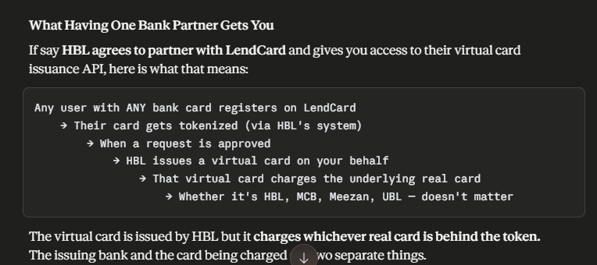

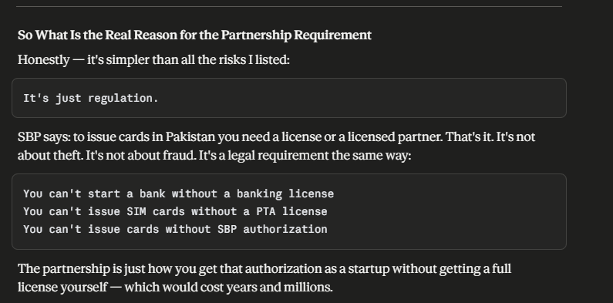

So now what? What options do we have?
Yes. Here are all your realistic options:

Option 1 — Direct SBP Licensed Bank Partnership
You → negotiate with HBL/MCB/Meezan
→ they give you API access under their license
Pros: Full control, local, understands Pakistan market Cons: Slow, requires traction first, months of negotiation

Option 2 — Visa Fintech Fast Track
Visa's own program specifically built for startups that want card issuing without going directly to a bank.
You apply to Visa
→ Visa connects you with a partner bank
→ Bank issues cards under Visa network
→ You get the API
Pros: Visa does the bank relationship work for you, faster than direct negotiation, globally recognized Cons: Still needs a local acquiring bank somewhere in the chain

Option 3 — Mastercard Fintech Express
Exact same concept as Visa's program but from Mastercard's side.
Both Visa and Mastercard have these programs because they want more fintechs on their network — more transactions = more revenue for them. So they actively help startups get access.

Option 4 — Safepay (Local Pakistani Option)
Safepay is a Pakistani payment infrastructure company that already has the bank relationships and licenses in place.
You integrate Safepay's API
→ They handle SBP compliance
→ They handle bank relationships
→ You just build your product
Pros: Already in Pakistan, understands local market, faster onboarding, they handle regulatory headache Cons: Dependent on their capabilities, revenue share, less control

Option 5 — Stripe Atlas + Stripe Issuing
Register a US company via Stripe Atlas
→ Get access to Stripe Issuing
→ Issue virtual cards globally
→ Route payments back to Pakistan
Pros: Best API in the world, most developer friendly, full virtual card control Cons: Complex for Pakistani users, currency conversion, tax complications, not ideal long term

Option 6 — Checkout.com
They operate in MENA region and have card issuing capabilities in the Middle East. Growing presence in Pakistan.
You → Checkout.com API
→ Virtual card issuing via their MENA infrastructure
Pros: MENA focused, understands regional market, single API for issuing + processing Cons: Enterprise focused, might be expensive for early stage, less Pakistan-specific

Option 7 — Marqeta
The most powerful virtual card issuing platform in the world. Used by Cash App, DoorDash, Uber. They specialize in exactly what LendCard needs — programmatic virtual card creation with merchant locking and amount caps.
You → Marqeta API
→ Create virtual card
→ Lock to Netflix
→ Set PKR 1,470 limit
→ Set 15 min expiry
→ Done
Pros: Built exactly for this use case, incredibly powerful API Cons: Not yet in Pakistan, needs US/EU entity, enterprise pricing

Realistic Ranking for LendCard Right Now
Most realistic for MVP
────────────────────────────────
1. Safepay — already in Pakistan, fastest path
2. Visa Fintech Fast Track — they want you on their network
3. Mastercard Fintech Express — same as above

Once you have traction
────────────────────────────────
4. Direct bank partnership (HBL/MCB/Meezan)
5. Checkout.com if expanding to MENA

If you register abroad
────────────────────────────────
6. Stripe Issuing via Stripe Atlas
7. Marqeta — when you're scaling seriously

Short Answer
Safepay is your fastest path in Pakistan right now — they've already solved the SBP and bank relationship problem and expose it as a clean API. Visa and Mastercard's fintech programs are your second option because they actively want startups on their network and do the bank legwork for you. Everything else is either too global, too enterprise, or too slow for where LendCard is right now.

