EduGenie
AI-Powered Academic Learning Assistant
Full Technical Documentation — Consolidated, Two Project Variants
Compiled from project source materials
Document generated: September 25, 2026

Table of Contents

(Right-click the table above and choose “Update Field” in Word to populate/refresh page numbers.)

0. Documentation Note — Two Distinct Implementations
The two source materials provided for this documentation both describe a project named “EduGenie,” but they describe two different systems: different backend frameworks, different frontend stacks, different AI models, and different fallback strategies. They are not versions of the same codebase — there is no evidence one evolved from the other. Rather than force them into a single, internally contradictory specification, this document treats them as two separate variants and documents each in full, followed by a direct comparison and a set of consolidation notes.

0.1 Summary of the Conflict
Dimension | Variant A (Source: README) | Variant B (Source: PDF / SmartInternz report)
Backend framework | Express.js (Node.js / TypeScript) | FastAPI (Python)
Frontend | React 19 + Vite + Tailwind CSS v4 | Server-rendered HTML (Jinja2) + plain CSS
Primary AI model | gemini-3.8-flash (cloud) | Gemini 1.5 Pro (cloud)
Fallback models | gemini-3.5-flash-lite → gemini-flash-latest, then an offline knowledge base | None described for Q&A / quiz / summary / roadmap
Local / on-device model | None | LaMini-Flan-T5-783M, used only for the Explanation module
Quiz output guarantee | Schema-enforced JSON via responseSchema | Free-text JSON requested by prompt, cleaned with a regex before parsing
Markdown rendering | marked.js + Tailwind .prose classes | Not specified (server-rendered strings)
Entry point | server.ts | main.py
Package manager / runtime | npm / Node.js 18+ | pip / Python 3.10+, Uvicorn ASGI server
Attribution | Generic open-source README | SmartBridge / SmartInternz internship submission, authored by Tella Divya Sree, mentor Siri, dated 11/04/2025

0.2 How This Document Is Organized
- Part I documents Variant A in full: architecture, model cascade, webflow, tech stack, setup, API reference, file structure, testing, and deployment.
- Part II documents Variant B in full: project description, architecture, prerequisites, milestone-by-milestone build log, module logic, API reference, file structure, and example walkthroughs.
- Part III compares the two variants side by side.
- Part IV gives consolidation notes — direct, critical observations on gaps and risks in each variant, useful before either is taken into production.

Part I — Variant A: React + Express + Gemini Multi-Model Cascade

1.1 Overview & Value Proposition
EduGenie (Variant A) is an academic learning assistant built as a full-stack TypeScript application. Its stated design goals are to avoid raw, unformatted LLM output and instead enforce four things: student-centric prompting (analogies, real-world examples, beginner-friendly scaffolding), clean typography (Markdown rendered through Tailwind's typography plugin, with no stray asterisks or formatting artifacts), structured, self-contained learning tools (interactive self-grading quizzes, phased roadmaps), and reliability through a multi-model cascade with an offline fallback knowledge base so the app degrades gracefully rather than failing outright.

1.2 Key Features
Feature | Endpoint | Description
Instant Academic Q&A | /qa | Answers academic, historical, and scientific questions with structured bullet points.
Concept Explainer | /explain | Breaks down complex topics using analogies and key-takeaway summaries.
Text Summarizer | /summarize | Condenses textbook chapters, papers, and transcripts into revision-ready summaries.
Interactive Quiz Engine | /quiz | Generates 3 MCQs with 4 options each, instant scoring, explanations, and a confetti animation on completion.
Adaptive Roadmap Advisor | /learn/recommendations | Builds a 3-phase (Beginner → Intermediate → Advanced) roadmap with timeframes and resources.
Interactive Project Kanban | /docs (in-app view) | Built-in tracker showing milestone progress and architecture specs.

1.3 High-Level System Architecture
The client never talks to Gemini directly. All requests pass through the Express server, which injects system prompts, selects the model tier, and normalizes the response shape before it reaches the browser.
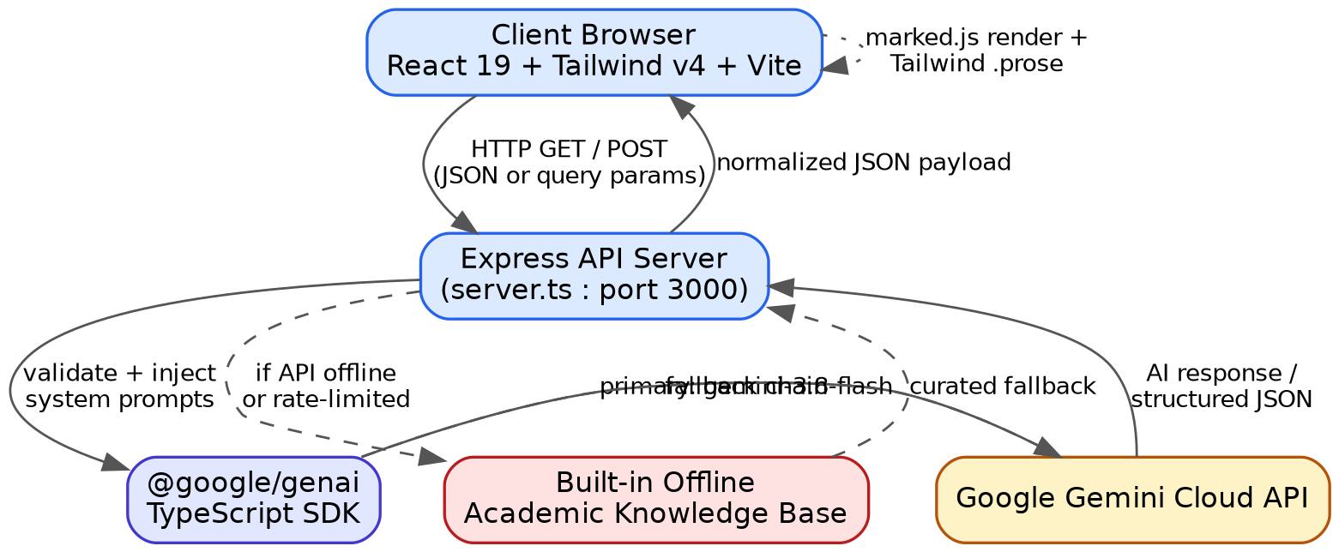
Figure 1.1 — High-level system architecture
- Client (React 19 + Tailwind v4 + Vite) sends HTTP GET or POST requests, either as query parameters or a JSON body.
- The Express server (server.ts, port 3000) validates the request and injects the system prompt appropriate to the module.
- The @google/genai TypeScript SDK issues the call, trying gemini-3.8-flash first, then falling back through the cascade described in §1.4.
- If the API is offline or rate-limited at every tier, the server serves a curated response from the built-in offline knowledge base instead of failing the request.
- The server returns a normalized JSON payload; the client renders it with marked.js and Tailwind's .prose classes.

1.4 Multi-Model Cascade & Fallback Logic
Every request first checks whether GEMINI_API_KEY is configured. If not, the app serves the offline knowledge base immediately — it never attempts a network call it knows will fail. If a key is present, the server tries three model tiers in order, only advancing on a failure (404) or quota error (429).
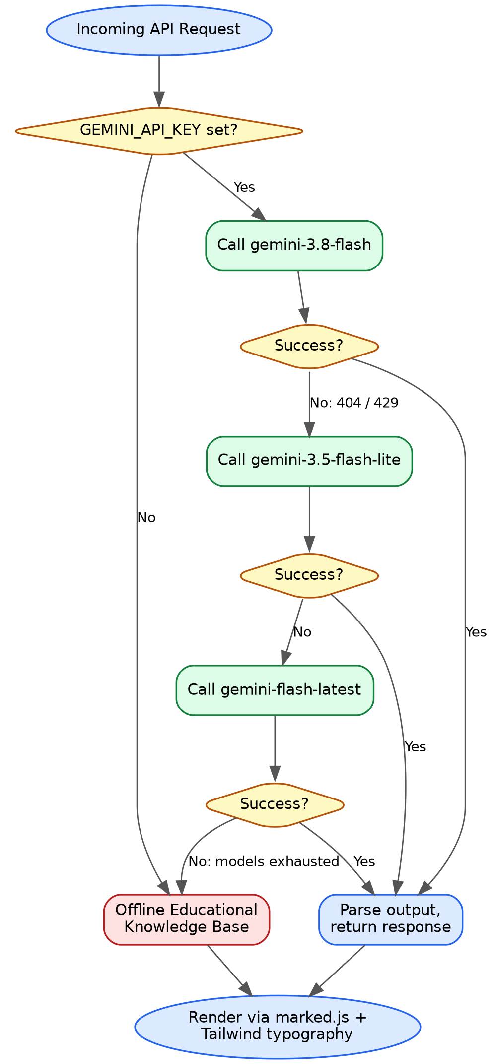
Figure 1.2 — Multi-model cascade & fallback flowchart
1. Attempt gemini-3.8-flash (primary reasoning model).
2. On 404 or 429, attempt gemini-3.5-flash-lite.
3. On further failure, attempt gemini-flash-latest.
4. If all three are exhausted, fall back to the offline educational knowledge base.
5. Whatever the source, render the result through marked.js and Tailwind typography.

1.5 Quiz Generation & Validation Engine
Quiz output is constrained with responseMimeType: "application/json" and an explicit responseSchema passed to the Gemini call, rather than relying on prompt wording alone. The sequence below is the request/response path for a single quiz generation:
1. Student enters a topic (e.g. “Solar System”) into the QuizModule component.
2. The UI issues POST /quiz with { "text": "Solar System" }.
3. The Express handler calls Gemini with responseMimeType: "application/json" and the quiz responseSchema.
4. Gemini returns a JSON string: an array of { question, options[4], answer, explanation } objects.
5. The server runs JSON.parse() as a verification step before responding.
6. The API responds with { quiz: [...], model: "gemini-3.8-flash" }.
7. The UI renders 3 interactive cards with radio-button options.
8. The student selects answers and clicks “Check Answers.”
9. The UI scores the attempt client-side against the answer key and displays green/red badges, explanations, and a confetti animation.

1.6 Application Webflow
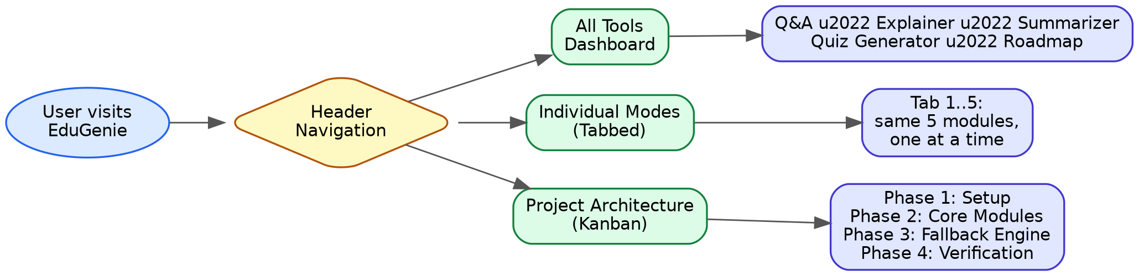
Figure 1.3 — Application webflow

1.6.1 Header Navigation
- All Tools — shows all 5 modules simultaneously on one page; suited to desktop study sessions.
- Individual Modes — a focused, tab-by-tab workflow; suited to mobile or single-topic sessions.
- Project Architecture — an interactive Kanban board tracking requirements, specs, and build status.

1.6.2 Scenarios Bar
One-click test scenarios pre-populate inputs across modules: Largest Ocean, Photosynthesis, Industrial Revolution, Solar System, and Full Stack Web Development.

1.6.3 Response Rendering
- Content passes through marked.parse() and Tailwind's .prose classes for consistent lists, bold terms, headers, and code formatting.
- A navigator.clipboard-based copy button gives temporary “Copied” feedback on each response.

1.7 Complete Technology Stack
Layer | Technology | Purpose
Frontend | React 19 (^19.0.1) | Declarative UI and hooks
Frontend | Tailwind CSS v4 (^4.3.3) | Utility styling and typography (.prose)
Frontend | Marked (^18.0.14) | Markdown to sanitized HTML
Frontend | Canvas Confetti (^1.9.4) | Quiz-completion celebration animation
Frontend | Lucide React (^0.546.0) | UI iconography
Frontend | Vite (^8.3.0) | Build tooling and bundling
Backend | Node.js (v18+ / v20+) | Runtime environment
Backend | Express.js (^4.21.2) | HTTP REST server and middleware
Backend | tsx (^4.21.0) | Native TypeScript execution
Backend | Archiver (^7.0.1) | Project export / zipping
AI / Intelligence | @google/genai (^2.4.0) | Official Google GenAI SDK
AI / Intelligence | gemini-3.8-flash | Primary reasoning model
AI / Intelligence | gemini-3.5-flash-lite | High-speed fallback model
AI / Intelligence | gemini-flash-latest | Secondary fallback model

1.8 Quick Start & Setup Guide

1.8.1 Prerequisites
- Node.js v18.0.0 or higher
- npm v9.0.0 or higher (ships with Node.js)
- A Google Gemini API key (free from Google AI Studio) — see §1.9

1.8.2 Step 1 — Clone the Repository
git clone https://github.com/your-username/edugenie.git
cd edugenie

1.8.3 Step 2 — Install Dependencies
npm install

1.8.4 Step 3 — Configure Environment Variables (.env)
Copy the example file to create an active .env:
# Linux / macOS
cp .env.example .env

# Windows (Command Prompt)
copy .env.example .env

# Windows (PowerShell)
Copy-Item .env.example .env
Then edit the new .env file:
# EduGenie Environment Configuration

GEMINI_API_KEY="YOUR_GEMINI_API_KEY_HERE"

PORT=3000
Security notice
Never commit .env to version control. The repository's .gitignore is already configured to exclude it.

1.8.5 Step 4 — Launch the Development Server
npm run dev
Then open http://localhost:3000 in a browser.

1.8.6 Step 5 — Production Build
# 1. Compile TypeScript and bundle the frontend with Vite
npm run build

# 2. Run the production Express server
npm start

1.9 Obtaining a Gemini API Key
1. Go to https://aistudio.google.com/ and sign in with a Google account.
2. Click “Get API key” in the sidebar or top navigation.
3. Click “Create API key in new project” (or select an existing Google Cloud project).
4. Copy the generated key (it typically starts with AIzaSy...).
5. Paste it into .env as GEMINI_API_KEY.
6. Restart the dev server (npm run dev).
The app is designed to run without a key: omitting GEMINI_API_KEY routes every request straight to the offline knowledge base instead of crashing.

1.10 API Endpoints Specification
All study routes accept both GET (URL query parameters) and POST (JSON body), and are available at both the bare path and an /api-prefixed alias.

1.10.1 Q&A — GET | POST /qa (alias /api/qa)
Request (POST):
{
"question": "Which is the largest ocean on Earth?"
}
Response:
{
"answer": "The largest ocean on Earth is the Pacific Ocean...",
"model": "gemini-3.8-flash"
}

1.10.2 Concept Explainer — GET | POST /explain (alias /api/explain)
Request (POST):
{
"topic": "XGBoost Machine Learning"
}
Response:
{
"topic": "XGBoost Machine Learning",
"explanation": "Imagine building a LEGO tower with friends...",
"model": "gemini-3.5-flash-lite"
}

1.10.3 Summarizer — GET | POST /summarize (alias /api/summarize)
Request (POST):
{
"text": "The Industrial Revolution was the transition to new
manufacturing processes... from around 1760 to 1840."
}
Response:
{
"summary": "Industrial Revolution: Key Points...",
"model": "gemini-3.8-flash"
}

1.10.4 Quiz Generator — GET | POST /quiz (alias /api/quiz)
Request (POST):
{
"text": "Photosynthesis"
}
Response:
{
"quiz": [
{
"question": "Which pigment absorbs sunlight during photosynthesis?",
"options": ["Hemoglobin", "Chlorophyll", "Melanin", "Carotene"],
"answer": "Chlorophyll",
"explanation": "Chlorophyll is the green pigment that traps light energy."
}
// ...2 more questions
],
"model": "gemini-3.8-flash"
}

1.10.5 Learning Recommendations — GET | POST /learn/recommendations (alias /api/learn/recommendations)
Request (POST):
{
"topic": "Full Stack Web Development"
}
Response:
{
"topic": "Full Stack Web Development",
"recommendation": "## Learning Path...\n### Stage I: Beginner (2-3 weeks)...",
"model": "gemini-3.8-flash"
}

1.10.6 Health & Status Check — GET /api/status
{
"status": "ok",
"hasApiKey": true,
"defaultModel": "gemini-3.8-flash",
"fallbackModel": "gemini-3.5-flash-lite",
"version": "1.0.0",
"appName": "EduGenie"
}

1.11 Directory & File Structure
edugenie/
├── .env # Active environment variables (git-ignored)
├── .env.example # Example environment template
├── .gitignore
├── index.html # HTML5 entry template
├── metadata.json # Project capabilities / permissions manifest
├── package.json # Dependencies, scripts, engine config
├── README.md
├── server.ts # Express server & Gemini cascade logic
├── tsconfig.json / tsconfig.node.json
├── vite.config.ts
│
└── src/
├── App.tsx # Root component & layout state
├── index.css # Global Tailwind CSS & .prose typography
├── main.tsx # Client DOM bootstrap
├── types.ts # Shared TypeScript models
│
└── components/
├── ApiKeyModal.tsx # Status & key configuration inspector
├── ExplainModule.tsx # Concept explainer UI
├── Header.tsx # Navigation header
├── LearningPathModule.tsx# Roadmap advisor UI
├── ProjectShowcase.tsx # Architecture & Kanban board
├── QAModule.tsx # Q&A UI with Markdown rendering
├── QuizModule.tsx # Quiz UI, scoring & confetti
├── ScenariosBar.tsx # One-click test scenarios
└── SummarizeModule.tsx # Revision summarizer UI

1.12 Testing & CLI Verification
The backend can be exercised directly with curl:
# 1. Verify API status
curl -s http://localhost:3000/api/status

# 2. Test Q&A with a GET query
curl -s "http://localhost:3000/qa?question=What%20causes%20the%20tides"

# 3. Test Concept Explainer with a POST body
curl -s -X POST http://localhost:3000/explain \
-H "Content-Type: application/json" \
-d '{"topic":"Quantum Computing"}'

# 4. Test Quiz Generator
curl -s -X POST http://localhost:3000/quiz \
-H "Content-Type: application/json" \
-d '{"text":"Pythagorean Theorem"}'

1.13 Production Deployment

1.13.1 Option A — Google Cloud Run / Container Platforms
1. Provide PORT=3000 and GEMINI_API_KEY as environment secrets.
2. Build command: npm run build
3. Start command: npm start

1.13.2 Option B — Render / Railway
1. Connect the GitHub repository.
2. Set the environment to Node.
3. Build command: npm install && npm run build
4. Start command: npm start
5. Add GEMINI_API_KEY in the environment settings tab.

1.14 License
Released under the MIT License.

Part II — Variant B: FastAPI + Gemini 1.5 Pro + Local LaMini-Flan-T5
This variant is documented from a SmartBridge / SmartInternz internship project submission (submitted by Tella Divya Sree, mentor Siri, dated 11/04/2025).

2.1 Project Description
EduGenie (Variant B) is a lightweight AI-powered educational assistant that simplifies learning through generative AI, designed for students of all academic levels. It enables users to ask questions and receive concise answers, understand complex concepts through simplified explanations, generate quizzes from topics or text, receive personalized learning recommendations, and summarize long educational passages. It is built with FastAPI on the backend and a simple HTML + CSS frontend, combining a lightweight local model with cloud-based AI for efficiency and power, and is reported to run well on modest hardware such as an Apple M1 Mac.

2.2 Usage Scenarios
- Scenario 1: A student curious about oceans and rivers asks EduGenie, “Which is the largest ocean?”
- Scenario 2: A student wants to check her understanding of the Pythagorean Theorem and clicks “Generate Quiz.”
- Scenario 3: A learner exploring SQL requests a learning path — a structured plan from beginner to advanced topics with timelines and resource suggestions.

2.3 Architectural Diagram
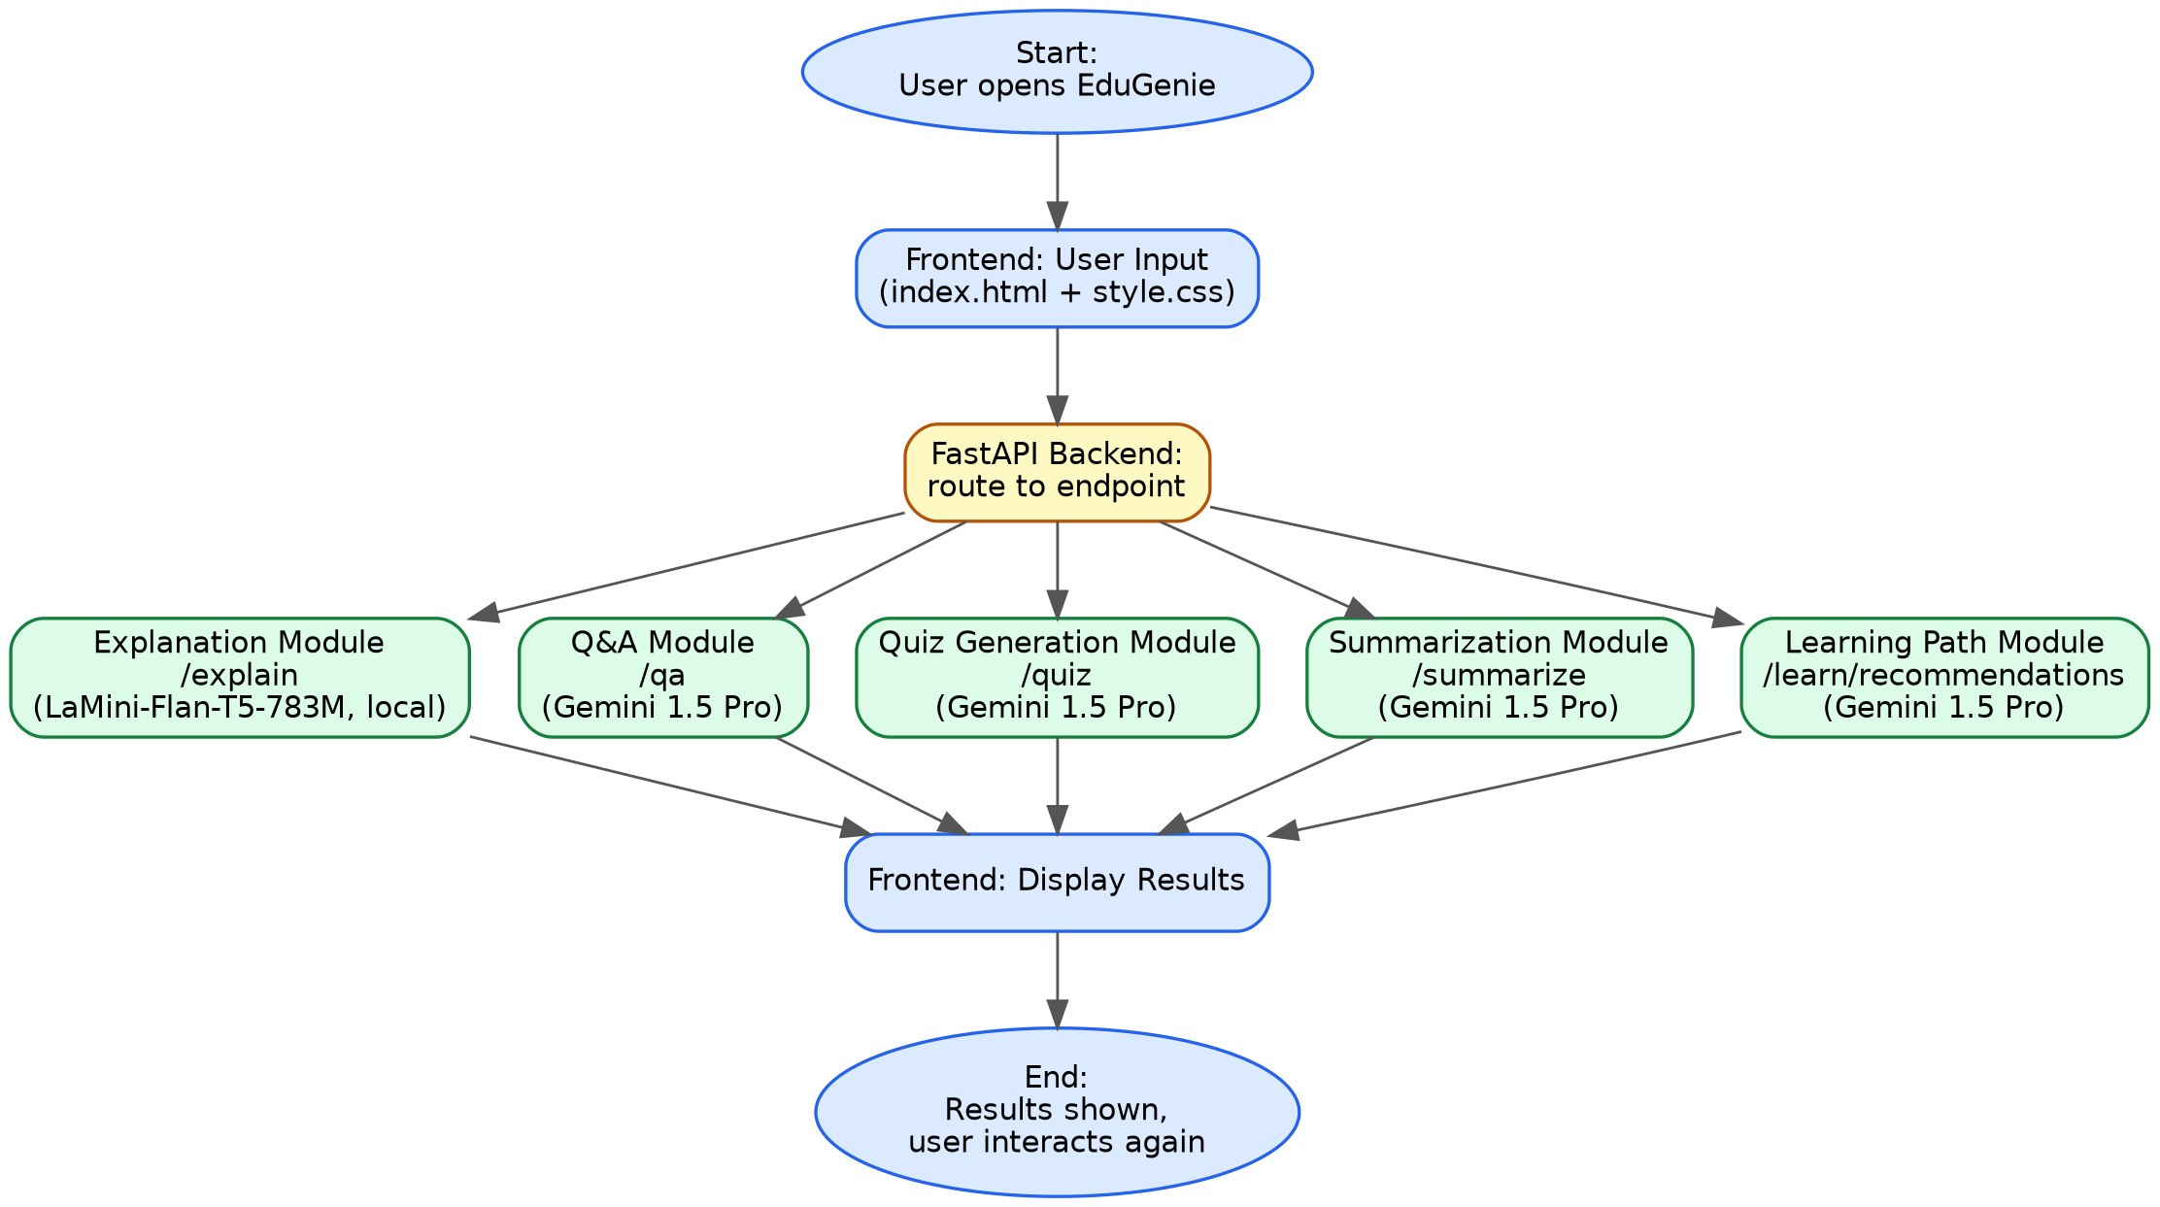
Figure 2.1 — System architecture (FastAPI backend routing to five modules)
- User opens EduGenie → the frontend (templates/index.html + static/style.css) captures input.
- The FastAPI backend routes the request to the module matching the user's selection.
- Five independent modules handle Explanation, Q&A, Quiz Generation, Summarization, and Learning Path requests.
- Results are returned to the frontend and displayed; the user can continue interacting, restarting the cycle.

2.4 Prerequisites

2.4.1 Python 3.10+
1. Download the Python 3.10+ installer for your OS from the official site.
2. Run the installer and check “Add Python to PATH.”
3. Follow the setup prompts to complete installation.
4. Verify with: python --version

2.4.2 FastAPI Framework
Backend web framework used for all five module endpoints.

2.4.3 HTML & CSS
Basic templating used under /templates and /static for the frontend.

2.4.4 Google Gemini API Key
1. Visit Google AI Studio and sign in with a Google account.
2. Create a new project and enable the Gemini API.
3. Generate an API key and store it securely.

2.4.5 Uvicorn (ASGI Server)
pip install uvicorn

2.4.6 Jinja2 (HTML Templating Engine)
pip install jinja2

2.5 Project Workflow — Development Milestones
Figure 2.2 — Development milestone sequence

2.5.1 Milestone 1 — Model Selection & Architecture
Activity 1.1: Select AI Models
Model | Used for | Why
Gemini 1.5 Pro (via API) | Q&A, summarization, quiz generation, learning paths | Advanced reasoning, structured outputs, cloud inference
LaMini-Flan-T5-783M (local) | Concept explanation only | Instruction-tuned, lightweight, CPU-compatible
Folder architecture established at this milestone:
EduGenie/
├── main.py # FastAPI app
├── explanation_module.py # Concept explanation logic
├── qna.py # Question answering
├── quiz_module.py # Quiz generation
├── summary_module.py # Summarization
├── learning_path.py # Learning recommendations
├── templates/index.html # HTML frontend
├── static/style.css # Styling
└── requirements.txt # Python dependencies

2.5.2 Milestone 2 — Core Functionalities Development
Activity 2.1: Module Implementation

1. Explanation Module
Uses the local LaMini-Flan-T5 model to deliver simplified, context-aware explanations aimed at beginners and self-learners, without a network round-trip to Gemini.
from transformers import AutoTokenizer, AutoModelForSeq2SeqLM
import torch

explain_tokenizer = AutoTokenizer.from_pretrained("MBZUAI/LaMini-Flan-T5-783M")
explain_model = AutoModelForSeq2SeqLM.from_pretrained("MBZUAI/LaMini-Flan-T5-783M")

def explain_topic(topic: str) -> str:
input_text = f"Explain the concept of '{topic}' in a simple and"
f" clear way for a school student."
inputs = explain_tokenizer(input_text, return_tensors="pt")
outputs = explain_model.generate(
**inputs, max_new_tokens=150, temperature=0.7,
top_k=50, top_p=0.95, do_sample=True,
)
return explain_tokenizer.decode(outputs[0], skip_special_tokens=True)

2. QnA Module
Powered by Gemini 1.5 Pro for general knowledge and academic question answering.
def answer_question_with_gemini(question: str) -> str:
try:
model = genai.GenerativeModel(model_name="models/gemini-1.5-pro")
response = model.generate_content(question)
return response.text.strip()
except Exception as e:
return f"Error in QnA: {e}"

3. Quiz Module
Generates three MCQs (4 options each) from a passage via a structured prompt, then cleans and parses the model's JSON output.
def clean_json_block(text):
# Remove Markdown ```json code fences
return re.sub(r"```(?:json)?\n(.*?)```", r"\1", text,
flags=re.DOTALL).strip()

def generate_quiz(text: str) -> list:
try:
model = genai.GenerativeModel(model_name="models/gemini-1.5-pro")
prompt = f"""
You are a quiz generator.
From the following passage, create 3 multiple-choice questions.
Each question should include: a "question", a list of 4 "options",
and a correct "answer" that must exactly match one of the options.
Format your output as valid JSON.

Passage:
{text}
"""
response = model.generate_content(prompt)
cleaned_text = clean_json_block(response.text.strip())
return json.loads(cleaned_text)
except Exception as e:
return {"error": f"Quiz generation failed: {e}"}
If generation or parsing fails, the module returns a detailed error message for debugging rather than a silent failure.

4. Summary Module
Uses Gemini's generative capabilities to condense long passages while retaining core information.
def summarize_text(text: str) -> str:
try:
model = genai.GenerativeModel(model_name="models/gemini-1.5-pro")
prompt = f"Summarize the following text in simple language:\n\n{text}"
response = model.generate_content(prompt)
return response.text.strip()
except Exception as e:
return f"Error in Summary: {e}"

5. Learning Path Module
Generates a structured, adaptive learning path for any topic — beginner through advanced — with recommended resources (videos, articles, books), and handles API errors gracefully.
def get_learning_recommendations(topic):
prompt = f"""
You are an AI tutor. The student wants to learn about: {topic}.
Suggest a structured and adaptive learning path including key topics,
order of learning, and resources. Include beginner, intermediate,
and advanced levels if needed.
"""
try:
response = model.generate_content(prompt)
if hasattr(response, "text"):
return response.text
elif hasattr(response, "parts") and response.parts:
return response.parts[0].text
else:
return "Could not extract content from Gemini response."
except Exception as e:
import traceback; traceback.print_exc()
return f"Error occurred: {str(e)}"

Activity 2.2 — Backend API with FastAPI
RESTful endpoints defined and wired to their respective module logic:
@app.get("/qa")
async def answer_question(question: str = Query(...)):
answer = answer_question_with_gemini(question)
return {"answer": answer}

@app.post("/explain/")
async def explain_api(request: Request):
data = await request.json()
topic = data.get("topic")
if not topic:
return JSONResponse(content={"error": "Please provide a topic."}, status_code=400)
explanation = explain_topic(topic)
return {"topic": topic, "explanation": explanation}

@app.post("/summarize/")
async def summarize_api(request: Request):
data = await request.json()
text = data.get("text")
if not text:
return JSONResponse(content={"error": "Please provide text to summarize."}, status_code=400)
summary = summarize_text(text)
return {"summary": summary}

@app.post("/quiz")
async def quiz_api(request: Request):
data = await request.json()
text = data.get("text")
if not text:
return JSONResponse(content={"error": "Please provide text for quiz."}, status_code=400)
quiz = generate_quiz(text)
return JSONResponse(content={"quiz": quiz})

@app.get("/learn/recommendations")
async def learning_recommendation_api(topic: str = Query(...)):
recommendation = get_learning_recommendations(topic)
return {"topic": topic, "recommendation": recommendation}

2.5.3 Milestone 3 — Frontend Development
Activity 3.1: Build Web Interface
- HTML form (index.html): task dropdown (Explain, QnA, Quiz, Summary, Recommend Path), a text input per task, and a submit button.
- CSS styling (style.css): responsive layout, styled buttons, input areas, and a result container beneath each form.
Activity 3.2: Live Integration
- Form submission sends a POST request to the FastAPI backend.
- The result is injected below the input box in real time (no full page reload).

2.5.4 Milestone 4 — Deployment
Activity 4.1: Run Locally
uvicorn main:app --reload
# then open http://127.0.0.1:8000
Activity 4.2: Functional Testing checklist
- Ask a question
- Get an explanation
- Generate a quiz
- Summarize content
- Get a personalized learning plan

2.6 API Endpoints Specification
Endpoint | Method | Body / Query | Backing model
/qa | GET | question (query param) | Gemini 1.5 Pro
/explain/ | POST | { "topic": string } | LaMini-Flan-T5-783M (local)
/summarize/ | POST | { "text": string } | Gemini 1.5 Pro
/quiz | POST | { "text": string } | Gemini 1.5 Pro
/learn/recommendations | GET | topic (query param) | Gemini 1.5 Pro

2.7 Directory & File Structure
EDUGENIE/
├── __pycache__/
├── static/
│ └── style.css
├── templates/
│ └── index.html
├── explanation_module.py
├── learning_path.py
├── main.py
├── qna.py
├── quiz_module.py
├── requirements.txt
└── summary_module.py

2.8 Exploring EduGenie — Example Walkthroughs

a. Asking a question
Input: "which is the largest ocean?"
Output: "The Pacific Ocean is the largest ocean on Earth."

b. Explaining a topic
Input: "quantum computing" → a plain-language explanation covering qubits and why quantum calculations can outperform classical ones for certain problems.
Input: "Binary Search Algorithm" → explained via a "needle in a haystack" analogy over a sorted list.

c. Summarizing a paragraph
A paragraph on the Industrial Revolution is condensed into a short summary covering the shift from farming to factories, key inventions (e.g. the steam engine), and both the benefits and downsides (working conditions, child labor, pollution, urban crowding).

d. Generating a quiz
Input topic: "Pythagoras theorem." The module returns three MCQs in sequence; each is checked immediately — a correct pick shows a green "Correct!" badge, an incorrect pick shows a red badge with the correct answer (e.g. "Incorrect. Correct answer: a² + b² = c²").

e. Learning recommendations
Input topic: "SQL." The module returns a structured "Zero to Hero" path:
- Beginner (1–2 weeks): relational model basics, SELECT/FROM/WHERE, data types, filtering, ordering, aggregate functions — with resources such as SQLZoo, Khan Academy, Codecademy, and freeCodeCamp.
- Intermediate (2–3 weeks): joins (INNER/LEFT/RIGHT/FULL OUTER), subqueries, GROUP BY / HAVING, set operations, string and date functions, views — with resources such as “SQL Queries for Mere Mortals” and vendor documentation.
- Advanced (3–4+ weeks): stored procedures, triggers, indexing and performance tuning, transactions and concurrency, database design/normalization — with resources such as “SQL Performance Explained” and “Database Internals.”
- The response also includes general adaptive-learning tips: master fundamentals first, practice regularly, use real datasets, focus on underlying logic over memorized syntax, break problems down, and use community help when stuck.

2.9 Conclusion (as reported by the project team)
EduGenie (Variant B) is presented as a robust, accessible AI-powered educational assistant combining cloud intelligence with a lightweight web interface, aimed at self-learners, educational institutions, and content platforms. Reported challenges during development included ensuring accuracy in AI-generated responses, maintaining performance across devices, and balancing personalization with general usability — addressed through iterative testing, prompt tuning, UI refinement, and attention to data-privacy concerns.
Future directions noted by the project team:
- Voice-based interaction for hands-free, accessible use.
- Multilingual support to reach a broader audience.
- A mobile application with offline access.
- Progress-tracking dashboards with learning metrics.
- Gamified elements: badges, streaks, challenge-based assessments.
- Data-driven adaptive learning paths.
- Group study sessions and teacher/parent dashboards.
- Integration with LMS platforms such as Moodle or Google Classroom.
- Image and PDF input recognition for snapshot-based doubt solving.

2.10 Project Submission Details
Field | Value
Submitted by | Tella Divya Sree
Mentor | Siri
Date | 11/04/2025
Program | SmartBridge / SmartInternz

Part III — Side-by-Side Comparison
Dimension | Variant A | Variant B
Backend | Express.js / TypeScript | FastAPI / Python
Frontend | React 19, Vite, Tailwind CSS v4 | Jinja2 templates, plain CSS
Primary model | gemini-3.8-flash | Gemini 1.5 Pro
Fallback strategy | 2 additional Gemini tiers, then an offline KB | None outside the local explanation model
Runs fully offline? | Yes — offline KB covers all 5 modules | No — 4 of 5 modules require Gemini; only Explanation is local
Quiz reliability mechanism | Schema-enforced JSON (responseSchema) | Prompt-requested JSON + regex fence-stripping + json.loads()
Quiz UX on completion | Confetti animation, color-coded scoring | Inline correct/incorrect badge per question, no animation noted
Roadmap depth | 3 phases (Beginner/Intermediate/Advanced) with timeframes | 3 levels with timeframes and named external resources
State / navigation modes | All-Tools dashboard, tabbed modes, Kanban view | Single-page form with one result block per module
Deployment targets documented | Cloud Run, Render, Railway | Local Uvicorn only
Hardware note | Not specified | Reported to run on an Apple M1 Mac

Part IV — Consolidation Notes & Risks
These are direct observations on gaps and risks in the source material, not restatements of the marketing copy in either document. Worth resolving before either variant is treated as production-ready.

4.1 One project, two incompatible implementations
Nothing in either source document indicates a migration path or version history between the two stacks. If both are meant to be “EduGenie,” that needs to be resolved explicitly — pick one as canonical, or rename one of them — before onboarding contributors or users. Shipping documentation for both under a single name, as this document does, is a stopgap, not a fix.

4.2 Variant A's model names are unverified
gemini-3.8-flash, gemini-3.5-flash-lite, and gemini-flash-latest do not correspond to any Gemini model family Google had publicly documented as of this assistant's knowledge cutoff (January 2026). This may reflect a newer release this document's author isn't aware of, a placeholder/internal naming scheme, or a documentation error. Before deploying against these identifiers, confirm them against Google's current model list — an unverified model name in a cascade is a silent failure mode: the primary call could 404 indefinitely and the app would run permanently on fallback tiers without anyone noticing.

4.3 Variant B has a single point of failure
Variant A's design explicitly trades complexity (three model tiers plus an offline KB) for resilience: a Gemini outage degrades gracefully. Variant B's local model only covers the Explanation module — Q&A, Quiz, Summarize, and Learning Path all call Gemini 1.5 Pro directly with a try/except that returns a string error message, not a fallback response. A Gemini outage or quota exhaustion takes down 4 of 5 features simultaneously. If Variant B is the direction to build on, this is the first gap worth closing.

4.4 “Strict JSON Schema Enforcement” is not the same guarantee in both variants
Variant A's README claims strict JSON schema enforcement for quizzes, backed by an actual responseSchema parameter passed to the Gemini call — the API itself is constrained to emit matching JSON. Variant B achieves the same output shape by asking for JSON in the prompt text and then stripping Markdown code fences with a regex before calling json.loads(). That is meaningfully weaker: a model deviation (extra prose before the JSON, a trailing comma, an unescaped quote) will throw at parse time with no fallback, versus Variant A's error being structurally prevented up front. If reliability matters, Variant B's quiz module should adopt schema-constrained generation rather than post-hoc string cleanup.

4.5 Neither variant's API layer validates output content, only structure
Both variants check that a response parses (valid JSON, non-empty string) but neither validates that quiz answers actually match one of the four listed options, that explanations stay within a length budget, or that the model didn't hallucinate a fact. That's a correctness gap independent of the plumbing differences above, and it exists in both variants.

End of consolidated documentation.

