**ABSTRACT**

PRISON MANAGEMENT SYSTEM is an efficient application for maintaining Prisoners information. More than a data storage program, it helps you manage the prisoners. It offers a wide variety of Reports that give you exactly the information you need. Add new prisoner details and about new cases. It enables to track every prisoner and their activities. There are three kinds of users Data administrator, Police officials and Administrator. Administrator is considered as Super user and he has full access and rights over the system than anybody else. Administrator can view the details of prisoners, cases, release diary, parole register and interview requests as well as in-out register. Next Police officials have rights to view the nominal rolls, case, parole, interview requests and his functionality is to check the nominal roll which comprises of whole details of prisoners and to fix date for court hearing as per court’s advice. Finally, Data administrator prepares reports and enters data on behalf of the administrator with appropriate data. They have privilege to add and update the data as per administrator’s concern. The interview requests of relatives are made through data admin to administrator and the status of reports can reflect appropriately.

The system is part of a large Application and shall be responsible for maintaining information about prisoners,

* Nominal Roll,
* New case details,
* Automated release diary generator,
* Parole register.

1. **INTRODUCTION**

Basically prison is a correctional institution where persons are confined while on trial or for punishment. Each prison may have hundreds of criminals. With hardcopy of records it is hard to search report or record about a particular criminal in prison. The purpose of Prison Management System is to make the search of those records easier. The purpose of this document is to present a detailed description of the Prison Management System. The document will describe what the system will do, the constraints under which it must operate and how the system will react to external stimuli.

Scope of Project

This software system will be a Prison management System for Prison Department. This system will be efficient collection of records and reports about the prisoners in prison. Besides police officers and higher government authorities can see reports about prisoners easily. The public can search their relatives or friends who are imprisoned for certain lawful detention, about the crime, place where they imprisoned or release date of imprisoned person. Public can request to the prison authorities for meeting imprisoned person through this system. More specifically, this system will design to allow a data manager to add/update record about prisoners and administrator who may be prison administrator or government higher official to have full access rights. The police officer can search record about prisoner with confidential data. The software will facilitate communication between police officers, data manager and the administrator via E-Mail.

1. **BACKGROUND**

**EXISTING SYSTEM**

The prison system uses the documentation form storage which is a single user system to find the wanted information.

* The important and the most significant drawback is that the system is manual. There may be errors due to carelessness or oversight that may result in loss to the data and as to the organization. For an organization, time is very important factor.
* The prison information is stored in the document form which is like a data sheet. This makes it impossible to search for information in such a huge number of documents manually and to add new information if the searched information is not available.

**PROPOSED SYSTEM**

The proposed system is designed to eliminate all the drawbacks of the existing system. The system is part of a large Application and shall be responsible for maintaining information about prisoners,

* Demographic details,
* New case details,
* Automated release diary generator,
* Parole register,
* Interview request register,
* In-out register,
* Court hearing register,

The major advantage of the proposed system is,

* It is an application, so that information is available anytime.
* High integrity and security.
* Ability to incorporate newly available data.
* It is user friendly.
* Speed and accuracy is increased.
* Fully automated.
* Security is associated with user authentication
* Duplication of information is curbed.

**PROJECT GOALS**This project is aimed at developing a prison management system that is a collection of registers and reports for the effective management of prisons. Besides this police and government officials can see crime/criminals reports for their purpose.

**1. Nominal Roll**: The details of the prisoner and his/her demographic details should be captured. A digital photo comprising different views of the prisoner and the list of articles surrendered by prisoner during nominal roll are to be recorded.

**2 .** **Case register**: All the details of the cases against the prisoner should be captured. This must include the sentence details, remand/conviction details, etc.

**3 Automated release diary generator:** This report should be display the list of prisoners to be released on a day, the next day, the next week, the next month, or any given duration of time. The system should consider the reduction of sentence length due to various considerations.

**4 Parole register:** This module should track all prisoners on parole and provide necessary reports on this data.

**5 Duty register:** Who was where, why and when.

**6 Interview requests:** All interview requests by the relatives of the prisoners need to be recorded and tracked.

**7 In-out register:** An in-out register will track all prisoners and others who move in and out for various reasons. This should include provisions for recording the prisoners sent to courts for hearing.

8 Fund allotted and routine accounting transactions should be captured.

1. **OVERALL DESCRIPTION**

**Police Officer**: should be given read only access to the information of prisoners. Police officers can seek information regarding prisoners and convicts. The information is used to make decisions regarding court hearings, remands, release dates etc. He is also given permission to view all the details and registers such as parole register, case register, interview register and in out register. He can add data to in out register that means he can fix a prisoner to go for court hearing as he receives orders from the court to his cabinet. He can also view and modify the interview requests if only there exists some critical issues or endangers in fixing a prisoner to meet his fellow men. The duty register is also supervised by the police officials.

**Data Manager**: should be given the responsibility of adding or updating the existing information. On the behalf of administrator data manager prepares all the registers with appropriate data. They can have the privilege to add and update data in the different registers. Data administrator adds the details of a new prisoner details such as name, age, identity marks, nationality etc. He also registers the details of new case with details of case and persons involved in that particular case and date of court hearings. Parole register is also maintained by the data administrator he tracks the details and particulars of prisoner who is paroled and parole respectively. Automated release diary is also in control of data administrator under the supervision of administrator, data administrators can be able to add the details of release dairy and date particulars. The interview requests is also made by data administrators and the request is send to administrator for approval and the status of requests can be tracked by data administrators. In out register is entered in accordance with the court hearings and other personal events of particular prisoner.

**Administrator**: can be a Jail administrator or government official to handle the troubleshooting or the managing of the system. Administrator is treated as a super user in this system. Administrator can maintain different registers such as Nominal Rolls, Case Register, Automated Release Register, Parole Register, Duty Register and In-Out Register. Other tasks done by the administrator are generation of reports, maintenance of log files, backup, and recovery of data any time. Administrator also manages details of number of cells and their usage. Administrator is also responsible for managing finances of prison. Administrators are given permission to approve or decline the interview requests by the relatives and friends of prisoners to meet them and also administrator is given superior power to overlook the in and out timings in a register where prisoner is going out of prison for various reasons such as court hearings, family function and personal problems. He can also look over and supervise the parole register; automated release diary is also managed under his guidance. The duty register and case register is also overviewed by the administrator. The new cases and new prisoners are supervised by the administrator.

* + 1. **USECASE DIAGRAM**

The use case consists of three users :

1. Police officer: He who is provided with read only access to the information related to the prisoners. After logging in his own account, a police officer will be able to view information of criminals. He can then view nominal role, case register, in-out register, duty register, release diary and he has to confirm the interview requests by the relatives of criminals.
2. Administrator: can be a Jail Administrator or a government official. Has a right to view data and also generation of various reports.
3. Data Manager: Deals with the addition or updation of the existing data.

**USE CASE DIAGRAM:**

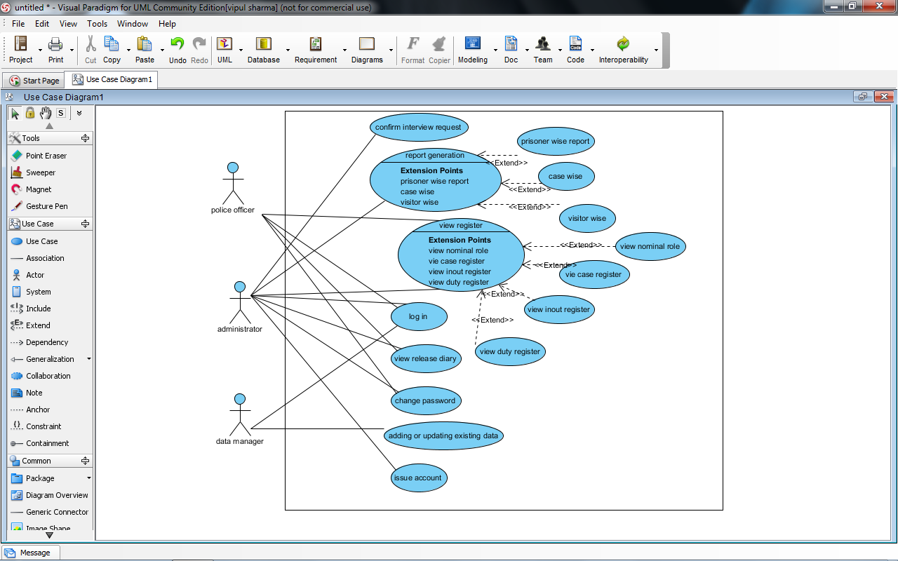

**2.9 Class Diagram**

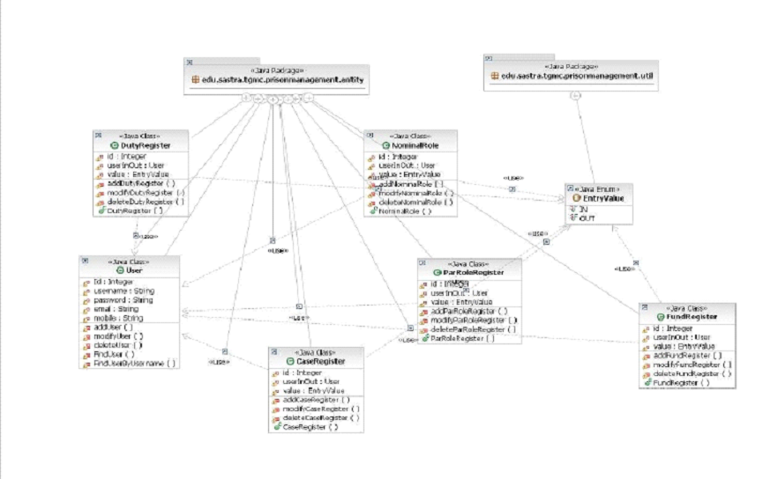

**3.1.2ACTIVITY DIAGRAM:FIGURE 9: ACTIVITY DIAGRAM OF E-CRIME REPORTING SYSTEM**

**USER LOGIN ACTIVITY:**

User is made to enter the username and password. If it is a valid username and password, then the user is logged in, or else they are asked to re enter the correct values.

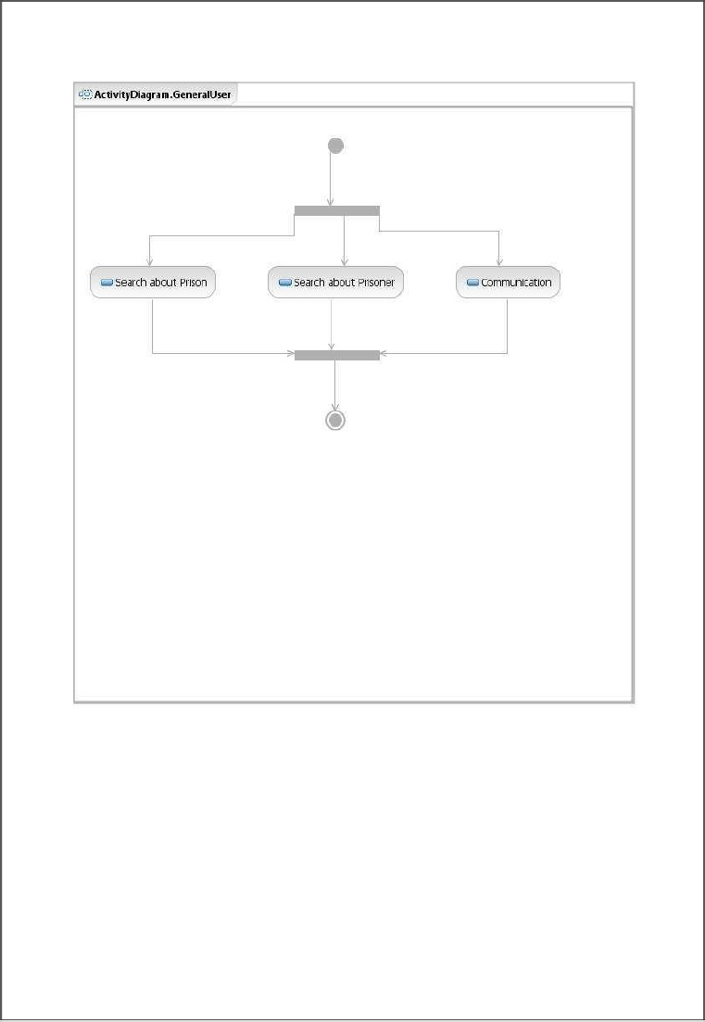

**FIGURE 10 : USER LOGIN ACTIVITY**

**3.1.3 DATAFLOW DIAGRAM**

**2.8 Data Flow Diagram**

**0 LEVEL:**

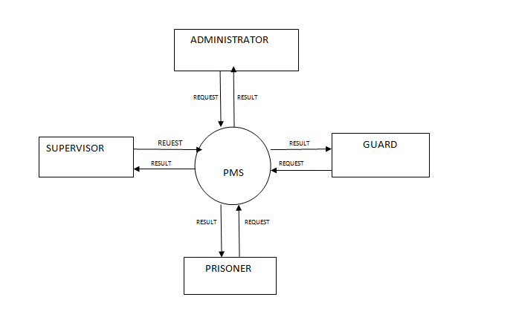

**1 LEVEL:**

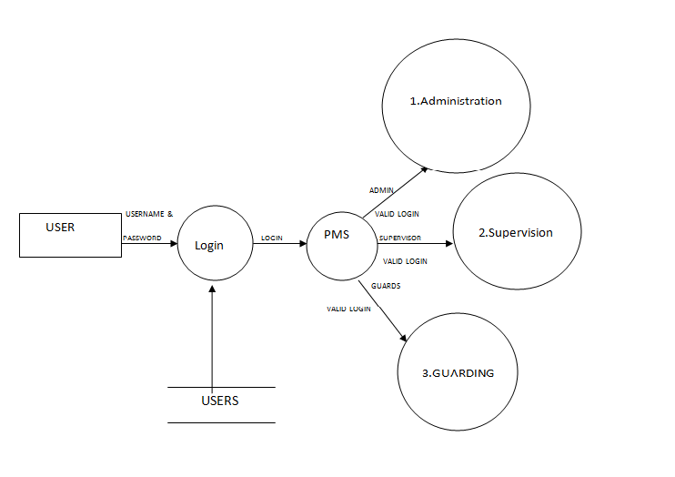

4. **SYSTEM DESIGN**

**4.1 PHYSICAL SYSTEM DESIGN:**

Following the logical design is the physical design. This produces the working system by defining the design specifications that tell the programmers exactly what the candidate system must do.

**4.2 ARCHITECTURAL DESIGN:**

Architectural design is a comprehensive framework that describes its form and a structure its components and how they fit together. Architectural design is a software component that can be something as simple as program module, but it can also be extended to include database and middleware that enable the configuration of a network of client and servers .Architectural design focuses on the representation of the structure of software components their properties and interaction.

**4.3 INTERFACE DESIGN:**

Interface design creates an effective communication medium between a human and a computer. In this project it is the communication between Administrator and station in-charge design. Since this project requires a database, the client machines require proper connection with the server machine. The users will interact with the software through the user friendly web pages

**4.4 DATABASE DESIGN:**

Database design is the most important part of the system design phase. In a database environment common data are available and are used by several users. Instead of each program managing its own data, authorized users share data across application with the database software managing the data as an entity. In our project both the administrator and station in-charge share the crime details and criminal details. The primary objective of database design is fast response time to inquire, more information at low cost, control of redundancies, clarity and ease of use, data and program independencies, accuracy and integrity of the system.

The Database consists of the following information:-   
**Database Specification:**

1. Login Table:

|  |  |  |  |
| --- | --- | --- | --- |
| **Serial Number** | **Field name** | **Type of field** | **Remark** |
| **1** | Username | Varchar(15) | Primary key |
| **2** | Password | Number(10) | -- |

1. Nominal Roll Register:

|  |  |  |  |
| --- | --- | --- | --- |
| **Serial number** | **Fieldname** | **Type of field** | **Remark** |
| 1 | Prisoner id | Number(1000) | Primary key |
| **2** | Case id | Number(1000) | Foreign key |
| **3** | Name | Varchar(15) | No special characters allowed |
| **4** | Gender | Varchar(1) | M/F |
| **5** | Type | Varchar(15) | Duration specific/ life term |
| **6** | Duration of sentence | Number(100000) | No. of days |
| **7** | Height | Number(500) | In cms |
| **8** | Criminal Snaps | <img object> | -- |
| **9** | Status | Number(1) | 1.in jail  2.on parole  3.released  4. dead |

3. Case Register:

|  |  |  |  |
| --- | --- | --- | --- |
| Serial number | Field name | Type of variable | Remark |
| 1 | Case id | Number(1000) | Primary key |
| 2 | description | varchar(15) | Special characters not allowed |
| 3 | type | Number(1) | 1.murder  2.theft  3.forgery  4.counterfeiting |

1. Parole Register:

|  |  |  |  |
| --- | --- | --- | --- |
| **Serial number** | **Field name** | **Type of variable** | **Remarks** |
| 1 | Prisoner id | Number(1000) | Primary key |
| 2 | Address of residence | Varchar(15) | Special keys not allowed |
| 3 | Entry date | Date | -- |
| 4 | Exit date | Date | -- |
| 5 | Remand frequency days | Number(1000) | Should visit jail for remand |
| 6 | Last frequency days | Number(1000) | T/F |
| 7 | Last remand visit status | Varchar(1) | -- |
| 8 | Last visited on | Date | -- |

**5. TESTING**

Testing is the process of executing the program to find if there are any errors. It is the final verification and validation activity .In testing phase we have tried to affirm the quality of the product. We have also tried to eliminate errors in the previous stages.

**5.1 UNIT TESTING:**

|  |  |  |  |  |  |  |  |  |  |
| --- | --- | --- | --- | --- | --- | --- | --- | --- | --- |
| Serial No. | Unit | | Input | | Expected output | Output obtained | | status | remedies |
| 1. | Login | | Username and password | | Check with database for their relevance and redirect to the admin home page | Database is verified and application redirected to admin home page  Inserted into table | | pass |  |
| Serial No. | Unit | | Input | | Expected output | Output obtained | | status | remedies |
| 2. | Police registration | | Police_id,police_ name, police_idcard,  Email_id,  Security_question,answer  Username,  Password | | Insert into table ‘policelogin’  In the database |  | | pass |  |
| 3. | | Change password | | Username and password | Update existing password | | Password changed | success |  |

**TABLE 4: ADMINISTRATOR MODULE**

**6. TOOLS AND TECHNOLOGY USED**

**6.1 APPLICATION ARCHITECTURE**

* **J2EE:** (Servlet, JSP, JAXP, Java Beans) Application architecture.
* **JAVA:** Application architecture.
* **WASCE:** (WebSphere Application Server Community Edition) Web Server
* **SQLite:** IBM Database.

**6.3.3 SOFTWARE INTERFACES:**

* Programming Language : Java
* Technologies : Android V4.2.2
* Database Connectivity : JDBC
* Java Version : JDK 8
* Backend Database : SQLite.
* Operating System : Windows XP/2000.
* Web Server : Tomcat 6.0
  + 1. **HARDWARE INTERFACES:**

**MINIMUM REQUIREMENTS:**

**Client Side**

|  |  |  |  |
| --- | --- | --- | --- |
| **Client Side** | | | |
|  | **Processor** | **RAM** | **Disk Space** |
|  | **Intel Pentium 4 1GHZ or faster processor** | **512 MB** | **10 GB(32 bit operating system)** |

**TABLE 5 : CLIENT SIDE REQUIREMENTS**

|  |  |  |  |
| --- | --- | --- | --- |
| **Server Side** | | | |
|  | **Processor** | **RAM** | **Disk Space** |
| **MySQL** |  | 2.5 GB RAM | Atleast 1 GB |

**TABLE 6 : SERVER SIDE REQUIREMENTS**

**RECOMMENDED REQUIREMENTS:**

**C**

|  |  |  |  |
| --- | --- | --- | --- |
| **Client Side** | | | |
|  | **Processor** | **RAM** | **Disk Space** |
|  | **Intel or AMD - 1 GHZ** | **4GB** | **10 GB ( 32-bit)**  **1.6 GB(64-bit**) |
| **Server Side** | | | |
| **MySQL** |  | **4GB** | **Atleast 4 GB** |

**TABLE 7: RECOMMENDED REQUIREMENTS FOR CLIENT AND SERVER**

**6.3.5 COMMUNICATION INTERFACES:**

* Client (customer) on Internet will be using HTTP/HTTPS protocol.
* Client (system user) on Internet will be using HTTP/HTTPS protocol.  
  + 1. **CONSTRAINTS:**
* **Compatibility**
  + Software should run compatibly (i.e. under the same operating system, database and networking capabilities) with the other subsystems software it works together with.
  + It should allow an Administrator to enroll new users and give them access rights to read the data.
* **Reliability and Availability**
  + It should permit 1 hour per day for maintenance and backup activities with minimal disruption to users.
  + Any failure should cause no more than 10-minute downtime, with the average not exceding 2 minutes.
  + Backup should spot-tested to ensure they are reliable.
  + 24X7 availability
  + Better component design for to get better performance at peak time.
  + It should allow up to 10 users to logon simultaneously and receive an average response time not exceeding 3 seconds.

**7. SNAPSHOTS**

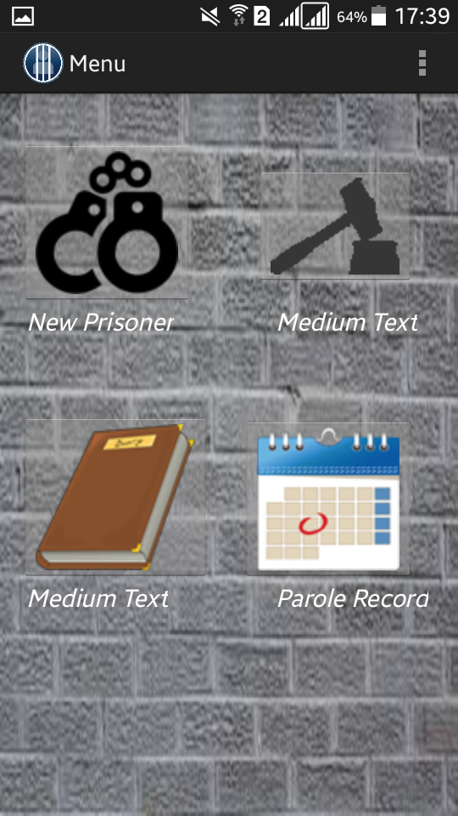

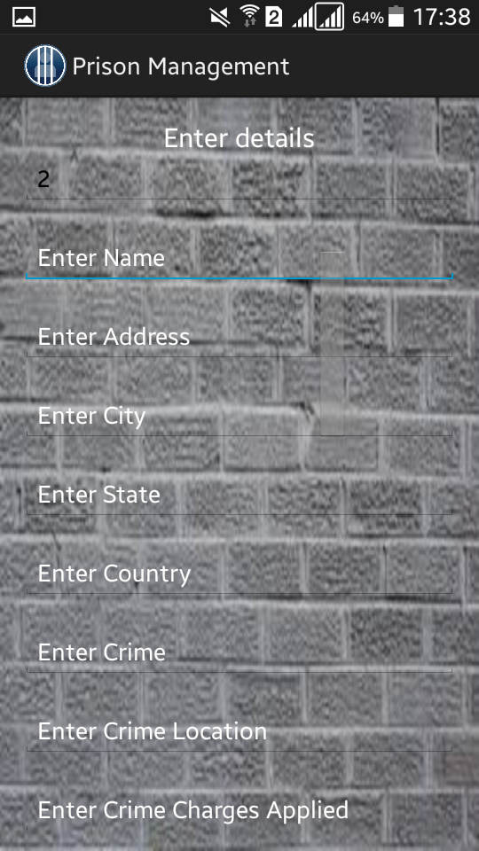

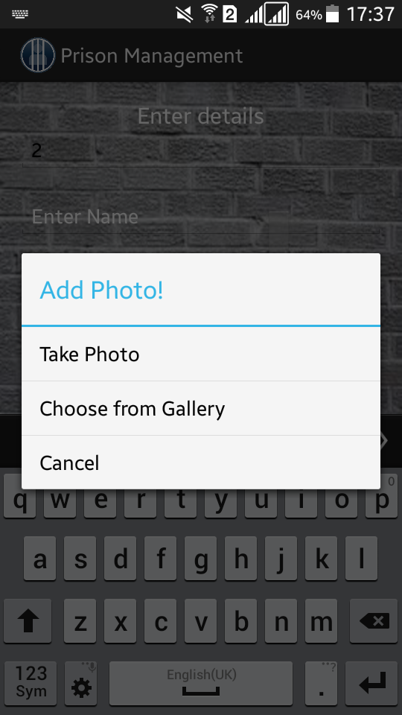

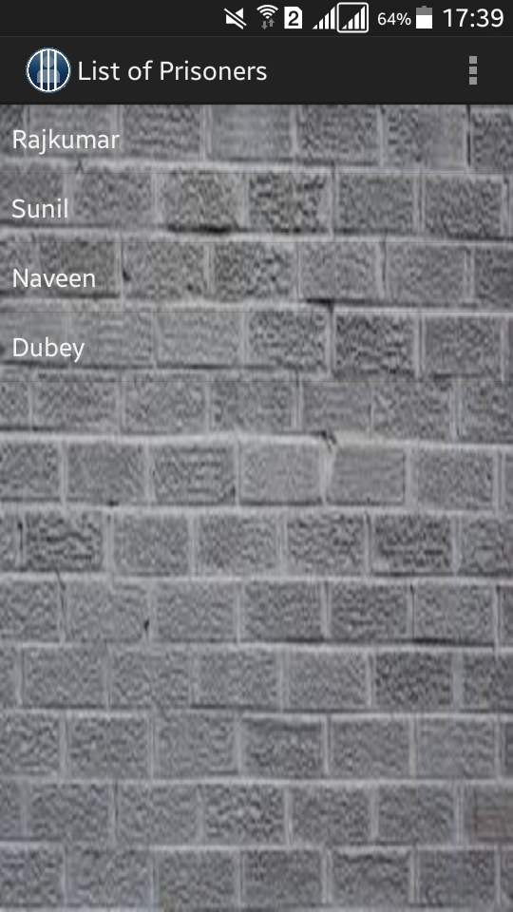



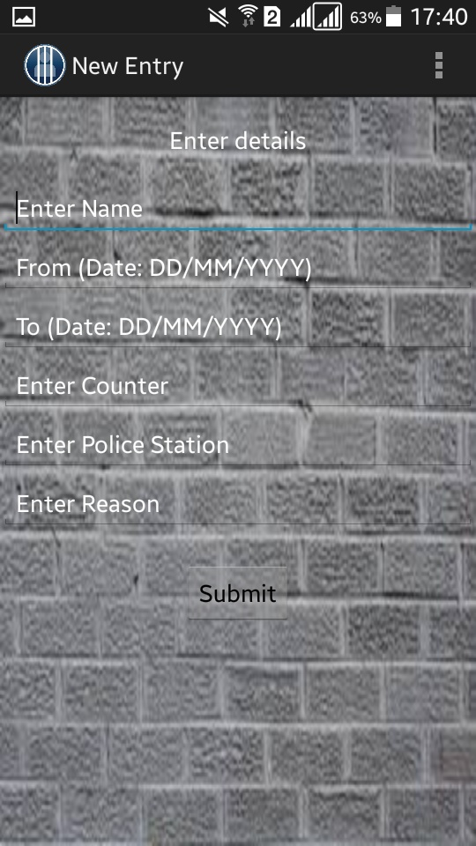



**8. CONCLUSION**

The development of a prototype crime reporting system is described and system components are explained. The project goal was to develop a crime reporting system suitable for small, medium, and large cities and for use by both urban and rural law enforcement agencies. Five elements necessary for each event were also established: event information, personal descriptors, property descriptors, location information, and time information. Finally, a prototype crime reporting system was designed that relies on two reporting forms: a quick complaint reporting form and detailed a crime event report form. The conceptual crime reporting system design and data elements thus developed.  
  
The technological benefits of the project are to maintain information, monitor and enhance the performance of the department, to take a critical look at the existing system, processes and procedures of the department so as to identify and remove the redundancy.

The case registered at one police station can be tracked at any police station. This reduces the discretionary dependence of police. Once the case is registered the investigation and follow up activities relating to the case cannot be delayed.

This project result in great improvement in the organization’s functioning by reducing the effort spent by the general people.

**9. FUTURE WORK**

Learning is not a one day program, it is a continuous process. Our next plan is:-

* To provide users a platform where they could implement technology.
* To add more location specifications for the better Security of Prisoners.
* Update the system with the advancement of technology.

**10. REFERENCES**

[1] <http://www.ci.pasadena.ca.us/police/>

[2] [http://www.w3schools.com/](http://www.w3schools.com/html/)

[3] <http://stackoverflow.com/>

[4] <http://www.freezecoders.com/2012/09/>

[5] <http://police.rajasthan.gov.in/>

**REFERENCE PAPER**

**IMPLEMENTATION OF PRISON MANAGEMENT SYSTEM**

**Abstract**

PRISON MANAGEMENT SYSTEM is an efficient application for maintaining Prisoners information. More than a data storage program, it helps you manage the prisoners. It offers a wide variety of Reports that give you exactly the information you need. Add new prisoner details and about new cases. It enables to track every prisoner and their activities. There are three kinds of users Data administrator, Police officials and Administrator. Administrator is considered as Super user and he has full access and rights over the system than anybody else. Administrator can view the details of prisoners, cases, release diary, parole register and interview requests as well as in-out register. Next Police officials have rights to view the nominal rolls, case, parole, interview requests and his functionality is to check the nominal roll which comprises of whole details of prisoners and to fix date for court hearing as per court’s advice. Finally, Data administrator prepares reports and enters data on behalf of the administrator with appropriate data. They have privilege to add and update the data as per administrator’s concern. The interview requests of relatives are made through data admin to administrator and the status of reports can reflect appropriately.

1. **Introduction**

Basically prison is a correctional institution where persons are confined while on trial or for punishment. Each prison may have hundreds of criminals. With hardcopy of records it is hard to search report or record about a particular criminal in prison. The purpose of Prison Management System is to make the search of those records easier. The purpose of this document is to present a detailed description of the Prison Management System. The document will describe what the system will do, the constraints under which it must operate and how the system will react to external stimuli.

**2.Existing Systems**

There are already many existing prison management systems. Some of which are mentioned below:

* Matrix Jail Management System

The Matrix Jail Management System was installed in 2008. Since then the personnel at Northland IT have been exceptionally accommodating while helping them to customize the jail management software specifically to ever changing needs. Moving from our antiquated "green screen" software to their highly intuitive web based windows system has given the ability grant numerous state and local entities access to our software and in doing so has also helped us to streamline all the aspects of the jail management process without having to pay for each additional user we add. Matrix's ability to utilize multiple facilities has provided the ability to automate all our facilities under one software to the point that they are considering utilizing Matrix as a regional/multi-county jail management system so that people, and other neighboring counties, are able to transfer and share inmate information such a demographics, contact information, photos, criminal history and disciplinary history, just to name a few, while under one comprehensive system thus helping to remove the ever increasing amount of redundancy of inmate information which we have become accustomed to while each county continues to utilize separate jail management systems. 

* Aegis Public Safety

New World Systems has built its industry leading Aegis public safety software solution, integrating our solutions for dispatch, mobile computing, field reporting, records management and corrections. Our more than 25 years of experience, financial strength and extensive input from our large customer base, enables New World to continuously enhance and further integrate our solutions for Dispatch, Mobile Computing, Field Reporting, Records Management and Corrections.

1. **Proposed System:**

The proposed system is designed to eliminate all the drawbacks of the existing system. The system is part of a large Application and shall be responsible for maintaining information about prisoners,

We have provided the demographic details , new case details , automated release diary generator , Parole register, interview request register , in - out register, court hearing register. The major advantage of this system is that it is an application so as the info is available anytime, also this is providing high integrity and security, ability to incorporate newly available data , user friendly , speedy and accurate , fully automated , security is associated with authentication , duplication of info is curbed.

1. **Methodology:**

The project is developed using soft wares such as eclipse and android studio. The user interface is designed using the xml and the functioning is implemented using the Java language. Various concepts of object oriented programming are used during this project implementation. As during the implementation of security such as a prisoner data and faculty data and also maybe some confidential details, for securing them we have implemented the access specifiers.

1. **Implementation:**

This project is aimed at developing a prison management system that is a collection of registers and reports for the effective management of prisons. Besides this police and government officials can see crime/criminals reports for their purpose. The main functions are nominal roll entry , case register , automated release diary generator , parole register , duty register , interview requests , in – out register ,etc. Some of the screenshots are

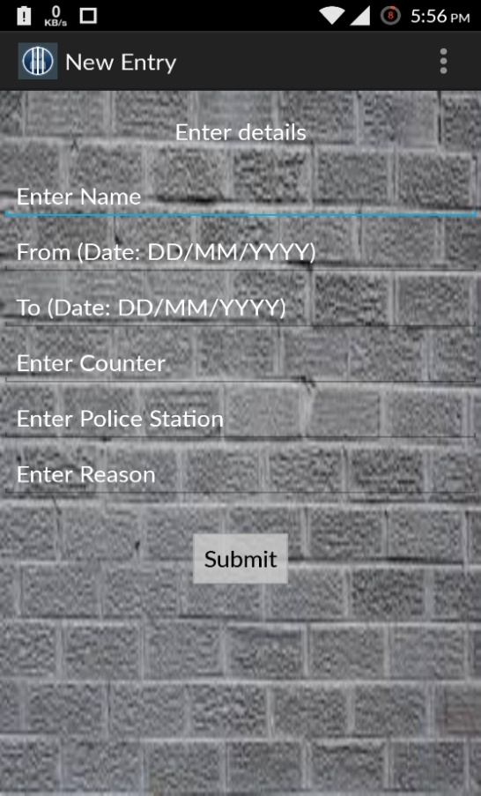

This was the page for a new entry for a parole.

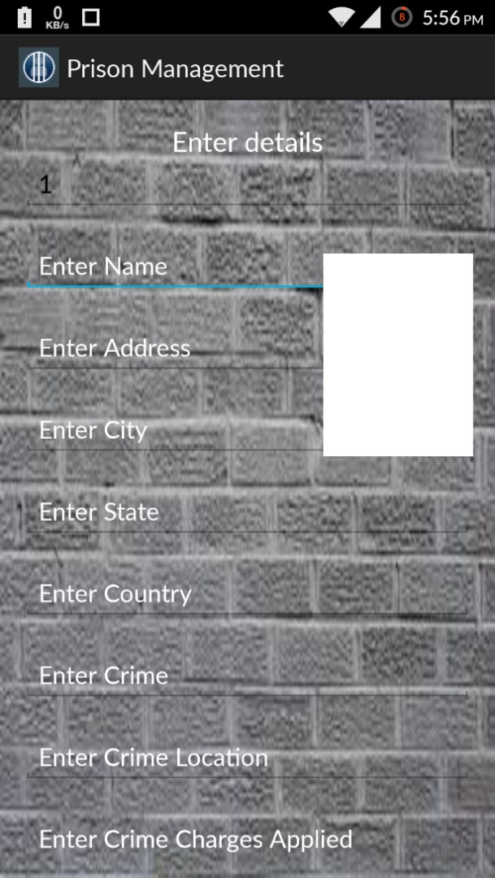

This is new prisoner entry page.

**7. References:**

➢ www.ibm.in/developerworks

➢ www.w3schools.com

➢ www.stackoverflow.com

➢ Java The Complete Reference