Project Title: Autosage app using gemini flash

- The Problem: The automotive market in 2026 is flooded with complex specs, especially with the rapid shift to EVs, leaving consumers overwhelmed.

- The Vision: AutoSage was conceived as a "Digital Sage"—a wise, always-available assistant that simplifies technical jargon into actionable advice.

- Persona Development: We identified three primary user personas: "Sarah" (the budget-conscious performance seeker), "Emma" (the eco-advocate looking for sustainable incentives), and "General Owners" needing proactive maintenance.

- Strategic Scope: The project focuses on two-wheelers and four-wheelers, bridging the gap between static manuals and real-time AI intelligence.

Milestone Timeline:
- Development Methodology: An Agile approach was used, breaking the build into four distinct "Activities" or sprints.

- Activity 1 (Foundation): Focus on requirement gathering and establishing a local Python environment.

- Activity 2 (Authentication): Secure integration of the Google AI Studio API.

- Activity 3 (Inference Logic): Building the "Brain" of the app to process both natural language and structured PDF data.

- Activity 4 (Deployment): Designing the Streamlit UI and conducting local server tests at localhost:8501.

- Software Stack: Python 3.x, Streamlit for the UI, google-generativeai for LLM interaction, and PyPDF2 for document ingestion.

- Data Requirements: Access to real-time vehicle data via the Gemini Flash model and user-provided PDF manuals for model-specific "grounding".

- Interface Requirements: A clean, responsive dashboard with a dedicated "Settings" sidebar for file management and a main chat input for conversational queries.

- System Constraints: The app must stay within API quota limits and ensure that sensitive API keys are never exposed in the source code.

Development Highlights:
- Backend Construction (engine.py): Development of modular functions to handle API configuration, PDF parsing, and prompt engineering.

- Persona Engineering: Writing a specific system prompt to ensure Gemini always responds as a "Vehicle Expert" rather than a general AI.

- Frontend Construction (app.py): Using Streamlit widgets like st.chat_input, st.sidebar, and st.file_uploader to create an interactive experience.

- Integration: Merging the logic from engine.py into the UI flow so that clicking "Get Advice" triggers the full AI pipeline.

Architectural Pattern: A 3-Tier Machine Learning Pipeline.
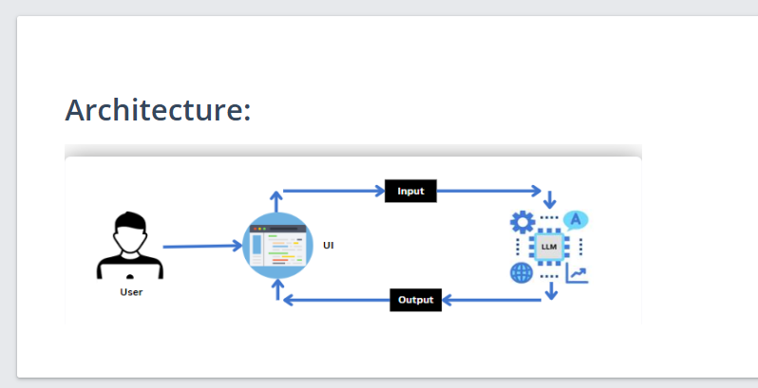

- System Architecture: A high-level view showing the Streamlit frontend acting as the "User Proxy" and the Gemini API acting as the "Inference Engine".

- Logical Workflow:
  - The User interacts with the UI to enter input (e.g., asking about mileage).
  - The input is transmitted to the backend script using the authenticated Google API key.
  - The input is forwarded to the Gemini Flash model via a secure API call.
  - The pre-trained model processes the natural language, compares it against internal data (or uploaded PDF text), and generates a response.
  - Results are formatted and displayed back to the user in the Streamlit window.

Deployment Information:
- GitHub Repository: https://github.com/sameer-1126/AutoSage-App .
- Backend Construction (engine.py): Development of modular functions to handle API configuration, PDF parsing, and prompt engineering.

- Persona Engineering: Writing a specific system prompt to ensure Gemini always responds as a "Vehicle Expert" rather than a general AI.

- Frontend Construction (app.py): Using Streamlit widgets like st.chat_input, st.sidebar, and st.file_uploader to create an interactive experience.

- Integration: Merging the logic from engine.py into the UI flow so that clicking "Get Advice" triggers the full AI pipeline.
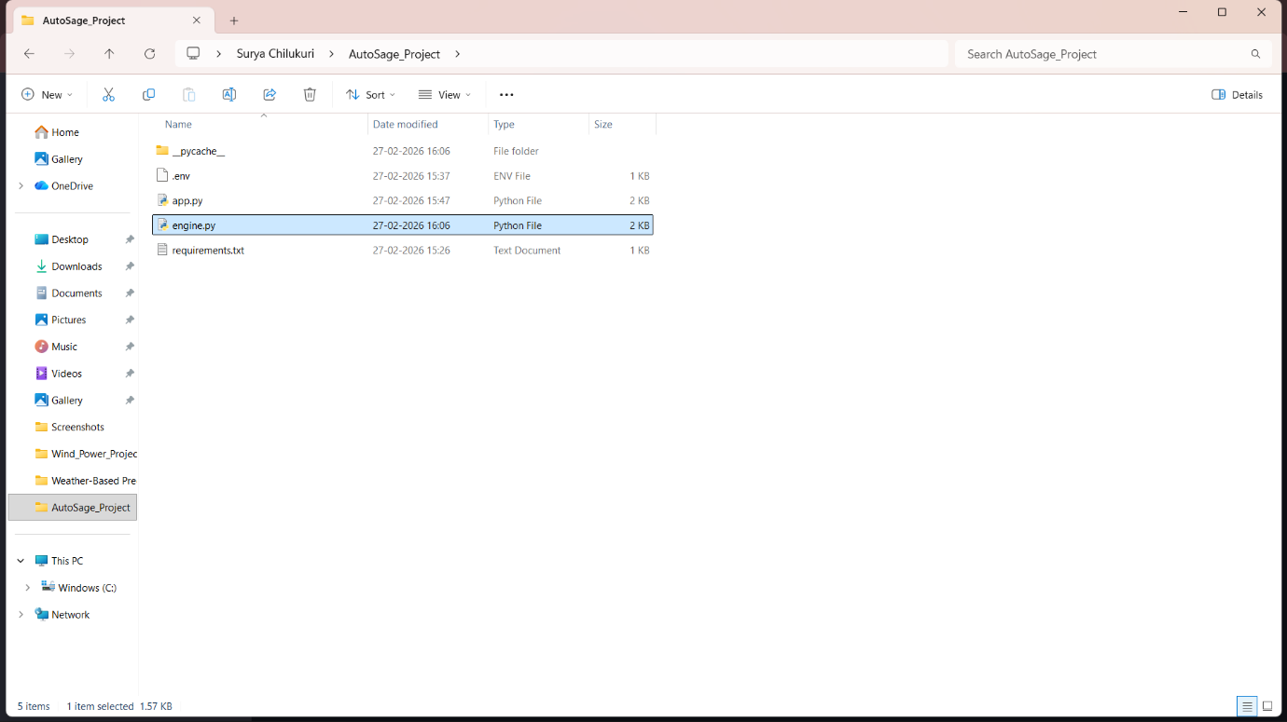
Real-Time Simulation Results:
- Operational Success: The app successfully launches using the streamlit run app.py command.
- Feature Validation:
  - Scenario 1: The app provides accurate comparisons for new motorcycles.
  - Scenario 2: It correctly identifies seasonal maintenance needs like antifreeze levels and tire pressure.
  - Scenario 3: It identifies eco-friendly vehicle options and relevant incentives.
- Conclusion: AutoSage represents a successful integration of generative AI into a niche vertical (automotive), providing measurable value to end-users..

