REACT NATIVE ACTIVITY – REACT CALCULATOR APP
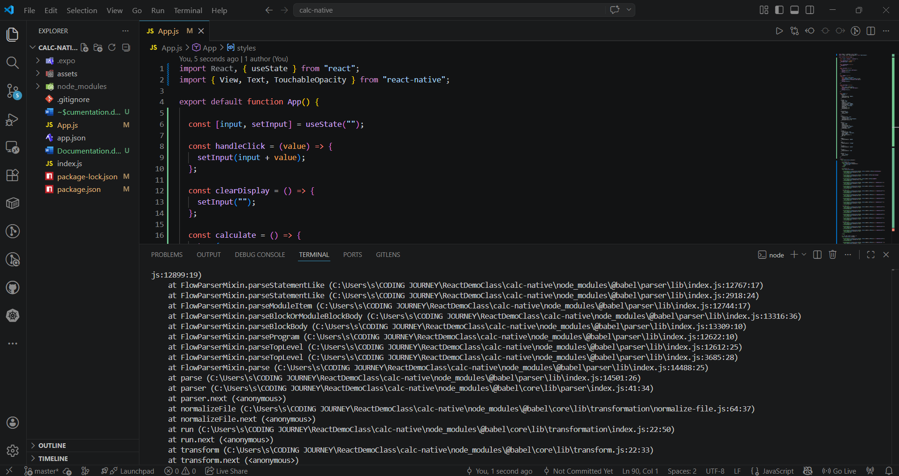

FOLDER STRUCTURE:
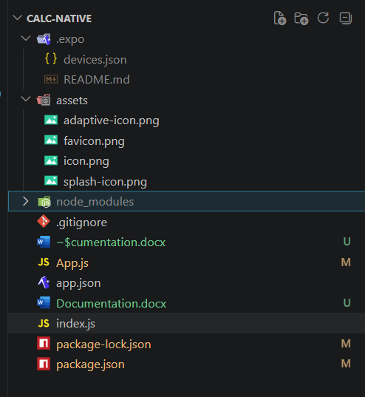

App in Phone :

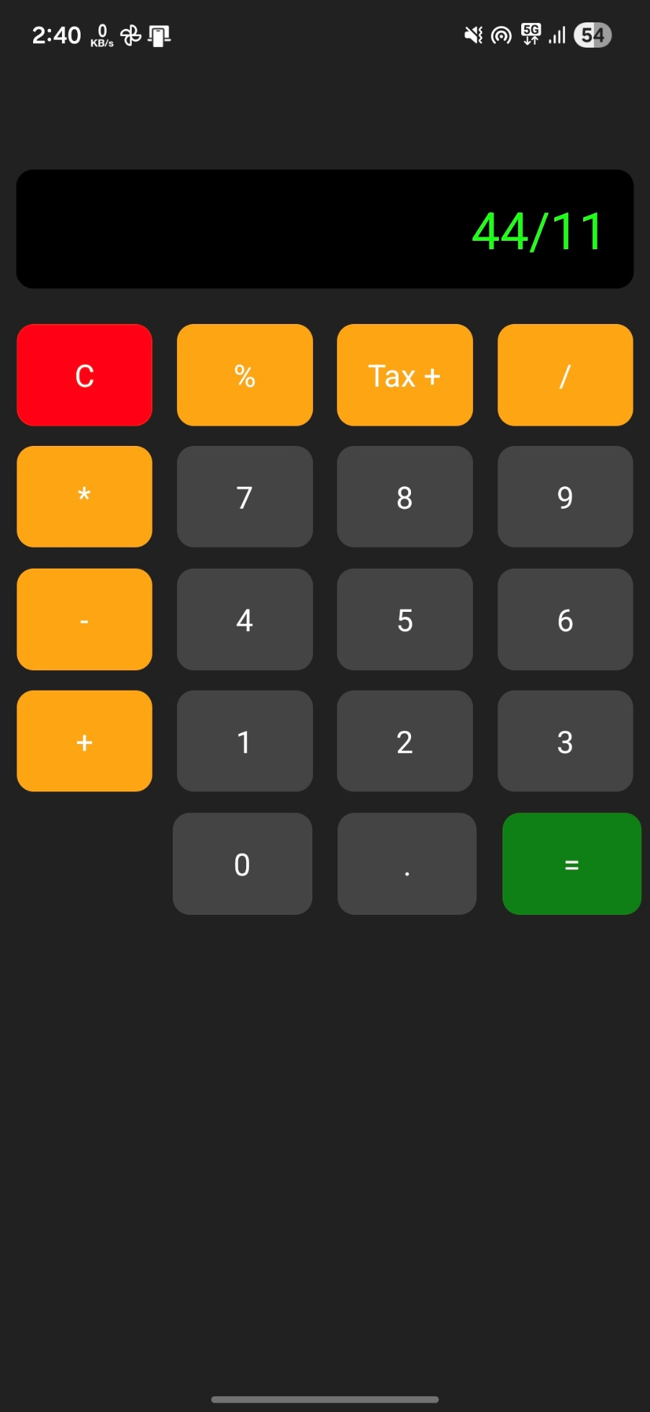
Web App:
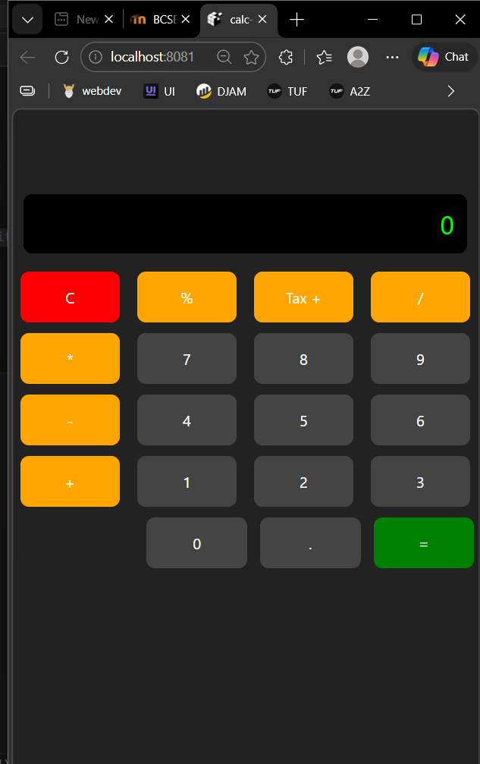
Cmd:
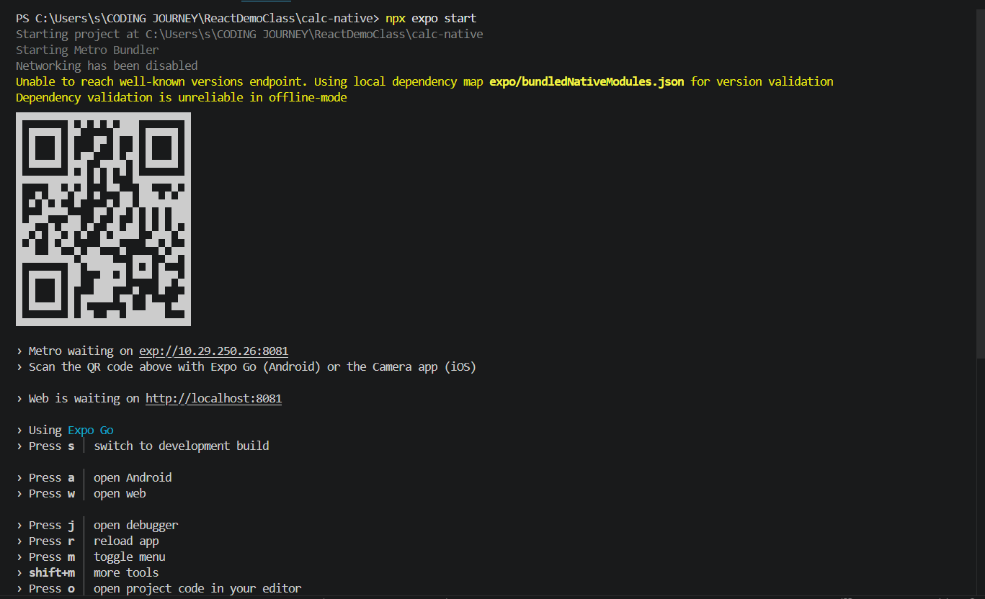
app.js
import React, { useState } from "react";
import { View, Text, TouchableOpacity } from "react-native";

export default function App() {

const [input, setInput] = useState("");

const handleClick = (value) => {
setInput(input + value);
};

const clearDisplay = () => {
setInput("");
};

const calculate = () => {
try {
setInput(eval(input).toString());
} catch {
setInput("Error");
}
};

const addGST = () => {
try {
const value = eval(input);
const gstValue = value + (value * 0.18);
setInput(gstValue.toFixed(2).toString());
} catch {
setInput("Error");
}
};

const percentage = () => {
try {
const value = eval(input);
setInput((value / 100).toString());
} catch {
setInput("Error");
}
};

const styles = {
container: {
flex: 1,
backgroundColor: "#222",
paddingTop: 100,
},

display: {
width: "95%",
height: 70,
alignSelf: "center",
backgroundColor: "#000",
justifyContent: "center",
alignItems: "flex-end",
padding: 15,
borderRadius: 10,
marginBottom: 15
},

displayText: {
color: "#0f0",
fontSize: 30
},

grid: {
flexDirection: "row",
flexWrap: "wrap",
justifyContent: "space-between",
paddingHorizontal: 10
},

button: {
width: "22%",
height: 60,
marginVertical: 6,
justifyContent: "center",
alignItems: "center",
borderRadius: 10
},

lastRow: {
flexDirection: "row",
justifyContent: "flex-end",
width: "100%",
paddingHorizontal: 5,
gap: 15
},

numBtn: {
backgroundColor: "#444"
},

opBtn: {
backgroundColor: "orange"
},

equalBtn: {
backgroundColor: "green"
},

clearBtn: {
backgroundColor: "red"
},

btnText: {
color: "white",
fontSize: 18
}
};

return (
<View style={styles.container}>

{/* Display */}
<View style={styles.display}>
<Text style={styles.displayText}>
{input || "0"}
</Text>
</View>

{/* Buttons */}
<View style={styles.grid}>

<TouchableOpacity style={[styles.button, styles.clearBtn]} onPress={clearDisplay}>
<Text style={styles.btnText}>C</Text>
</TouchableOpacity>

<TouchableOpacity style={[styles.button, styles.opBtn]} onPress={percentage}>
<Text style={styles.btnText}>%</Text>
</TouchableOpacity>

<TouchableOpacity style={[styles.button, styles.opBtn]} onPress={addGST}>
<Text style={styles.btnText}>Tax +</Text>
</TouchableOpacity>

<TouchableOpacity style={[styles.button, styles.opBtn]} onPress={() => handleClick("/")}>
<Text style={styles.btnText}>/</Text>
</TouchableOpacity>

<TouchableOpacity style={[styles.button, styles.opBtn]} onPress={() => handleClick("*")}>
<Text style={styles.btnText}>*</Text>
</TouchableOpacity>

{/* Row 2 */}
<TouchableOpacity style={[styles.button, styles.numBtn]} onPress={() => handleClick("7")}>
<Text style={styles.btnText}>7</Text>
</TouchableOpacity>

<TouchableOpacity style={[styles.button, styles.numBtn]} onPress={() => handleClick("8")}>
<Text style={styles.btnText}>8</Text>
</TouchableOpacity>

<TouchableOpacity style={[styles.button, styles.numBtn]} onPress={() => handleClick("9")}>
<Text style={styles.btnText}>9</Text>
</TouchableOpacity>

<TouchableOpacity style={[styles.button, styles.opBtn]} onPress={() => handleClick("-")}>
<Text style={styles.btnText}>-</Text>
</TouchableOpacity>

{/* Row 3 */}
<TouchableOpacity style={[styles.button, styles.numBtn]} onPress={() => handleClick("4")}>
<Text style={styles.btnText}>4</Text>
</TouchableOpacity>

<TouchableOpacity style={[styles.button, styles.numBtn]} onPress={() => handleClick("5")}>
<Text style={styles.btnText}>5</Text>
</TouchableOpacity>

<TouchableOpacity style={[styles.button, styles.numBtn]} onPress={() => handleClick("6")}>
<Text style={styles.btnText}>6</Text>
</TouchableOpacity>

<TouchableOpacity style={[styles.button, styles.opBtn]} onPress={() => handleClick("+")}>
<Text style={styles.btnText}>+</Text>
</TouchableOpacity>

{/* Row 4 */}
<TouchableOpacity style={[styles.button, styles.numBtn]} onPress={() => handleClick("1")}>
<Text style={styles.btnText}>1</Text>
</TouchableOpacity>

<TouchableOpacity style={[styles.button, styles.numBtn]} onPress={() => handleClick("2")}>
<Text style={styles.btnText}>2</Text>
</TouchableOpacity>

<TouchableOpacity style={[styles.button, styles.numBtn]} onPress={() => handleClick("3")}>
<Text style={styles.btnText}>3</Text>
</TouchableOpacity>

</View>

{/* LAST ROW (RIGHT ALIGNED) */}
<View style={styles.lastRow}>

<TouchableOpacity style={[styles.button, styles.numBtn]} onPress={() => handleClick("0")}>
<Text style={styles.btnText}>0</Text>
</TouchableOpacity>

<TouchableOpacity style={[styles.button, styles.numBtn]} onPress={() => handleClick(".")}>
<Text style={styles.btnText}>.</Text>
</TouchableOpacity>

<TouchableOpacity style={[styles.button, styles.equalBtn]} onPress={calculate}>
<Text style={styles.btnText}>=</Text>
</TouchableOpacity>

</View>

</View>
);
}

