**Q1.** Explain the differences between coding, implementation, development, and programming.

Ans:-

|  |  |
| --- | --- |
| **Term** | **Description** |
| Coding | The process of writing instructions in a programming language to create a software program. |
| Implementation | The process of deploying and integrating a software solution into an existing environment. |
| Development | The entire life cycle of creating software, including planning, designing, coding, testing, and deployment. |
| Programming | The act of writing code using programming languages, involving understanding algorithms and data structures. |

**Q2.** List five hybrid companies that have their own products. Ans:-

* Infosys:- Finacle
* Microsoft Corporation :- MS Office
* Oracle :- Oracle Database
* Adobe :- Adobe creative cloud
* Google :- Gmail,Google Drive , Google Docs , Google Sheets

**Q3.** Justify the factors you would consider when updating the "Expected Output" column in your test case template.

Ans:-

**Requirements Specification:** The expected output should align with the requirements specified for the system. It should reflect the intended behavior as described in the requirements document, ensuring that the system functions as intended.

**Design Specifications:** Consider the design specifications and architecture of the system. The expected output should be in line with the design principles and guidelines set for the system, ensuring that it adheres to the overall design approach.

**Use Case Scenarios:** Analyze the use case scenarios and user stories to understand the expected outcomes from the user's perspective. The expected output should match the expected results that users anticipate when interacting with the system.

**Error Handling and Exception Scenarios:** Consider how the system should handle error conditions and exceptions. The expected output should reﬂect the appropriate error messages, alerts, or system responses that are expected when the system encounters errors or exceptions.

**Q4.**In your own words, explain the concept of the deferred state in the bug life cycle.

Ans:-The bug, changed to deferred state means the bug is expected to be fixed in next releases. There may be several reasons for changing the bug to this state. For some of them the priority of bugs is low, lack of time for release or bugs may not have a major effect on software.

**Q5.**Provide your own definitions for the terms: Mistake, Error, Bug, and Defect.

Ans:-Anomalies are something that deviates from normal, standard or expected. Based on different situations anomalies are termed as listed below.

* **Mistake**:-When the developer identifies mistakes in his code, he says Error for the anomaly.
* **Error**:-When the developer identifies mistakes in his code, he says Error for the anomaly.
* **Bug**:-When the reported defect is accepted by the developer, it is called Bug.
* **Defect**:-When Tester discovers and reports the anomaly, he says Defect to the anomaly.

**Q6**.Discuss whether it is necessary to follow the test case design technique for all requirements when writing test cases. Justify your answer with a real-time example.

Ans:- Without a well-crafted test case design, the testing engineers will not be able to test the software efficiently. They will have little or no visibility on testing coverage, which could lead to poor-quality software filled with defects and bugs. Testing engineers must spend enough time designing a test case to ensure that the software is safe and ready to be released in the market.

Ex:- If a testing engineer has performed all the test cases and the product is out the testing phase , if the user faces any serious issues (which can design related , requirement related,etc) it would easier to tell the manager/higher ups that these are test case you have written using a **Test Case Design Technique.**

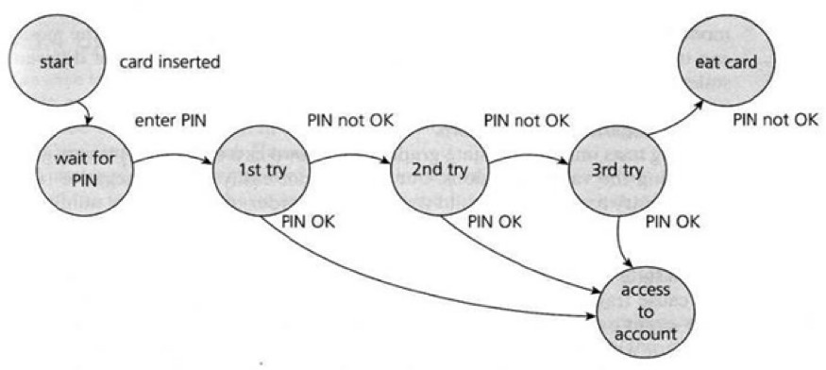**Q7**.Determine how many test cases you can create for a given diagram using state transition.

Ans:- Now, we need to know how many test cases should be created to cover all possible transitions in the system

Simply we can use this formula “TC = SN * (SN - 1)“, where:

TC = Number of test cases.

SN = States number.

By applying the formula to the example: TC = 3 * (3 -1)

Which will result in 6 test cases from card Inserted to removed.