Python (3.5.4)/Django (Version-1.9)

**App Features:**

1) Adding Task

Add a task by clicking “create New”

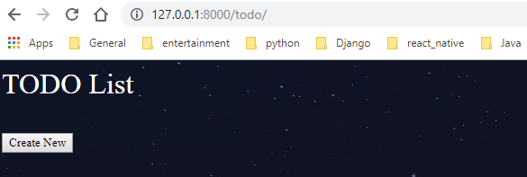

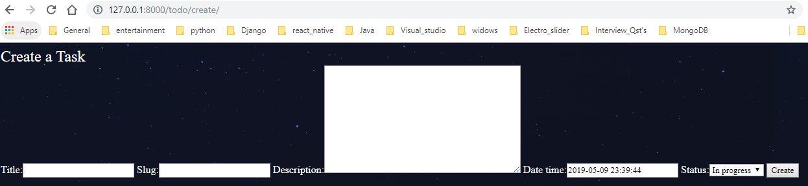

“Slug” should be unique and date_time will be set to “current date”+10 days (default).

2) Update Task

Click on recharge

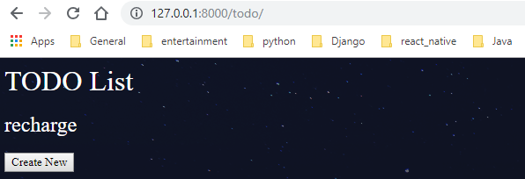

Click on “Update” button

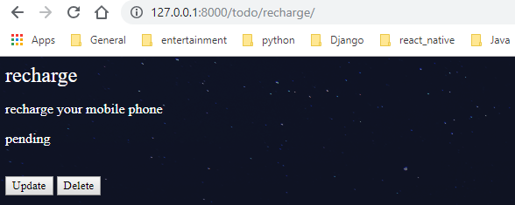

Click “Update” button to complete.

3) Delete Task

Click “Delete” button to delete.

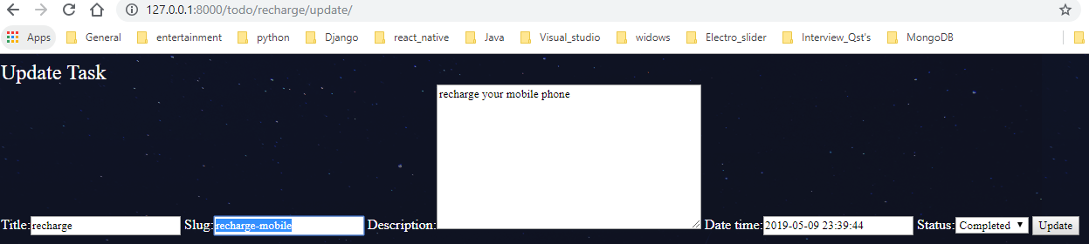

4) Entries deleted from non-admin interface will be still visible from the Admin Interface (in green tick).

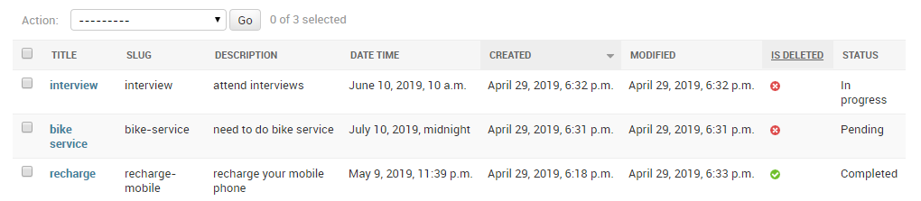

5) List display of all the fields with search and filtering in the admin interface.

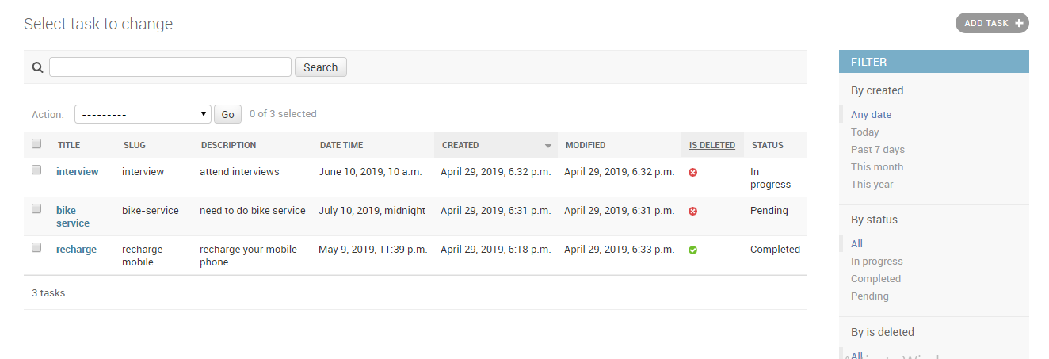

6) Admin will be able to download the bulk entries of todo list in csv format from Django Admin Interface.

Click “action” dropdown menu + select “Export selected as CSV” + click “Go”

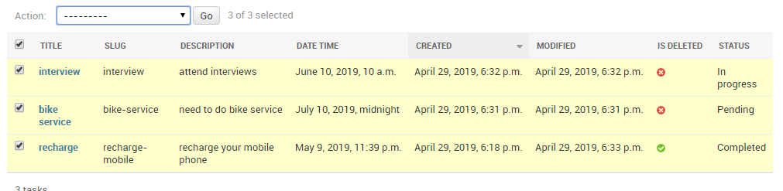

Output:

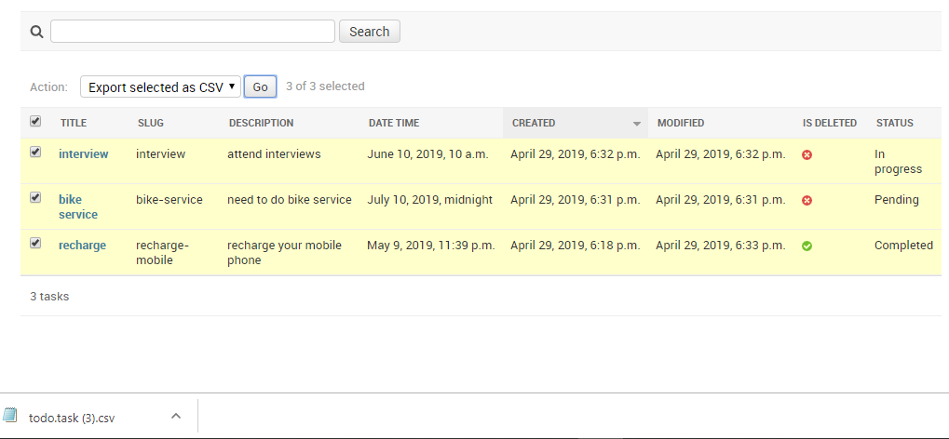

7) API to list all the TODO items as well as individual item without using any API Framework.

a) For all task

url: 

result:

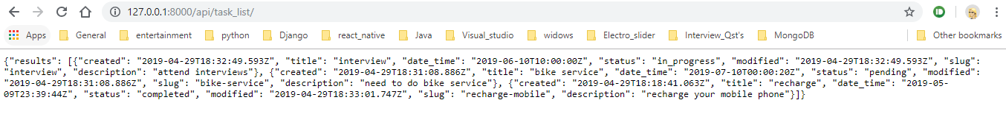

b) For individual

url: 

result:

