**Experiment No.5**

**Title: Execution of In-memory database queries**

**Batch: B1 Roll No.: 1714071 Experiment No.: 5**

**Aim: To execute In-memory database queries**

**Resources needed: MySQL**

**Theory**

In-Memory database is a database that uses a system's main memory for data storage rather than the disk-based storage typically utilized by traditional databases. In-memory databases, or IMDBs, are frequently employed in high-volume environments where response time is critical, as access times and database requests are typically considerably faster when system memory is used as opposed to hard disk storage.

The traditional databases and in-memory databases can be used together and referred as hybrid databases, which support both in-memory and disk-based storage in order to maximize performance as well as reliability of the system. All most all RDBMS systems available in market supports In-Memory databases.

**MySQL In-Memory database:**

In MySQL DB, the MEMORY storage engine creates special-purpose tables with contents that are stored in memory. Because the data is vulnerable to crashes, hardware issues, or power outages, use of these tables are limited to temporary work areas or read-only caches for data pulled from other tables.

A typical use case for the MEMORY engine involves these characteristics:

▪ Operations involving transient, non-critical data such as session management or caching. When the MySQL server halts or restarts, the data in MEMORY tables is

  lost. 

▪ In-memory storage for fast access and low latency. Data volume can fit entirely in

memory without causing the operating system to swap out virtual memory pages. 

 

▪ A read-only or read-mostly data access pattern (limited updates). 

 

MEMORY tables cannot contain BLOB or TEXT columns.

 

To create a MEMORY table, specify the clause ENGINE=MEMORY on the CREATE TABLE statement.

CREATE TABLE EMP (emp_Id INT, name CHAR (30)) ENGINE = MEMORY;

As indicated by the engine name, MEMORY tables are stored in memory. They use hash indexes by default, which makes them very fast for single-value lookups, and very useful for creating temporary tables. However, when the server shuts down, all rows stored in MEMORY tables are lost. The tables themselves continue to exist because their definitions are stored in .frm files on disk, but they are empty when the server restarts.

To load the data in memory from other existing table use,

CREATE TABLE EMP (emp_Id INT, name CHAR (30))) ENGINE=MEMORY as

SELECT * FROM employee;

To move the data from In-Memory table to hard drive (using any text file) use the following syntax,

SELECT * INTO OUTFILE ''emp_data.txt' FROM EMP;

To populate a MEMORY table when the MySQL server starts, use the INFILE option. For example,

LOAD DATA INFILE 'emp_data.txt' INTO TABLE EMP; Where, emp_data.txt is a data file.

**Procedure:**

Perform following tasks:

* Create In-memory table using Engine as Memory.
* Insert values in that table.
* Attempt to retrieve values from the table after restarting the database server.
* Load the data into table using file load.

**Results: (Program printout with output)**

create table audit_course(

ac_no int,

ac_name varchar(30),

ac_faculty varchar(20)) engine = memory

insert into audit_course values(29, ‘Data Visualization’, ‘Vaibhav Vasani’);

insert into audit_course values(19, ‘Big Data using NoSql’, ‘Pradnya Bhangale’);

insert into audit_course values(10, ‘Personality Development’, ‘Tripti Anchan’);

insert into audit_course values(21, ‘React JS’, ‘Swapnil Pawar’);

select * from audit_course;

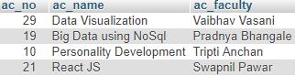

select * into outfile ‘AC_data.txt’ from audit_course;

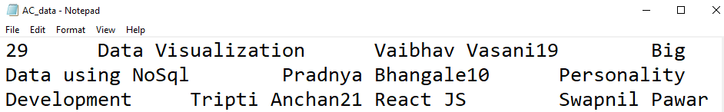

load data infile ‘AC_add.txt’ into table audit_course;

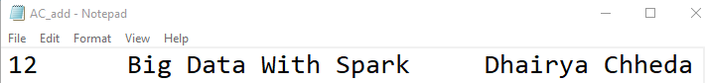

select * into outfile ‘AC_data.txt’ from audit_course;

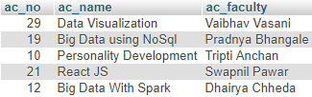

**Questions:**

**1. What is the difference between traditional and In-memory databases?**

|  |  |
| --- | --- |
| ***Traditional Databases*** | ***In-Memory Databases*** |
| * All data stored on disk, disk I/O needed to move data into main memory when needed. | * All data stored in main memory, no need to perform disk I/O to query or update data. |
| * Data is always persisted to disk. | * Data is persistent or volatile depending on the in-memory database product. |
| * Traditional data structures like B-Trees designed to store tables and indices efficiently on disk. | * Specialized data structures and index structures assume data is always in main memory. |
| * Virtually unlimited database size. | * Optimized for specialized workloads; i.e. communications industry-specific HLR/HSS workloads. |
| * Support very broad set of workloads, i.e. OLTP, data warehousing, mixed workloads, etc. | * Database size limited by the amount of main memory. |

**Outcomes:**

Design advanced data systems using Object, Parallel, Distributed and Spatial databases.

**Conclusion: (Conclusion to be based on outcomes achieved)**

We were successfully able to execute in-memory database queries.

**Grade: AA / AB / BB / BC / CC / CD /DD Signature of faculty in-charge with date**

**References:**

1. https://dev.mysql.com/doc/refman/5.5/en/memory-storage-engine.html

2. http://opensourceforu.efytimes.com/2012/01/importance-of-in-memory-databases/

3. http://pages.cs.wisc.edu/~jhuang/qual/main-memory-db-overview.pdf

4. http://docs.memsql.com