**Experiment No: 02**

**Title: Single digit counter using timer 0 and seven segment LED**

**Batch: B2 Roll No.: 1714071 Experiment No.: 02**

**Aim:** Single digit counter using timer 0 and seven segment LED (Assembly)

**Resources needed:**  Proteus software simulator with 8051 VSM

# Theory

Seven segment displays are used to indicate numerical information. Seven segments display can display digits from 0 to 9 and even we can display few characters like A, b, C, H, E, e, F, etc. These are very popular and have many more applications.

Seven segment displays internally consist of 8 LEDs. In these LEDs, 7 LEDs are used to indicate the digits 0 to 9 and single LED is used for indicating decimal point. Generally seven segments are two types, one is common cathode and the other is common anode.

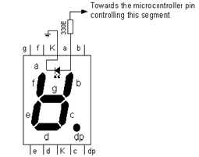

In common cathode, all the cathodes of LEDs are tied together and labeled as com. and the anode are left alone. In common anode, seven segment display all the anodes are tied together and cathodes are left freely. Below figure shows the internal connections of seven segments Display.

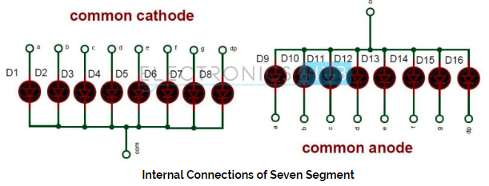

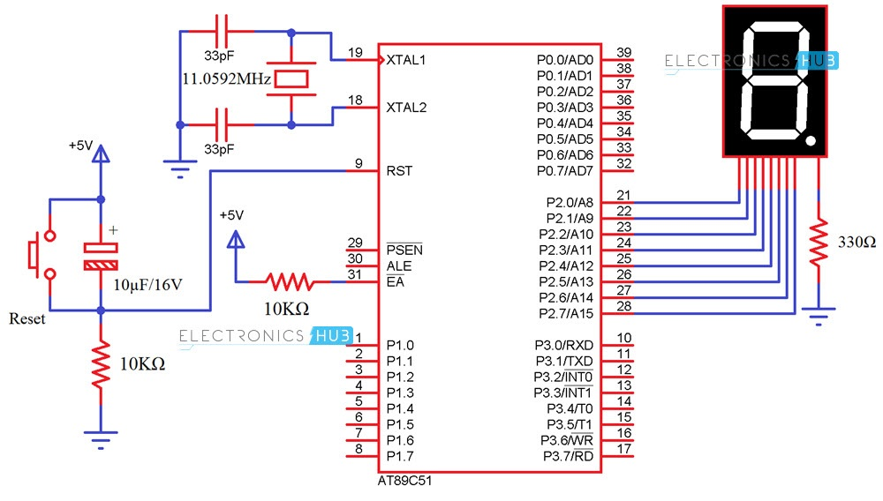

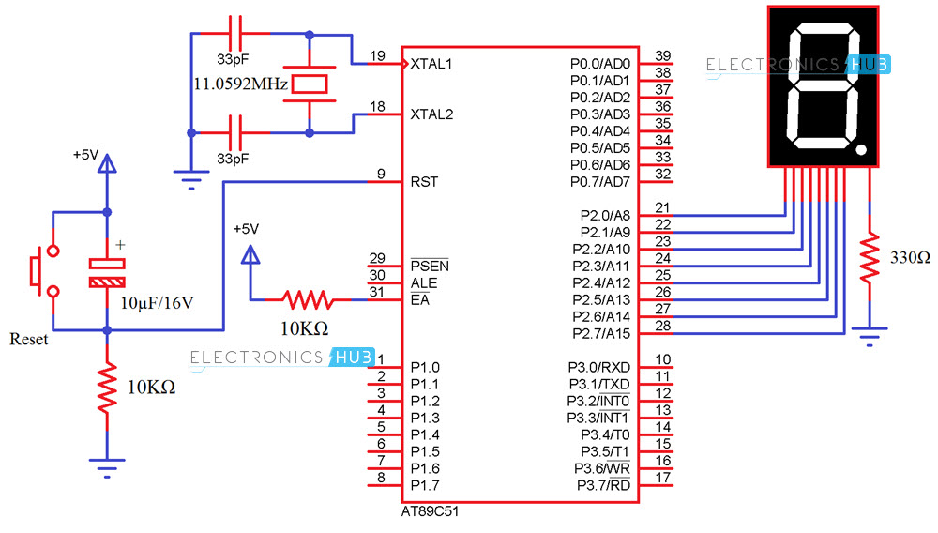

**Procedure/Approach/Algorithm/Activity/Diagram:**

Interfacing 7 Segment Display to 8051 (Single Digit – CC)

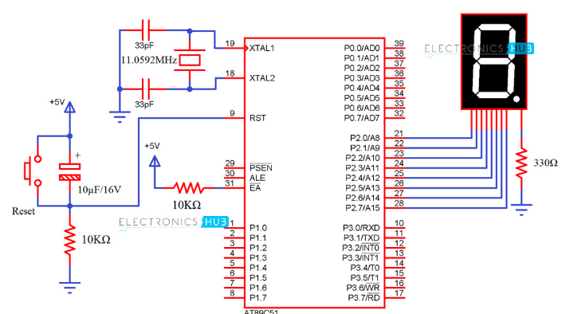

Digit Drive Pattern

To display the digits on 7 segment, we need to glow different logic combinations of segments. For example if you want to display the digit 3 on seven segment then you need to glow the segments a, b, c, d and g. The below table show you the Hex decimal values what we need to send from PORT2 to Display the digits from 0 to 9

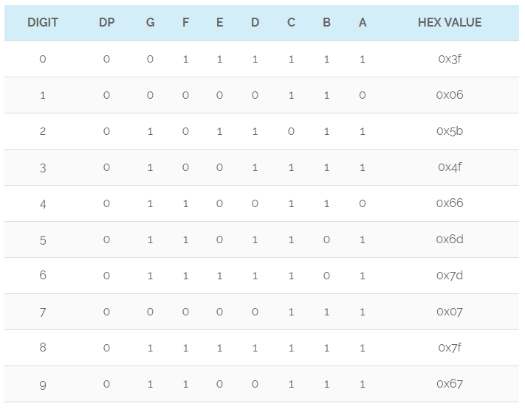

Algorithm (Rotating LED program):

Step 1: Connect Port0 to LED row.

Step2: Send pattern 0x01 to P0.

Step3: Introduce delay.

Step4: Shift bit pattern left.

Step5: Repeat Steps 2, 3, 4 in an infinite loop.

**Procedure/Approach/Algorithm/Activity/Diagram:**

Algorithm (4 digit counter):-

Step 1: Start

Step 2: Connect 8 simple LEDs to Port1

Step 3. Initialize reg A and Port1 with 0x01h

Step 4; Set counter to 9

Step 5: Set time delay of approx. 0.5 sec

Step 6: Rotate left contents of reg A and send to port1

Step 7: Also decrement counter. If counter is not zero go to step 5

Step 7: Go to step 4

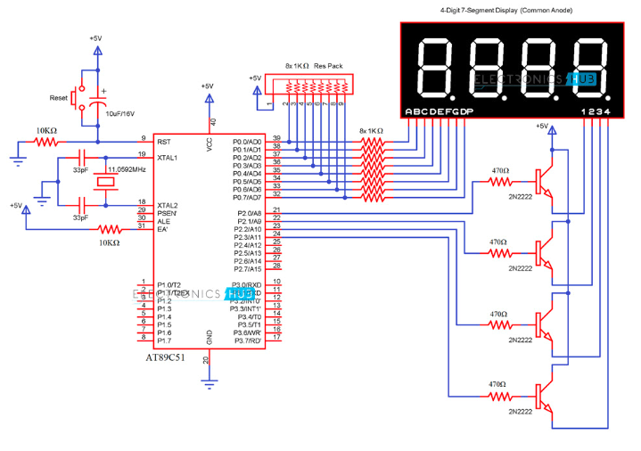

**Results: (Program printout with output / Document printout as per the format)**

1. Upload Assembly program and schematic for rotating LED.

**Ans:**

***Code:***

ORG 0000H

SJMP MAIN

ORG 0030H

MAIN:

MOV R0,00H

LOOP:CJNE R0,#00H,NUM1

NUM0:MOV P1,#0C0H

LJMP NXT

NUM1:CJNE R0,#01H,NUM2

MOV P1,#0F9H

LJMP NXT

NUM2:CJNE R0,#02H,NUM3

MOV P1,#0A4H

LJMP NXT

NUM3:CJNE R0,#03H,NUM4

MOV P1,#0B0H

LJMP NXT

NUM4:CJNE R0,#04H,NUM5

MOV P1,#99H

LJMP NXT

NUM5:CJNE R0,#05H,NUM6

MOV P1,#92H

LJMP NXT

NUM6:CJNE R0,#06H,NUM7

MOV P1,#82H

LJMP NXT

NUM7:CJNE R0,#07H,NUM8

MOV P1,#0F8H

LJMP NXT

NUM8:CJNE R0,#08H,NUM9

MOV P1,#80H

LJMP NXT

NUM9:

MOV P1,#90H

LJMP NXT

NXT: LCALL DELAY_1SEC

LCALL DELAY_1SEC

LCALL DELAY_1SEC

LCALL DELAY_1SEC

LCALL DELAY_1SEC

INC R0

CJNE R0,#10D,SKIP

MOV R0,#00H

SKIP:LJMP LOOP

DELAY_100SEC:

MOV R5,#0FFH

L1:MOV R6,#0FFH

HERE:

DJNZ R6,HERE

DJNZ R5,L1

RET

END

***Output:***

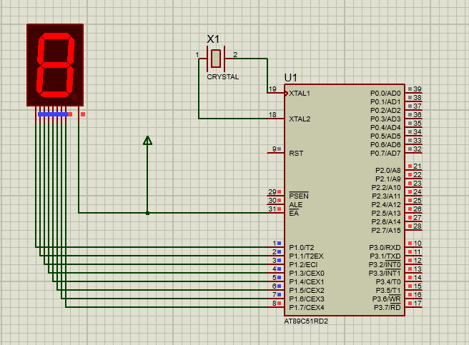

# Questions:

1. List out types of display devices can use with 8051.

**Ans:**

* Electroluminescent Display.
* Electronic Paper.
* LED Display.
* Liquid Crystal Display(LCD)
* Plasma Display.
* Digital Light Processing Technology.
* Liquid on Silicon (LCoS)

**Outcomes (covered by this lab)**:

**CO4:** Ability to perform hardware and software interfacing using knowledge of microcontroller and software tools.

**Conclusion: (Conclusion to be based on outcomes)**

Hence, in this experiment, we have implemented a single digit counter using timer 0and seven segment LED using Proteus software and have written an Assembly Program for the same.

# Grade: AA / AB / BB / BC / CC / CD /DD

**Signature of faculty in-charge with date**

**Recommended Books::**

1. Introduction to embedded systems, ShibuK.V., McGrawHill.

2. 8051 Microcontroller and Embedded Systems using Assembly and C by Mazidi, Mazidi and D.MacKinlay, 2006 Pearson Education Low Price Edition.

3. Microprocessor and Microcontroller by R.Theagarajan, Sci Tech Publication, Chennai.

4. Barry B. Brey, “The Intel Microprocessors: Architecture, Programming & Interfacing” PHI, 6th Edition, 2003.

**5.** D. V. Hall, “Microprocessor and Interfacing Prsogramming & Hardware” TMH – 2nd Edition

**Referred Site:**

<https://www.electronicshub.org/interfacing-7-segment-display-8051/>