**Experiment No: 04**

**Title: Experiments 2and 3 using Keil C compiler**

**Batch: B2 Roll No.: 1714103 Experiment No.: 04**

**Aim:** Experiments 2and 3 using Keil C compiler

**Resources needed:**  Proteus software simulator with 8051 VSM

# Theory

Seven segment displays are used to indicate numerical information. Seven segments display can display digits from 0 to 9 and even we can display few characters like A, b, C, H, E, e, F, etc. These are very popular and have many more applications.

Seven segment displays internally consist of 8 LEDs. In these LEDs, 7 LEDs are used to indicate the digits 0 to 9 and single LED is used for indicating decimal point. Generally seven segments are two types, one is common cathode and the other is common anode.

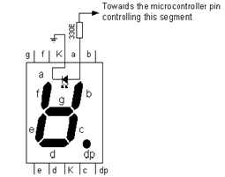

In common cathode, all the cathodes of LEDs are tied together and labeled as com. and the anode are left alone. In common anode, seven segment display all the anodes are tied together and cathodes are left freely. Below figure shows the internal connections of seven segments Display.

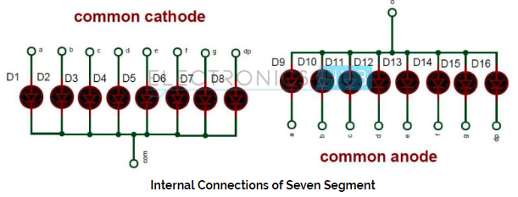

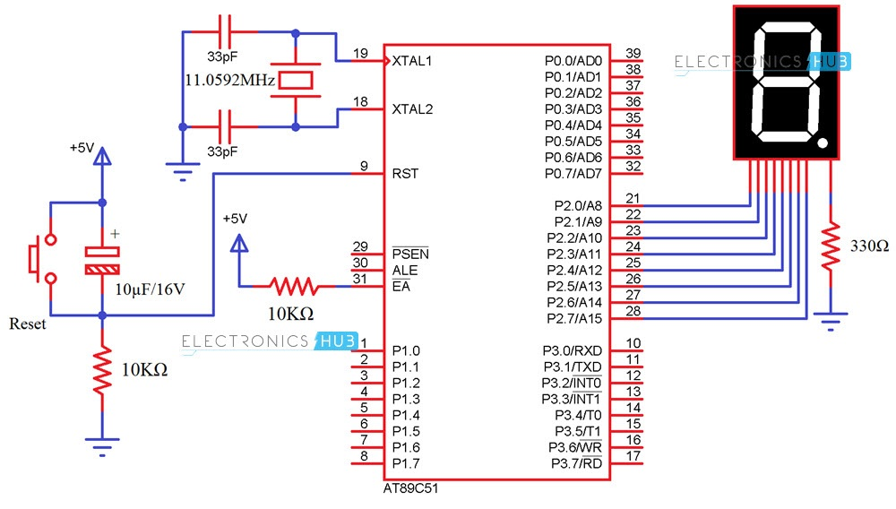

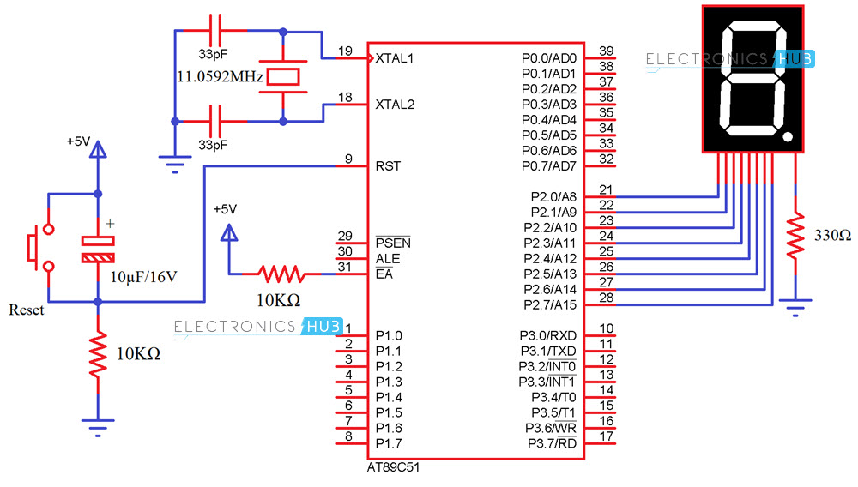

**Procedure/Approach/Algorithm/Activity/Diagram:**

Interfacing 7 Segment Display to 8051 (Single Digit – CC)

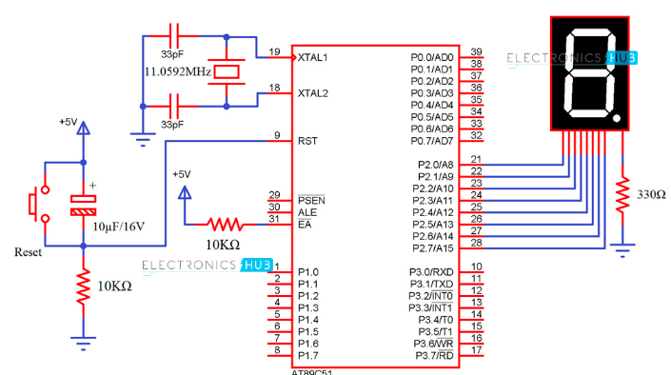

Digit Drive Pattern

To display the digits on 7 segment, we need to glow different logic combinations of segments. For example if you want to display the digit 3 on seven segment then you need to glow the segments a, b, c, d and g. The below table show you the Hex decimal values what we need to send from PORT2 to Display the digits from 0 to 9

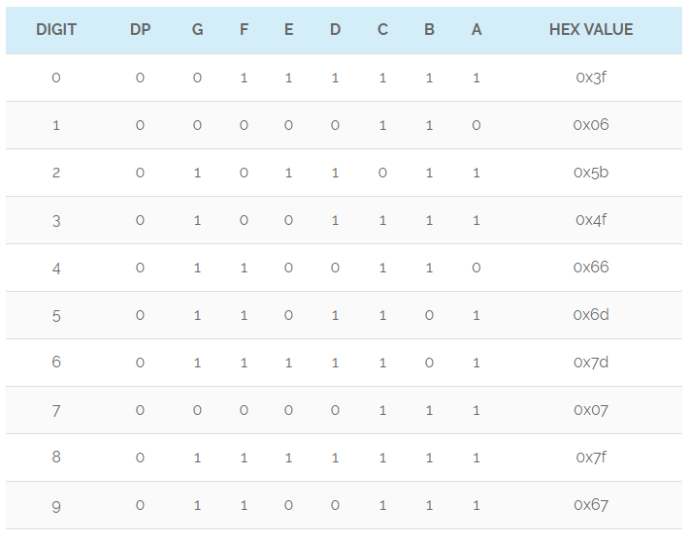

Algorithm (Rotating LED program):

Step 1: Connect Port0 to LED row.

Step2: Send pattern 0x01 to P0.

Step3: Introduce delay.

Step4: Shift bit pattern left.

Step5: Repeat Steps 2, 3, 4 in an infinite loop.

**Procedure/Approach/Algorithm/Activity/Diagram:**

Algorithm (4 digit counter):-

Step 1: Start

Step 2: Connect 8 simple LEDs to Port1

Step 3. Initialize reg A and Port1 with 0x01h

Step 4; Set counter to 9

Step 5: Set time delay of approx. 0.5 sec

Step 6: Rotate left contents of reg A and send to port1

Step 7: Also decrement counter. If counter is not zero go to step 5

Step 7: Go to step 4

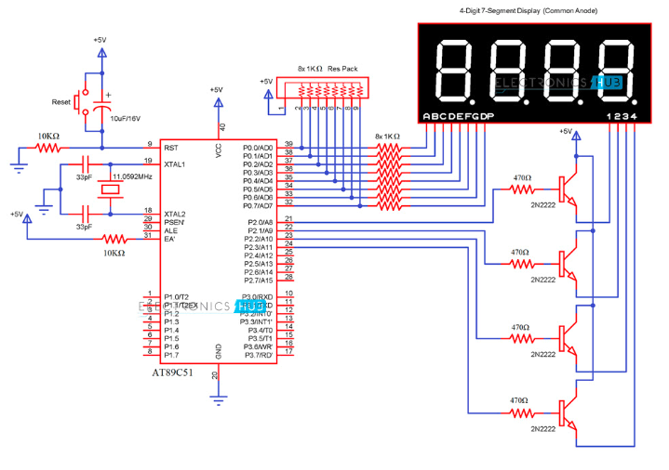

**Results: (Program printout with output / Document printout as per the format)**

1. Upload C program and schematic for rotating LED.

**Ans:**

**CODE:**

include <reg51.h>

void DELAY_ms(unsigned int ms_Count)

{

unsigned int i,j;

for(i=0;i<ms_Count;i++)

{

for(j=0;j<100;j++);

}

}

int main()

{

char seg_code[]={0xc0,0xf9,0xa4,0xb0,0x99,0x92,0x82,0xf8,0x80,0x90};

int i;

while (1)

{

for (i = 0; i <= 9; i++) // loop to display 0-9

{

P2 = seg_code[i];

DELAY_ms(1000);

}

}

}

**OUTPUT:**

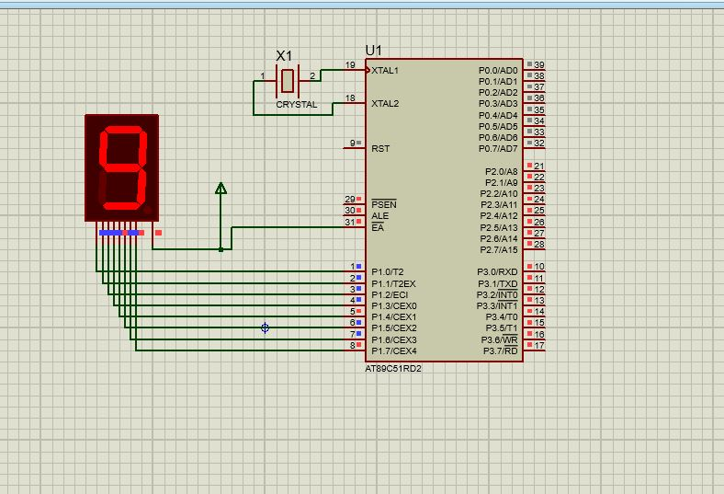

# Questions:

1. List out types of display devices can use with 8051.

**Ans:** We can use these display devices with 8051:

1. LED Display.
2. Liquid on Silicon (LCoS)
3. Electroluminescent Display.
4. Liquid Crystal Display(LCD)
5. Plasma Display.
6. Digital Light Processing Technology.
7. Electronic Paper

**Outcomes (covered by this lab)**:

**CO4:** Ability to perform hardware and software interfacing using knowledge of microcontroller and software tools.

**Conclusion: (Conclusion to be based on outcomes)**

Hence we were successfully able to implement a single digit counter using timer 0and seven segment LED using Keil C compiler.

# Grade: AA / AB / BB / BC / CC / CD /DD

**Signature of faculty in-charge with date**

**Recommended Books::**

1. Introduction to embedded systems, ShibuK.V., McGrawHill.

2. 8051 Microcontroller and Embedded Systems using Assembly and C by Mazidi, Mazidi and D.MacKinlay, 2006 Pearson Education Low Price Edition.

3. Microprocessor and Microcontroller by R.Theagarajan, Sci Tech Publication, Chennai.

4. Barry B. Brey, “The Intel Microprocessors: Architecture, Programming & Interfacing” PHI, 6th Edition, 2003.

**5.** D. V. Hall, “Microprocessor and Interfacing Prsogramming & Hardware” TMH – 2nd Edition

**Referred Site:**

<https://www.electronicshub.org/interfacing-7-segment-display-8051/>