**Install KeyStore Explorer**

**Create server keystore**

1.Create a keystore

2.Generate key pair

3.Export the key pair as “server.p12”

4.Export the certificate as “server.cer”

**Create client keystore**

1.Create a keystore

2.Generate key pair

3.Export the key pair as “client.p12”

4.Export the certificate as “client.cer”

**Add server.cer to client keystore**

1.Open client.p12 file in KeyStore Explorer

2.Click on the “Import trusted certificate” button from the toolbar(it is a read button, next to Generate Key button)

3.select server.cer

4.save client.p12 file

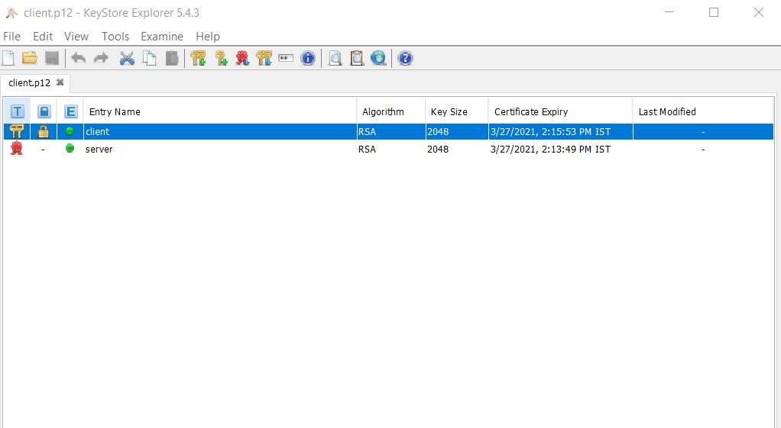

**Add client.cer to server keystore**

1.Open server.p12 file in KeyStore Explorer

2.Click on the “Import trusted certificate” button from the toolbar(it is a read button, next to Generate Key button)

3.select client.cer

4.save server.p12

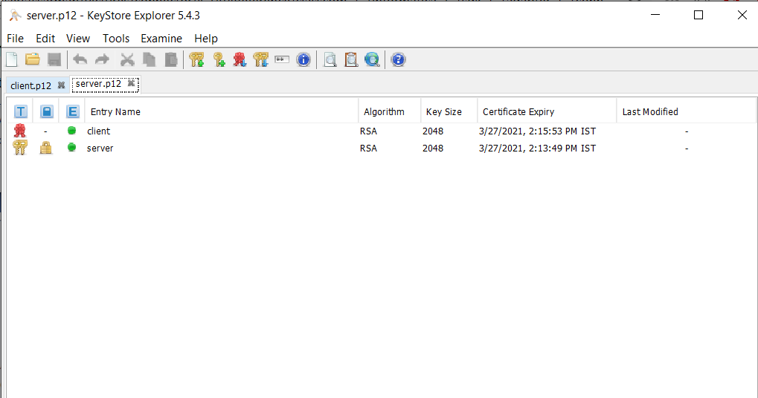

Certificate with postman

