THE OXFORD COLLEGE OF ENGINEERING
HOSUR ROAD, BANGALORE 68

DEPARTMENT OF MCA
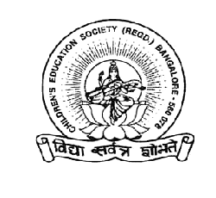

C E R T I F I C A T E

This is to certify that the Project entitled

ON-LINE EXAMINATION SYSTEM (OLES)

is a bonafide work carried out by

SAMEER SEKHAR 1OX02MCA18

in the Department of MCA – T O C E, Bangalore in
partial fulfillment towards the requirement of Fifth Semester course
work of MCA degree of Visveswaraiah Technological University for the
academic session Sept 2004 – Jan 2005.

Project Guide H.O.D – Dept. of MCA

