1. ABSTRACT

Examinations are the easiest way of assessing an individual’s capability to handle the given responsibility or job. Every institution relies on these examinations for evaluating the efficiency quotient of its members. Be it an educational institution or a corporate, timely assessing the progress of its affiliates is a must.

This project is designed to simplify the needs of examination conduction. The process of examination is made easier and efficient both for the examinee and the examiner by providing a series of simpler user interfaces and a strong backend for data storage.

Online Examination System (OLES) is designed to be accessed by the members of the institution over the net thus neutralizing the effects of geographical factors. It provides for member registration and conduction of examination for the members based upon the subject of their choice. The questions are randomly generated and so minimizing the chances of cheating and stuffs like that. The question paper is time bound i.e. after the stipulated period of time the paper is automatically submitted thus making the system capable of assessing the examinees efficiency and accuracy. After an examinee submits the paper, a certificate is generated there itself showing the grades obtained by him.

The system also provides for help regarding loss of registration number or user id. It also provides for a tabular display of marks obtained by every user along with his other details.

To add to the features stated above, it also provides a refreshment section for the recreation of the user. There is also a separate section for site administration making it easier for the institution to handle the site activities.

2. INTRODUCTION
2.1 Introduction of Project:

The project is about enabling an organization to conduct its examinations over the Internet or the Intranet. On-Line Examination system or OLES is a web-based application developed using HTML, JavaScript, and PERL etc. The application is developed using N - Tier architecture. It belongs to “Web Application Category” with HTML forms being the front-end, flat files (Text files) and MS-ACCESS being the back-end, and CGI / PERL being the server side programming language acting as the gateway.

2.1.1 Aim of the Project:

The aim of the project is to enable an organization to test and improve the skill-set of its employees, members or students by conducting On-Line Examinations over the Internet or the Intranet

2.1.2 Objective of the Project:

The main objective of the project is to measure the skill-set of the user by conducting on-line examination over the Internet or the Intranet. Each user appearing for the exam of his/her specified subject should be able to view his/her certificates with regard to the marks obtained. The question paper should be time bound and each user should have different set of questions. The application should also account for help facility in case user losses his/her user_id or registration number.

The basic functionalities offered by the application should include

Registration for New Users
- Help facility in case a user losses User_Id or Registration Number
- Different set of questions for each user or randomly generated questions
- Time limitation for the question paper
- Automated generation of Certificates

2.2 Introduction of Manual:

This document describes the purpose of the document and the intended audience for the document.

2.2.1 Purpose of the document:

This document is the operational manual for OLES (On - Line Examination System) – an Internet/Intranet based knowledge enhancement system. This document is intended to teach you how to use it.

Upon completion of reading of this manual, you will know how to :
- Use the various interfaces (screens) in the application
- Perform all your tasks in the application
- Take the exam
- And finally, view your result

2.2.2 Intended Audience:

OLES is intended to be used by students or general public who wish to test their knowledge at any point of time at any place. This web application is developed to be used as a unique standard for measuring one’s logical ability and IT skills.

The testing is to be done using a web-based application to enable quicker movement of data with minimal infrastructural requirements. The application is developed using N - Tier architecture. The web server is IIS (Internet Information Server) running on Windows NT Server 4.0. Text files and MS ACCESS act as database; client end validation is done through JavaScript and the browser pages are created using HTML and PERL.

This document assures that you have knowledge of using Internet Explorer 4.0 + and are familiar with various parameters that are being captured by the application. This manual does not explain in details that are familiar to such an audience.

3. SRS (SOFTWARE REQUIREMENT SPECIFICATION)

SRS is a document that completely describes what the proposed software should do, without describing how the software will do it. In software requirement specification the client and the user needs are accurately specified.

3.1 Requirement process:

The ultimate objective of the requirement process is to produce a high quality SRS document. As far as possible, all the requirements of the software are elicited and analyzed clearly as specified in the document describing the SRS. Due to this the requirement phase typically consists of three basic activities:
- Problem or requirement analysis
- Requirement specification
- Requirement validation

3.2 Problem analysis:

The basic aim of problem analysis is to obtain a clear understanding of the needs of the clients and the users. The analysis involves interviewing the clients and end users.
- A record should be maintained for each of the user registering with the site.
- A unique Registration number is to be issued by the site to each user after confirming registration. This registration number is to be used as password.
- Every user should be able to choose his area of interest or subject from the given list.
- Proper validation and verification should be maintained while registering users.
- Examination. Should be time bound
- Questions should be generated at the fly. There shouldn’t be a fixed pattern.
- Proper certificate should be generated based upon the marks obtained
- Provisions should be made for searching database in case a user looses his registration number or user id.

3.3 Requirement specification documentation:

3.3.1 Abstract:

The software to be developed is to satisfy the requirement of a firm or institution that involves periodic assessment of its employees or staff. The domain of this project should include all probable examinees along with a provision for site administrator.

3.3.2 Purpose:

To fulfill the requirements of a real life examination conduction process.

3.3.3 Scope:

This document is the only one that describes the requirements of the system. It is meant for use by the developers and will be the basis for validating the final delivered system. Any changes made to the requirements in the future will have to go through a formal change approval process. The developer is responsible for asking for clarifications, where necessary, and will not make any alterations without permission of the client.

3.3.4 Project Function Overview:

The software to be developed should provide as much functionalities required in the daily working in a Life Insurance Firm as possible. Including the functionalities present in the current manual procedures followed in a Life Insurance Firm, it should also provide as much extra functionalities as possible, so as to provide ease of use to the users of the system.

3.3.5 User Characteristics:

The users are the employees, as well as the students and the web master. The user should know the basics of how to handle a GUI based applications.

3.3.6 Functional Requirements:

- The administrator should add and review new information to the user of the software, regularly and properly.
- Proper maintenance of the database.
- To find out hardware specification, i.e. what should work on which hardware platform.
- Registration number should be generated by the site and validated during logon.

3.3.7 Performance requirements:

No such limitation on number of users as the software is supposed to be deployed on a Local Intranet or hosted over the internet. Any number of terminals can access the software. Dynamic requirements include time taken to validate the request and less response time while querying the database.

3.3.8 Design Constraints:

There are a number of factors in the user environment that may restrict the choices of a designer.

3.3.9 Reliability and fault tolerance:

Any failure such as database failure should not affect the system. Standby database should be there to tolerate the database crash and thus increasing the reliability of the system.

4. TOOLS / ENVIRONMENT USED:

A number of different tools are used for the creation of this project. The working environment along with the tools used plays a very important role in successful completion of the OLES project.

4.1 Tools used:

GUI Tools | MS FrontPage 2000
Scripting Tools | Notepad
Languages | HTML, JavaScript, PERL, ASP

4.2 Environment Used:

4.2.1 Hardware platform:

HArdware | specification
Processor | P I and above
ram | 32 MB and above
Hard-disk | 4 GB and above
Monitor | 4” color SVGA supporting 800*600 resolution at 64K
Modem | 33.6 kbps and above

4.2.2 Software platform:

Software | Specification
Operating System | Window 98, Windows NT 4.0 and above
Web Server | PWS for Window 98, IIS 4.0
Backend (DBMS) | Oracle 8/8i
Browser | Internet Explorer 4.0 and above

4.2.3 Browser Settings:

Attributes | Value
Play animation | Checked
Play Sound | Checked
Show Pictures | Checked
Scripting | Enabled
Scripting of Applets | Enabled
Text Size | Medium
Format document using my style sheet | Unchecked

5. DESIGN

5.1 Sequence Diagram:

These diagrams are used to illustrate interaction between objects; that is the messages sent and received between the objects. Sequence diagrams are used to describe a specific scenario.

Sequence diagrams have two axes, vertical axis showing the time while the horizontal axis showing a set of objects that interact in that particular scenario. The vertical dashed line indicates the objects existence during the sequence. During this time the object is said to be instantiated and active to perform send and receive messages. Communication between objects is represented by horizontal message lines within the objects lifeline. Reading of sequence diagram is done top down to view the exchanges of messages between objects taking place as time passes.

While drawing a sequence diagram points to be borne in mind are:
- Events are depicted by horizontal lines
- Objects by vertical lines
- Time is depicted vertically starting from top, representing the events in the order of their occurrence.

5.1.1 Sequence Diagram for exam conduction process:

USER
Server
DATABASE

Submits Registration Form
Validates and Sends Data to the Database

Checks for Duplicate Data

Registration Complete If Data Found Unique
Confirmation Message to the User
Requests for help for user_id or registration number
Sends user information to the database

Queries the database for user information

Sends the result of the query to the server
Displays the result to the user

Requests for generation of question paper
Sends information about the user and the subject applied for

Checks for User validation

Sends question data from the data files stored
Displays the question paper
Displays Certificate to the user
Sends user result data to the server
Checks for valid user
Checks for appearance in exam
Evaluates the result
Submits the question paper
Sends the submitted answers for evaluation

5.2 Data Flow Diagram:

Homepage

New User’s Registration
Process
Request For Registration
Duplicate Or Inadequate Data

Student Data File

Login
Process

Question Generation Process

Answer Files

Marks Evaluation Process
User Request For Login
User Submits Question Paper
Question Files
Un-authenticated User
Re-submission Of Question Paper

Student Data File

Marks Data File

Un-authenticated User Or Not Appeared For Exam
Certificate Generation Process
User Request For Certificate

Certificate Generation

5.3 Flowchart:

Flowchart for the registration event:

5.3.1

NEW REGISTRATION
IS
ENTRY COMPLETE
REGISTRATION COMPLETE BY UPDATING STUDENT FILE WITH NEW DATA
IS DATA PRESENT IN STUDENT FILE
HOMEPAGE

CONFIRMATION PAGE WITH USER ID AND REGISTRATION NUMBER
ERROR PAGE
ERROR PAGE
NO
YES
YES
NO
Duplicate Data

5.3.2
Flowchart for the find event:
ACCEPTS SEARCH DATA
READING THE SPECIFIED RECORD FROM THE STUDENT FILE
IS DATA PRESENT IN STUDENT FILE
IS SEARCH CRITERIA FULFILLED
HOMEPAGE

HELP
DISPLAYING USER_ID AND REGISTRATION NUMBER
YES
ERROR PAGE
ERROR PAGE
NO
NO
YES

5.3.3
LOGIN INFORMATION
GENERATION OF THE FRONT PAGE OF THE QUESTION PAPER
IS DATA PRESENT IN MARKS FILE
IS DATA PRESENT IN STUDENT FILE
HELP
HOMEPAGE
REGISTRATION
GENERATION OF QUESTION PAPER WITH RANDOM QUESTIONS
Flowchart for the login event:
ERROR PAGE
ERROR PAGE
Unauthenticated user
Authenticated user
Appeared For Exam
YES
YES
NO
NO

5.3.4
Flowchart for the question submission event:

HOMEPAGE
QUESTION PAPER
SUBMISSION OF QUESTION PAPER
WRITING OF DATA REGARDING MARKS OBTAINED, INTO THE MARKS FILE
IS DATA PRESENT IN MARKS FILE
EVALUATION OF MARKS
ERROR PAGE
YES
NO
DISPLAY MARKS
Re-submission of Question Paper

Flowchart for the certificate issue event:

5.3.5

ACCEPTS USER DATA
IS DATA PRESENT IN MARKS FILE
IS DATA PRESENT IN STUDENT FILE
HOMEPAGE
DISPLAY MARKS
HELP
MARKSHEET
GENERATE CERTIFICATE
ERROR PAGE
ERROR PAGE
YES
NO
NO
YES
Unauthenticated user
Authenticated user
Not Appeared For Exam

5.3.6
Flowchart for the mark sheet generation event:
READ DATA FROM MARKS FILE
FORMATS THE READ DATA
HOMEPAGE
DISPLAYS THE ENTIRE MARKSHEET IN TABULAR FORM

5.4 Table Structure:

For the handling of data (user information), MS-ACCESS tables have been used. Each registration information is stored in “US_ENTRY” table and the marks information generated after submission of the question paper is stored in “TRY_MARKS” table. Flat files i.e. “.txt” files can be used along with the MA_ACCESS tables to store questions and other related information.

5.4.1 Structure of the tables:

5.4.1.1 US_ENTRY

Field Name | Datatype | Field Size | Field Description
User_id | text | 50 | Store User_id of the new user
Nam | text | 50 | Store Name of the user
Sub | text | 15 | Store Subject selected by user
E_id | text | 50 | Store Email_id of the user
M_add | text | 255 | Store Mailing address of the user
Reg_no | number | 5 | Store Registration Number of the user

TRY_MARKS

Field Name | Datatype | Field Size | Field Description
Userid | text | 50 | Store User_id of the new user
Registerno | number | 10 | Store Registration Number of the user
Subject | text | 15 | Store Subject selected by user
Marks | number | 5 | Store Marks obtained by the user

6 CODING

6.1 HTML Files:

6.1.1 Homepage.htm:

<html>

<head>

<script language="JavaScript">

var img_index=0;

Imageban=new Array("Samsnet.gif","rhlogo.gif","lycoslogo.gif","itklogo.gif","icicilogo.gif","ibmlogo.gif","brain_ad12.gif");

function Main()

{

setInterval("callidimage()",6000);

}

function callidimage()

{

ban.src=Imageban[img_index];

img_index++;

if(img_index>6){img_index=0;}

}

</script>

<script language="JScript">

function update_hitcounter()

{

var f,text,obj,tristate=0,forReading=1,forWriting=2,hitcount=1;

obj=new ActiveXObject("Scripting.FileSystemObject");

if(!obj.FileExists("C:\\apache\\Apache\\exam\\hitcounter.txt"))

{

obj.CreateTextFile("C:\\apache\\Apache\\exam\\hitcounter.txt");

f=obj.GetFile("C:\\apache\\Apache\\exam\\hitcounter.txt");

text=f.OpenAsTextStream(forWriting,tristate);

text.write(hitcount);

}

else

{

f=obj.GetFile("C:\\apache\\Apache\\exam\\hitcounter.txt");

text=f.OpenAsTextStream(forReading,tristate);

hitcount=parseInt(text.readline());

text.Close();

hitcount++;

text=f.OpenAsTextStream(forWriting,tristate);

text.write(hitcount);

}

text.Close();

}

</script>

</head>

<body topmargin="0" leftmargin="0" marginwidth="0" marginheight="0" rightmargin="0" onload="Main(),update_hitcounter();" >

<style type="text/css">

<!--

.effect { color:#000000;font-family:normal;font-size:13pt;filter:glow(color=white,strength=4);}

-->

</style>

<script language="JavaScript">

function hover(r)

{

r.style.color="#bf313e";

r.style.filter="glow(color=#cfffcf,strength=4)";

}

function hoveroff(r)

{

r.style.color="#000000";

r.style.filter="glow(color=#96c8c8,strength=4)";

}

function hover1(r)

{

r.style.color="#cfffcf";

}

function hoveroff1(r)

{

r.style.color="#ffffff";

}

if (document.all)

{

msg= new Array("B","R","A","I","N","W","O","R","L","D",".","C","O","M");

document.write('<div id="starsDiv" style="position:absolute;top:0px;left:0px">')

for (xy=0;xy<14;xy++)

{

document.write('<div style="position:relative; width:6px; height:6px;font-size:10px;color:red; visibility:visible">');

document.write(msg[xy]);

document.write('</div>');

}

document.write('</div>')

}

if (document.layers)

{

window.captureEvents(Event.MOUSEMOVE);

}

var yBase = 200, xBase = 200, yAmpl = 10, yMax = 40, step = .2, ystep = .5, currStep = 0, tAmpl=1, Xpos = 1;

var Ypos = 1, i = 0, j = 0;

if (document.all)

{

function MoveHandler()

{

Xpos = document.body.scrollLeft+event.x;

Ypos = document.body.scrollTop+event.y;

}

document.onmousemove = MoveHandler;

}

else if (document.layers)

{

function xMoveHandler(evnt)

{

Xpos = evnt.pageX;

Ypos = evnt.pageY;

}

window.onMouseMove = xMoveHandler;

}

function animateLogo()

{

if (document.all)

{

yBase = window.document.body.offsetHeight/4;

xBase = window.document.body.offsetWidth/4;

}

else if (document.layers)

{

yBase = window.innerHeight/4 ;

xBase = window.innerWidth/4;

}

if (document.all)

{

var totaldivs=document.all.starsDiv.all.length

for ( i = 0 ; i < totaldivs ; i++ )

{

var tempdiv=document.all.starsDiv.all[i].style

tempdiv.top = Ypos + Math.cos((20*Math.sin(currStep/20))+i*70)*yBase* (Math.sin(10+currStep/10)+0.2)*Math.cos((currStep + i*25)/10);

tempdiv.left = Xpos + Math.sin((20*Math.sin(currStep/20))+i*70)*xBase* (Math.sin(10+currStep/10)+0.2)*Math.cos((currStep + i*25)/10);

}

}

else if (document.layers)

{

for ( j = 0 ; j < 7 ; j++ )

{

var templayer="a"+j

document.layers[templayer].top = Ypos + Math.cos((20*Math.sin(currStep/20))+j*70) *yBase* (Math.sin(10+currStep/10)+0.2)*Math.cos((currStep + j*25)/10);

document.layers[templayer].left =Xpos + Math.sin((20*Math.sin(currStep/20))+j*70) *xBase*(Math.sin(10+currStep/10)+0.2)*Math.cos((currStep + j*25)/10);

}

}

currStep += step;

setTimeout("animateLogo()", 15);

}

animateLogo();

TMonth = new Array('January','February','March','April','May','June','July','August','September','October','November','December');

TDay = new Array('Sunday','Monday','Tuesday','Wednesday','Thursday','Friday','Saturday');

TDate = new Date();

CurDay = TDate.getDay();

CurMonth = TDate.getMonth();

Month = TMonth[CurMonth];

Day = TDay[CurDay];

NDay = TDate.getDate();

CurYear = TDate.getYear();

Year = "" + CurYear;

</script>

<table border=1 bordercolor="#64a8ae" bgcolor=white height="425">

<tr><td bgcolor=#000000 height=105>

<img src="brain_logo12.gif" width ="143" height ="70" style="position:absolute;left:10;top:20;z-index:2;"></img>

</td></tr>

<tr bgcolor=#000000><td style="color:white;font-size:10pt; height:110;"><form method=post action="http:\\127.0.0.1\exam\login1.pl">&nbsp;User id &nbsp;&nbsp;&nbsp<input type="text" name="uid" value="" size="10" style="background:#96c8c8;height:18"><br> &nbsp;Reg No &nbsp;&nbsp;<input type="password" name="rno" value="" size="10" style="background:#96c8c8;height:18;"><br><br>

&nbsp;&nbsp;&nbsp;&nbsp;<input style="WIDTH: 50; POSITION: absolute; HEIGHT: 18px;background:#64a8ae;color:black;font-size:7pt" type="reset" name="reset" value="Cancel" title="Reset the fileds">&nbsp;&nbsp;&nbsp;&nbsp;&nbsp;&nbsp;&nbsp;&nbsp;&nbsp;&nbsp;&nbsp;&nbsp;&nbsp;&nbsp;&nbsp;&nbsp;&nbsp;&nbsp;&nbsp;&nbsp;&nbsp;&nbsp;<input style="WIDTH:50; POSITION: absolute; HEIGHT: 18px;background:#64a8ae;color:black;font-size:7pt" type="submit" value="Login" title="Go for Examination"> </form></td></tr>

<tr bgcolor=#000000><td>&nbsp;&nbsp;&nbsp;&nbsp;<A href="http:\\127.0.0.1\exam\help.htm" target =_top

title="Search your user id and registration number" style="color:white;font-size:11pt;" id=mnulnk1 onmouseover=hover1(mnulnk1) onmouseout=hoveroff1(mnulnk1) > Forget Password</A><br></td></tr>

<tr bgcolor=#000000><td>&nbsp;&nbsp;&nbsp;&nbsp; <A href="http:\\127.0.0.1\exam\register.htm" target=_top

title="Registration form for New Users" style="color:white;font-size:11pt;" id=mnulnk2 onmouseover="hover1(mnulnk2)" onmouseout="hoveroff1(mnulnk2)">New Registration</A></td></tr>

<tr bgcolor=#000000><td><img id="ban" width="150" height="50" src="brain_ad12.gif"></img></td></tr>

</table>

<div style="position:absolute;top:-20;left:550;z-index:-1;"><img src="brainworld3.gif" width=220 height=100></div>

<div style="position:absolute;top:39;left:557"> <hr color="maroon" width ="130" size = "2"></div>

<div style="position:absolute;left:175;top:10;"><table border=0 bgcolor=white>

<tr align="right"><td height="2"><font style="color:#64a8ae;font-size:8pt;" face="MS Sans Serif, Arial, Verdana">

<script language="JavaScript">

document.write(Day);

document.write(", ");

document.write(Month);

document.write(" ");

document.write(NDay);

document.write(", ");

document.write(Year);

</script>

&nbsp; </font></td></tr></table></div>

<div style="position:absolute;top:70;left:215;z-index:-1;"><img src="spider2.gif" width=370 height=250></div>

<div id="r8" style="position:absolute;top:110;left:600;color:black;font-family:normal;font-size:7pt; letter-spacing:2pt;filter:glow(color=#96c8c8,strength=4);" onmouseover="hover(r8)" onmouseout="hoveroff(r8)"><a href="register.htm" title="Registration form for new users"><font color="black">REGISTRATION</font></a></div>

<div id="r7" style="position:absolute;top:160;left:600;color:black;font-family:normal;font-size:7pt; letter-spacing:2pt;filter:glow(color=#96c8c8,strength=4);" onmouseover="hover(r7)" onmouseout="hoveroff(r7)"><a href="http:\\127.0.0.1\exam\marksheet.pl" title="Click here to view Results"><font color="black">RESULT</a></div>

<div id="r6" style="position:absolute;top:220;left:600;color:black;font-family:normal;font-size:7pt; letter-spacing:2pt;filter:glow(color=#96c8c8,strength=4);" onmouseover="hover(r6)" onmouseout="hoveroff(r6)"><a href="help.htm" title="Search your user id and registration number"><font color="black">FORGET PASSWORD</a></div>

<div id="r5" style="position:absolute;top:70;left:207;color:black;font-family:normal;font-size :7pt; letter-spacing:2pt;filter:glow(color=#96c8c8,strength=4);" onmouseover="hover(r5)" onmouseout="hoveroff(r5)"><a href="aboutme.htm" title="Click here to know about the maker of the site"><font color="black">ABOUT ME</a></div>

<div id="r4" style="position:absolute;top:290;left:600;color:black;font-family:normal;font-size:7pt; letter-spacing:2pt;filter:glow(color=#96c8c8,strength=4);" onmouseover="hover(r4)" onmouseout="hoveroff(r4)"><a href="sample.htm" title="Click here for sample test" ><font color="black">SAMPLE QUESTIONS</a></div>

<div id="r3" style="position:absolute;top:325;left:480;color:black;font-family:normal;font-size:7pt;letter-spacing:2pt;filter:glow(color=#96c8c8,strength=4);" onmouseover="hover(r3)" onmouseout="hoveroff(r3)"><a href="strategy.htm" title="Click here to know about the purpose of the site"><font color="black">STRATEGY</a></div>

<div id="r2" style="position:absolute;top:180;left:200;color:black;font-family:normal;letter-spacing:2pt;font-size:7pt; filter:glow(color=#96c8c8,strength=4);" onmouseover="hover(r2)" onmouseout="hoveroff(r2)"><a href="webmaster.htm" title="Gateway for Site Administrator"><font color="black">WEB MASTER</a></div>

<div id="r1" style="position:absolute;top:325;left:290;color:black;font-family:normal;font-size:7pt; letter-spacing:2pt;filter:glow(color=#96c8c8,strength=4);" onmouseover="hover(r1)" onmouseout="hoveroff(r1)"><a href="refreshment.htm" title="Click here to get Refreshed"><font color="black">REFRESHMENT</a></div>

<div style="position:absolute;top:320;left:675;z-index:-2;"><img src="cartoon.bmp" width=95 height=105></div>

<marquee CLASS="effect" loop="-1" scrolldelay="100" style="position:absolute;top:365;left:180;width:510;color:brown;"><img src="BrainLogo.bmp" width="350" height="50">&nbsp;&nbsp;&nbsp;&nbsp;&nbsp;&nbsp;&nbsp;&nbsp;&nbsp;&nbsp;&nbsp;&nbsp;&nbsp;&nbsp;&nbsp;&nbsp;&nbsp;&nbsp;&nbsp;&nbsp;&nbsp;&nbsp;&nbsp;&nbsp;&nbsp;&nbsp;&nbsp;&nbsp;&nbsp;&nbsp;&nbsp;

&nbsp;&nbsp;&nbsp;&nbsp;&nbsp;&nbsp;&nbsp;&nbsp;&nbsp;&nbsp;&nbsp;&nbsp;&nbsp;&nbsp;&nbsp;&nbsp;&nbsp;&nbsp;&nbsp;&nbsp;&nbsp;&nbsp;&nbsp;&nbsp;&nbsp;&nbsp;&nbsp;&nbsp;&nbsp;&nbsp;&nbsp;&nbsp;&nbsp;&nbsp;&nbsp;&nbsp;&nbsp;&nbsp;&nbsp;&nbsp;&nbsp;&nbsp;&nbsp;&nbsp;&nbsp;&nbsp;&nbsp;&nbsp;&nbsp;&nbsp;&nbsp;&nbsp;&nbsp;&nbsp;&nbsp;&nbsp;&nbsp;&nbsp;&nbsp;&nbsp;&nbsp;&nbsp;&nbsp;&nbsp;&nbsp;&nbsp;&nbsp;&nbsp;&nbsp;&nbsp;&nbsp;&nbsp;&nbsp;&nbsp;&nbsp;&nbsp;&nbsp;&nbsp;&nbsp;&nbsp;&nbsp;&nbsp;&nbsp;&nbsp;&nbsp;&nbsp;&nbsp;&nbsp;&nbsp;&nbsp;&nbsp;&nbsp;&nbsp;&nbsp;&nbsp;&nbsp;&nbsp;<img src="redhatbanner.gif" width="350" height="50">&nbsp;&nbsp;&nbsp;&nbsp;&nbsp;&nbsp;&nbsp;&nbsp;&nbsp;&nbsp;&nbsp;&nbsp;&nbsp;&nbsp;&nbsp;&nbsp;&nbsp;&nbsp;&nbsp;&nbsp;&nbsp;&nbsp;&nbsp;&nbsp;&nbsp;&nbsp;&nbsp;&nbsp;&nbsp;&nbsp;&nbsp;&nbsp;&nbsp;&nbsp;&nbsp;&nbsp;&nbsp;&nbsp;&nbsp;&nbsp;&nbsp;&nbsp;&nbsp;&nbsp;&nbsp;&nbsp;&nbsp;&nbsp;&nbsp;&nbsp;&nbsp;&nbsp;&nbsp;&nbsp;&nbsp;&nbsp;&nbsp;&nbsp;&nbsp;&nbsp;&nbsp;&nbsp;&nbsp;&nbsp;&nbsp;&nbsp;&nbsp;&nbsp;&nbsp;&nbsp;&nbsp;&nbsp;&nbsp;&nbsp;&nbsp;&nbsp;&nbsp;&nbsp;&nbsp;&nbsp;&nbsp;&nbsp;&nbsp;&nbsp;&nbsp;&nbsp;&nbsp;&nbsp;&nbsp;&nbsp;&nbsp;&nbsp;&nbsp;&nbsp;&nbsp;&nbsp;&nbsp;&nbsp;&nbsp;&nbsp;&nbsp;&nbsp;&nbsp;&nbsp;&nbsp;&nbsp;&nbsp;&nbsp;&nbsp;&nbsp;&nbsp;&nbsp;&nbsp;&nbsp;&nbsp;&nbsp;&nbsp;&nbsp;&nbsp;&nbsp;&nbsp;&nbsp;<img src="itknowledgebanner.gif" width="350" height="50"></marquee></BODY></html>

6.1.2 Register.htm:

<HTML><head>

<FRAMESET border=0 cols="160,*" frameBorder=0 frameSpacing=0 noscroll>

<FRAME name=mnu src="menu_frame.htm">

<FRAMESET border=0 rows="85,*" frameBorder=0 frameSpacing=0 noscroll>

<FRAME name=heading src="heading.htm">

<FRAMESET border=0 rows="39,*" frameBorder=0 frameSpacing=0 noscroll>

<FRAME name=heading_register src="heading_register.htm" >

<FRAME name=content src="register_content.htm">

</FRAMESET>

</FRAMESET>

</FRAMESET>

</head>

</HTML>

6.1.3 Menu_frame.htm:

<html><head>

<script language="JavaScript">

var img_index=0;

Imageban=new Array("Samsnet.gif","rhlogo.gif","lycoslogo.gif","itklogo.gif","icicilogo.gif","ibmlogo.gif","brain_ad12.gif");

function Main()

{

setInterval("callidimage()",6000);

}

function callidimage()

{

ban.src=Imageban[img_index];

img_index++;

if(img_index>6){img_index=0;}

}

</script>

</head>

<body topmargin="0" leftmargin="0" marginwidth="0" marginheight="0" rightmargin="0" onload="Main()" >

<style type="text/css">

<!--

.effect { color:#000000;font-family:normal;font-size:13pt;filter:glow(color=white,strength=4);}

-->

</style>

<script language="JavaScript">

function hover(r)

{

r.style.color="#bf313e";

r.style.filter="glow(color=orange,strength=1)";

}

function hoveroff(r)

{

r.style.color="#000000";

r.style.filter="glow(color=#96c8c8,strength=4)";

}

function hover1(r)

{

r.style.color="#ff1111";

}

function hoveroff1(r)

{

r.style.color="#ffffff";

}

</script>

<table border=1 bordercolor="#64a8ae" bgcolor=white height="432">

<tr><td bgcolor=#000000 height=90>

<img src="brain_logo12.gif" width ="143" height ="70" style="position:absolute;left:10;top:15;z-index:2;"></img>

</td></tr>

<tr bgcolor=#000000><td>&nbsp;&nbsp;&nbsp;&nbsp;<A href="http:\\127.0.0.1\exam\homepage.htm" target =_top

title="Back To Homeapage" style="color:white;font-size:11pt;" id=mnulnk1 onmouseover=hover1(mnulnk1) onmouseout=hoveroff1(mnulnk1) >Home</A></td></tr>

<tr bgcolor=#000000><td>&nbsp;&nbsp;&nbsp;&nbsp; <A href="http:\\127.0.0.1\exam\register.htm" target=_top

title="Registration form for New Users" style="color:white;font-size:11pt;" id=mnulnk2 onmouseover="hover1(mnulnk2)" onmouseout="hoveroff1(mnulnk2)">New Registration</A></td></tr>

<tr bgcolor=#000000><td>&nbsp;&nbsp;&nbsp;&nbsp;<A href="http:\\127.0.0.1\exam\help.htm" target =_top

title="Search your user id and registration number" style="color:white;font-size:11pt;" id=mnulnk3 onmouseover=hover1(mnulnk3) onmouseout=hoveroff1(mnulnk3) > Forget Password</A></td></tr>

<tr bgcolor=#000000><td>&nbsp;&nbsp;&nbsp;&nbsp; <A href="http:\\127.0.0.1\exam\marksheet.pl" target=_top

title="Click here to View the Results" style="color:white;font-size:11pt;" id=mnulnk4 onmouseover="hover1(mnulnk4)" onmouseout="hoveroff1(mnulnk4)">Result</A></td></tr>

<tr bgcolor=#000000><td>&nbsp;&nbsp;&nbsp;&nbsp;<A href="http:\\127.0.0.1\exam\Aboutme.htm" target =_top

title="About the maker of the site" style="color:white;font-size:11pt;" id=mnulnk5 onmouseover=hover1(mnulnk5) onmouseout=hoveroff1(mnulnk5) >About Me</A></td></tr>

<tr bgcolor=#000000><td>&nbsp;&nbsp;&nbsp;&nbsp;<A href="http:\\127.0.0.1\exam\sample.htm" target =_top

title="Click here to see Sample questions" style="color:white;font-size:11pt;" id=mnulnk6 onmouseover=hover1(mnulnk6) onmouseout=hoveroff1(mnulnk6) > Sample</A></td></tr>

<tr bgcolor=#000000><td>&nbsp;&nbsp;&nbsp;&nbsp;<A href="http:\\127.0.0.1\exam\refreshment.htm" target =_top

title="Click here to get Refreshed" style="color:white;font-size:11pt;" id=mnulnk7 onmouseover=hover1(mnulnk7) onmouseout=hoveroff1(mnulnk7) >Refreshment</A></td></tr>

<tr bgcolor=#000000><td>&nbsp;&nbsp;&nbsp;&nbsp;<A href="http:\\127.0.0.1\exam\strategy.htm" target =_top

title="Click here to know the purpose of the site" style="color:white;font-size:11pt;" id=mnulnk8 onmouseover=hover1(mnulnk8) onmouseout=hoveroff1(mnulnk8) >Strategy</A></td></tr>

<tr bgcolor=#000000><td>&nbsp;&nbsp;&nbsp;&nbsp;<A href="http:\\127.0.0.1\exam\webmaster.htm" target =_top

title="Gateway for Web Master" style="color:white;font-size:11pt;" id=mnulnk9 onmouseover=hover1(mnulnk9) onmouseout=hoveroff1(mnulnk9) >Web Master</A></td></tr>

<tr bgcolor=#000000><td height="85"><img id="ban" width="150" height="50" src="brain_ad12.gif"></img></td></tr>

</table>

</body></html>

6.1.3 Heading.htm:

<html>

<body bgcolor="#ffffff">

<script language="JavaScript">

TMonth = new Array('January','February','March','April','May','June','July','August','September','October','November','December');

TDay = new Array('Sunday','Monday','Tuesday','Wednesday','Thursday','Friday','Saturday');

TDate = new Date();

CurDay = TDate.getDay();

CurMonth = TDate.getMonth();

Month = TMonth[CurMonth];

Day = TDay[CurDay];

NDay = TDate.getDate();

CurYear = TDate.getYear();

Year = "" + CurYear;

</script>

<div style="position:absolute;top:-20;left:412;z-index:-1;"><img src="brainworld3.gif" width=220 height=100></div>

<div style="position:absolute;top:39;left:420"> <hr color="maroon" width ="130" size = "2"></div>

<div style="position:absolute;left:15;top:10;">

<table border=0 bgcolor=white>

<tr align="right"> <td height="2"><font style="color:#64a8ae;font-size:8pt;" face="MS Sans Serif, Arial, Verdana">

<script language="JavaScript">

document.write(Day);

document.write(", ");

document.write(Month);

document.write(" ");

document.write(NDay);

document.write(", ");

document.write(Year);

</script>

&nbsp; </font></td></tr>

</table></div>

</body>

</html>

6.1.4 Heading_register.htm:

<html><body>

<DIV STYLE="POSITION:ABSOLUTE;top:4;left:0;z-index:-2;;">

<hr color="#64a8ae" width=635>

</div>

<div style="position:absolute;top:0;left:7;background:white;z-index:-2;">

<h3>New Registration</h3>

</div>

</body></html>

6.1.5 Register_content.htm:

<html>

<head>

<script language = "JavaScript">

var flag=0;

function h()

{

document.location.replace("homepage.htm");

document.location.target="_top";

}

function chek()

{

var u="";

el=document.forms[0].elements.length;

for(j=0;j<el;j++)

{

u=document.forms[0].elements[j].value;

l_u=u.length;

for(i=0;i<l_u;i++)

{

if((u.substring(i,i+1)=="%") || (u.substring(i,i+1)=="?") || (u.substring(i,i+1)=="+") || (u.substring(i,i+1)=="~") || (u.substring(i,i+1)==";") || (u.substring(i,i+1)=="*") || (u.substring(i,i+1)=="#") || (u.substring(i,i+1)=="\""))

{

flag=1;

document.forms[0].elements[j].value="";

u="";

}

}

}

if(!flag)

{

document.forms[0].submit();

}

else

{

alert("Your entry contains certain characters that are not allowed. Please Refresh the form.");

}

}

</script>

</head>

<body>

<div style="position:absolute;left:15;top:10;">

<form action="http:\\127.0.0.1\exam\register_users.pl" method="post">

<b>

<table border=0>

<tr><td>User_Id</td>

<td>&nbsp&nbsp&nbsp&nbsp&nbsp:&nbsp&nbsp&nbsp&nbsp&nbsp</td><td><input type=text name="u_id" size=15 maxlength=40 style="HEIGHT: 20px;background:#64a8ae;color:black;font-size:7pt"></td></tr>

<tr><td>Name</td>

<td>&nbsp&nbsp&nbsp&nbsp&nbsp:&nbsp&nbsp&nbsp&nbsp&nbsp</td><td><input type=text name="nam" size=15 maxlength=40 style="HEIGHT: 20px;background:#64a8ae;color:black;font-size:7pt"></td></tr>

<tr><td>Subject</td>

<td>&nbsp&nbsp&nbsp&nbsp&nbsp:&nbsp&nbsp&nbsp&nbsp&nbsp</td><td><select name="sub" style="width:87;HEIGHT: 22px;background:#64a8ae;color:black;font-size:7pt">

<option value="iq" selected>IQ Test</option>

<option value="java">Java</option>

<option value="oracle">Oracle</option>

</select></td></tr>

<tr><td>E-mail</td>

<td>&nbsp&nbsp&nbsp&nbsp&nbsp:&nbsp&nbsp&nbsp&nbsp&nbsp</td><td><input type=text name="e_id" size=15 maxlength=40 style="HEIGHT: 20px;background:#64a8ae;color:black;font-size:7pt"></td></tr>

<tr><td>Mailing Address</td>

<td>&nbsp&nbsp&nbsp&nbsp&nbsp:&nbsp&nbsp&nbsp&nbsp&nbsp</td><td><input type=text name="m_add" size=15 maxlength=75 style="HEIGHT: 20px;background:#64a8ae;color:black;font-size:7pt"></td></tr>

</table></form>

</div>

<div style="position:absolute;top:150;left:145;">

<center>

TERMS AND CONDITIONS&nbsp&nbsp&nbsp&nbsp&nbsp</center><br>1. One registration is valid for only one examination <br>2. The result/certificate will be mailed at your mailing address.<br>3. Please fill the form as per the given instructions.

</center>

</div>

<div style="position:absolute;top:270;left:80;"><a href="homepage.htm" target="_top" title="Back To HomePage" style="color:#64a8ae;font-size:12pt;">DisAgree</a>

&nbsp;&nbsp;&nbsp;&nbsp;&nbsp;&nbsp;&nbsp;&nbsp;&nbsp;&nbsp;&nbsp;&nbsp;&nbsp;&nbsp;&nbsp;&nbsp;&nbsp;&nbsp;&nbsp;&nbsp;&nbsp;&nbsp;&nbsp;&nbsp;&nbsp;&nbsp;&nbsp;&nbsp;&nbsp;&nbsp;&nbsp;

<Input type=button value=Agree onClick="chek()" title="Click to Register" style="background:#64a8ae;color:white;font-size:8pt">

</div>

<div style="position:absolute;top:7;left:345;">

<table border=1 frame=box bordercolor="#64a8ae" bgcolor=white height="120" width="220" cellpadding="10"><tr><td>Please do not use characters like (; " / ? < > \ % + & ^ # * ! ~ | ') while filling the form. These characters may disrupt the functioning. Thanks!</td></tr></table>

</div>

</BODY></html>

* * * * * * * * * * * * * * * * * * * * * * * * * * * * * * * * * * * * * * * * * * *
* *
* The files Menu_frame.htm and Heading.htm are common for most of the *
* links of the project like forget password, webmaster, refreshment, aboutme *
* strategy etc. The files for specific headings differ in only its string value. *
* The content frame files for the above mentioned links are as follows……… *
* *
* ** * * * * * * * * * * * * * * * * * * * * * * * * * * * * * * * * * * * * * * * * * ********

6.1.6 Help_content.htm:

<html>

<head></head>

<body>

<div style="position=absolute;top:10;left:20;"><H4> Enter the fields and its corresponding value that U remember<br>

Atleast two field should match in order to satisfy the search</h4><br><br><form method="post" action="http:\\127.0.0.1\exam\find.pl"><b>Select the fields &nbsp&nbsp&nbsp&nbsp&nbsp&nbsp&nbsp&nbsp &nbsp&nbsp&nbsp&nbsp Enter the value<br><br><select name=field1 style="width:130;HEIGHT: 26px;background:#64a8ae;color:black;font-size:7pt"><option value="u_id" selected>User id</option><option value="reg_no" >Registration number </option></select>&nbsp&nbsp&nbsp&nbsp&nbsp&nbsp&nbsp&nbsp <input type=text name=value1 value="" style="HEIGHT: 21px;background:#64a8ae;color:black;font-size:7pt"><br><br> <select name=field2 style="width:130;HEIGHT: 26px;background:#64a8ae;color:black;font-size:7pt"><option value="nam">User Name</option><option value="sub" selected>Subject</option><option value="e_id" >E-mail id</option></select>&nbsp&nbsp&nbsp&nbsp&nbsp&nbsp&nbsp&nbsp<input type=text name=value2 value="" style="HEIGHT: 21px;background:#64a8ae;color:black;font-size:7pt"><br><br>&nbsp&nbsp&nbsp&nbsp&nbsp &nbsp&nbsp&nbsp&nbsp&nbsp&nbsp&nbsp&nbsp&nbsp&nbsp&nbsp&nbsp&nbsp&nbsp&nbsp&nbsp&nbsp&nbsp&nbsp&nbsp&nbsp&nbsp<input type="submit" value=search style="width:80;HEIGHT: 22px;background:#64a8ae;color:white;font-size:7pt"></b></form></center>

</div>

<div style="position:absolute;top:100;left:350;"><table border=1 frame=box bordercolor="#64a8ae" bgcolor=white height="120" width="220" cellpadding="10"><tr><td>Any one of Registration number and User Id is important for searching. For subject choose from iq, java and oracle only........... <br>&nbsp&nbsp&nbsp&nbsp&nbsp&nbsp &nbsp&nbsp&nbsp&nbsp&nbsp&nbsp&nbsp&nbsp&nbsp&nbsp&nbsp&nbsp&nbsp&nbsp&nbsp&nbsp&nbsp&nbsp&nbsp&nbsp&nbsp&nbsp&nbsp&nbsp&nbsp&nbsp&nbsp&nbsp&nbspThanks!</td></tr></table>

</div>

</BODY></html>

6.1.7 WebMaster_content.htm:

<html><body>

<div style="position:absolute;left:33;top:45;z-index:1;"><h4 style="background:white;">WebMaster Login.......</h4>

</div>

<div style="position:absolute;left:25;top:55;">

<form method =post action="http:\\127.0.0.1\exam\webmasterlogin.pl">

<table border=1 frame=box bordercolor="#64a8ae" bgcolor=white height="120" width="250" cellpadding="8">

<tr><td><br><b>WebMaster_Id &nbsp&nbsp&nbsp: &nbsp&nbsp<input type=text name="w_id" size=15 maxlength=40 style="HEIGHT: 20px;background:#64a8ae;color:black;font-size:7pt"><br>

Password &nbsp&nbsp&nbsp&nbsp&nbsp&nbsp&nbsp&nbsp&nbsp&nbsp&nbsp&nbsp&nbsp: &nbsp&nbsp<input type=password name="pasw" size=15 maxlength=40 style="HEIGHT: 20px;background:#64a8ae;color:black;font-size:7pt"><br><br>&nbsp&nbsp&nbsp&nbsp&nbsp&nbsp&nbsp&nbsp&nbsp&nbsp&nbsp&nbsp &nbsp&nbsp&nbsp&nbsp&nbsp&nbsp<input type=submit value=login style="WIDTH:60; HEIGHT: 23px;background:#64a8ae;color:white;font-size:8pt;"><br>

</td></tr></table>

</form>

</div>

<div style="position:absolute;top:43;left:400;"><table border=0 frame=void bordercolor="#64a8ae" bgcolor=white height="120" width="220" cellpadding="1"><th><u>WebMaster Features.....</u></th>

<tr><td>&nbsp&nbsp&nbsp&nbsp&nbsp * Hit Counter<br>&nbsp&nbsp&nbsp&nbsp&nbsp * DataBase Information<br>&nbsp&nbsp&nbsp&nbsp&nbsp * Querry processing<br>&nbsp&nbsp&nbsp&nbsp&nbsp * Question Addition<br>&nbsp&nbsp&nbsp&nbsp&nbsp * Record Manipulation<br>&nbsp&nbsp&nbsp&nbsp&nbsp * Change Password<br></td></tr></table></div>

<div style="position:absolute;top:270;left:10;">

<marquee><font color="red" size="4"> This section is currently under construction.....Kindly bear with us..... Thanks...!!!</font></marquee>

</div>

</body></html>

6.1.8 Aboutme_content.htm:

<html>

<body topmargin="0" leftmargin="0" marginwidth="0" marginheight="0" rightmargin="0" >

<div style="position:absolute;top:0;left:10;width:420;height:300;"><P>This project, titled "<b>Online Examination System</b>", has been developed by <b>Mr. Sameer Sekhar</b> (USN -> <b>1OX02MCA18</b>), a student of <b>Oxford College Of Engineering</b>, Bomenhalli, Bangalore, India, (Batch -> <b>2002 - 2005</b>), as part of the <b>VTU MCA-5th sem</b> curriculum. Though this is my first individual project, i have tried my best to simplify the exam conduction process for the benefit of examiner as well as the examinee. It is upto you to decide whether i have been successful in my attempt or not. My best efforts may not be good enough to give the desired output. Therefore i would be glad to accept your suggestions and comments.<br><br> Thank you very much for viewing my site.

</p></div>

<div style="position:absolute;top:5;left:450;"><table border=2 frame=box ><tr><td><table border=5 frame=lhs bordercolor=black><tr><td><img src="sameer.jpg" height=105 width=125></td></tr></table></td></tr></table>

</div>

<div style="position:absolute;top:250;left:10;"><p>Mail me at:<br><a href="mailto:sameer_sekh@yahoo.com">sameer_sekh@yahoo.com</a><br> (091)9342882065</p></div>

<div style="position:absolute;top:140;left:465;"><font color=red size=4>Sameer Sekhar</font></div>

<div style="position:absolute;top:280;left:485;"><font color=black size=3>Signature</font></div>

<div style="position:absolute;top:195;left:465;"><img src="Signature.gif" height=85 width=145></div>

</BODY></html>

6.1.9 Sample.htm:

<html>
<head>
<title>Sample Test</title>
<style type="text/css">
.text{font-family:Palatino Linotype;font-size:20pt;
color:brown;
}
.set{font-family:MS Serif;font-size:15pt;
color:green;
}
</style>

<script language="JavaScript">
var m=0;

function sub()
{
alert("your marks is "+m);
}

function mark()
{
var k=0;
if(q1[1].checked) {k=k+1;}
if(q2[2].checked) {k=k+1;}
if(q3[3].checked) {k=k+1;}
if(q4[1].checked) {k=k+1;}
if(q5[2].checked) {k=k+1;}
if(q6[0].checked) {k=k+1;}
if(q7[3].checked) {k=k+1;}
if(q8[2].checked) {k=k+1;}
if(q9[0].checked) {k=k+1;}
if(q10[2].checked){k=k+1;}
m=k;
}

</script>
</head>
<body background="q3.gif" bgproperties=fixed>

<span class="text">
Q1.. When a class 'B' is declared to be friend<br>&nbsp&nbsp&nbsp&nbsp&nbsp&nbsp&nbsp&nbspof class 'A' then , the members of class<br>&nbsp&nbsp&nbsp&nbsp&nbsp&nbsp&nbsp&nbspA ( private and public ) is _____________<br>&nbsp&nbsp&nbsp&nbsp&nbsp&nbsp&nbsp to class B .<br></span>
<span class="set"style="position:absolute;left:60;top:220;">

a.<input type=radio name=q1 onclick="mark()">not accessible<br><br>
b.<input type=radio name=q1 onclick="mark()">accessible<br><br>
c.<input type=radio name=q1 onclick="mark()">sometimes accessible<br><br>
d.<input type=radio name=q1 onclick="mark()">none of the above
</span>

<span class="text" style="position:absolute;top:450;">
Q2.. The value of Y after executing the<br>&nbsp&nbsp&nbsp&nbsp&nbsp&nbsp&nbsp following program segment is :</span>
<span class="set"style="position:absolute;left:90;top:540;">
float a = 5 ;<br>float b = 2 ; <br>float Y ;<br>Y=a % b;<br><br><br>
a.<input type=radio name=q2 onclick="mark()">0.0<br><br>
b.<input type=radio name=q2 onclick="mark()">2.0<br><br>
c.<input type=radio name=q2 onclick="mark()">1.0<br><br>
d.<input type=radio name=q2 onclick="mark()">2.5
</span>

<span class="text" style="position:absolute;top:900;left:20;">
Q3.. ___________ helps the user to manage the error<br>&nbsp&nbsp&nbsp&nbsp&nbsp&nbsp&nbsp conditions in the applications by specifing user-definrd<br>&nbsp&nbsp&nbsp&nbsp&nbsp&nbsp&nbsp error numbers and messages .</span>

<span class="set"style="position:absolute;left:90;top:990;"><br><br>
a.<input type=radio name=q3 onclick="mark()">Show errors<br><br>
b.<input type=radio name=q3 onclick="mark()">Raise_Application_error<br><br>
c.<input type=radio name=q3 onclick="mark()">Execute<br><br>
d.<input type=radio name=q3 onclick="mark()">None of the above
</span>

<span class="text" style="position:absolute;left:20;top:1320;">
Q4.. The data dictionary view used to display all<br>&nbsp&nbsp&nbsp&nbsp&nbsp&nbsp&nbsp tables , views , synonyms and sequence for which<br>&nbsp&nbsp&nbsp&nbsp&nbsp&nbsp&nbsp user is the owner .</span>
<span class="set" style="position:absolute;left:90;top:1430;"><br><br>
a.<input type=radio name=q4 onclick="mark()">All_users<br><br>
b.<input type=radio name=q4 onclick="mark()">User_Costraints<br><br>
c.<input type=radio name=q4 onclick="mark()">User_Cons_Columns<br><br>
d.<input type=radio name=q4 onclick="mark()">User_catalog
</span>

<span class="text" style="position:absolute;top:1720;left:20;">
Q5.. _______________ is a modal window that displays<br>&nbsp&nbsp&nbsp&nbsp&nbsp&nbsp&nbsp a message notifying the user of some application <br>&nbsp&nbsp&nbsp&nbsp&nbsp&nbsp&nbsp conditions .</span>
<span class="set"style="position:absolute;left:90;top:1840;"><br><br>
a.<input type=radio name=q5 onclick="mark()">Layout editor<br><br>
b.<input type=radio name=q5 onclick="mark()">Properties window<br><br>
c.<input type=radio name=q5 onclick="mark()">Alert<br><br>
d.<input type=radio name=q5 onclick="mark()">PL/SQL editor
</span>

<span class="text" style="position:absolute;top:2150;">
Q6.. gotoxy(int x , int y);<br>&nbsp&nbsp&nbsp&nbsp&nbsp&nbsp&nbsp&nbsp&nbspthe above function places the <br>&nbsp&nbsp&nbsp&nbsp&nbsp&nbsp&nbsp&nbsp&nbspcursor at ______________ .<br></span>
<span class="set"style="position:absolute;left:90;top:2260;"><br>
a.<input type=radio name=q6 onclick="mark()">Column = x , Row = y<br><br>
b.<input type=radio name=q6 onclick="mark()">Column = y , Row = x<br><br>
c.<input type=radio name=q6 onclick="mark()">Column = x+y , Row = y<br><br>
d.<input type=radio name=q6 onclick="mark()">Column = x , Row = y+x
</span>

<span class="text" style="position:absolute;top:2620;">
Q7.. Protected Modifier attached to member<br>&nbsp&nbsp&nbsp&nbsp&nbsp&nbsp&nbsp of a class : <br></span>
<span class="set"style="position:absolute;left:90;top:2760;"><br>
a.<input type=radio name=q7 onclick="mark()">Allows to access it from any class in the same package .<br><br>
b.<input type=radio name=q7 onclick="mark()">Allows to access it from any class outside the package . <br><br>
c.<input type=radio name=q7 onclick="mark()">Allows to access it from a subclass outside the same package .<br><br>
d.<input type=radio name=q7 onclick="mark()">( a ) & ( c )
</span>

<span class="text" style="position:absolute;top:3000;">
Q8.. Which of the following are illegal loop <br>&nbsp&nbsp&nbsp&nbsp&nbsp&nbsp&nbsp constructs ?</span>
<span class="set"style="position:absolute;left:90;top:3120;">
a.<input type=radio name=q8 onclick="mark()">While( int i > 0 )<br>&nbsp&nbsp&nbsp&nbsp&nbsp&nbsp&nbsp{ i++ ; other statements ;}<br><br>
b.<input type=radio name=q8 onclick="mark()">for ( int i = 10 , int j = 0 ;i+j > 5 ; i = i - 2 , j++) <br>&nbsp&nbsp&nbsp&nbsp&nbsp&nbsp&nbsp{ body statements }<br><br>
c.<input type=radio name=q8 onclick="mark()">int i = 10 ;<br>&nbsp&nbsp&nbsp&nbsp&nbsp&nbsp&nbspwhile( i )<br>&nbsp&nbsp&nbsp&nbsp&nbsp&nbsp&nbsp{ body statements }<br><br>
d.<input type=radio name=q8 onclick="mark()">int i = 1 , sum = 0 ;<br>&nbsp&nbsp&nbsp&nbsp&nbsp&nbsp&nbspdo{ loop statements }<br>&nbsp&nbsp&nbsp&nbsp&nbsp&nbsp&nbspwhile( sum < 10 || i < 5 );
</span>

<span class="text" style="position:absolute;top:3550;">
Q9. &nbsp&nbsp&nbsp&nbsp&nbsp Identify the error of the code </span>
<span class="set"style="position:absolute;left:90;top:3590;">
Class X <br>
{ <br>
int i ; <br>
public : <br>
int f() const; <br>
{ <br>
&nbsp &nbsp return i++ ; <br>
} ; <br>
<br> <br>
a.<input type="radio" name="q9" onclick="mark()">Member Functions f( ) cannot be modified since<br>&nbsp&nbsp&nbsp&nbsp&nbsp&nbsp&nbsp&nbsp it doesnot have an access level associated with it <br><br>
b.<input type="radio" name="q9" onclick="mark()">Member function f( ) must be static <br><br>
c.<input type="radio" name="q9" onclick="mark()"> You cannot modify the integer since it doesnot have <br>&nbsp&nbsp&nbsp&nbsp&nbsp&nbsp&nbsp&nbsp an access level associated with it<br><br>
d.<input type="radio" name="q9" onclick="mark()">f( ) is aconst and modifies the state of calling object.
</span>

<span class="text" style="position:absolute;top:4150;left:20;">
Q10.. ____________ menu items are useful<br>&nbsp&nbsp&nbsp&nbsp&nbsp&nbsp&nbsp for creating menu items for standard <br>&nbsp&nbsp&nbsp&nbsp&nbsp&nbsp&nbsp functions like cut , copy , etc . </span>
<span class="set"style="position:absolute;left:90;top:4300;">
a.<input type="radio" name="q10" onclick="mark()"> Action<br><br>
b.<input type="radio" name="q10" onclick="mark()">Block <br><br>
c.<input type="radio" name="q10" onclick="mark()">Magic<br><br>
d.<input type="radio" name="q10" onclick="mark()" >Query
<br><br>
</span>

<input type=button value="submit" onclick="sub()" style="position:absolute;top:4400;left:580;">
</body></html>

6.2 PERL Files:

6.2.1 Register_users.pl:

#!c:/perl/bin/perl

use Win32::ODBC;

$dsn="perl_exam";

$database = new Win32::ODBC($dsn) || print "<br>error";

$flag=0;

$p=0;

$q=0;

$r=0;

print "content-type:text/html\n\n";

read (stdin,$data,$ENV{'CONTENT_LENGTH'});

@info=split(/&/,$data);

for ($i=0;@info[$i];$i++)

{

($name,$value)=split(/=/,$info[$i]);

$value=~tr/+/ /;

$info[$i]=$value;

}

&inc_entry unless ($info[0]);

if($q==0)

{

&inc_entry unless ($info[1]);

}

if($r==0)

{

&inc_entry unless ($info[4]);

}

if($p==1){exit;}

$sql="select * from us_entry";

$database->sql($sql);

while($database->FetchRow())

{

($uid,$nam,$sub,$e_id,$m_add,$reg_no) = $database->Data("u_id","nam","sub","e_id","m_add","reg_no");

if ($uid eq $info[0])

{

$flag=1;

last;

}

}

if(!$flag)

{

$info[5]=$reg_no+1;

$insrt="insert into us_entry values('$info[0]','$info[1]','$info[2]','$info[3]','$info[4]',$info[5])";

$database->sql($insrt);

$n=ucfirst($info[1]);

print "<html><title>Welcome</title><body bgcolor=\"white\"><h3><center> CONGRATS..!!! <br></h3>

<font size=\"3pt\">

<font color=\"red\" >$n</font>. Your entry has been successfully received<br>Now you are one of our registered users<br>

Welcome to our world...The BRAIN WORLD<hr color=\"gold\"><br>Your user id is <font color=\"red\">$info[0]</font><br>

Your registration number is <font color=\"red\">$info[5]</font>.

<br><br>

<sup>** </sup> User_id and Registration number are required at the time of login.<br>

<sup>** </sup> To Continue for examination login from the homepage.&nbsp;&nbsp;&nbsp;&nbsp;&nbsp;&nbsp;&nbsp;&nbsp;&nbsp;&nbsp;&nbsp;&nbsp;&nbsp;&nbsp;&nbsp;&nbsp;&nbsp;<br>

<hr width=\"100%\" color=\"gold\">

<a href=\"homepage.htm\" target=\"_top\">HOME</a>

</font></center></body></html>";

}

else

{

print "<html><title>Welcome</title><body><center><h4>Duplicate Entry.....!!!!</h4><br><hr width=\"100%\" color=\"gold\"><br>

<font size=\"3pt\"><font color=\"red\" ><b>$info[$u_id]</b></font> has already been choosen by someone.<br>

Kindly choose a different User Id.<br><b>Thanks...!!</b><br><hr width=\"100%\" color=\"gold\">

<br><a href=\"register_content.htm\" title=\"Back to Registration Form\"> Registration form</a>&nbsp;&nbsp;&nbsp;&nbsp;&nbsp;&nbsp;&nbsp;&nbsp;&nbsp;&nbsp;&nbsp;&nbsp;&nbsp;&nbsp;&nbsp;&nbsp;&nbsp;&nbsp;&nbsp;&nbsp;&nbsp;&nbsp;&nbsp;&nbsp;&nbsp;<a href=\"homepage.htm\" target=\"_top\" title=\"Return to Homepage\">Home</a></center></font></body></html>";

}

$database->Close();

sub inc_entry

{

print "<html><title>Welcome</title><body><center>You have not filled the form properly.<br>

<hr><br>

Click here to return <a href=\"register_content.htm\">Back to registration form</a> and fill it completely</center></body></html>";

$q=1;$r=1;$p=1;

}

6.2.2 Login1.pl:

#!c:/perl/bin/perl

use Win32::ODBC;

$dsn="perl_exam";

$database = new Win32::ODBC($dsn) || print "<br>error";

print "Content-type:text/html\n\n";

$f1="student.txt";

$f2="marks.txt";

$flag1=0;

$flag2=0;

read(stdin,$data,$ENV{'CONTENT_LENGTH'});

@info=split(/&/,$data);

for($i=0;$i<($#info)+1;$i++)

{

($f,$v)=split(/=/,$info[$i]);

$v=~tr/+/ /;

$info[$i]=$v;

}

$sql1="select * from us_entry";

$database->sql($sql1);

while($database->FetchRow())

{

($uid,$nam,$sub,$e_id,$m_add,$reg_no) = $database->Data("u_id","nam","sub","e_id","m_add","reg_no");

if ($uid eq $info[0])

{

if ($reg_no == $info[1])

{

$n=$nam;

$s=$sub;

$flag1=1;

last;

}

}

}

if($flag1)

{

$sql2="select * from try_marks";

$database->sql($sql2);

while($database->FetchRow())

{

($nam1,$uid1,$reg_no1,$sub1,$mar1) = $database->Data("nam","u_id","reg_no","sub","mar");

if($uid1 eq $info[0])

{

if($reg_no1==$info[1])

{

$flag2=1;

last;

}

}

}

}

else

{

print "<html><title>Unauthorised entry</title><body bgcolor=\"black\">

<div style=\"position:absolute;top:10;left:320;\"><img src=\"brain_ad12.gif\" height=\"75\" width=\"200\"></div>

<div style=\"position:absolute;top:100;left:0;\">

<hr width=\"100%\" color=\"#cafcbb\">

<center><br><h3><font color=\"red\">Un-Authorised Entry....!!!!</font></h3><br><font color=\"white\"> Invalid Username and Registration Number</font><br><br><hr color=\"gold\"><br>

<h4>Back to<a href=\"homepage.htm\">HOME</a>&nbsp&nbsp&nbsp&nbsp&nbsp&nbsp&nbsp&nbsp Click here for <a href=\"help.htm\"><b> HELP</b></a></h4></center>

</div></body></html>";

}

if($flag1)

{

if($flag2)

{

$n=ucfirst($n);

print"<html><title>Duplicate Entry</title><body bgcolor=\"black\">

<div style=\"position:absolute;top:10;left:320;\"><img src=\"brain_ad12.gif\" height=\"75\" width=\"200\"></div>

<div style=\"position:absolute;top:100;left:0;\">

<hr width=\"100%\" color=\"#cafcbb\">

<center><br><h3><font color=\"red\">Duplicate Entry....!!!!</font></h3><br><font color=\"white\">

<br><h4><font color=\"red\">$n </font>! You have already given an examination for <font color=\"red\">$sub1</font> .<br>To appear for exam of some other subject,<br> please , re-register yourself .<br>Thanks !<br></h4><br><hr color=\"gold\"><br>

<h4>Back to <a href=\"homepage.htm\">HOME</a>&nbsp&nbsp&nbsp&nbsp&nbsp&nbsp&nbsp&nbsp Click here for <a href=\"register.htm\"><b> New Registration </b></a></h4></center></div></body></html>";

exit;

}

else

{

print"<html>

<head><title>Instruction</title>

<style type=\"text/css\">

H2{font-family:Copperplate Gothic Bold\;

color=red\;

}

H5{font-family:Courier New\;

color=red\;

}

.inst{font-family:times new roman\;font-size:12pt\;

color:#cafcbb\;

}

</style>

</head>

<body background=\"black\" bgcolor=\"black\">

<table border=2 width=100% frame=vsides height=400 bordercolor=\"#64a8ae\">

<tr><td colspan=2><center><img src=\"brain_ad12.gif\" height=\"75\" width=\"200\"></center>

</center></td></tr>

<tr><td rowspan=2 width=300><h2 style=\"position:absolute;top:140;left:34;color:white;\">&nbsp&nbspINSTRUCTIONS . .</h2>

<hr width=270 color=black style=\"position:absolute;top:170;left:35;\">

<span class=\"inst\" style=\"position:absolute;top:180;left:25;\"><b>

1.. You will have to answer 10 question.<br>

2.. Each question carries 10 marks.<br>

3.. After 3 minutes the question paper<br>&nbsp&nbsp&nbsp&nbsp will get locked and you will be<br>&nbsp&nbsp&nbsp&nbsp shown the result.<br>

4.. Time will be continuosly shown on<br>&nbsp&nbsp&nbsp&nbsp the status-bar.<br>

5.. Double click on the question paper<br> &nbsp&nbsp&nbsp&nbspto see the instructions.<br>

6.. Time will start as soon as you <br>&nbsp&nbsp&nbsp&nbsp click the start button.<br>

</b></span>

<hr width=270 color=black style=\"position:absolute;top:399;left:35;\"></td>

<td><form action=\"read.pl\" method=\"post\"> <b><font color=\"#cafcbb\">

&nbsp&nbsp&nbspName &nbsp&nbsp&nbsp&nbsp&nbsp&nbsp&nbsp&nbsp&nbsp&nbsp&nbsp&nbsp&nbsp&nbsp&nbsp&nbsp&nbsp:&nbsp&nbsp $n <input type=hidden name=nam1 value=\"$n\"><br>

&nbsp&nbsp&nbspUser_id &nbsp&nbsp&nbsp&nbsp&nbsp&nbsp&nbsp&nbsp&nbsp&nbsp&nbsp&nbsp&nbsp&nbsp:&nbsp&nbsp $info[0]<input type=hidden name=uid1 value=\"$info[0]\" ><br>

&nbsp&nbsp Registration No :&nbsp&nbsp$info[1]<input type=hidden name=regno1 value=$info[1] ><br>

&nbsp&nbsp&nbspSubject &nbsp&nbsp&nbsp&nbsp&nbsp&nbsp&nbsp&nbsp&nbsp&nbsp&nbsp&nbsp&nbsp&nbsp :&nbsp&nbsp$s<input type=hidden name=sub1 value=$s ><br>

<input type=submit value=START style=\"position:absolute;top:409;left:130;\">

</font></b></form></td></tr>

<tr><td><center>

<applet code=\"Wave4\" width=100% height=100></applet>

</center> </td></tr>

</table>

</body>

</html>";

}

}

$database->Close();

6.2.3 Find.pl:

#!c:/perl/bin/perl
use Win32::ODBC;
$dsn="perl_exam";
$database = new Win32::ODBC($dsn) || print "<br>error";
print"content-type:text/html\n\n";

$flag=0;
$flag1=0;
read(STDIN, $data,$ENV{'CONTENT_LENGTH'});
@info=split(/&/,$data);

for($i=0;$i<=($#info);$i++)
{
($f,$v)=split(/=/,$info[$i]);
$v=~tr/+/ /;
$info[$i]=$v;
}
$serfield1=$info[0];
if($serfield1 eq "u_id")
{$flag1=0;}
if($serfield1 eq "reg_no")
{$flag1=1;}
$serfield2=$info[2];
if($serfield2 eq "nam"){$y=1;}
if($serfield2 eq "sub"){$y=2;}
if($serfield2 eq "e_id"){$y=3;}

if($serfield1 eq $serfield2)
{
print "<html><body><center><br><h3>Search criteria not fulfilled.</h3><br><hr color=\"gold\"><br>
<h4>Back to<a href=\"homepage.htm\" target=\"_top\">HOME</a>&nbsp&nbsp&nbsp&nbspClick here for <a href=\"help_content.htm\">Help</a></h4></center></body></html>";
exit;

}

$servalue1=$info[1];
$servalue2=$info[3];

if($flag1)
{

$sql1="select * from us_entry where $serfield1 = $servalue1 and $serfield2 = \'$servalue2\'";
}
else
{
$sql1="select * from us_entry where $serfield1 = \'$servalue1\' and $serfield2 = \'$servalue2\'";
}

$database->sql($sql1);

while($database->FetchRow())
{
($uid,$nam,$sub,$e_id,$m_add,$reg_no) = $database->Data("u_id","nam","sub","e_id","m_add","reg_no");
$n=$nam;
$s=$sub;
$flag=1;
last;
}

if(!$flag)
{
print "<html><title>Unauthorised entry</title><body>
<center><br><h2>No such record exists .</h2><br><hr color=\"gold\"><br>
<h3>Back to<a href=\"homepage.htm\" target=\"_top\">HOME</a></h3></center></body></html>";

}
else
{
print "<html><title>Search Result</title><body>
<center><br><h3>U'r user_id is <font color=\"red\">$uid</font><br>U'r registration number is <font color=\"red\">$reg_no</font></h3><br><hr color=\"gold\"><br>
<h3>Back to<a href=\"homepage.htm\" target=\"_top\">HOME</a></h3></center></body></html>";
}

6.2.4 Read.pl:

#!c:/perl/bin/perl

print "Content-type:text/html\n\n";

@question_iq=("qi1.txt","qi2.txt","qi3.txt","qi4.txt","qi5.txt","qi6.txt","qi7.txt","qi8.txt","qi9.txt","qi10.txt","qi11.txt","qi12.txt","qi13.txt","qi14.txt","qi15.txt","qi16.txt");

@question_java=("qj1.txt","qj2.txt","qj3.txt","qj4.txt","qj5.txt","qj6.txt","qj7.txt","qj8.txt","qj9.txt","qj10.txt","qj11.txt","qj12.txt","qj13.txt","qj14.txt","qj15.txt","qj16.txt");

@question_oracle=("qo1.txt","qo2.txt","qo3.txt","qo4.txt","qo5.txt","qo6.txt","qo7.txt","qo8.txt","qo9.txt","qo10.txt","qo11.txt","qo12.txt","qo13.txt","qo14.txt","qo14.txt","qo14.txt");

$f1="start.txt";

$total_questions=16;

$questions_displayed=10;

$flag=0;

read(stdin,$data,$ENV{'CONTENT_LENGTH'});

@info=split(/&/,$data);

for($i=0;@info[$i];$i++)

{

($f,$v)=split(/=/,$info[$i]);

$v=~tr/+/ /;

$fields_passed[$i]=$f;

$info[$i]=$v;

}

if($fields_passed[0] eq "nam1" and $fields_passed[1] eq "uid1" and $fields_passed[2] eq "regno1" and $fields_passed[3] eq "sub1")

{

$flag=1;

}

if($flag)

{

$subject=$info[3];

$form_variable="<form method=\"post\" action=\"try_marks.pl\" >

<input type=hidden value=\"$info[0]\" name=\"nam2\">

<input type=hidden value=\"$info[1]\" name=\"uid2\">

<input type=hidden value=\"$info[2]\" name=\"regno2\">

<input type=hidden value=\"$info[3]\" name=\"sub2\">";

open(fh1,$f1);

$r1=<fh1>;

while($r1 ne "")

{

print "$r1";

$r1=<fh1>;

}

print"$form_variable";

$X=0;

$qno=0;

srand(time);

while($qno < $questions_displayed)

{

$qrand=int(rand($total_questions)+0);

foreach $num(@gen_arr)

{

if($qrand == $num)

{

$X=1;

last;

}

}

if ($X==1)

{

$X=0;

redo;

}

else

{

$qno_prn=$qno+1;

print"&nbsp&nbsp&nbsp&nbsp&nbsp$qno_prn";

$gen_arr[$qno]=$qrand;

if($subject eq "java")

{

$f2=$question_java[$qrand];

}

elsif($subject eq "oracle")

{

$f2=$question_oracle[$qrand];

}

elsif($subject eq "iq")

{

$f2=$question_iq[$qrand];

}

open(fh2,$f2);

$r2=<fh2>;

while($r2 ne "")

{

print "$r2";

$r2=<fh2>;

}

$qno+=1;

close(fh2);

print"<br><br><br><br><br><br>";

}

}

print"</form><input type=\"button\" value=\"Submit\" onclick=\"sub()\"></body></html>";

}

else

{

print "<html><title>Unauthorised entry</title><body bgcolor=\"black\">

<div style=\"position:absolute;top:10;left:320;\"><img src=\"brain_ad12.gif\" height=\"75\" width=\"200\"></div>

<div style=\"position:absolute;top:100;left:0;\">

<hr width=\"100%\" color=\"#cafcbb\">

<center><br><h3><font color=\"red\">Un-Authorised Entry....!!!!</font></h3><br><font color=\"white\"> Invalid Username and Registration Number</font><br><br><hr color=\"gold\"><br>

<h4>Back to<a href=\"homepage.htm\">HOME</a>&nbsp&nbsp&nbsp&nbsp&nbsp&nbsp&nbsp&nbsp Click here for <a href=\"help.htm\"><b> HELP</b></a></h4></center>

</div></body></html>";

}

6.2.5 Try_marks.pl:

#!c:/perl/bin/perl

use Win32::ODBC;

$dsn="perl_exam";

$database = new Win32::ODBC($dsn) || print "<br>error";

@que_papers=("i_que_ans.txt","j_que_ans.txt","o_que_ans.txt");

$mark=0;

print "Content-type:text/html\n\n";

read(stdin,$data,$ENV{'CONTENT_LENGTH'});

@info=split(/&/,$data);

for($i=0;@info[$i];$i++)

{

($f,$v)=split(/=/,$info[$i]);

$v=~tr/+/ /;

$info[$i]=$v;

if($i>3)

{

$info_que_num[$i-4]=$f;

$given_ans[$i-4]=$v;

}

}

for($j=0;$j<4;$j++)

{

$hidden_fields[$j]=$info[$j];

}

$p=0;

if($hidden_fields[3] eq "iq")

{

$f1=$que_papers[0];

}

elsif($hidden_fields[3] eq "java")

{

$f1=$que_papers[1];

}

elsif($hidden_fields[3] eq "oracle")

{

$f1=$que_papers[2];

}

foreach $sel_que(@info_que_num)

{

open(fh1,$f1);

$line=<fh1>;

while($line ne "")

{

($qnum,$answer)=split(/,/,$line);

if($sel_que eq $qnum)

{

if($given_ans[$p] == $answer)

{

$mark+=1;

}

last;

}

$line=<fh1>;

}

$p=$p+1;

close(fh1);

}

$mark*=10;

$hidden_fields[4]=$mark;

$sql2="select * from try_marks";

$database->sql($sql2);

while($database->FetchRow())

{

($nam1,$uid1,$reg_no1,$sub1,$mar1) = $database->Data("nam","u_id","reg_no","sub","mar");

if($uid1 eq $hidden_fields[1])

{

if($reg_no1==$hidden_fields[2])

{

$flag=1;

last;

}

}

}

if($flag)

{

$n=ucfirst($nam1);

print"<html><title>Duplicate Entry</title><body bgcolor=\"black\">

<div style=\"position:absolute;top:10;left:320;\"><img src=\"brain_ad12.gif\" height=\"75\" width=\"200\"></div>

<div style=\"position:absolute;top:100;left:0;\">

<hr width=\"100%\" color=\"#cafcbb\">

<center><br><h3><font color=\"red\">Duplicate Entry....!!!!</font></h3><br><font color=\"white\">

<br><h4><font color=\"red\">$n </font>! Your marks have been already stored for the current examination.<br>To appear again for the exam, please re-register yourself .<br>Thanks !<br></h4><br><hr color=\"gold\"><br>

<h4>Back to <a href=\"homepage.htm\">HOME</a>&nbsp&nbsp&nbsp&nbsp&nbsp&nbsp&nbsp&nbsp Click here for <a href=\"register.htm\"><b> New Registration </b></a></h4></center></div></body></html>";

exit;

}

else

{

$sql2="insert into try_marks values('$hidden_fields[0]','$hidden_fields[1]',$hidden_fields[2],'$hidden_fields[3]',$hidden_fields[4])";

$database->sql($sql2);

print"<html><head><title>Marks information</title></head>

<body bgcolor=\"black\">

<div style=\"position:absolute;top:10;left:320;\"><img src=\"brain_ad12.gif\" height=\"75\" width=\"200\"></div>

<div style=\"position:absolute;top:100;left:0;\"><hr width=\"100%\" color=\"#64a8ae\">

<center><font color=\"white\">

<h2>Your score is</h2><br><h3><font color=\"#cafcbb\"> $hidden_fields[4]</font> out of <font color=\"#cafcbb\"> 100</font>.</h3><br>Return to <a href=\"homepage.htm\">HOME</a>

<form action=\"result.pl\" method=\"post\"><input type=hidden name=\"uid1\" value=\"$hidden_fields[1]\"><input type=hidden name=\"regno1\" value=$hidden_fields[2]><input type=submit value=\"Certificate\" style=\"border:0;background:#64a8ae;color:white\"></form>

</font></center>

</div></body><html>";

}

$databse->Close();

6.2.6 Marksheet.pl:

#!c:/perl/bin/perl

use Win32::ODBC;

$dsn="perl_exam";

$database = new Win32::ODBC($dsn) || print "<br>error";

print "Content-type:text/html\n\n";

$count=0;

print"<HTML>

<HEAD>

<TITLE>RESULT</TITLE>

</HEAD>

<BODY BGCOLOR=\"#FFDD99\"><center>

<h2>Enter the User_id and the Registration number to view the result\(Certificate\)</h2><br><br>

<center>

<form method=\"post\" action=\"result.pl\">

<table>

<tr>

<td><font size=4>User_id:</font></td>

<td><input type=\"text\" name=\"uid1\" value=\"\"></td>

</tr>

<tr>

<td><font size=4>Registration number\:</font></td>

<td><input type=\"text\" name=\"regno1\" value=\"\"></td>

</tr>

<tr>

<td colspan=2><center><input type=\"Submit\" value=\"View Certificate\" ></center></td>

</tr>

</table>

</form>

<br><br><h2>Brain-World Academy for Competitive Examination ( BACE )</h2> <br><br>

<table border=2 width=\"100\%\" height=\"100\%\">

<tr bgcolor=beige>

<td align=center><font color=brown><b>Serial No :</b></font></td>

<td align=center><font color=brown><b>Name</b></font></td>

<td align=center><font color=brown><b>User Id</b></font></td>

<td align=center><font color=brown><b>Registration No:</b></font></td>

<td align=center><font color=brown><b>Subject</b></font></td>

<td align=center><font color=brown><b>Marks</b></font></td>

<td align=center><font color=brown><b>Grade</b></font></td>

</tr>";

$sql2="select * from try_marks";

$database->sql($sql2);

while($database->FetchRow())

{

($nam1,$uid1,$reg_no1,$sub1,$mar1) = $database->Data("nam","u_id","reg_no","sub","mar");

$count++;

if($mar1>90){$grade="A";}

elsif($mar1>80){$grade="B";}

elsif($mar1>70){$grade="C";}

elsif($mar1>60){$grade="D";}

else{$grade="F";}

$bg="#cafcbb";

if($grade eq "F")

{

$bg="white";

}

print"<tr bgcolor=$bg><td align=center>$count</td><td align=center>$nam1</td>

<td align=center>$uid1</td><td align=center>$reg_no1</td><td align=center>$sub1</td>

<td align=center>$mar1</td><td align=center>$grade</td>";

}

print"<tr bgcolor=beige>

<td colspan=7>&nbsp;</td>

</tr>

<tr bgcolor=white>

<td colspan=7 align=center>&nbsp;**&nbsp;&nbsp;FAIL CANDIDATES</td>

</tr>

<tr bgcolor=#cafcbb>

<td colspan=7 align=center>&nbsp;**&nbsp;&nbsp;PASS CANDIDATES</td>

</tr>

</table>

<hr color=\"#64a8ae\"><br>

<h4>Back to <a href=\"homepage.htm\">HOME</a></h4>

</body></html>";

6.2.7 Webmasterlogin.pl:

#!c:/perl/bin/perl
use Win32::ODBC;
$f1="hitcounter.txt";
$dsn="perl_exam";
$database = new Win32::ODBC($dsn) || print "<br>error";
print "Content-type:text/html\n\n";

$flag1=0;
read(stdin,$data,$ENV{'CONTENT_LENGTH'});
@info=split(/&/,$data);
for($i=0;$i<($#info)+1;$i++)
{
($f,$v)=split(/=/,$info[$i]);
$v=~tr/+/ /;
$info[$i]=$v;
}
$sql1="select * from webmaster";
$database->sql($sql1);
while($database->FetchRow())
{
($wid,$pasw) = $database->Data("w_id","pasw");
if ($wid eq $info[0])
{
if ($pasw eq $info[1])
{
$flag1=1;
last;
}
}
}
if($flag1)
{
print "<html><body bgcolor=\"#cafcbb\"><br><br><font color=red size=4> Hit Counter .. ";
open(fh1,$f1);
$r1=<fh1>;
print "$r1";
close(fh1);
print "</font></body</html>";
}
else
{
print "<html><body bgcolor=\"#cafcbb\">
<center><br><h3><font color=\"red\">Invalid WebMaster ID or Password</font></h3><br><hr color=\"gold\"><br>
<h3>Access Denied....</h3></center></body></html>";
}
$database->Close();

6.2.8 Result.pl:

#!c:/perl/bin/perl
use Win32::ODBC;
$dsn="perl_exam";
$database = new Win32::ODBC($dsn) || print "<br>error";
print "Content-type:text/html\n\n";
$flag1=0;
$flag2=0;
read(stdin,$data,$ENV{'CONTENT_LENGTH'});
@info=split(/&/,$data);

\for($i=0;@info[$i];$i++)
{
($f,$v)=split(/=/,$info[$i]);
$v=~tr/+/ /;
$info[$i]=$v;
}
$sql="select * from us_entry";
$database->sql($sql);
while($database->FetchRow())
{
($uid,$nam,$sub,$e_id,$m_add,$reg_no) = $database->Data("u_id","nam","sub","e_id","m_add","reg_no");
if ($uid eq $info[0])
{
if($reg_no==$info[1])
{
$flag1=1;
last;
}
}
}
if($flag1)
{
$sql2="select * from try_marks";
$database->sql($sql2);
while($database->FetchRow())
{
($nam1,$uid1,$reg_no1,$sub1,$mar1) = $database->Data("nam","u_id","reg_no","sub","mar");
if($uid1 eq $info[0])
{
if($reg_no1==$info[1])
{
$flag2=1;
$n1=$nam1;
$sub=$sub1;
$mark=$mar1;
if($mark>90){$grade="A";$remark="";}
elsif($mark>80){$grade="B";$remark="";}
elsif($mark>70){$grade="C";$remark="";}
elsif($mark>60){$grade="D";$remark="";}
else{$grade="F";$remark="He\/she has been declared fail";}
}
}
}
}
else
{
print"<html><title>Error Entry</title><body bgcolor=\"black\">
<div style=\"position:absolute;top:10;left:320;\"><img src=\"brain_ad12.gif\" height=\"75\" width=\"200\"></div>
<div style=\"position:absolute;top:100;left:0;\">
<hr width=\"100%\" color=\"#cafcbb\">
<center><br><h3><font color=\"red\">Un-authenticated Entry....!!!!</font></h3><br><font color=\"white\">
<br><h4>There is no one with these values registered with us.<br>Kindly register yourself to avail our features.<br>Thanks...!!<br></h4><br><hr color=\"gold\"><br>
<h4>Back to <a href=\"homepage.htm\">HOME</a>&nbsp&nbsp&nbsp&nbsp&nbsp&nbsp&nbsp&nbsp Click here for <a href=\"register.htm\"><b> New Registration </b></a></h4></center></div></body></html>";
exit;
}

if($flag2)
{
print"<html>
<head>
<title> Certificate Of Excellence</title>
<style type= \"text/css\">
h2{position:absolute;top:40;left:160;
text-decorate:blink;font-size:30pt;font:bold;
color:black;font-family:Monotype Corsiva;
filter:shadow(color=#fa8834);}
h1{position:absolute;top:100;left:140;
text-decorate:blink;font-size:20pt;font:bold;
color:black;font-family:normal;
filter:glow(color=#fa8834;strength=4);}
p{position:absolute;top:200;left:40;
text-decorate:blink;font-size:14pt;
color:green;font-family:normal;
}
</style>
</head>
<body background=\"q3.gif\">
<img src=\"cer_logo.gif\" style=\"position:absolute;top:7;left:45;\" height=140 width=700><h1 style=\"position:absolute;top:124;left:190;\">CERTIFICATE OF EXCELLENCE</H1>

<p><br>This is to certify that Mr/Miss/Mrs&nbsp;&nbsp;&nbsp;<font color=black>
$n1</font>&nbsp;&nbsp;
&nbsp;registration number&nbsp;&nbsp;&nbsp;&nbsp;<font color=black> $info[1] </font>&nbsp;&nbsp;has appeared for the skill enhancement test regarding the subject of &nbsp;&nbsp;&nbsp;<font color=black> $sub </font>&nbsp;&nbsp;and has secured &nbsp;&nbsp;<font color=black> $mark % </font>&nbsp;&nbsp;&nbsp;marks with Grade &nbsp;&nbsp; <font color=black> $grade </font>.<br><br>&nbsp;&nbsp;&nbsp;&nbsp;&nbsp;&nbsp;&nbsp;&nbsp;&nbsp;&nbsp;&nbsp;&nbsp;&nbsp;&nbsp;&nbsp;&nbsp;&nbsp;&nbsp;&nbsp;&nbsp;&nbsp;&nbsp;&nbsp;&nbsp;&nbsp;&nbsp;&nbsp;&nbsp;&nbsp;&nbsp;&nbsp;&nbsp;&nbsp;&nbsp;&nbsp;&nbsp;&nbsp;&nbsp;&nbsp;&nbsp;&nbsp;&nbsp;&nbsp;&nbsp;&nbsp;&nbsp;&nbsp;&nbsp;&nbsp;&nbsp;&nbsp;&nbsp;<span style=\"color:red\">$remark</span></p>

<div style=\"position:absolute;top:110;left:580;\"><p><img src=\"signature.gif\" width=100 height=80 style=\"z-index:-1;\"></p></div>

<div style=\"position:absolute;top:170;left:10;\"><p>General Secretary<br><font color=maroon>Sekhar Sameer</font></p></div>

<div style=\"position:absolute;top:140;left:310;\"><p><img src=\"logo.gif\" width=120 height=100 style=\"z-index:-1;\"></p></div>

<div style=\"position:absolute;top:170;left:570;\"><p>Director<br><font color=maroon>Sameer Sekhar</font></p></div>

<div style=\"position=absolute;top:425;left:35;\">
<hr color=black width=710>
<p><font color=black><center>Copyright : BRAINWORLD International<sup style= \"font-size:15pt\">&copy;</sup><br>#80, 3rd Cross, 5th block <BR>Koramangala Layout, Bangalore - 95<BR></center></font>
<h3><CENTER><a href=\"homepage.htm\">HOME</CENTER></A></H3>
</div></body>
</html>";
}

else
{
$n=ucfirst($nam);
print"<html><title>InValid Entry</title><body bgcolor=\"black\">
<div style=\"position:absolute;top:10;left:320;\"><img src=\"brain_ad12.gif\" height=\"75\" width=\"200\"></div>

<div style=\"position:absolute;top:100;left:0;\">
<hr width=\"100%\" color=\"#cafcbb\">
<center><br><h3><font color=\"red\">Invalid Entry....!!!!</font></h3><br><font color=\"white\">
<br><h4><font color=\"red\">$n </font>! You have not appeared for any examination till date.<br>Kindly appear for a exam in order to generate your certificate .<br>Thanks...!!<br></h4><br><hr color=\"gold\"><br>
<h4>Back to <a href=\"homepage.htm\">HOME</a>&nbsp&nbsp&nbsp&nbsp&nbsp&nbsp&nbsp&nbsp Click here for <a href=\"register.htm\"><b> New Registration </b></a></h4></center></div></body></html>";
exit;
}

6.3 Text Files:

6.3.1 Start.txt:

<html>
<head>
<title>Question Paper</title>
<script language="javascript">
var m=0;
var x=3;
var y=0;
var msg=" time left(minutes):- ";
function showtime()
{
var now = new Date();
var hours = now.getHours();
var minutes = now.getMinutes();
var seconds = now.getSeconds();
var timeValue = "" + ((hours >12) ? hours -12 :hours);
timeValue += ((minutes < 10) ? ":0" : ":") + minutes;
timeValue += ((seconds < 10) ? ":0" : ":") + seconds;
timeValue += (hours >= 12) ? " P.M." : " A.M.";
y++;
if(y==60)
{
y=0;
x--;
if(x==0)
{
clearTimeout();
alert("Time ends");
document.forms[0].submit();
}
}
window.status = timeValue + msg + x;
timerID = setTimeout("showtime()",1000);
}

function star()
{
alert("Please do not refresh this page. If you would do so the question paper will get submitted.");
showtime();
}
function sub()
{
document.forms[0].submit();
}
function newwind()
{
a=window.open("instructions.html","instwin","toolbar=no,menubar=no,statusbar=no, height=400,width=360,resizeable=no,dependent=yes");
}
</script>
</head>
<body ondblclick="newwind()" onLoad="star()" onunload="sub()">

6.3.2 O_que_ans.txt:

q1,2
q2,2
q3,0
q4,2
q5,1
q6,3
q7,2
q8,1
q9,3
q10,0
q11,3
q12,0

* * * * * * * * * * * * * * * * * * * * * * * * * * * * * * * * * * * * * * * * * * *
* *
* All the answer files are created the same way. One each for IQ, Java and *
* Oracle with their names being I_que_ans for IQ files, O_que_ans for *
* Oracle files and J_que_ans for Java answer files. *
* *
* *
* * * * * * * * * * * * * * * * * * * * * * * * * * * * * * * * * * * * * * * * * * *

6.3.3 Qo1.txt:

<span style="font-family:Palatino Linotype;font-size:20pt;color:brown;">
.. The Keyword used to access the <br>&nbsp&nbsp&nbsp&nbsp&nbsp&nbsp &nbsp nested table is:<br></span>

<br><br>

<span style="font-family:MS Serif;font-size:15pt;color:green;">&nbsp&nbsp &nbsp&nbsp&nbsp&nbsp&nbsp&nbsp a.<input type=radio name="q1" value= "0">ME<br><br>&nbsp&nbsp&nbsp&nbsp&nbsp&nbsp&nbsp&nbspb.<input type=radio name="q1" value="1">NEST<br><br>&nbsp&nbsp&nbsp&nbsp &nbsp&nbsp&nbsp&nbspc.<input type=radio name="q1" value="2">THE <br><br>&nbsp&nbsp&nbsp&nbsp&nbsp&nbsp&nbsp&nbspd.<input type
=radio name="q1" value="3">TAB</span>

* * * * * * * * * * * * * * * * * * * * * * * * * * * * * * * * * * * * * * * * * * **
* *
* All the question files are created the same way. 16 each for IQ, Java and *
* Oracle with their names being Qi1…. Qi16 for IQ files, Qo1…. Qo16 for *
* Oracle files and Qj1…Qj16 for Java question files. *
* *
* *
* * * * * * * * * * * * * * * * * * * * * * * * * * * * * * * * * * * * * * * * * * *

7. SCREEN SHOTS

7.1 Homepage (homepage.htm):

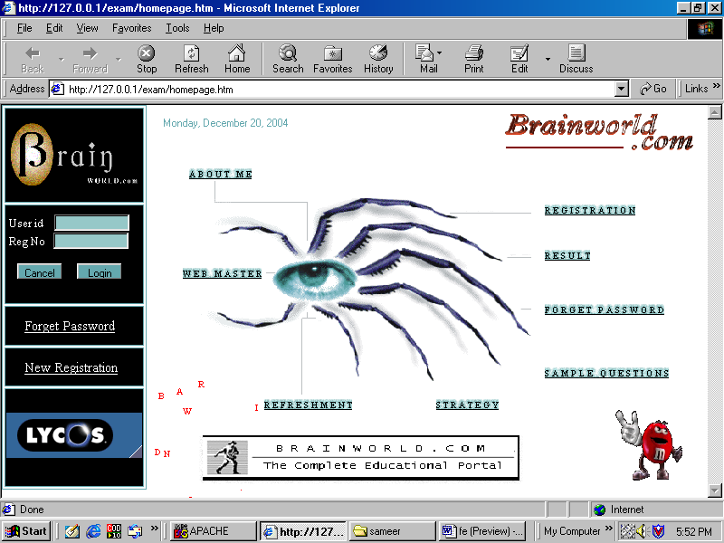

Ad Rotator

Login Form

Site Banner

Site Logo

System Date

7.2 Registration Form (Register.htm):

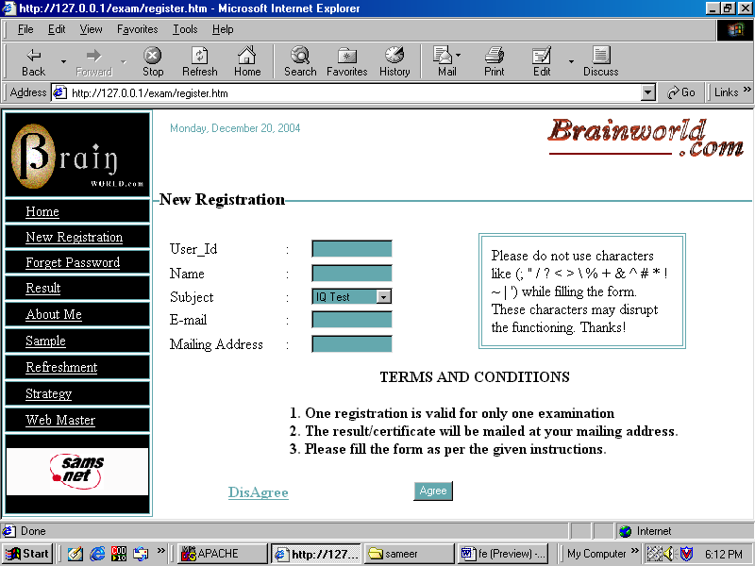

Registration form

NavigationMenus

7.3 Registration Confirmation Page (Register_users.pl):

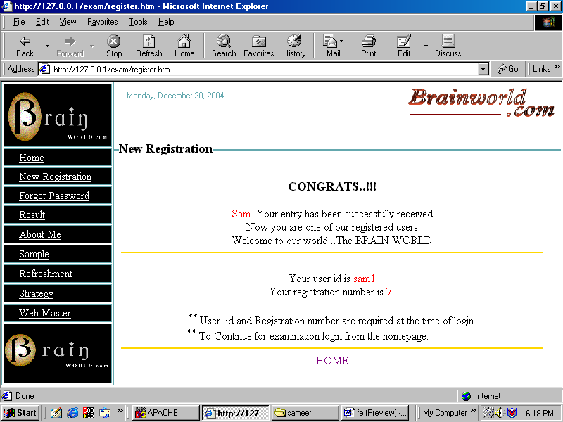

Instructions Registration Number

User_Id

Navigation Menu

7.4 Front Page of The Question Paper (Login1.pl):

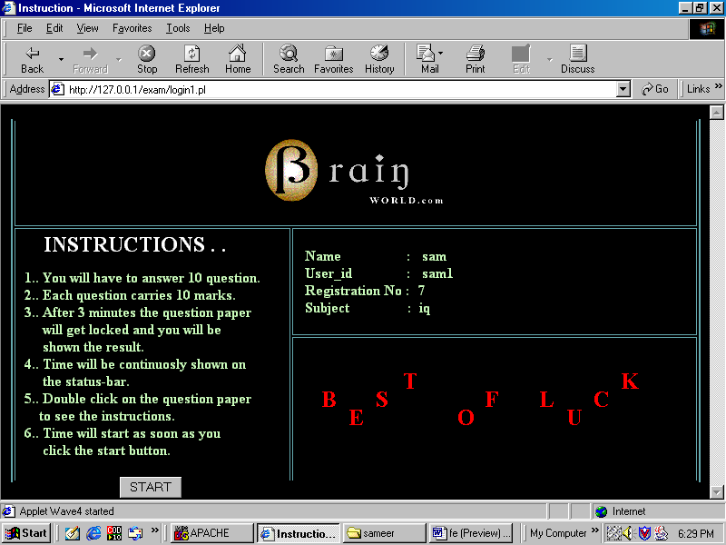

Instructions

Applet wishing luck

Site Logo

User Data

7.5 Question Paper (Read.pl):

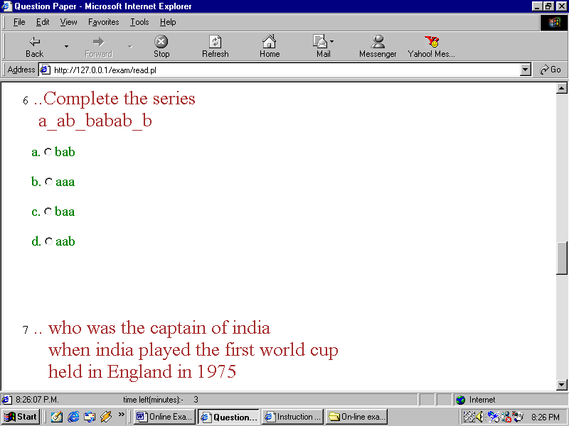

Time Left Questions

Current Time

7.6 Marks Obtained (Try_marks.pl):

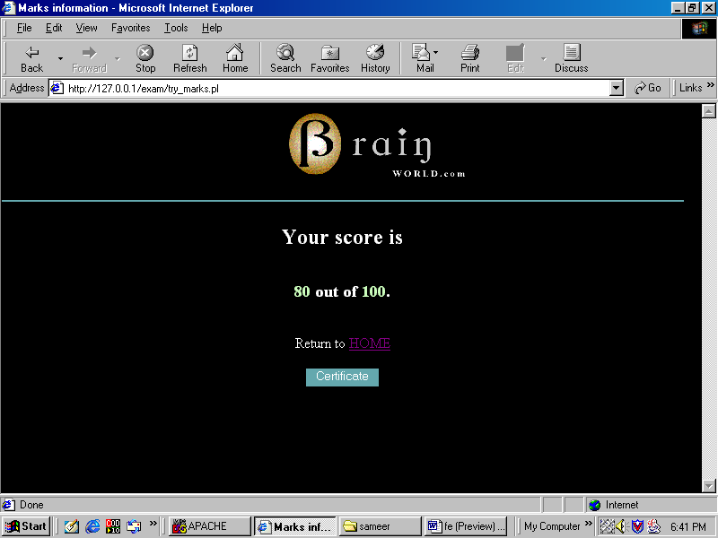

7.7 Certificate (Result.pl):



Subject

Grade Marks Obtained

Name Registration Number

7.8 Marksheet (Marksheet.pl):

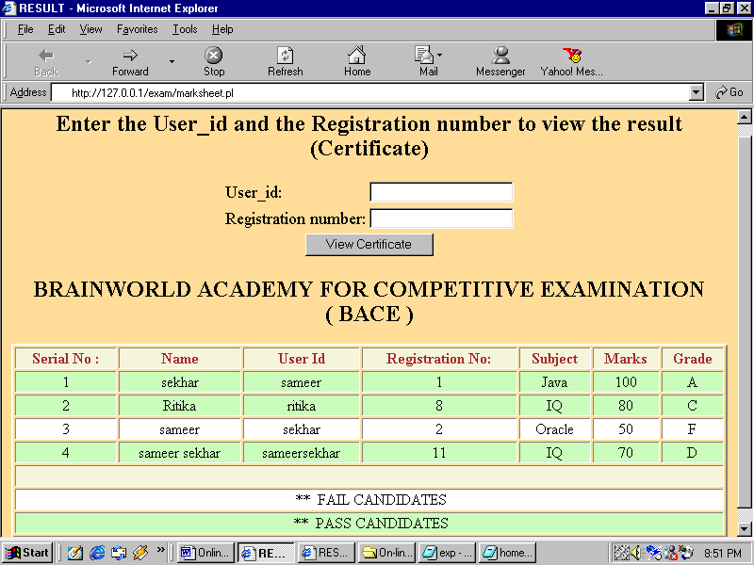

Fail Candidates Pass Candidates
Form for viewing certificate Result.pl

7.9 Search ( Help.htm):

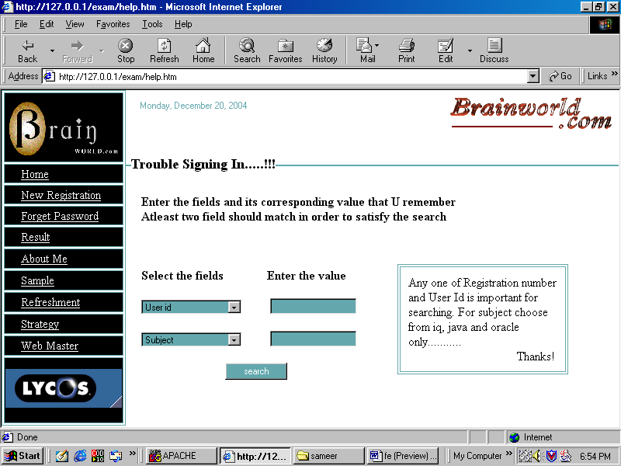

List of Fields User Data

7.10 Web Master(webmaster.htm):

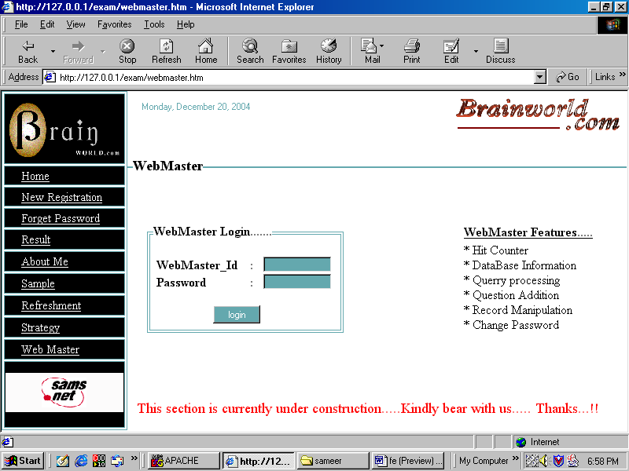

Web Master Login Web Master Features

8. DOCUMENTATION

8.1 Documentation for Project Modules:

8.1.1 Homepage.htm:

Main page containing links to various parts of the application like registration form, help page, results, sample questions, about us page etc. Also contains the login form.

8.1.2 Register.htm:

Page displaying registration form for new user with terms and conditions.

8.1.3 Aboutme.htm:

It says about the maker of the site, Mr. Sameer Sekhar.

8.1.4 Help.htm:

Form to search a specific record for user_id and registration number based on certain criteria. Used by user when they click over ‘forget password’ link on the homepage or when login fails.

8.1.5 Strategy.htm:

It says about the basic purpose of the site and the motivation behind the creation of site.

8.1.6 Sample.htm:

Sample questions for the user to have a feel of what is in store for the registered user.

8.1.7 Instructions.htm:

Page displaying general instructions that can be handy at the time of examination. Question paper can be double clicked to get this page.

8.1.8 Refreshment.htm:

It provides for diversion from the general matters of the mind. It deals with various recreational activities like games, lovemeter, message board and flame.

8.1.9 WebMaster.htm:

It provides a gateway for the site administrator to handle and monitor several resources and events of the site.

8.1.10 Register_users.pl:

PERL file that resides on the server and makes user registration a success. Checks for duplicate data entry and updates the ‘Student’ data file as the case may be.

8.1.11 Login1.pl:

File that gets executed when a user logins for the exam. Checks for user authentication and if found true then displays the front page of the question paper with the start button.

8.1.12 Read.pl:

PERL file that actually reads the scripting file ‘Start.txt’ and the various question files depending upon the question number randomly generated by the computer and finally generating the whole question paper.

8.1.13 Try_marks.pl:

PERL File that is used to store marks information into the database.

8.1.14 Result.pl:

PERL file to generate the user certificate based on the marks scored by the user.

8.1.15 Marksheet.pl:

PERL file to generate the dynamic list of all user marks and related data with separate encoding for pass and fail candidates.

8.1.16 Find.pl:

PERL file for searching the database for the data specified through the help.htm file. If a record is found, it returns the user id and registration number.

8.1.17 Start.txt:

It is a simple text file containing javascript code which is used by Read.pl file while generating the question paper.

8.1.18 Qo1.txt:

Text files containing the question number 1 for oracle. The naming convention used is :
“Q<subject initial><question number>.txt”.

8.1.19 O_que_ans.txt:

Text file containign the answers of Oracle questions. The naming convention followed is:
“<subject initial>_que_ans.txt”. It contains all questions of that particular subject along with its answer option seperated by a comma.

8.1.20 Hitcounter.txt:

This file is created by javascript constructs residing insiding Homepage.htm. After the first instance, the file is constantly updated with the new hit counter value at every subsequent access of the homepage.

8.2 Documentation for Project Execution:

In order to execute the OLES application successfully and efficiently it is required to be stored in the root part of the web-server in a directory or virtual directory with read and execute permissions. All the files from the self-extracting file ‘Sameer’s OLES’ should be extracted into this directory. There might be some problems with path settings, as you may not have the same location for web-server. This problem can be dealed with by manually editing the path settings in all the files encountering the error.

The web-server can be any of the following. PWS-4.0 and above, IIS-4.0 and above, Apache etc.
While using Apache, care must be taken for its proper configuration. The project directory should be given all the required rights and permission.

Another important aspect is that PERL for windows must have been installed successfully on the server. For a good feel of the application the browser must be Internet Explorer 4.0 and above preferably version 5.0 and above.

9. CONCLUSION

The project, OLES, is well designed to cover almost all aspects of an examination conduction process. The interfaces have been carefully designed keeping user perception in mind. The integration of various components over multiple scripting languages has been taken care of providing the project with ease of use, visual delights alongwith a smooth set of transactions.

The features of Online Examination System (OLES) are:

Registration for New Users
- Help facility in case a user losses User_Id or Registration Number
- Different set of questions for each user or randomly generated questions
- Time limitation for the question paper
- Automated generation of Certificates
- Dynamic display of marks for all users with suitable encoding for pass and fail candidates.
- Web-Master features enabling the site to be dynamically administered.
- Choice of subjects for the user.
- Choice of date and time for the user to appear for examination.
- Easily maintenable and upgradable.
- Highly user friendly.

10. FUTURE SCOPE

The project entitled On-Line Examination system is complete in its own domain with each and every aspect of the application being carefully handled. The application can be used by an organization over its own Intranet for measuring the skill-set of its employees and assessing their skills or can be used over the Internet as part of an educational site for providing certification in various subjects.

The project can be made much more flexible by using XML as it provides for user defined tags and hence is more easier to handle. From the database point of view, the flat files can be replaced with stronger DBMS or for that matter RDBMS package enabling more data security and integration. Normalization of database can also be done to increase the efficiency of the application.

From the application point of view, the capability of the application can be much enhanced by increasing the number of questions and the subjects for that matter. The maintenance aspect can also be taken care off by adding a feature for inserting new subjects and questions easily and for deletion of old records. Of-course this feature would be secured with only some specified users permitted to do so.

At present the application is best viewed in Internet Explorer 4.0 and above but it can be made browser independent thus, enabling it to be viewed and accessed across different platforms.

11. BIBLOGRAPHY

Books Referred :

- PURE JavaScript (Techmedia) by Jason Gilliam, Charlton Ting and R. Allen Wyke
- Complete HTML () by
- Complete Reference – HTML () by
- Compete CGI / PERL, HTML and JavaScript () by

Links Referred:

- http://www.deakin.edu.au/~agoodman/scc381/installperl.html
- http://www.activeserverpages.com
- http://www.brainbench.com
- http://www.amazon.com

