1. Set the global configuration file with your user name, email and editor as Notepad++. List all the properties which you just set.

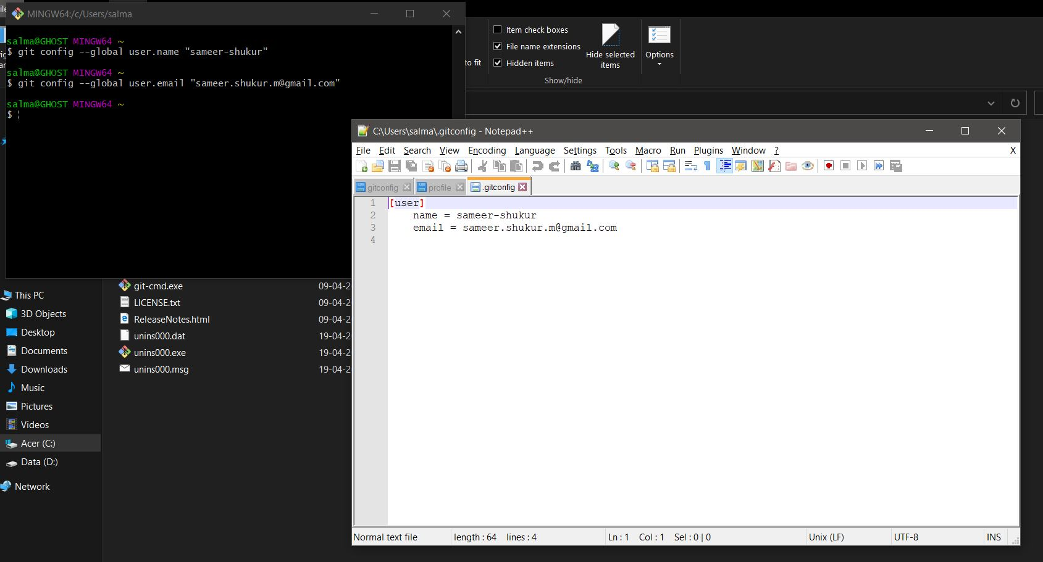

1. Make a fresh Git project

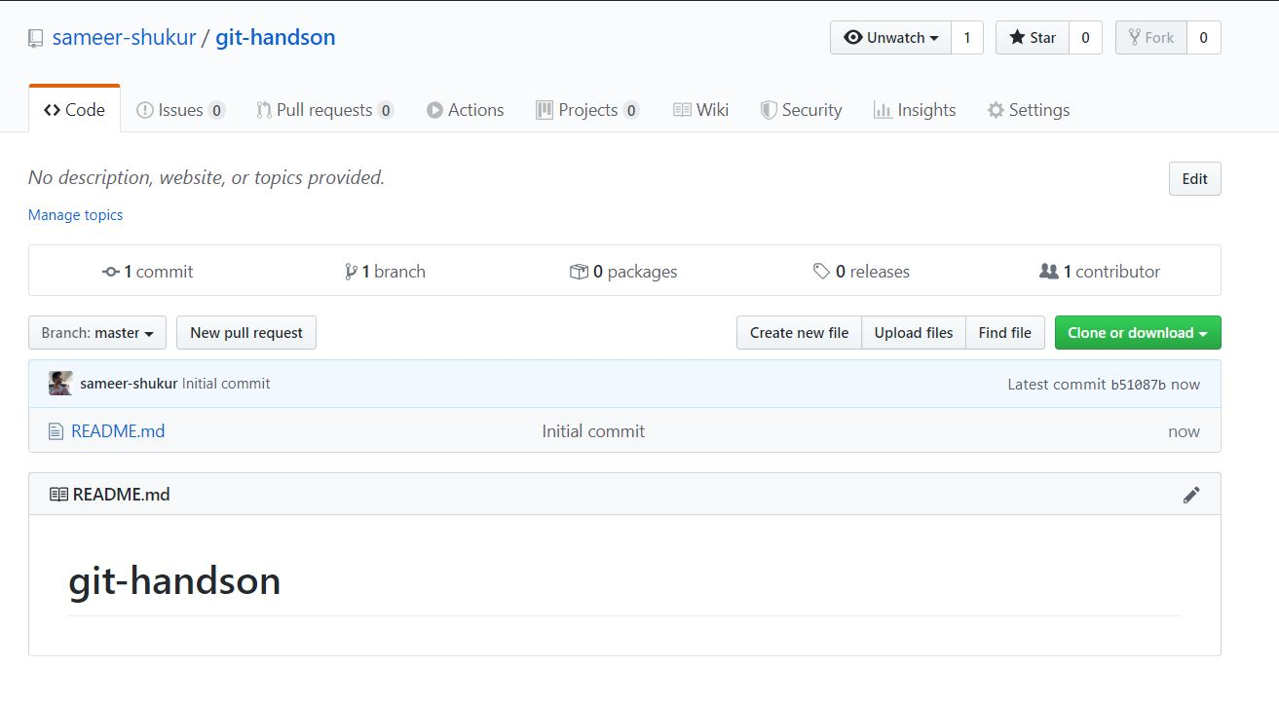

1. Using existing Github account and cloning the above created projected to local repository.

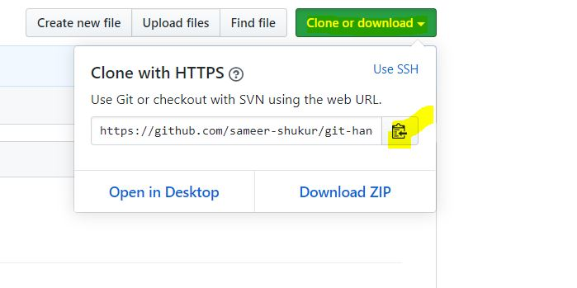

1. Push the project to remote repo

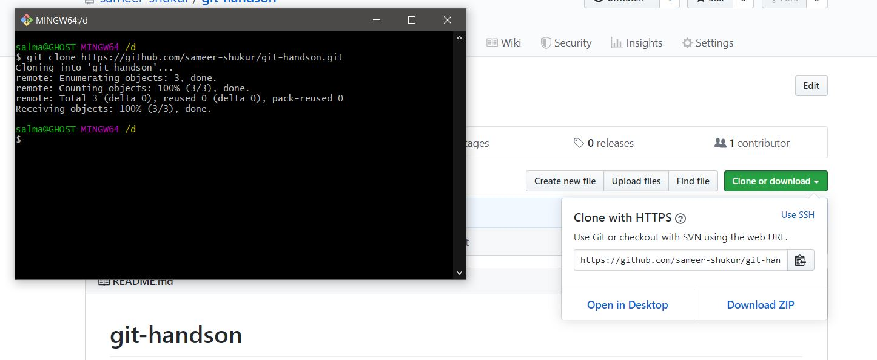

1. Use the different ways of renaming and moving files

