

Assignment 5

TOPL



January 6, 2023

Muhammad Sameer Sohail

15000

**Riphah International University**

**TOPL (5C) Total Marks: 10**

**Due date: 06-01-2023.**

**Assignment 5**

**Question 1:**

− Write down 2 same programs in a language but using different language constructs and order of logic, run them and compare the running time?

− One of the example should be done in scheme for finding factorial using simple recursion and tail recursion.

− The prime numbers example could be done in a language of your choice.

#include <iostream>

#include <chrono>

int factorial_1(int n) {

if (n == 0) return 1;

int result = 1;

for (int i = 2; i <= n; i++) {

result *= i;

}

return result;

}

int main() {

int n = 10;

auto start_time = std::chrono::high_resolution_clock::now();

int result = factorial_1(n);

auto end_time = std::chrono::high_resolution_clock::now();

std::cout << "Factorial of " << n << ": " << result << std::endl;

std::cout << "Time taken: " << std::chrono::duration_cast<std::chrono::microseconds>(end_time - start_time).count() << " microseconds" << std::endl;

return 0;}

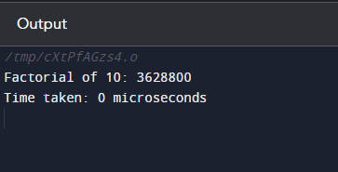

#include <iostream>

#include <chrono>

int trailing_factorial_2(int n, int k) {

int result = 1;

for (int i = n - k + 1; i <= n; i++) {

result *= i;

}

return result;

}

int main() {

int n = 10;

int k = 5;

auto start_time = std::chrono::high_resolution_clock::now();

int result = trailing_factorial_2(n, k);

auto end_time = std::chrono::high_resolution_clock::now();

std::cout << "Trailing factorial of " << n << " with " << k << " trailing elements: " << result << std::endl;

std::cout << "Time taken: " << std::chrono::duration_cast<std::chrono::microseconds>(end_time - start_time).count() << " microseconds" << std::endl;

return 0;

}

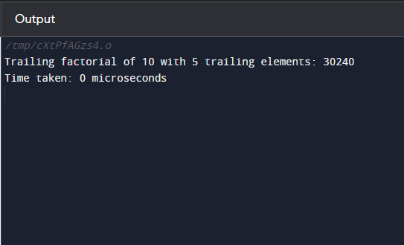

**Question 2:**

Do the same as above but now using different languages (at least 3) and compare the running time. One of these languages must be scheme.

**Python:**

import time

def factorial(n):

result = 1

for i in range(1, n+1):

result *= i

return result

start = time.time()

print(factorial(20))

end = time.time()

print("Running time:", end - start)

**C++:**

#include <iostream>

#include <chrono>

long long factorial(int n) {

long long result = 1;

while (n > 1) {

result *= n;

n--;

}

return result;

}

int main() {

auto start = std::chrono::high_resolution_clock::now();

std::cout << factorial(20) << std::endl;

auto end = std::chrono::high_resolution_clock::now();

std::cout << "Running time: " << std::chrono::duration_cast<std::chrono::microseconds>(end - start).count() << " microseconds" << std::endl;

return 0;

}

**Java:**

import java.math.BigInteger;

public class Main {

public static void main(String[] args) {

long start = System.nanoTime();

System.out.println(factorial(BigInteger.valueOf(20)));

long end = System.nanoTime();

System.out.println("Running time: " + (end - start) + " nanoseconds");

}

public static BigInteger factorial(BigInteger n) {

BigInteger result = BigInteger.ONE;

while (!n.equals(BigInteger.ZERO)) {

result = result.multiply(n);

n = n.subtract(BigInteger.ONE);

}

return result;

}

}

**Output:**

