**CAPSTONE REPORT ON**

**INTELLIGENT CHATBOT USING CHATTERBOT AND FLASK**

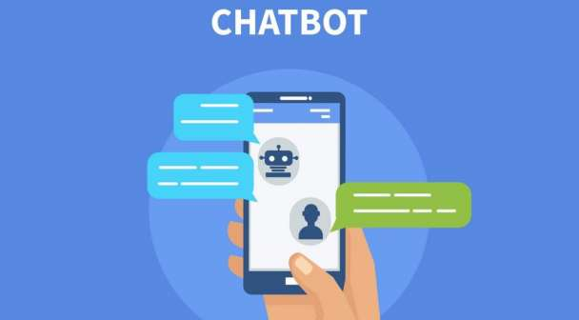

##### SUBMITTED BY :-

**SAMEER KHAIRMODE**

##### SUBMITTED TO :-

**DEXTERITY GLOBAL**

**ABSTRACT**

Chatbot or conversational interfaces as they are also known, present a new way for individuals to interact with computer systems. Traditionally, to get a question answered by a software program involved using a search engine, or filling out a form. A chatbot allows a user to simply ask questions in the same manner that they would address a human. The most well known chatbots currently are voice chatbots: Alexa and Siri. However, chatbots are currently being adopted at a high rate on computer chat platforms.

|  |  |
| --- | --- |
|  |  |

Table of Contents

* Introduction**4**
* What is ChatBot**5**
* Evolution of ChatBot**6**
* Types of ChatBot**7**
* Procedure**9**
* Prerequisite**9**
* Download and Install Environment**9**
* Download and Install Libraries**10**
* Flowchart**11**
* Applications**12**
* Limitations**13**
* Conclusion**14**
* References**15**
* Appendices**16**

**Introduction**

Chatbot, or conversational interfaces as they are also known, present a new way for individuals to interact with computer systems. Traditionally, to get a question answered by a software program involved using a search engine, or filling out a form. A chatbot allows a user to simply ask questions in the same manner that they would address a human.

A simple chatbot can be created by loading an FAQ (frequently asked questions) into chatbot software. The functionality of the chatbot can be improved by integrating it into the organization’s enterprise software, allowing more personal questions to be answered, like “What is my balance?” or “What is the status of my order?”

Nowadays almost 30 percent of the tasks are fulfilled by chatbots. Companies use the chatbots to provide services like customer support, generating information, etc. With examples like Siri, Alexa it becomes clear how a chatbot can make a difference in our daily lives. Chabot’s are currently being adopted at a high rate on computer chat platforms.

I have created a chatbot using Chatterbot library and Flask which is micro framework. This chatbot can answer all the question related to the institution, about himself. We can build the chatbot as per our requirement and use.

## ****What Is a Chatbot****

A chatbot also known as a chatterbot, bot, artificial agent, etc is basically software program driven by artificial intelligence which serves the purpose of making a conversation with the user by texts or by speech. Famous examples include Siri, Alexa, etc.

These chatbots are inclined towards performing a specific task for the user. Chatbots often perform tasks like making a transaction, booking a hotel, form submissions, etc. The possibilities with a chatbot are endless with the technological advancements in the domain of artificial intelligence.

Almost 30 percent of the tasks are performed by the chatbots in any company. Companies employ these chatbots for services like customer support, to deliver information, etc. Although the chatbots have come so far down the line, the journey started from a very basic performance. Let’s take a look at the evolution of chatbots over the last few decades.

**Evolution of ChatBot**

In 1950, [Alan Turing](https://en.wikipedia.org/wiki/Alan_Turing)’s famous article "[Computing Machinery and Intelligence](https://en.wikipedia.org/wiki/Computing_Machinery_and_Intelligence)" was published,[[7]](https://en.wikipedia.org/wiki/Chatbot#cite_note-7) which proposed what is now called the [Turing test](https://en.wikipedia.org/wiki/Turing_test) as a criterion of intelligence. This criterion depends on the ability of a [computer program](https://en.wikipedia.org/wiki/Computer_program) to impersonate a human in a real-time written conversation with a human judge to the extent that the judge is unable to distinguish reliably—on the basis of the conversational content alone—between the program and a real human. The notoriety of Turing's proposed test stimulated great interest in [Joseph Weizenbaum](https://en.wikipedia.org/wiki/Joseph_Weizenbaum)'s program [ELIZA](https://en.wikipedia.org/wiki/ELIZA), published in 1966, which seemed to be able to fool users into believing that they were conversing with a real human. However Weizenbaum himself did not claim that ELIZA was genuinely intelligent, and the introduction to his paper presented it more as a debunking exercise

|  |  |  |
| --- | --- | --- |
| **Traditional Bots** | **Current Bots** | **Future Bots** |
| System Driven | Driven by back-and-forth communication | Communication at multiple-levels |
| Automation based | The automation is at the task level | Automation at the service level |
| Minimal Functionality | Maintains system context | Ability to maintain task, system and people context |
| Maintained only system context | Maintains task context as well | Introduction to master bots and eventually a bot OS as well. |

**Types of ChatBot**

1. **Button based bots :-** The purpose of a button-based bot is to lead a user through a pre-defined scenario tree. This type of bot resembles a text-based IVR system. Just like an IVR, a button-based bot offers choices and asks for data. Usually, it says: “I’m a bot that can help you with the following issues, please press the relevant button: X, Y, Z…”. A button-based bot is perfect for onboarding, surveys, sales support and practically for any simple process automation task where the communication scenarios are clearly defined.
2. **Hybrid bots :-** A hybrid bot is a button-based bot with an option to ask a question on natural language. Usually, it says: “I’m a bot that can help you with the following issues; please press the relevant button X, Y, Z or type your question in the field below”. Frequently, the NLU ( natural language understanding) in these bots duplicates the buttons. A hybrid bot is a transitional stage between the button-based and an AI/ NLU bot. A bot can exist in a hybrid stage for quite a long time, while developers are enriching its AI engine with a better understanding of relevant context.
3. **AI bot** :- An AI bot can automate complex simultaneous communication with multiple users, covering many loosely connected topics. For example, a telecom operator chatbot can consult on the tariffs and upgrade options, at the same time report on the current client’s usage stats. A retail sales support bot consults on various product categories, terms of purchase and delivery. A tech support bot conducts initial diagnostic and offers help. An AI bot project should be managed and implemented by a professional team with strong conversational AI competence.
4. **Voice based bots** :- By utilizing the most natural interface voice these solutions can appeal to users and bring a lot of benefits to companies. However, the development of voice-based solutions requires specific domain expertise from an architect, a linguist, a UX designer, a developer, and a range of other professions. To work effectively, each member of the team needs dedicated tools. There are not too many voice solution development platforms, that support the whole development cycle, for example, DialogFlow from Google, SAP Conversational AI, JAICP from Just AI.

**Procedure**

* **Prerequisite :-**

1. Basic Knowledge about programming.
2. Knowledge about one programming language.
3. Knowledge about chatterbot library.
4. Knowledge about chatterbot_corpus library.
5. Knowledge about Flask micro framework.

* **Download and Install Environment** :-

For this project I have used Python as a programming language as well as Anaconda Navigator and Spider as Environment. You can use any environment as per the availability. You can use Atom, Jupyter Notebook, Netbeans Etc.

To Download Anaconda on your PC please refer this link :-

<https://docs.anaconda.com/anaconda/install/windows/>

* **Download and Install libraries :-**

1. **Chatterbot library -** 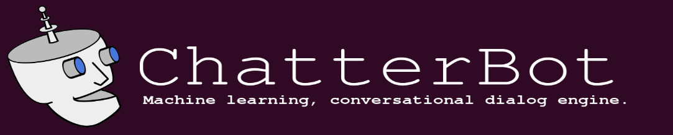

**Steps to install:-**

* **Download and install Python :-**

<https://docs.python.org/3/using/windows.html>

* **To install Pip refer this link :-**

<https://pip.pypa.io/en/stable/installing/>

* **Chatterbot:- Go to command prompt or anaconda prompt and type -**

pip install chatterbot

OR

<https://pypi.org/project/ChatterBot/#files>

* **Chatterbot_corpus :- Go to command prompt or anaconda prompt and type -**

pip install chatterbot_corpus

OR

<https://pypi.org/project/chatterbot-corpus/#files>

* **Flask :- Go to command prompt or anaconda prompt and type -**

pip install –U flask

OR

<https://pypi.org/project/Flask/#files>

* **Flowchart :-**

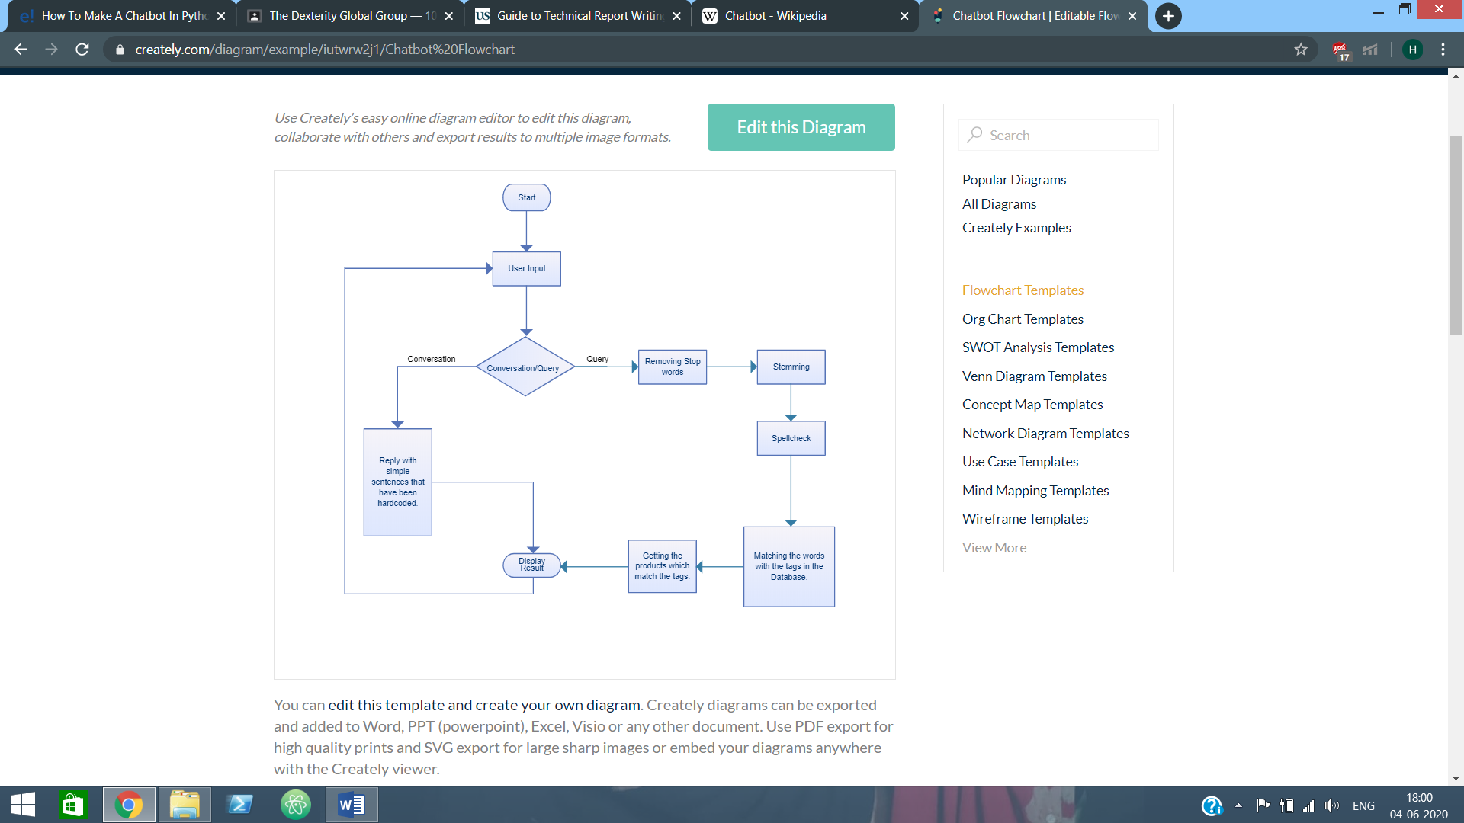

**Applications**

1. **Messaging Apps :-** Many companies chatbots run on [messaging apps](https://en.wikipedia.org/wiki/Messaging_apps) or simply via SMS. They are used for [B2C](https://en.wikipedia.org/wiki/B2C) customer service, sales and marketing. In 2016, Facebook Messenger allowed developers to place chatbots on their platform. There were 30,000 bots created for Messenger in the first six months, rising to 100,000 by September 2017.
2. **Customer Service :-** Many high-tech banking organizations are looking to integrate automated AI-based solutions such as chatbots into their customer service in order to provide faster and cheaper assistance to their clients who are becoming increasingly comfortable with technology. In particular, chatbots can efficiently conduct a dialogue, usually replacing other communication tools such as email, phone, or [SMS](https://en.wikipedia.org/wiki/SMS). In banking, their major application is related to quick customer service answering common requests, as well as transactional support.

**3. HealthCare :-** Chatbots are also appearing in the healthcare industry. A study suggested that physicians in the United States believed that chatbots would be most beneficial for scheduling doctor appointments, locating health clinics, or providing medication information. Certain patient groups are still reluctant to use chatbots. A mixed-methods study showed that people are still hesitant to use chatbots for their healthcare due to poor understanding of the technological complexity, the lack of empathy and concerns about cyber-security.The analysis showed that while 6% had heard of a health chatbot and 3% had experience of using it, 67% perceived themselves as likely to use one within 12 months. The majority of participants would use a health chatbot for seeking general health information (78%), booking a medical appointment (78%) and looking for local health services (80%)

**Limitations**

The creation and implementation of chatbots is still a developing area, heavily related to [artificial intelligence](https://en.wikipedia.org/wiki/Artificial_intelligence) and [machine learning](https://en.wikipedia.org/wiki/Machine_learning), so the provided solutions, while possessing obvious advantages, have some important limitations in terms of functionalities and use cases. However this is changing over time.

**The most common ones are listed below:-**

* As the database, used for output generation, is fixed and limited, chatbots can fail while dealing with an unsaved query.
* A chatbot's efficiency highly depends on language processing and is limited because of irregularities, such as accents and mistakes that can create an important barrier for international and multi-cultural organisations.
* Chatbots are unable to deal with multiple questions at the same time and so conversation opportunities are limited.
* Chatbots require a large amount of conversational data to train.
* As it happens usually with technology-led changes in existing services, some consumers, more often than not from the old generation, are uncomfortable with chatbots due to their limited understanding, making it obvious that their requests are being dealt with by machines.

**Conclusion**

we have learned how to make a chatbot in python using the ChatterBot library using the flask framework. With new-age technological advancements in the artificial intelligence and machine learning domain, we are only so far away from creating the best version of the chatbot available to mankind.From my perspective, chatbots or smart assistants with artificial intelligence are dramatically changing businesses. There is a wide range of chatbot building platforms that are available for various enterprises, such as e-commerce, retail, banking, leisure, travel, healthcare, and so on. Chatbots can reach out to a large audience on messaging apps and be more effective than humans. They may develop into a capable information-gathering tool in the near future.

**References**

1. **Wikipedia :-** <https://en.wikipedia.org/wiki/Chatbot>
2. **Chatterbot :-** <https://pypi.org/project/ChatterBot/#files>
3. **Chatterbot_corpus :-** <https://pypi.org/project/chatterbot-corpus/#files>
4. **Flask :**- <https://pypi.org/project/Flask/#files>
5. **Edureka :**- <https://www.youtube.com/channel/UCkw4JCwteGrDHIsyIIKo4tQ>

**Appendices**

**App.py**

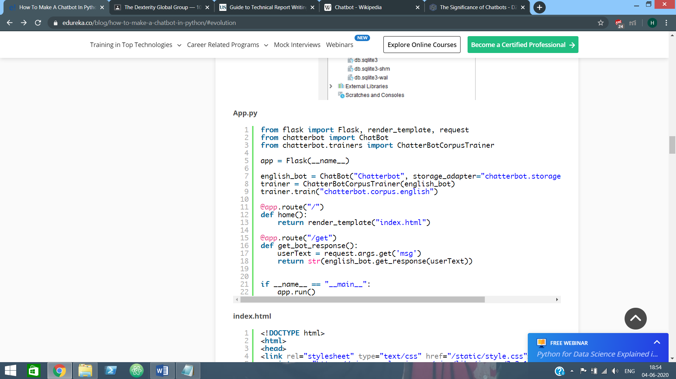

**Index.html**

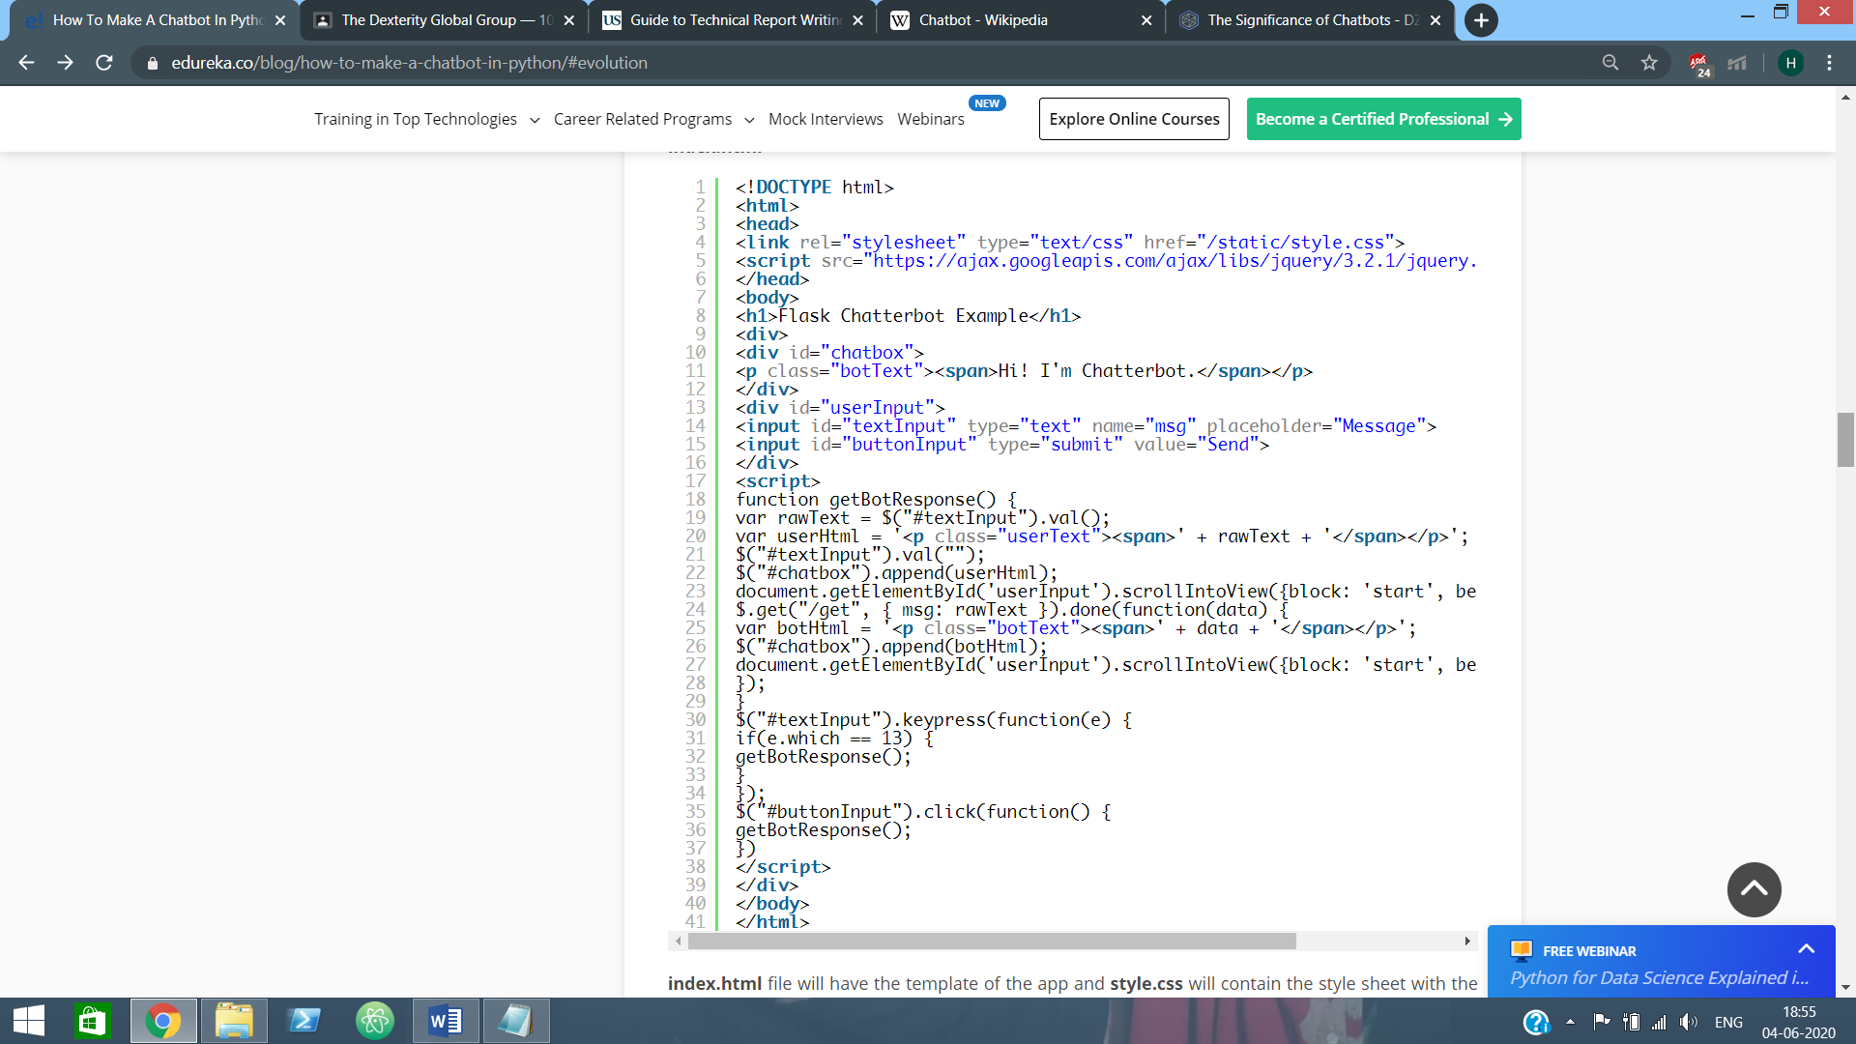

**Style.css**

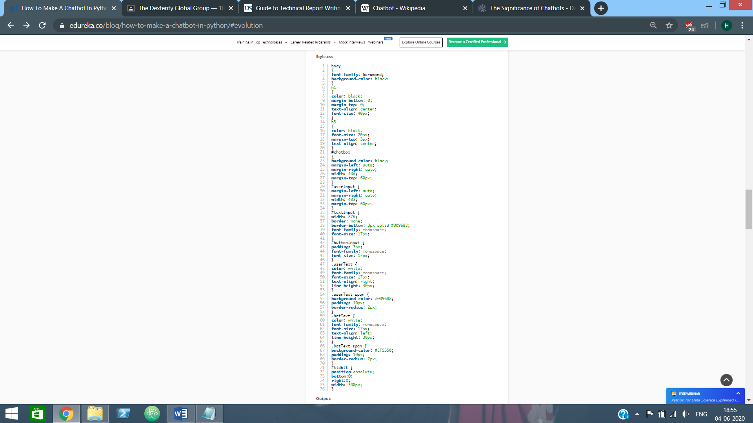

**Chatbot**

