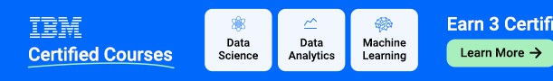

[Software Testing Course](https://www.geeksforgeeks.org/courses/complete-guide-to-software-testing-automation?utm_campaign=517_software_engineering&utm_medium=gfgcontent_shm&utm_source=geeksforgeeks&ref=shm) [Software Engineering Tutorial](https://www.geeksforgeeks.org/software-engineering/?ref=shm) [Software Development Life Cycle](https://www.geeksforgeeks.org/software-development-life-cycle-sdlc/?ref=shm) [Waterfall Mod](https://www.geeksforgeeks.org/waterfall-model/?ref=shm)

Software Development Life Cycle (SDLC)

Last Updated : 20 Nov, 2024

[Ads](https://www.geeksforgeeks.org/software-engineering/?ref=shm) [by](https://www.geeksforgeeks.org/software-development-life-cycle-sdlc/?ref=shm)

[Send feedback](https://googleads.g.doubleclick.net/pcs/click?xai=AKAOjstURo1Vl_4IbflTTXEdI3VbW9aBnnpvPP6J1Wn_SKZkn8F2qHDNbmdg0SbwkfdJ5sKh-qi0PaVQYtFWu0biMZcNh-QfTf5-9rcLW8Wo86AKKA5_hXmhriZmKiy5IMdx-kb56DKCDZ3HKe-s7QRKvD3VYkjdN1lNlSt37KoGGPL9M4-av8HhWGep8wA7jJQ93Szzg6ZzPWXXeWWXmKB7heRPUMmvgtYXBfTsoiD2vLnD0I-WMLcKm82_NQWUZyN6cL2oCCHbAUFIFQx6fHILoXdwF0Hgof0wIfUgzat9c6jsachK7FHJ4FXoYsOjt4rREeAF5NBCMnHB6BOc8mtN9cHy8k2VvwmnAtfg9xCyiWRS7oxAk6tuzypPcNbGve9q8xSzXKECKp3c_9DScJ_2jaSAW0Q-dINEvX1b6z8&sai=AMfl-YTpAlbQcR6In72JEB5uyGogS2UPTJsOyqaQTn81IxZyivxP90bTrOBe2d7nCJSYEvRcT2BH5aANTLCcZ7D00__665pZK8bQp_WakHTrnQ&sig=Cg0ArKJSzPqzHfqXV0id&fbs_aeid=%5Bgw_fbsaeid%5D&adurl=https%3A//www.geeksforgeeks.org/courses/category/ibm-certification%3Futm_source%3Dgeeksforgeeks%26utm_medium%3Dabove_article_title%26utm_campaign%3Dcourses&nm=2) [Why this ad?](https://adssettings.google.com/whythisad?source=display&reasons=AU2hxZ2TXvgIIRoXNMkpJFhepjuc9AmhX0TP-I2tKTg_bsPpMmJv1iopTsVu1sNbirLkE9GjxAZUU_PSgDcOBkOtpBRa8xdbNfqFZLV1YssdXkzK5RThKsHgw2AP9WIYiMPb0kQhSW8YOc2NLlrrI5KuksPoW5ZmOAKF7V_4G7KE1WBfBBAkYKCdbkTohifV2tz6L2C75pwe2DEYSP_jos1yvX0SmbZAvbZoMom-Fg1lnVYF6ynpGzlFugAyyigJAUOPv7ifo5-RClD6oV9WTrnJPsqNad0c9HRB9cwbAtx3Z1_h1HsACAfDdOhvDGgrlrDvovGOJ1invxW-NEsaw9m30-3gQpiY0j-8prrQ0NIxanzBg7ASI_4FXDhPkUPgjZx9ZTIJ1-iNnoMy_NcebGFI9bPSKHpDWgdaNEgXVjjaSbAXJs1CjLLsq53E1wyndjBFfZ8wSf_ki-lt_WKayG7QoxB_LIdiDThEClBfXChtGm7JHVeH-w88HJLm8aLMIwaWME35f5-GYd4JJ3a2V8a_H3ItNfTsGCGE7cnKqXC__vb9kg9J4M-bgzTT_JG_C5D8OS_nPcW-oufM75VCZ3e4icv2ZHlJ1lXtAJJLSUkpV33eSbTAH408j6TGUamYgLvWA_O9gQNS5lTV0KZcLQ9-XQxEuIrDnMplDLCDMfejYbGz4x-_gAKPNKuJNdRpdOz_idppfupaWtWbULVnIc5O1bhWfdraSbkDnL-tPcur-m2j0L2oHMba56DqEDOebt7TvHNW73lMvIotEE7oSvKgYXpnnfzN8Go9vm6RnzYCvAp_nBAc9A_ObjBnMc_Mz3JxnDNxFGO3TFKdny5d7tICk1yLqtZNwEgqK7sQWUJ_JWLuKY4Kz-EUg6rDWQs4R0bkwG_uobYM-sgj8Ee940Zmco_1-Mi0ViTCAeGYPr7PPj-Wv0h4qpShGS9Pfr_B3oePRMZMuSWweo5ghpZ1ZWaTehgEz7RMaGfUy-L7V7PGCS_iYJNwdvQvxxZGlVqX8pXDRWyuK1bsQKUrhaiyzFSO9QjuhiRO8gYezuoxH7s0YAncNuRwWikMzEeZPGD09wc1Z3lRKL5a4juKb9wSdXj_LmN2C71ZdqB7_L-TbnM9MrG9TLBCBSyug3ckdj8azaiwoeJoOPR0GH9fxQcTnbQ3WthATmLrtZtkjhd31bKiG-zpN-NfBunUpug3Fyhrr8gljRkAGY9cNsZqulVEt0k5aUcQGykycW72ENeHiX44Az0o9lfpfs6nG4tY_B7uARVXJaiVHAEpqYoyb2TxdlU1qtJN74-j5eb5Pwz8LMwf7VCE4AhgvY3ZI-lXNbnw-K_FDDXOVSx_afZ9-m2CsnCs3wLw7YAaDF05oBD2OPWBKyl_td2T0aGxtsZVJOhtyFX3fSMqLJcryOZywBHZBkKya2YxOBPBM4H2v0kQdYORo7DwGg9eUv-Rs6IkPFZuEYs&opi=122715837)

**Software development life cycle ( SDLC) is a structured process that is used to design, develop, and test good-quality software.** SDLC, or software development life cycle, is a methodology that defines the entire procedure of software development step-by-step. The **goal of the SDLC life cycle model** is to deliver high-quality, maintainable software that meets the user’s requirements. SDLC in software engineering models outlines the plan for each stage so that each stage of the software development model can perform its task efficiently to deliver the software at a low cost within a given time frame that meets users requirements. In this article we will see Software Development Life Cycle (SDLC) in detail.

# What is the Software Development Life Cycle ( SDLC) ?

**SDLC is a process followed for software building within a software**

**organization.** SDLC consists of a precise plan that describes how to develop, maintain, replace, and enhance specific software. The life cycle defines a method for improving the quality of software and the all- around development process.

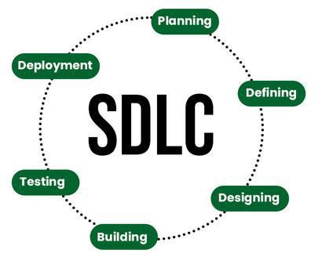

# Stages of the Software Development Life Cycle

SDLC specifies the task(s) to be performed at various stages by a software engineer or developer. It ensures that the end product is able to meet the customer’s expectations and fits within the overall budget. Hence, it’s vital for a software developer to have prior knowledge of this software development process. SDLC is a collection of these six stages, and the stages of SDLC are as follows:

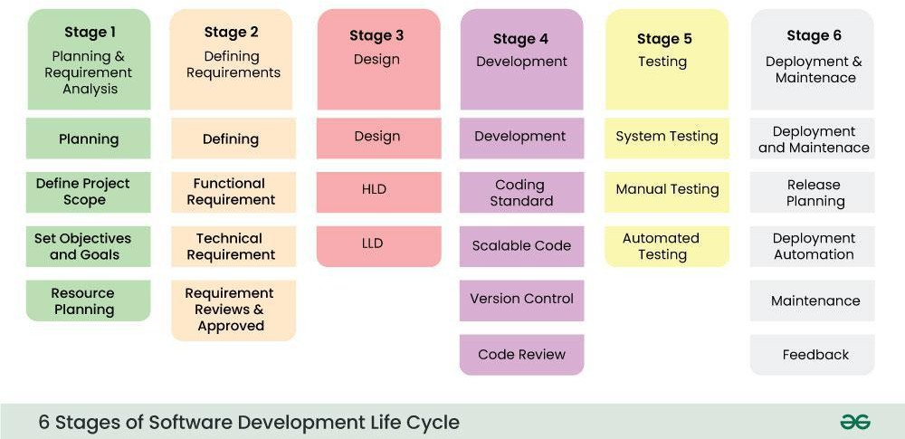

*Software Development Life Cycle Model SDLC Stages*

The [**SDLC Model**](https://www.geeksforgeeks.org/sdlc-models-types-phases-use) **involves six phases or stages** while developing any software.

## Stage-1: Planning and Requirement Analysis

Planning is a crucial step in everything, just as in [software development](https://www.geeksforgeeks.org/software-development). In this same stage, [requirement analysis](https://www.geeksforgeeks.org/activities-involved-in-software-requirement-analysis) is also performed by the developers of the organization. This is attained from customer inputs, and sales department/market surveys.

The information from this analysis forms the building blocks of a basic project. The quality of the project is a result of planning. Thus, in this stage, the basic project is designed with all the available information.

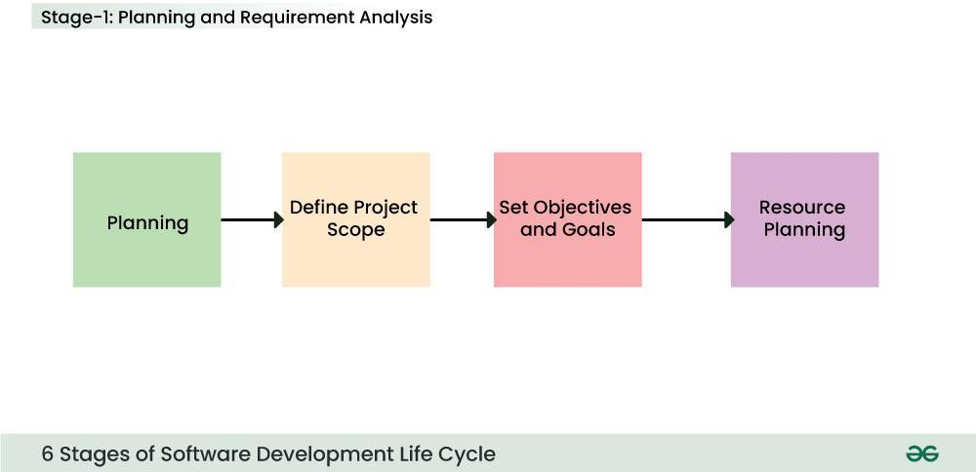

*Stage-1 : Planning and Requirement Analysis*

## Stage-2: Defining Requirements

In this stage, all the requirements for the target software are specified. These requirements get approval from customers, market analysts, and stakeholders.

This is fulfilled by utilizing SRS (Software Requirement Specification). This is a sort of document that specifies all those things that need to be defined and created during the entire project cycle.

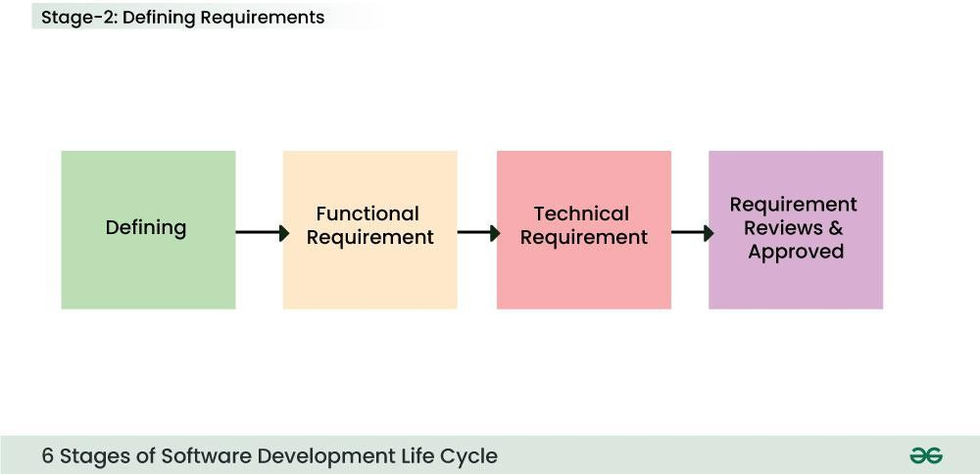

*Stage-2 : Defining Requirements*

## Stage-3: Designing Architecture

[SRS](https://www.geeksforgeeks.org/software-requirement-specification-srs-format) is a reference for software designers to come up with the best architecture for the software. Hence, with the requirements defined in SRS, multiple designs for the product architecture are present in the Design Document Specification (DDS).

This DDS is assessed by market analysts and stakeholders. After evaluating all the possible factors, the most practical and logical design is chosen for development.

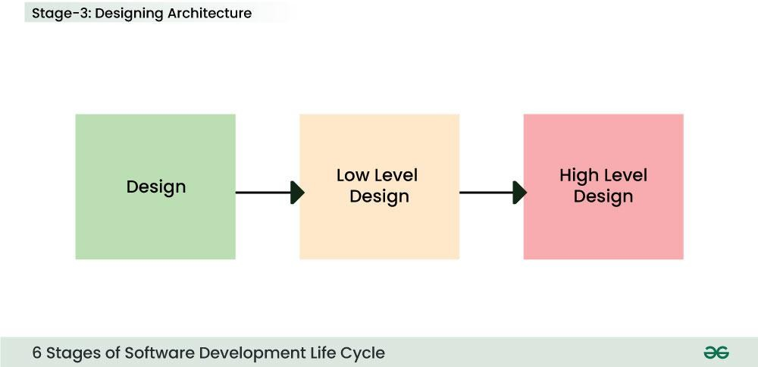

*Stage 3: Design*

**Stage-4: Developing Product**

**Identifying the functional and non functional requirements   
reference taken from Virtual lab (vlab)**

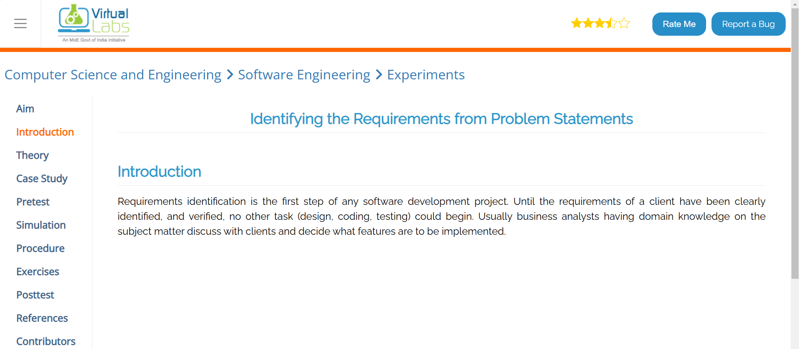**Link****:-** https://se-iitkgp.vlabs.ac.in/exp/problemstatements/casestudy.html

**Then I use Reserch Paper from Reserch gate for Requirements**

**Link:-** <https://www.researchgate.net/publication/373420785_Vehicle_Service_Automation>

**Garage Management Software Blogs** (<https://www.autoleap.com/blog>) – Articles on digital transformation in automobile servicing.