**Estimation of project metrics for garage management system**

For this practical I refer Virtual lab

Link:- <https://se-iitkgp.vlabs.ac.in/exp/project-metrics/introduction.html>

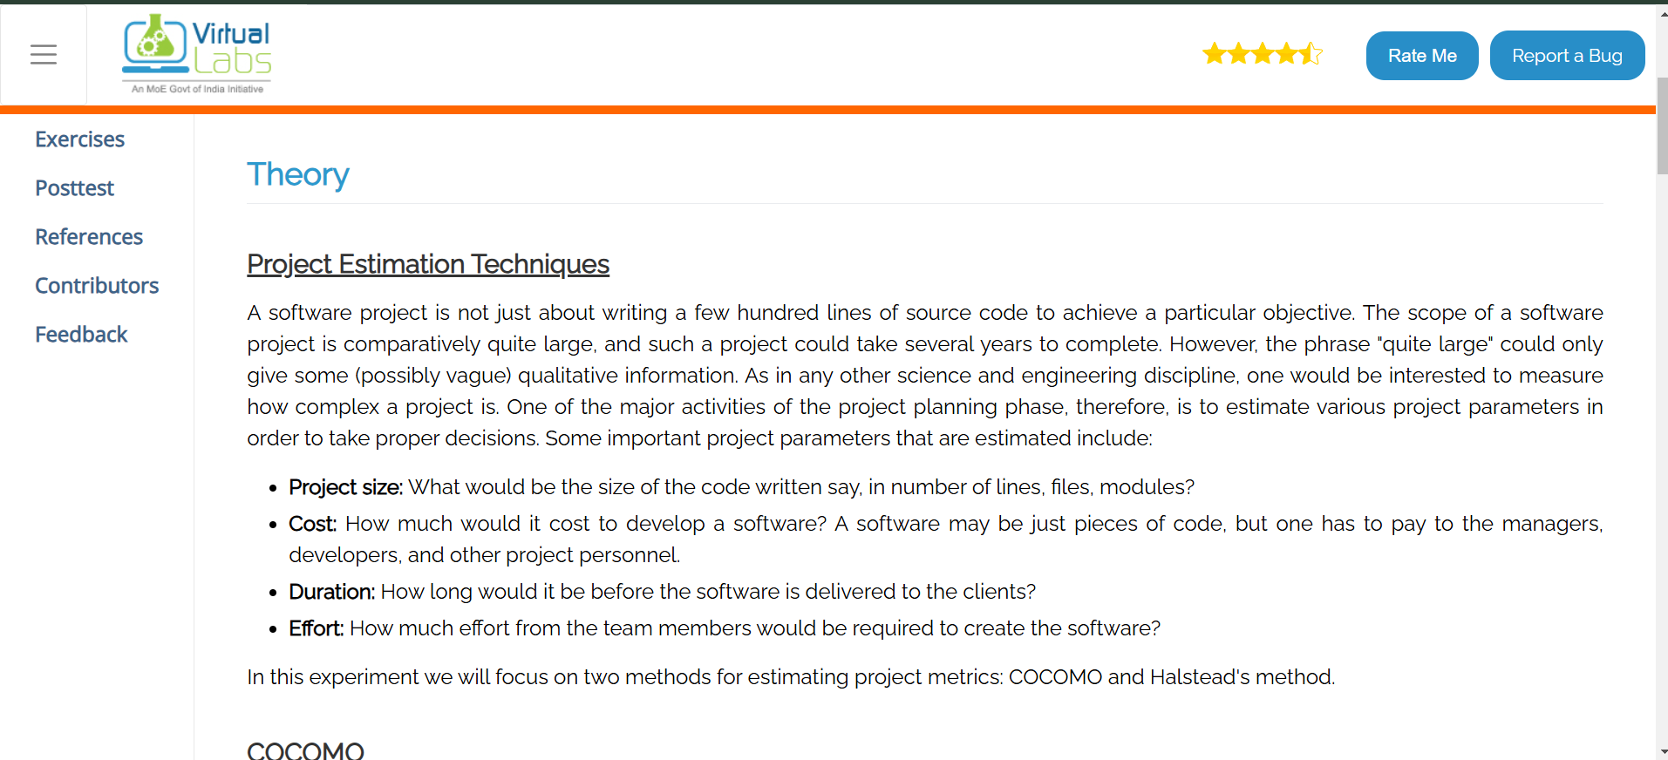

Case Study: Estimation of Project Metrics Using COCOMO Model

1. Introduction

Software cost estimation is a critical process in software engineering that helps predict the effort, time, and resources required for project completion. The Constructive Cost Model (COCOMO) is one of the most widely used models for estimating software project metrics.

In this case study, we apply the COCOMO model to estimate the development effort, cost, and time required for building a Garage Management System (GMS).

**Objectives of Using COCOMO Model**

* To estimate **effort, cost, and time** for GMS development.
* To categorize the project into the **Basic, Intermediate, or Detailed COCOMO Model**.
* To determine the required **manpower and resources**.
* To **avoid project overruns** by predicting realistic timelines and budgets.

**Application of the COCOMO Model**

**4.1 Identifying the Project Type**

The **COCOMO model** classifies projects into three categories:

1. **Organic** – Simple projects with small teams and well-defined requirements.
2. **Semi-Detached** – Medium complexity, moderate team size, and evolving requirements.
3. **Embedded** – Complex systems with high constraints and strict regulations.

**Simulation :=**

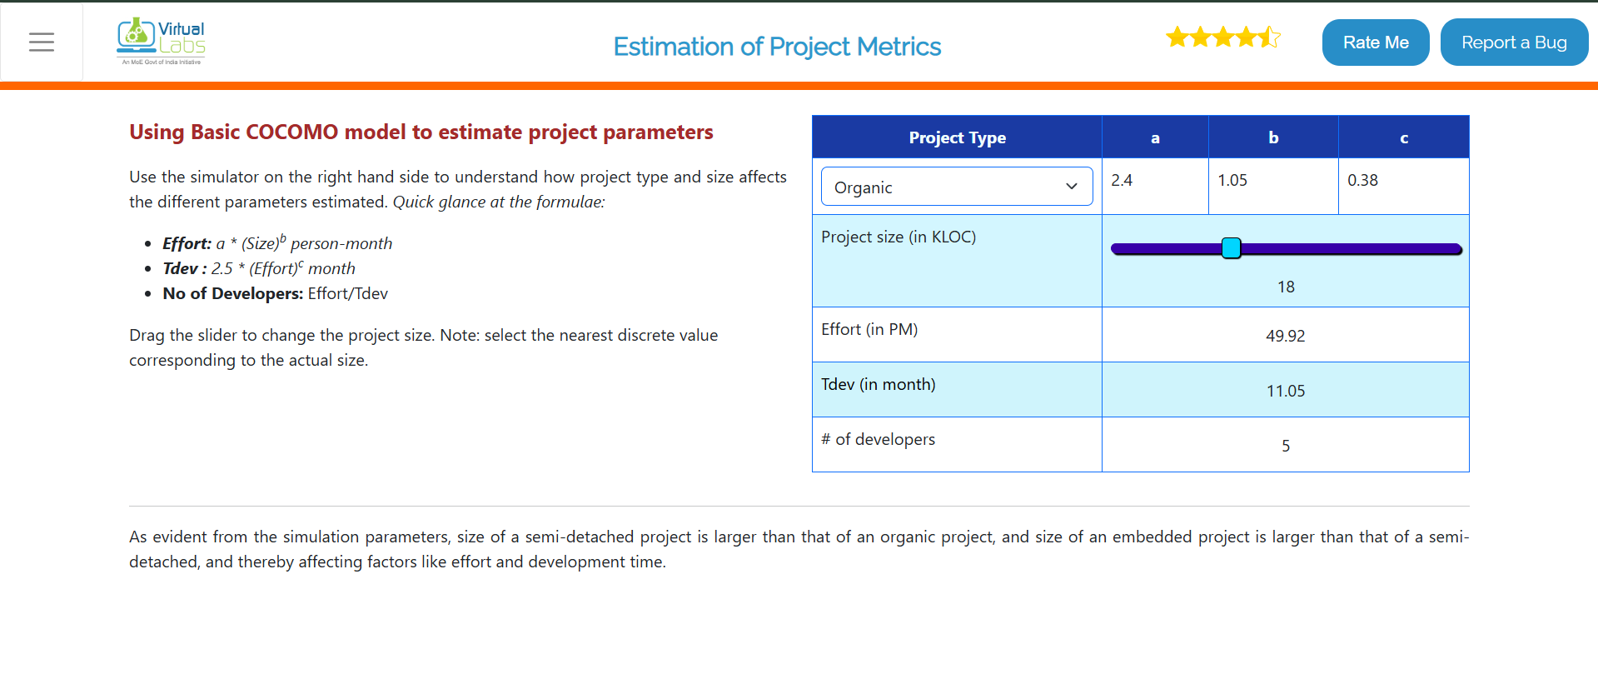

**Other references :-**

GeeksforGeeks – COCOMO Model –<https://www.geeksforgeeks.org/cocomo-model>

**TutorialsPoint – Software Engineering Estimation** – <https://www.tutorialspoint.com/software_engineering/software_project_estimation.html>

